FIRST YEAR

HeHeie

FIRST YEAR

LATIN

ROBERT J. HENLE, S.J.

LoYoLAPress.
CHiCAGo This one
BFPZ-BJE-91NN

BFPZ-BJE-91 NN

LoYoLAPress.
3441 N. Ashland Avenue Chicago, Illinois 60657

© 1958
Copyright 1945

Library of Congress Catalog Card Number: 58-10998

ISBN-13: 978-0-8294-1026-6
ISBN-10: 0-8294-1026-0

Printed in the United States of America.

PREFACE

The book of exercises and readings here presented under the title FirsT YeAr LATin is part of a complete and integrated four- year high-school Latin course and is to be used in conjunction with a companion volume, LATin GrAmmAr, of the same series. In addition, workbooks to accompany FirsT YeAr LATin and SeConD YeAr LATin are available.
General intellectual values—not factual nor utilitarian—con­ stitute the ultimate aim of this four-year course. The goals of linguistic training and humanistic insight are to be attained through mastery of the language itself and through the study of selected classics. The dominating objective of FirsT YeAr LATin is a thorough mastery of forms, basic syntax, and vocabulary, as well as ability to read and translate simple sentences.
A few points of variance with many Latin series now in use might be noted. The author does not accept the principle that mastery should be subordinated to the presentation, especially in first year, of material interesting in itself and possessed of some utilitarian value. For a complete discussion of teaching for mas­ tery the instructor should refer to the manual for the Henle Latin Series (first and second years). Such mastery implies habitual knowledge, lasting abilities, accuracy, sureness, and fa­ cility in use.
It is rather common practice in Latin textbooks to set down a limited vocabulary for mastery, but to employ many more words in the reading material. FirsT YeAr LATin limits its vocabulary for use largely to its vocabulary for mastery, and this vocabulary, incidentally, is drawn largely from the Caesar readings that will be taken in second year.
The formal rather than the functional or direct method is
favored in the learning of forms; that is, the paradigms are to be thoroughly memorized and then worked into active mastery by immediate and abundant exercise. The textbook provides gen-

v

erous exercises for private study and for class work, and the matter of one section is repeated in subsequent sections so that there is constant review. It is the teacher’s responsibility to assign exercises that fit the needs of his particular class. Only those ex­ ercises marked “Essential” are required of all pupils.
It is common knowledge that first-year classes vary consider­ ably in ability. Sufficient material to challenge the abilities of superior pupils is therefore included. Not every class, however, can be expected to complete the forty-two lessons in FirsT YeAr LATin. Since this textbook is part of a four-year series, adequate provision has been made for classes that cover fewer lessons.
In all cases it is essential that pupils learn to the point of mas­ tery the matter contained in Units One-Seven, or the first twenty- six lessons, in FirsT YeAr LATin. The textbook for second year has been so constructed that, in addition to reviewing the essen­ tials of first year, SeConD YeAr LATin explains both new matter and topics that were introduced in Units Eight-Fourteen of FirsT YeAr LATin. It is believed that all classes, no matter what their rate of learning may be, will find in this textbook a sufficient amount of matter to challenge their abilities and to prepare them adequately for the second year of Latin.
The LATin ProGress TesTs (for first year and second year) may
he used either as workbooks or for testing the mastery of pupils. They are objective, require little time, and are excellent for diag­ nosis and motivation.
The author gladly acknowledges his obligation to Mr. Henry A. Schaefer for the illustration on page 252; to Acme Newspictures, Incorporated, for the illustrations on pages 172 and 384; to
G. Bell and Sons for the illustrations on pages 67 and 89; to The Bettmann Archive for the illustrations on pages 18, 26, 45, 106, 130, 152, 273, 379, 410, and 443; to Compton's Source Materials for the illustration on page 186, and to Compton's Pictured Encyclopedia for the illustration on page 189; to Ewing Galloway for the illustration on page 3; to International News Photos for the illustration on page 291; to the Jesuit Bulletin for the illustration on page 12; to Keystone View Company for
vi

the illustrations on pages 347 and 408; to the Messenger of the Sacred Heart for the illustration on page 299; to the New World for the facsimile of the signature of Pope Pius XII on page 20; to RKO Radio Pictures, Incorporated, for the illustration on page 110; to Underwood and Underwood for the illustration on page 406.
The improvements made in the 1958 printing of LATin GrAm­ mAr, FirsT YeAr LATin, and SeConD YeAr LATin will not be found to prevent the use of these books and earlier printings in the same classroom.

vii

CONTENTS

INTRODUCTION 1
UNIT ONE
INTRODUCTION 3
LESSON 1 THE FIRST DECLENSION 6
- The declension of terra. 6
- Rules for gender 9
- Use of verbs 9
- The accusative case 13
- The genitive case 16
Lesson 2 THE SECOND DECLENSION 17
- The declension of serous 17
- The declension of bellum 20
- The indirect object 22
- Use of prepositions 24
- The predicate noun. 27
- Use of quod, ‘because’ 31
Lesson 3 THE THIRD DECLENSION 35
- Gender in the third declension . 35
- Rules for nouns like lex and pars 36
- The declension of lex 36
- Appositives 38
- The expletive there 42
- The declension of pars 44
- Review of nouns like lex and pars 47
- The declension of flumen. 51
- Review of the third declension. 53
Lesson 4 THE FOURTH DECLENSION 56
- The declension of portus 56
- In with the accusative 57
Lesson 5 THE FIFTH DECLENSION 62
Lesson 6 NOUNS WITH SPECIALMEANINGS
IN THE PLURAL 64
REVIEW OF UNIT ONE 70
ix
UNIT TWO
Lesson 7 ADJECTIVES OF THE FIRST AND SECOND DECLENSIONS 72
  - The declension of magnus, a, urn. *11
  - Agreement of adjectives.............................................. • . 73
  - Predicate adjectives 75
  - Use of pro. 77
Lesson 8 ADJECTIVES OF THE THIRD DECLENSION ... 82
- The declension of gravis, e 82
- Adjectives governing cases 85
- The declension of Jesus 87
MASTERY REVIEW VOCABULARY NO. 1 [UNITS ONE AND TWO] 91
UNIT THREE
Lesson 9 THE FIRST CONJUGATION 99
INTRODUCTION 99
- Principal parts: the first conjugation. 101
- Present indicative active of laudd. 102
- Agreement of verbs 105
- Imperfect indicative active of laudd. 108
- Future indicative active of laudd. 112
- Questions 114
- The interrogative particle -ne 117
LESSON 10 THE PRESENT, IMPERFECT, AND FUTURE
INDICATIVE ACTIVE OF MONEO 120
Lesson 11 PERSONAL PRONOUNS 125
- Pronouns of the first person. 125
- Pronouns of the second person. 128
- Pronouns of the third person. 132
- Direct reflexive pronouns 135
Lesson 12 PRESENT SYSTEM ACTIVE OF THE THIRD CONJUGATION 140
- Principal parts of the third conjugation. 140
- Present indicative active of mitto. 140
- Imperfect indicative active of mitto. 143
- Future indicative active of mitto ....... 145
Lesson 13 PRESENT SYSTEM ACTIVE OF THE FOURTH CONJUGATION 147
x
Lesson 14 PRESENT SYSTEM INDICATIVE OF SUM . . . . 1S1
  - Present, imperfect, and future indicative of sum . . . 151
  - Compounds of sum 153
LESSON 15 THE PERFECT SYSTEM ACTIVE ...... 155
- The perfect active stem 155
- The perfect indicative active 155
- Pluperfect and future perfect indicative active 160
UNIT FOUR
Lesson 16 ADDITIONAL NOUNS AND ADJECTIVES OF
THE FIRST AND SECOND DECLENSIONS ... 163
- Declension of puer, ager, and vir 163
- Declension of miser and integer 168
- Possessive adjectives of the first and second persons 173
UNIT FIVE
Lesson 17 PRESENT SYSTEM PASSIVE OF THE FIRST
CONJUGATION; AGENCY 179
- Active and passive voice 179
- Final personal signs in the passive 180
- Present system passive of the first conjugation ... 181
- The ablative of agent 185
LESSON 18 PRESENT SYSTEM PASSIVE OF THE SECOND
CONJUGATION; ABLATIVE OF MEANS .... 192
- Present system passive of the second conjugation 192
- The ablative of means 194
Lesson 19 PRESENT SYSTEM PASSIVE OF THE THIRD CONJUGATION 197
- Present system passive of the third conjugation . 197
- Ablatives of agency and means compared. 199
Lesson 20 PRESENT SYSTEM PASSIVE OF THE FOURTH CONJUGATION; ACCOMPANIMENT 202
- Present system passive of the fourth conjugation . 202
- Ablative of accompaniment 203
LESSON 21 THE PERFECT SYSTEM OF THE INDICATIVE PASSIVE 208
MASTERY REVIEW VOCABULARY NO. 2 [UNITS THREE, FOUR,
AND FIVE] 217
xi
UNIT SIX
Lesson 22 THE PRESENT SUBJUNCTIVE; PURPOSE CLAUSES . 225
INTRODUCTION 225
  - The present subjunctive active 225
  - Mood in purpose clauses 226
  - Primary tenses 228
  - Negative purpose clauses 230
Lesson 23 THE IMPERFECT SUBJUNCTIVE ACTIVE .... 235
- Imperfect subjunctive active of the four conjugations 235
- Secondary tenses 237
- Adjectives used as nouns; imperfect subjunctive of sum . 241
LESSON 24 RELATIVE CLAUSES; THE USEOF AD .... 246
- CM, WU, quod. 246
- The use of ad. 253
- Relative clauses of purpose 258
- Purpose clauses introduced by qud. 263
UNIT SEVEN
Lesson 25 DIRECT QUESTIONS 267
INTRODUCTION 267
- Interrogative adverbs 267
- Interrogative particles 269
- The interrogative pronoun. 271
- The interrogative adjective 274
LESSON 26 THE PERFECT SYSTEM ACTIVE OF THE SUBJUNCTIVE 280
- Perfect and pluperfect subjunctive active 280
- Indirect questions; primary sequence 281
- Secondary sequence 286
UNIT EIGHT
Lesson 27 THE VOCATIVE;IMPERATIVE MOOD 293
- The vocative 293
- Present imperative active 296
- The subjunctive in wishes and exhortations .... 300
LESSON 28 SUUS AND SUl 305
- Suus and sui as direct reflexives 305
- Suus and sui as indirect reflexives 309
xii
Lesson 29 THE PASSIVE SUBJUNCTIVE 314
- Present and imperfect subjunctive passive . . 314
- The perfect system of the passive subjunctive . 317
- The ablative of cause 319
UNIT NINE
Lesson 30 THE PERFECT PARTICIPLE PASSIVE 325
LESSON 31 HIC, HAEC, HOC 331
- The declension of hie, hate, hoc 331
- Uses of hie, haec, hoc 332
Lesson 32 THE PREPOSITIONS EX (E), AB (A),
AND DE 336
LESSON 33 ILLE AND IS. 341
Lesson 34 ABLATIVE CONSTRUCTIONS 345
- The ablative of separation. 345
- Review of ablative constructions 347
UNIT TEN
Lesson 35 POSSUM; THE INFINITIVE IN NOUN CONSTRUCTIONS 351
- Indicative of possum 351
- The infinitive as subject, predicate noun, and object 352
- Subjunctive of possum 360
- The infinitive with subject accusative 363
Lesson 36 NUMERALS; IRREGULAR ADJECTIVES .... 370
- Numerals 370
- Adjectives with irregular endings in the genitive and dative singular 374
UNIT ELEVEN
Lesson 37-IO VERBS; RULES FOR TIME 381
- Indicative active of -id verbs 381
- Time when. 386
- Subjunctive activeof -id verbs 389
- Extent of time and space 393
- Indicative passive of -w verbs 398
- Time within which. 401
- Subjunctive passive of -id verbs 403
xiii
Lesson 38 DATIVE VERBS; THE PASSIVE OF VERBS
OF CALLING 407
UNIT TWELVE
Lesson 39 THE ACCUSATIVE WITH THE INFINITIVE ... 412
  - Perfect and future infinitives active 412
  - Accusative with the infinitive after verbs of saying, think­
ing, seeing, and the like 414
  - Accusative with the infinitive after verbs of saying, think­
ing, seeing, and the like (continued) 420
  - Passive infinitives 428
UNIT THIRTEEN
Lesson 40 THE COMPARISON OF ADJECTIVES 434
- Regular comparison of adjectives 434
- Declension of comparative and superlative adjectives 435
- The ablative of comparison. 439
- Irregular comparatives and superlatives 440
LESSON 41 DEPONENT VERBS 445
- Indicative of deponent verbs 445
- Subjunctive of deponent verbs 448
- Perfect participle of deponent verbs 450
- Infinitives of deponent verbs 453
UNIT FOURTEEN
LESSON 42 THE IRREGULAR VERB EO 4S7
- Indicative of ed. 457
- Subjunctive of ed. 460
- Infinitives of ed. 464
MASTERY REVIEW VOCABULARY NO. 3[UNITS SIX-FOURTEEN] . 473
LATIN-ENGLISH VOCABULARY 489
ENGLISH-LATIN VOCABULARY 499
INDEX 511

xiv

INTRODUCTION

To the Student
You are now beginning the study of Latin and you will con­ tinue it for two or more years. You want to make a success of it just as you do when you take up golf or bridge or build an air­ plane or work on a job. If you make a success of it, you will come to like Latin and to enjoy reading the great books written in that language. Besides, Latin will give you many things. It will teach you how to work intelligently and systematically; it will teach you what language—man’s most wonderful and useful invention—is; it will teach you to speak and write better. You will develop habits of concentration and correct thinking and many other habits which you will be able to appreciate only after you have acquired them.
You have perhaps heard that Latin is hard. We have tried to apply in this book the old Roman principle of war: Divide et impera—“Divide and conquer.” We have presented Latin in a series of easy steps. If you study each step day by day, Latin will become easier and you will get to like it. But you MUST study right from the beginning. Your knowledge of Latin is just like a building. If you don’t put down the foundation strongly and firmly, it will be very hard to keep the third story where it belongs.
Your success in Latin will depend on three things: (1) You must study each day’s lesson carefully right from the start. (2) You must learn to review for yourself so you won’t forget what you have already learned. A good method is to write out a series of questions on each lesson and go over these each night at home before beginning your new lesson. Don’t just look at the answers or read them. Make yourself recite the answers and then check them in the book. Gradually, you will have so much to review that you won’t be able to go over it all each day. Then do it by turns, one section today and another tomorrow. But whenever
1

2 FIRST YEAR LATIN

you find you cannot answer one of your questions, mark it down and review it specially every day for a week or so. If you do this regularly, you will soon find that Latin gets easier, and when you come to the examination, you won’t have a lot to learn and you won’t have to worry a bit. You will find hints on study­ ing vocabulary on page 8 of this book. (3) You must do the exercises carefully. Don’t try to get help on an exercise until you are really stuck. YOU LEARN BY WORKING OUT THE EXERCISES FOR YOURSELF, just as you learn to swim by blundering about in the water, not by watching someone else set a world’s record in the pool. THE MORE EXERCISES YOU DO, THE MORE QUICKLY YOU WILL MASTER LATIN, AND THE EASIER IT WILL BE LATER ON. If you really
want to learn, you will read and translate more Latin than your teacher assigns.
When your exercises are corrected, be sure to UNDERSTAND the corrections. Always try to learn WHY a thing is right or wrong. This is the way to develop your mind and to get a firm grasp on what you are learning. In class, too, be sure to under­ stand explanations; when you don’t understand, ask questions.
When you study at home, go some place where you will not be disturbed by other people or distracted by the radio. You simply waste time by studying without paying close attention to what you are doing. You will learn MORE in LESS time if you really concentrate on your work. You have an exercise to do. When you sit down to do it, DO IT. Don’t fiddle with your papers, don’t look out the window. That exercise is a job to be done and you are the one to do it—NOW. In this way you will learn how to concentrate, and the power of concentration is VITAL to any success. Great lawyers, doctors, engineers, and all successful men need and have the power to concentrate.

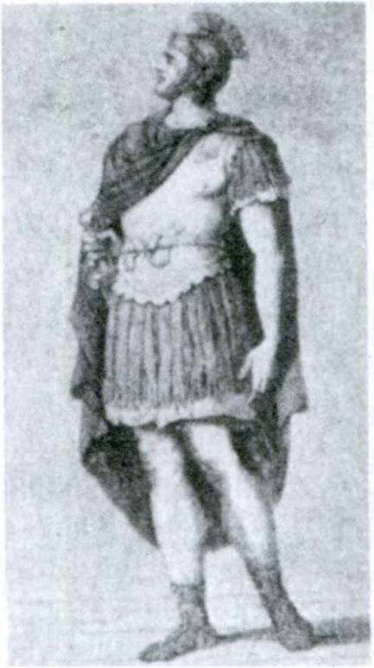

UNIT ONE

INTRODUCTION
To the right is a picture of a Roman soldier.
- He is stationed in Gaul.1
- His commander in chief is Caesar.
- Caesar once praised him for his bravery in fighting against the Gauls.
If you look over these sentences,
you will notice that the italicized words all MEAN the Roman soldier.
However, they are all spelled in dif­ ferent ways—he, his, him. Why is this? Because in each sentence they
have a DIFFERENT WORK to do,
and the spelling is changed to show what work the words do.
In the first sentence he is the SUBJECT, the person about whom we are speaking. He is in the nominative case and has the spelling which is the sign of the SUBJECT.
In the second sentence his modifies commander in chief and tells us to whom the commander in chief belongs. His thus answers the question: Whose? We call this form, his, the pos­ sessive case because it expresses the possessor, the person to whom something belongs (e. g., his book, his house, his soul).
In the third sentence him is the object of the verb praised;

1 Gaul was the ancient Roman name for that part of Europe which includes France, Belgium, Switzerland, and Germany west of the Rhine. See map, page 30. Northern Italy between the Alps and the river Po was called “Hither Gaul.” Julius Caesar, the great Roman general (100-44 B.C.), brought most of Gaul under Roman control during the Gallic War (58-51 B.C.).
3

4 FIRST YEAR LATIN

the action is done to him. This is the objective case, the case of the object.
If we were teaching a foreigner English and wanted to give him
help in selecting the correct form of he for each sentence, we might line up all the different forms like this:
CAse Form Use
Nominative he as subject
Possessive his to express the possessor
Objective him as object
This is called the DECLENSION of he. We have DECLINED the word he; that is, we have given in a simple, orderly way all its different spellings and uses.
Examine the declension of he. You will notice that one part
of the word is the same in all forms: A-. This is called the STEM, the part which, in declension, REMAINS THE SAME. The last part of the word changes: -e, -w, 4m \ these letters are called the ENDINGS. They show what case the word is and what work it does in the sentence, whether it expresses the subject, the possessor, or the object.
If we were talking about TWO OR MORE soldiers, we would have to say they, their, them. This would be the PLURAL, which shows that the word means MORE THAN ONE. (When the word means a SINGLE ONE, it is SINGULAR. Thus he is singular.)
Our complete declension, in singular and plural, would look like this:

 | CAse | Form | Use
Singular | Nominative Possessive Objective | h-e h-is h-im | as subject  to express the possessor as object
Plural | Nominative Possessive  Objective | th-ey th-eir th-em | as subject  to express the possessor  as object
Our friend the foreigner would now have a guide to help him

FIRST YEAR LATIN 5

choose the right word for any sentence. He would avoid saying such silly things as “Him is stationed in Gaul.”
In English our nouns change very little in declension. We have only three cases, and even in these three our nouns have only slight changes in spelling. Not all nouns have the same endings. Some, like son, dog, star, form their plural by adding -s: sons, dogs, stars; some add -es: negroes, glasses, boxes; others make no change at all, like sheep, deer, trout. This would be very con­ fusing to our foreigner. We could group all English nouns in classes for him with a model for each class; thus:

5. | Nominative Possessive | FirsT DeCLension  son son-’s | SeConD DeCLension  negro negro-’s
 | Objective | son | negro
P. | Nominative Possessive | son-s son-s’ | negro-es negro-es’
 | Objective | son-s | negro-es
We could then tell him that all words like son form their cases with the endings of son; and so for the other groups.
Now this is just what is done in Latin, to make it easier for us foreigners to learn. All Latin nouns are divided into five main groups called declensions, and in these groups we have a model which shows us the proper endings to use. All we have to find out about a new noun is this: What declension does it belong to? This we can tell from the Latin case called the GENITIVE. The GENITIVE SINGULAR always tells to what declension a noun belongs. And therefore always be sure to learn the genitive singular.

LESSON 1: THE FIRST DECLENSION

- THE DECLENSION OF TERRA
Open your GrAmmAr to No. 31. Here you see the declension of TERRA. Terra is a model for all Latin nouns that belong to the first declension. Look at the GENITIVE SINGULAR. It ends in -ae.

ALL NOUNS WHOSE GENITIVE ENDS IN -AE ARE IN THE FIRST DECLENSION.

The STEM of any noun is found by dropping the ending of the Genitive Singular. Thus, genitive: TERR-AE; STEM: TERR-.
A noun of the first declension is then declined by adding to the STEM the ENDINGS shown for TERRA.
You notice that the first five forms are all singular; the rest are plural—look at the MEANINGS.
There are five cases in each number. Study the MEANINGS given for the cases; the USES we shall study very gradually so they will not be too hard for you.
ASSIGNMENT: Memorize the declension of terra (GrAm­
mAr, No. 31).
Before you begin to study the vocabulary on page 7 your teacher will explain the rules for quantity and accent given in the GrAm­ mAr, Nos. 9-13. Learn these rules and see whether you can tell where the accent belongs in each of the words in the vocabulary.
Whenever nouns are given in vocabularies, both the nomina­ tive and genitive are printed. Be sure to learn the GENITIVE, because it tells you to what declension the noun belongs. Can you tell why all the words in the list are like terra?

6

FIRST YEAR LATIN 7

VOCABULARY

terra, terrae
porta, portae Maria, Mariae nauta, nautae victoria, victoriae silva, silvae
gloria, gloriae

earth land gate
Mary sailor victory forest
fame glory

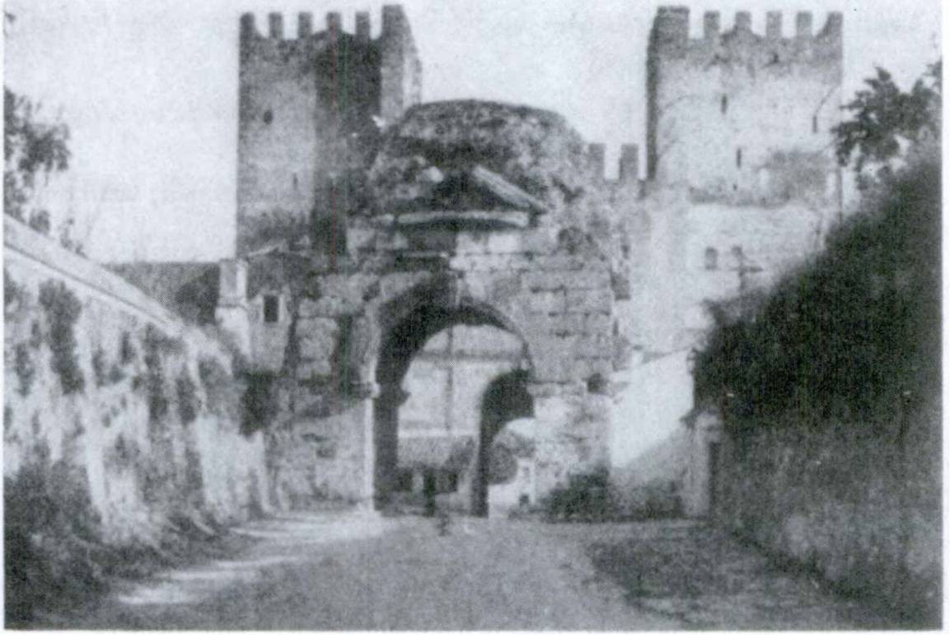RELATED ENGLISH WORDS
The following phrases contain English words related to some of the Latin words in the vocabulary: a nautical dictionary; a sylvan scene; the portals of the palace; rough terrain. Can you tell to which words they are related ?

PorTA

8 FIRST YEAR LATIN

HOW TO MAKE VOCABULARY STUDY EASY
- Read the words after your teacher, being very careful to pronounce them just as your teacher does.
- Look carefully at the genitive and the meanings; study them for a few minutes.
- Place a piece of paper over the English and try to recite the English meanings. Don’t look until you have really tried to remember them! Then do the same with the Latin. BE SURE TO LEARN EVERYTHING THAT IS GIVEN IN THE VO- CABULARY.
- Repeat this several times before class.
- Every day review some vocabulary before starting on your new lesson. If you learn each vocabulary very carefully and keep reviewing it, Latin will be easy. You will have VICTORIA over Latin and will gain the GLORIA which belongs to a good student.

EXERCISE 1
Decline the words in the vocabulary. Remember they are all like TERRA. Therefore:
- Find the STEM by dropping the -ae of the genitive singular, thus: glori-ae; stem: glori-;
- Add the ENDINGS of terra, thus: glori-a, glori-ae, glori-ae, etc.
EXERCISE 2
[Essential]
Tell what cases these forms are and give the meanings:

1. terram | 8. nautarum | 15. porta
2. silvas | 9. terrae | 16. silvis
3. portarum | 10. victoria | 17. victoria
4. gloriam | 11. nautae | 18. terra
5. portas | 12. victoriam | 19. portis
6. silvam | 13. gloriae | 20. nautis
7. victoriae | 14. Mariae | 21. porta

FIRST YEAR LATIN 9

22. Maria | 26. Mariam | 30. | silva
23. terrarum | 27. silvae | 31. | silvarum
24. terra | 28. terris | 32. | nauta
25. silva | 29. gloria | 33. | portae

EXERCISE 3
- How can you tell the difference between the nominative and ablative singular of the first declension?
- How can you find the stem of a Latin noun ?
- How can you tell to what declension a noun belongs?

RULES FOR GENDER
In English gender is very simple. Nouns naming men or male animals are MASCULINE, as John, man, sailor (sailors are usually men), bull, lion. Nouns naming women and female ani­ mals are FEMININE, as Mary, woman, waitress, cow, lioness. Nouns naming things are NEUTER, as book, lake, beauty, soul.
BUT IN LATIN nouns naming things are sometimes mascu­ line, sometimes feminine, sometimes neuter. Thus, terra, ae, is FEMININE although land is a THING and is NEUTER in English.
ASSIGNMENT: Learn the rules for the gender of nouns in the first declension, GrAmmAr, Nos. 32 and 33.

EXERCISE 4
Explain the gender of the words in the vocabulary on page 7.

USE OF VERBS
In Latin the pronouns (I, we, you, he, she, it, they), when used as subjects of a verb, are not ordinarily expressed separate­ ly. THEY ARE CONTAINED IN THE ENDING OF THE
VERB. Thus: drat means he, she, or it prays. He, she, or it is contained in the ending -at. Orant means they pray. They is contained in the ending -ant. The ending -at contains THREE

10 FIRST YEAR LATIN

English pronouns. How can you tell which one to use ? When we have been talking about a woman, and then say drat, translate
she prays. If we have been talking about a man, then orat means he prays.
Use he, she, or it accord­ ing to the person or thing of which the sentence speaks. (When you can’t tell to whom the sentence refers, use he.)
Orat. He prays. Orant. They pray. Mariam vident. Orat.
They see Mary. She is praying.
When a NOUN is used as the subject, the pronoun is NOT translated in English.
Nautae drant. The sailors pray.

MAriA orAT.
Maria orat. Mary prays.

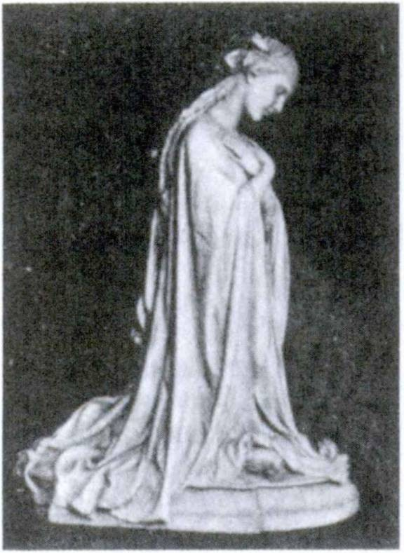Notice that in these sentences the subjects, nautae and Maria, are in the NOMINATIVE case.

RULE: THE SUBJECT OF A FINITE VERB IS IN THE NOMINATIVE CASE.

Notice that when the subject is singular—Maria—the singular (he, she, it) form of the verb, drat, is used; when the subject is plural—nautae—the plural (they) form of the verb, drant, is used.

RULE: A FINITE VERB AGREES WITH ITS SUB- JECT IN NUMBER (AND PERSON).

FIRST YEAR LATIN 11

HOW TO DIAGRAM A LATIN SENTENCE
Subject verb modifier modifier
Note that the subject and verb are separated by a straight line carried below the horizontal line. Thus:
Nautae non drant. Orat (subject not expressed).
Nautae | orant ( ) |  | drat
 |  | non

drat drant videt vident

VOCABULARY
he, she, it prays they pray
he, she, it sees they see

non, adverb
not

RELATED ENGLISH WORDS
A nowstop flight. The priest then read the orations.

EXERCISE 5
[Essential]
- Say in English;
- Diagram Sentences 1, 4, and 10:
1. Maria orat. 2. Nautae orant. 3. Nauta drat. 4. Nautae non orant. (Note. When the sentence contains not we use the helping verb do in English. Thus: The sailors do not pray.)
5. Vident. 6. Nauta videt. 7. Maria videt. 8. Videt. 9. Nautae non vident. 10. Non drat.

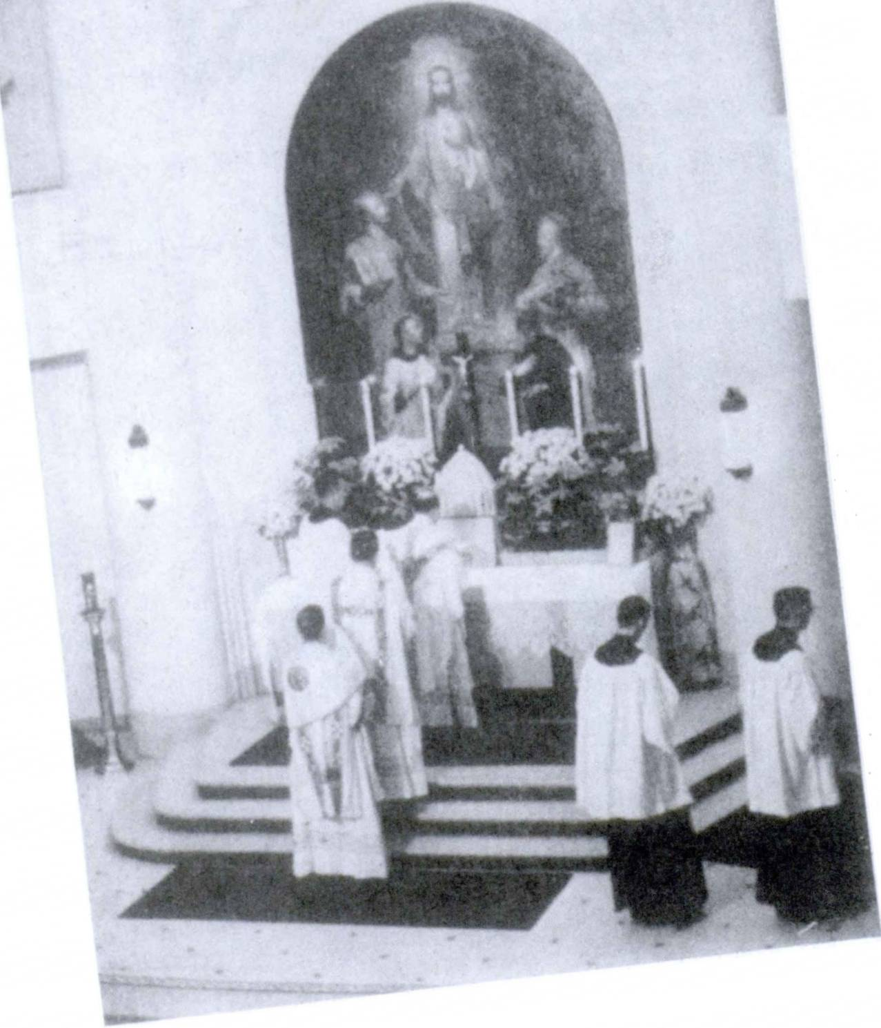
I

FIRST YEAR LATIN 13

READING NO. 1

LATIN STILL LIVES!
THe LAnGUAGe of PrAYer
As the light of the sun moves westward it falls upon chapels and cathedrals, hospitals and camps, where in endless repetition the Sacrifice of the Mass is being offered to God. At every mo­ ment, somewhere in the world, a priest stands at the foot of an altar and says, in Latin, “Introlbo ad altare Del,” “I shall go in to the altar of God.” Latin is the prayerful voice of the Roman Rite, of tens of millions of Catholics. In the universal offering of the Mass, the prophecy of the Old Testament is fulfilled: “From the rising of the sun to the going down thereof, my name is great among the gentiles.”
THe LAnGUAGe of PApAL TeACHinG
When a priest in Chungking receives an official document from Rome, he finds it is written in Latin. From Rome Latin carries the decisions and instructions of the Pope to the whole world, to the bishops of Brazil, to Chicago and South Africa, to Zanzibar and England. Latin, as the official language of the head of Chris­ tendom, is today a living and universal force.

THE ACCUSATIVE CASE
The sailors praise Mary.
Nautae Mariam laudant.
In this sentence Mary is the DIRECT OBJECT of the verb praise. In English Mary is in the OBJECTIVE CASE. In Latin the objective case is called the ACCUSATIVE CASE.

RULE: THE DIRECT OBJECT OF A TRANSITIVE VERB IS IN THE ACCUSATIVE CASE.

14 FIRST YEAR LATIN

HOW TO DIAGRAM A SENTENCE CONTAINING A
DIRECT OBJECT

Nautae
laudant
Mariam

Note that the verb and the direct object are separated by a straight line that is not carried below the horizontal line.
We can tell the direct object in the model sentence by the ACCUSATIVE ENDING -AM. The verb usually, as in the model on page 13, is put LAST in the sentence.

RULE: THE VERB USUALLY STANDS LAST IN THE SENTENCE.

laudat laudant
VOCABULARY
he, she, it praises they praise

provincia, ae
Province

RELATED ENGLISH WORDS
A laudatory speech; a provincial dialect.

EXERCISE 6
- Say in English;
- Diagram Sentences 1, 3, 6, and 9:
1. Nautae terram laudant. 2. Nautae provinciam vident.
- Maria silvas laudat. 4. Nauta silvas videt. 5. Nauta portam videt. 6. Provinciam non laudant. 7. Nautae Mariam laudant.
8. Victoriam laudant. 9. Nautae gloriam laudant. 10. Mariam laudat. 11. Provinciam videt.
Note the position of non, an adverb modifying the verb laudant, in Exercise 6, Sentence 6.

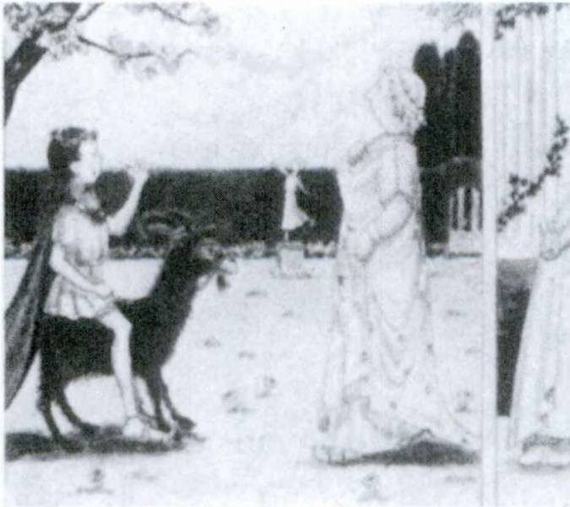FIRST YEAR LATIN 15

RULE: ADVERBS USUALLY STAND IMMEDIATELY BEFORE THE WORD THEY MODIFY.

EXERCISE 7
[Essential]
Say in Latin:
- They praise Mary. 2. The sailors see the province. 3. The sailors praise glory. 4. He sees the gate. 5. The sailor does not praise the province. 6. They praise the forest. 7. He sees the sailors. 8. She praises the victory. 9. They see the gate.
10. Mary does not praise the sailors. 11. The sailors see land.

TALKING LATIN NO. 1
When a Roman met one person and wished to say “Hello,” he said “Salve!”
When he met two or more persons, he said “Salvete!”
Say “Salve!” to your teacher tomorrow. That will show him you can talk Latin already.

SALveTe

16 FIRST YEAR LATIN

THE GENITIVE CASE
Mary’s glory, gloria Mariae
The glory of the province, gloria provinciae
The sailors’ victory, victoria nautarum
In these phrases the Latin genitive (underlined) translates the English possessive and the English ^/-phrases.

RULE: THE POSSESSIVE CASE AND MANY ENG­ LISH OF-PHRASES ARE TRANSLATED
BY THE GENITIVE.

EXERCISE 8
[Essential]
Say in English:
- gloria provinciae 3. gloria Mariae 6. victoria nautarum
- victoria nautae 4. gloria nautae 7. porta provinciae
  - silva provinciae

- the sailor’s victory
- Mary’s victory
- the gate of the province
EXERCISE 9
Say in Latin:
- Mary’s fame
- the sailors’ victory
- the forest of the province

LESSON 2: THE SECOND DECLENSION

We are now ready to study the second group of Latin nouns— the SECOND DECLENSION. If you look at the vocabulary below, you will see that the nouns all have -I in the genitive.

ALL NOUNS WHOSE GENITIVE SINGULAR ENDS IN -7 BELONG TO THE SECOND DECLENSION.

HOWEVER, SOME NOUNS OF THE SECOND DECLEN- SION HAVE -US IN THE NOMINATIVE, SOME HAVE
•UM. Those nouns of the second declension whose nominative ends in -us are declined like servus, servi and are generally MASCULINE. Those whose nominative ends in -um are declined like bellum, belli and are always NEUTER.
ASSIGNMENT: Learn the rules for gender in the GrAmmAr, Nos. 35 and 38.

  - THE DECLENSION OF SERVUS

VOCABULARY

servus, servi
filius, filii Deus, Dei amicus, amici
Christus, Christi Christianus, Christian! et, conjunction

slave servant son
God friend Christ Christian and

RELATED ENGLISH WORDS
A servile spirit; amicable relations; with filial affection.
17

18 FIRST YEAR LATIN

servi

AssIGNMENT: Memorize the declension of servus, GrAm­
mAr, No. 34.
EXERCISE 10
Decline all the nouns in the vocabulary (but decline Deus only in the singular). Remember:
- Find the stem by dropping the ending of the genitive singu- lar, -i;
- Add the endings of serv-us, serv-i, etc.

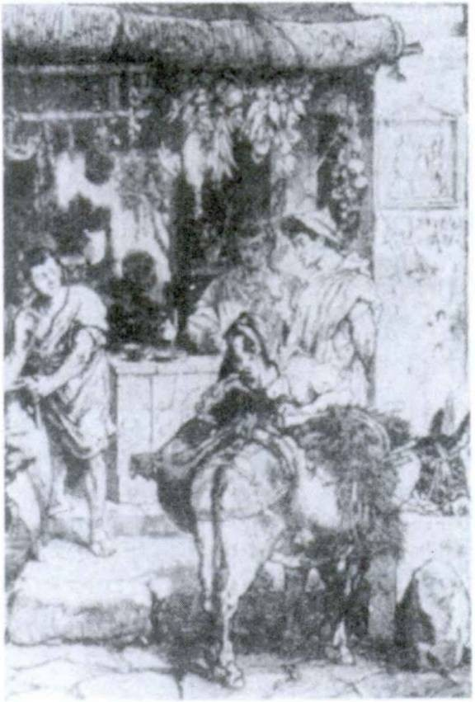

- Deus
- servos
EXERCISE 11
- Tell what forms these are;
- Give the English meaning:
- filiis
- Christum

- amicus
- Deum

FIRST YEAR LATIN 19

7. amicis | 15. filium | 23. | Christianorum
8. servus | 16. amici | 24. | filios
9. Christian! | 17. servo | 25. | Christus
10. amicos | 18. filius | 26. | servum
11. servorum | 19. Deo | 27. | Dei
12. amicum | 20. servis | 28. | Christo
13. filio | 21. amicorum | 29. | amico
14. servi | 22. filii | 30. | filiorum

EXERCISE 12
Translate:
gloria Del 6. gloria Mariae
amicus servi 7. victoria Christianorum
amicus Dei 8. servus Dei
victoria Dei 9. amicus Christi
gloria Christi 10. Filius Dei

EXERCISE 13
[Essential]
  - Translate;
  - Diagram Sentences 2, 3, and 10:
- Christian! drant.
- Amici Dei Christianos laudant.
- Christian! Filium Dei laudant.
- Christian! Mariam laudant.
- Nautae servos non vident.
- Servi Christianos laudant.
- Christian! servos Dei laudant.
- Gloriam Dei vident.
- ChFistiani Christum laudant.
- Maria et Christus amicos Dei laudant.
- Deus terram et silvas videt. Nautas et servos et Christianos videt.
- Christian! Filium Mariae laudant.

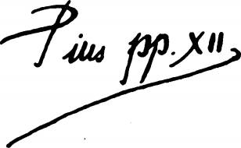20 FIRST YEAR LATIN

EXERCISE 14
[Essential]
Translate into Latin
1. Christians praise the Son of Mary. 2. Mary sees the Son of God. 3. Christians praise the victory of Christ. 4. Mary praises God. 5. God praises the glory of Christ. 6. Christ praises the friends of Mary. 7. The servants of Mary praise Christ. 8. The friends of God praise Mary. 9. The sailors do not praise the victory of the slaves. 10. Mary sees the glory of God and the victory of Christ. 11. God sees the earth; He sees the forests.

SERVUS SERVORUM DEI1

  - THE DECLENSION OF BELLUM
bellum, belli, war
This word has -i in the genitive. Therefore it is in the second declension. But its nominative ends in -um.

ALL WORDS OF THE SECOND DECLENSION WHOSE NOMINATIVE ENDS IN -UM ARE NEUTER AND ARE DECLINED LIKE BELLUM.

ASSIGNMENT: Learn the declension of bellum, GrAmmAr, No. 37. Note that it is like servus except in three cases.

1 Popes end their letters thus because Christ said: “Whoever wishes to be first among you shall be your slave” (Matthew 20:27).

FIRST YEAR LATIN 21

HINT: IN ALL NEUTER NOUNS AND ADJECTIVES THE ACCUSATIVE IS ALWAYS LIKE
THE NOMINATIVE.

VOCABULARY
bellum, belli caelum, caeli1
regnum, regni
praemium, praemil periculum, pericull

imperium, imperil

war sky heaven
kingdom royal power reward
danger command power
empire

RELATED ENGLISH WORDS
A belligerent nation. An interregnum. A premium was offered. His Imperial Majesty.
EXERCISE 15
- Tell what forms these are;
- Translate:

1. caeld | 4. imperio | 7. praemiis | 10. bella
2. periculdrum | 5. bellis | 8. regni | 11. regno
3. periculis | 6. periculi | 9. imperium | 12. praemia

- regnum Christi
- periculum servorum
- imperium Dei
- praemia Christian!
EXERCISE 16
Translate:
- porta Caeli
- praemium Mariae
- periculum amici
- victoria Christi

1 When Caelum is used to mean the Christian heaven the c will be capitalized.

22 FIRST YEAR LATIN

EXERCISE 17
[Essential]
Translate; underline the direct objects:
1. Amici Dei regnum Christi laudant. 2. Maria praemium et victoriam Christi videt. 3. Nautae caelum et terram vident.
- Deus pericula Christianorum videt. 5. Deus bella non laudat.
- Servi Christi imperium Christi laudant. 7. Maria gloriam regni Christi videt. 8. Filius Dei praemia Mariae laudat.
- Nautae pericula belli non laudant.

EXERCISE 18

REVIEW
  - Explain the gender of: (a) nauta, (b) porta, (c) regnum,
(d) Christus, (e) Maria, (f) praemium.
  - Mark the accents on the words in Number 1 and give the rule for each.
  - What is the position of adverbs in Latin? Of verbs?
  - How can you tell the difference between the nominative and ablative singular in the first declension ?

THE INDIRECT OBJECT

Christus gloriam Deo dedit. Christ gave glory to God. Christ gave God glory.
In these sentences to God and God are INDIRECT OBJECTS. (Glory is the DIRECT object.) The indirect object expresses the person (less frequently the thing) TO OR FOR WHOM some­ thing is said, told, given, entrusted, etc.

RULE: THE INDIRECT OBJECT IS PUT IN THE DATIVE CASE.

FIRST YEAR LATIN 23

HOW TO DIAGRAM SENTENCES CONTAINING AN
Christus | INDIRECT OBJECT  dedit [ gloriam
 |  | Deo

dedit dederunt gladius, i

VOCABULARY
he, she, it gave they gave sword

sed, conjunction
but

RELATED ENGLISH WORD
The gladiator fought bravely.

EXERCISE 19
[Essential]
- Translate;
- Diagram Sentences 3, 5, and 9:
Warning. One Latin sentence has no indirect object. Can you find that sentence?
1. Chrlstus Deo gloriam dedit. 2. Servis gladios non dederunt sed nautis gladios dederunt. 3. Nautae amicis victoriam dederunt.
- Deus amicis Mariae praemia dedit. 5. Deus Filio regnum dedit. 6. Christian! gloriam Mariae et Filio Mariae dederunt.
- Deus Christo terram dedit. 8. Nautae gloriam belli laudant sed pericula belli non laudant. 9. Provinciam amico dedit. 10. Deus gloriam et victoriam Christianis dedit. 11. Amico gladium dedit.

EXERCISE 20
[Essential]
Translate:
1. God gave a kingdom to Christ. 2. He gave a sword to the friend but not to the slave. 3. The Christians gave glory to God.

24 FIRST YEAR LATIN

4. They did not give the province to the slaves. 5. The Son of God gave heaven to the Christians. 6. Sailors do not praise the
dangers of war but they praise victory and the rewards of war.
- God gave a kingdom and an empire to Christ. 8. The sailors see the sky.
EXERCISE 21

REVIEW
Complete these sentences and translate:
1. Christian.............. drat. 2. Christiani or 3. Maria
De............vid.............. 4. Nautae terr................ vid. 5. Servus
Christi Cael............... laud............... 6. Amici Dei Christ...................
laud............. 7. Christus De................. vid............... 8. De..............
terras vid............... 9. Filius Dei Deum laud. 10. Maria
glori............ Deo dedit. 11. Servis gladi non dedit.
12. Christiani regn.............. et imperi Christi laudant.

USE OF PREPOSITIONS
Cum amico, with a friend
Cum is a preposition. It governs the word amico. (With
what? With a friend.) Amico is in the ablative case.

IN LATIN SOME PREPOSITIONS ARE FOLLOWED BY THE ABLATIVE CASE, SOME BY
THE ACCUSATIVE CASE.

Post bellum, after the war
Bellum is in the ACCUSATIVE case because the preposition post takes the accusative.
In provincia, in the province
Provincia is in the ABLATIVE because the preposition in, meaning in or on, takes the ablative case.

FIRST YEAR LATIN 25

oppidum, I Gallia, ae Gallus, i Romanus, i Roma, ae
VOCABULARY
town Gaul a Gaul
a Roman Rome

propter, prep. w. acc.
cum, prep. w. abl.
post, prep. w. acc.

in, prep. w. abl.
on account of with
(after
I behind

I on

NOTE
The abbreviations used are: prep., preposition, w., with. In vocabulary study always learn WHAT CASE A PREPOSITION GOVERNS.
RELATED ENGLISH WORDS
The French are famous for their Gallic wit. In the post-bellum
years.
EXERCISE 22
[Essential]
  - Translate;
  - Explain the cases of the nouns:
- in oppidd 11. propter victoriam
- in silva 12. in portis Romae
- cum GallO 13. cum Deo
- cum Marla 14. propter praemia Gallorum
- propter gloriam Romae 15. in caelo
- post victoriam 16. post victoriam Romanorum
- in silvIs Galliae 17. cum amicis
- cum nauta 18. in silvis
- propter pericula oppidi 19. in portis oppidi
- in terra 20. cum Romanis

26 FIRST YEAR LATIN

21. | in Gallia | 31. | propter periculum
22. | propter gloriam belli | 32. | in silvis et oppidis
23. | in provinces | 33. | post periculum
24. | in provincia | 34. | cum Christo
25. | cum servo | 35. | in bello
26. | post bellum | 36. | cum Christianis
27. | cum Romano | 37. | cum Gallis
28. | in regno | 38. | propter bellum
29. | in oppidis | 39. | post oppidum
30. | cum filiis | 40. | in porta
 |  | EXERCISE 23

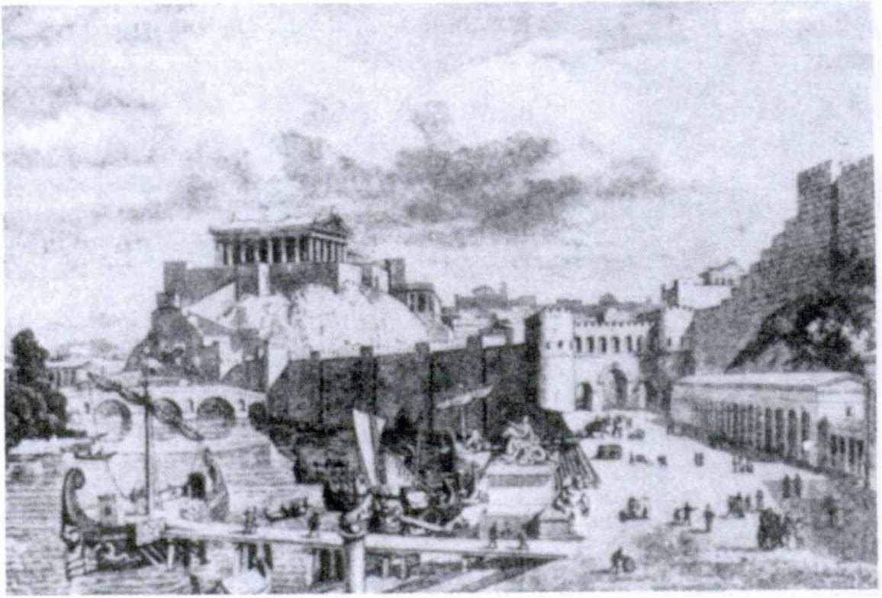

- with Mary
- after the war
- with God
[Essential]
Translate:
- on account of the war
- in the town
- after the danger

RomA

FIRST YEAR LATIN 27

- on account of the reward
- with the Son of God
- on account of the Christians
- in heaven
- on account of the kingdom
- with friends
- in Gaul
- with the Romans
- with the sailors

- in the forests
- on land
- in the provinces
- with the slave
- in danger
- on account of power
- with a Gaul
- behind the town
- on earth

- on account of the fame of Rome

- THE PREDICATE NOUN

Christus est Filius Dei.
Christ is the Son of God.
We have seen that transitive verbs take an object in the AC­ CUSATIVE CASE. In this sentence, however, we have a different kind of verb: est, is. The verb to be (of which is is a form) is called a LINKING verb because it LINKS two words together. IT DOES NOT TAKE AN ACCUSATIVE OBJECT. A noun
linked to the subject is in the NOMINATIVE case. Such a noun is called the PREDICATE NOUN. Filius is a predicate noun in this sentence and is therefore in the NOMINATIVE case.

RULE: AFTER A LINKING VERB THE PREDICATE NOUN IS PUT IN THE SAME CASE
AS THE SUBJECT.

HOW TO DIAGRAM A SENTENCE CONTAINING A PREDICATE NOUN

Christus
est Filius
Dei

28 FIRST YEAR LATIN

ASSIGNMENT: Learn the following forms of the verb I AM
and their meanings:

sum | I am | sumus | we are
es | you (singular) are | estis | you (plural) are
est | he, she, it is | sunt | they are

FORMS OF THE VERB SUM MAY STAND ANY­ WHERE IN THE SENTENCE.

EXERCISE 24
[Essential]
- Translate:
- Diagram Sentences 2, 4, and 7:
Warning. Some of the sentences in this exercise have no predi­ cate noun.
- “Estis filii Dei” (Words of Christ to His disciples).
- Christus est Filius Mariae. 3. Christian! sunt servi Dei.
4. Caelum est praemium Christiandrum. 5. Maria est in Caelo cum Deo. 6. Bellum in provincia est. 7. Sumus filii Dei.
- Amicus Dei es. 9. Galli sunt in Gallia, sed Romani non sunt in Gallia. 10. Galli sunt in oppidis et in silvis. 11. Romani gladios Gallis non dederunt. 12. Silvae in Gallia sunt. 13. Roma non est in Gallia. 14. Propter bellum Galli non sunt amici Ro­ mandrum. 15. Gladii sunt in oppido. 16. Nautae estis.
17. Nautae in silvis non sunt. 18. Cum amico in provincia sum.
19. Silvae sunt post oppidum. 20. Nautae sunt Christian!. 21. In oppidd sumus. 22. Romanus servo praemium dedit. 23. Sunt Dei amici. 24. Christianus es sed servus Romani es. 25. In Caelo non estis.

FIRST YEAR LATIN 29

EXERCISE 25
[Essential]
Translate:
1. Christ is the Son of God. 2. Sailors see the sky but not the land. 3. Christians are servants of Christ. 4. We are friends of God. 5. Mary is with Christ in heaven. 6. The slaves are in the towns and in the forest. 7. Christians praise God on account of the glory of Christ. 8. The Gauls are in Gaul. 9. You are the sons of God. 10. You are a servant of Christ. 11. I am on the earth. 12. Heaven is the reward of the servants of Christ.
13. After the war—the rewards of victory! 14. Romans are in the provinces. 15. Mary is the “Gate of Heaven.” 16. The servants are in the towns. 17. You are not in Gaul.

TALKING LATIN NO. 2
When a Roman thought something was pretty good (excellent, ‘swell’) he said, “Optime!” or “Optimum est.” But when some­ thing was pretty bad, he remarked in disgust, “Pessime” or “Pes- simum est.” So when your teacher groans “Pessime!” after your recitation DON’T SMILE HAPPILY.

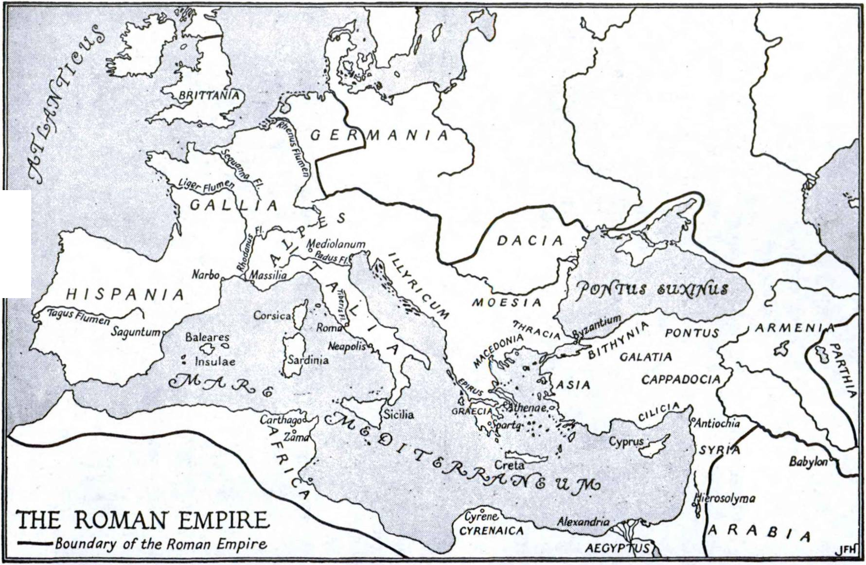

FIRST YEAR LATIN 31

  - USE OF QUOD, ‘BECAUSE’
I am a servant of Christ because Christ is God.
Servus Christi sum quod Christus Deus est.
Quod, because, is a conjunction which joins a subordinate clause to a main clause. In this sentence I am a servant of Christ is the main clause; because Christ is God is a subordinate clause.

VOCABULARY

quod, conj. because
i.t.aque, conj. . f1 therefore
[ ana so
incolunt they inhabit
videtis you (plural) see
vicerunt they conquered
NOTE
Quod and itaque NEVER change their spelling. Itaque is used at the beginning of a sentence as an introductory adverb.

EXERCISE 26
[Essential]
WHAT YoU See on THe MAp
In tabula1 videtis Romam et imperium Romanorum. Romani Rdmam incolunt. Provincias imperii Romanorum videtis. Gal- liam videtis. Romani Gallos in bellis vicerunt. Gladii non sunt in oppidis Galldrum quod Galli post bellum gladios Romanis dederunt. Itaque post victorias Romanorum provincia in Gallia est. Provinciam Galli et Romani incolunt. Pericula sunt in silvis Galliae, quod Galli non sunt amici Romanorum. Galli sunt servi Romanorum, quod Romani Gallos vicerunt. Itaque Galli imperium Romanorum non laudant, sed Romani propter gloriam belli imperium laudant.
1 tabula, ae: map.

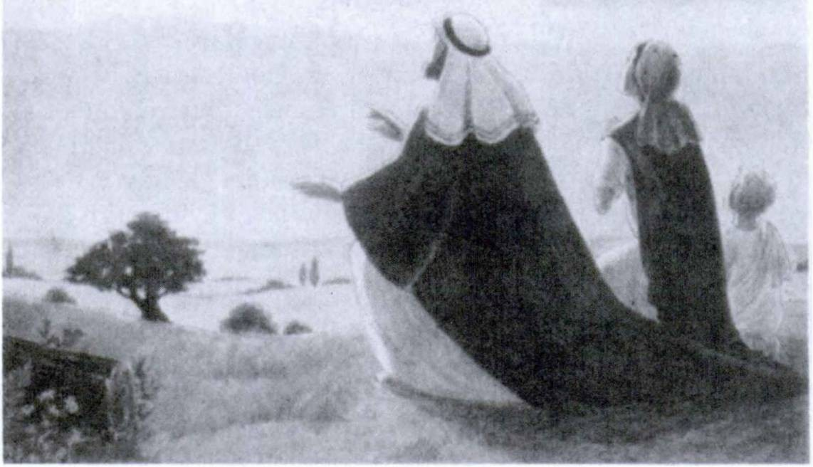

FIRST YEAR LATIN 33

EXERCISE 27
[Essential]
Videtis Christianos. Videtis Mariam et Christum et Deum. Christian! in terra sunt, sed Christus et Maria in Caeld cum Deo sunt. Pericula Christianorum in terra sunt, sed praemia sunt in Caeld. Itaque Christiani in terra drant. Maria cum Christianis drat quod Christiani filii Mariae sunt. Christiani Mariam lau­ dant quod Christus est filius Mariae. Christum laudant quod filius Dei est.

READING NO. 2
LATin, THe LAnGUAGe of Rome AnD of THe WorLD
We have seen that Latin is still widely in use in the Catholic Church. But who first spoke Latin and how did it become so important? Latin was the language of the people living in the region called Latium in ancient Italy. (See map, page 166.) Here was the city of Rome. There were dozens of other dialects spoken in Italy, but the language of Rome alone was destined to reach out into the world. For the Romans gradually conquered their neighbors; the soldiers from Rome marched to the southern shores as conquerors; their tread was heard in the Alps and in the African deserts. Gaul (the ancient name of France), Spain, northern Africa, the Mediterranean world—all were bound into one great empire under Rome.
So, just as Spanish and Portuguese have become the languages of South America because Spain and Portugal conquered and colonized there, Latin became the tongue of Gaul, Spain, north­ ern Africa, and of Roman cities throughout the Empire. Even after the fall of the Roman Empire, Latin continued to be spoken in Europe. Throughout the Middle Ages it was the universal lan­ guage of learning and science. Spanish, French, and Italian are all just modern editions of Latin and still show a close similarity to the ancient mother tongue. This is why one who knows Latin finds it easy to learn these modern languages.

34 FIRST YEAR LATIN

For example, from the word VICTORIA, which you have had, the modern languages (even ones not derived from Latin) have the following derivatives or cognates P

EnGLisH | Victory | United States, Canada, Great Britain.
 |  | Ireland, South Africa, New Zealand,
 |  | Australia
SpAnisH | Victoria | Spain, Mexico, Central America,
 |  | South America
PorTUGUese | Vitoria | Portugal, Brazil
FrenCH | Victoire | France, Belgium, Switzerland, French Canada
ITALiAn | Vittoria | Italy
RUmAniAn | Victorie | Rumania
Dutch | Victorie | Holland
PoLisH | Wiktorya | Poland
Read through the places listed here. Roman words—words that were heard thousands of years ago only in that small region called Latium—are now heard in all these places. Latin, the language of the Romans, has conquered far wider reaches of the world than Rome’s generals ever dreamed of.

1 Reprinted with permission from a chart prepared by B. L. Ullman for the American Classical League.

LESSON 3: THE THIRD DECLENSION
Here are some words which belong to the third declension:

NominATive | GeniTive | MeAninG
lex | legis | law
homo | hominis | man
veritas | veritatis | truth
imperator | im per a tons | commander
What do you notice about the endings of the nominative? Un­ like the first and second declensions, the third declension has NO REGULAR ENDING in the nominative singular. How then will you be able to tell when a word belongs to this declension? (Give the general rule!)

ALL NOUNS WHOSE GENITIVE SINGULAR ENDS IN -IS BELONG TO THE THIRD DECLENSION.

The STEM is found by dropping the -is of the genitive singu­ lar. Thus, genitive: legis, stem: leg-.

- GENDER IN THE THIRD DECLENSION
Nouns in the third declension may be masculine, feminine, or neuter. We shall study the masculine and feminine nouns first. You can tell whether a noun is masculine or feminine from the rules given in the GrAmmAr, Nos. 46-52.1 Read these rules care­ fully and see whether you can determine the gender of the nouns in the vocabularies on pages 39 and 42. Now memorize the rules.

EXERCISE 28
Without looking in the GrAmmAr determine the gender for the nouns listed on pages 36, 44, and 51. Give the proper rules.
1 There are many exceptions, to be marked m., f., or », in the vocabularies.
35

36 FIRST YEAR LATIN

- RULES FOR NOUNS LIKE LEX AND PARS
Look at Nos. 57 and 58 in the GrAmmAr. YoU will notice that two models are given for the masculine and feminine nouns of the third declension. They have exactly the same endings except in the nominative singular and in the GENITIVE PLURAL.
All masculine and feminine nouns of the third declension are declined like lex EXCEPT THOSE in the GrAmmAr, Nos. 59-63. All masculine and feminine nouns covered by these rules are de­ clined like pars.
ASSIGNMENT: Learn the rules for nouns declined like pars,
GrAmmAr, Nos. 59-63.

EXERCISE 29
Which words on pages 44 and 47 are like lex? Like pars?

- THE DECLENSION OF LEX
ASSIGNMENT: Memorize the declension of lex, GrAmmAr, No. 57.
VOCABULARY
(All the words in this vocabuary are like lex)

lex, legis rex, regis dux, ducis lux, lucis
homo, hominis imperator, imperatdris veritas, veritatis
law king leader light man
commander in chief general
truth

RELATED ENGLISH WORDS
The Duke of York; a regal manner; the eternal verities; Lucifer; a legal dispute.

FIRST YEAR LATIN 37

EXERCISE 30
- Give the gender and the proper gender rules for each word in the vocabulary.
- Decline each word in the vocabulary (but decline veritas and lux only in the singular). Follow these rules: (a) Find the declension from the genitive, (b) Find the stem by dropping the genitive ending, (c) Find the proper model (lex or pars), (d) Add the endings as in the model.
- Give the genitive plural of: (a) lex, (b) dux, (c) rex,
(d) homo, (e) imperator. Why are all these nouns like lex?

- legibus
- regum
- imperator I
- ducum
- luce
- duces
- veritatl
EXERCISE 31
- Tell what forms these are;
- Translate:
- homo
- imperatorum
- ducibus
- hominum
- veritatem
- regem
- imperatorem

- lucem
- hominibus
- duce
- veritate
- homine
- regibus
- leg!

  - lux veritatis
  - rex regum
  - rex hominum
EXERCISE 32
Translate:
- rex Christiandrum
- propter legem Dei
- cum rege

  - lex Dei 8. propter veritatem

- behind the king
- for men
- the light of truth
EXERCISE 33
Translate:
- for the commander in chief
- on account of the law of Christ
- with the leader of the Gauls

38 FIRST YEAR LATIN

EXERCISE 34
[Essential]
- Translate;
- Underline the direct objects:
1. Christus est Rex Regum. 2. Homines lucem vident.
- Nautae sunt homines. (Why is homines nominative?)
- Christian! veritatem Christi laudant. 5. Lux in silvis non est. 6. Romani legem et veritatem Christi non laudant. 7. Im- peratores Romandrum Gallos vicerunt. 8. Galldrum duces legem et imperium Romandrum non laudant. 9. Christus est Rex homi- num quod Deus est. 10. Dux Romandrum in Gallia est quod bellum est in Gallia. (Explain the use of quod.) 11. Romani imperatori et ducibus praemia dederunt quod Gallos vicerunt. (Explain the case of ducibus.) 12. Romani duces et reges Gal- lorum vicerunt.
EXERCISE 35
Translate:
1. The commander in chief does not praise the leaders of the Gauls. 2. Christ is the Light of Men because He gave men truth.
- The Gauls do not praise the laws of the Romans. 4. Christ is the King of Kings. 5. The leaders of the Romans are in Gaul. And so the kings of the Gauls are servants of the Romans. 6. The general sees the dangers of the war.

- APPOSITIVES
Christ, the Son of God, is the King of Kings.

Christus, Filius Dei, est Rex Regum.
Christians praise Christ, the Son of God.

Christian! Christum, Filium Dei, laudant.
In these sentences the word Son is a noun which is used to explain the word Christ. Such a noun is said to be in APPOSI­ TION to the noun it explains and is called an APPOSITIVE.

FIRST YEAR LATIN 39
Son is in apposition to Christ and is an appositive. Filius is in apposition to Christus and is an appositive. An appositive is frequently set off by commas. Note that Christus is in the nominative case because it is the sub­ ject of the sentence and that FILIUS IS IN THE SAME CASE; that
Christus is singular and FILIUS IS
IN THE SAME NUMBER. In the
same manner, explain the case and number of Filium in the second sen­ tence above. How do you explain the
case of imperator? (See illustration.) CAesAr, ImperATor
RomAnorUm

RULE: AN APPOSITIVE AGREES WITH ITS NOUN IN NUMBER AND CASE.

VOCABULARY

Caesar, Caesaris salus, salutis
vox, vocis audlvit
NOTE

Caesar
safety welfare salvation
voice cry
he, she, it heard

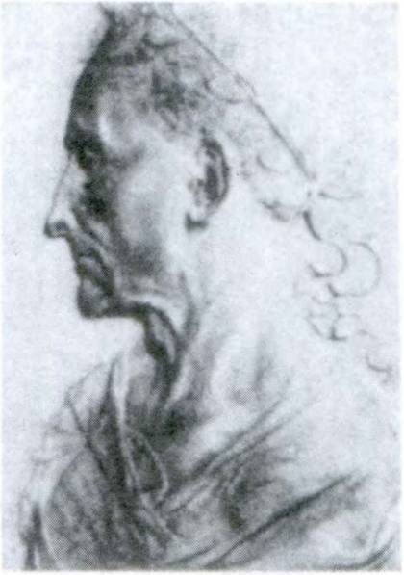What is the gender of Caesar, vox, and salus? Why? Why is vox like lex ?

RELATED ENGLISH WORDS
Salutary advice; vocal lessons; the Kaiser.

40 FIRST YEAR LATIN

HOW TO DIAGRAM A SENTENCE CONTAINING AN APPOSITIVE
Christus (Filius) |  | est Rex
 | Dei |  | Regum

EXERCISE 36
[Essential]
- Translate;
- Diagram Sentences 2, 3, and 7:
1. Galli Caesari, imperatori Romanorum, praemia non de- derunt. 2. Servus vocem Caesaris imperatoris audivit. 3. Deus, Rex Caeli et terrae, salutem hominibus dedit. 4. Caesar, dux Romanorum, voces Gallorum in silvis audivit. 5. Propter salutem hominum Christus est homo. 6. Christus, Filius Dei, est Filius Mariae. 7. Galli, servi Romanorum, Romanos non laudant.
- Christian! Christum, Filium Mariae, laudant.

Sanctus Joannes,1 Christi servus, vocem Christi audivit:
“Ego2 sum Via3 et Veritas et Vita.”4

EXERCISE 37
Complete and translate:
  - Christus, Rehominum, in Caeld est. 2. Salus homi­ num in Christo, Fili Dei, est. 3. Caesar, imperat Romanorum, in Gallia est. 4. Vox Christi, Fili Dei, est vox Dei. 5. Romani Caesarem imperatlaudant.
1 Sanctus Joannes: Saint John; i.e., St. John the Evangelist, one of the twelve Apostles, the author of the Fourth Gospel. The sentence quoted was spoken by Christ at the Last Supper the night before He died.
2 Ego: I.
3 Via, ae: the Way.
*Vita, ae: the Life.

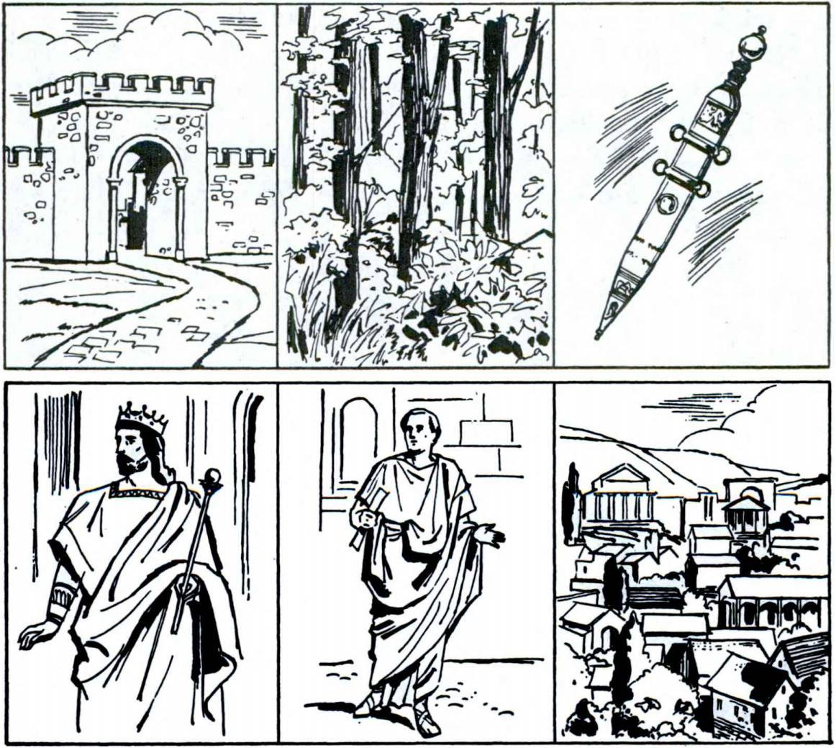FIRST YEAR LATIN 41

EXERCISE 38
[Essential]
Translate:
- Christ, the Son of God, is man on account of the salvation of men. 2. He heard the voice of Christ, the son of Mary.
3. Christ, the Son of God, is the King of Kings. 4. God gave a kingdom to Christ, the friend of men. 5. Christians praise Christ, the King and friend of men. 6. Caesar, the general of the Ro­ mans, heard the cries of the Gauls. 7. On account of the safety of the province Caesar, the commander in chief, is in Gaul.

EXERCISE 39
Name in Latin the objects pictured here:

42 FIRST YEAR LATIN

EXERCISE 40
- Tell what forms these are;
  - Translate:
imperatorum 5. regum 9. hominum 13. filiis
Romandrum 6. regnum 10. duel 14. bellis
amicum 7. veritatem 11. amici 15. lucis
periculum 8. Christum 12. homini 16. legis

- THE EXPLETIVE THERE
There are dangers in Gaul. There is a king in Gaul.
In these sentences there is an expletive. It merely introduces the sentence. The real subjects are dangers and king.
Do not confuse the EXPLETIVE there with the ADVERB there, as in the sentence,11 Were you there ?” In this sentence there is an adverb meaning in that place.
The expletive there is NOT TRANSLATED in Latin. There is and there are are expressed in Latin by EST or SUNT. There is not translated. Thus:
Sunt pericula in Gallia. Est rex in Gallia.

VOCABULARY
virtus, virtutis courage
virtue
miles, militis soldier
pax, pacis peace

via, ae populus, i muniverunt
road way people nation
they fortified
they constructed (w. viam or vias)

FIRST YEAR LATIN 43

NOTE
- To what declensions do the nouns in the vocabulary belong? What gender are they? Why?
- Muniverunt means they constructed ONLY when it has
viam or vias for its object. Otherwise it means they fortified.
RELATED ENGLISH WORDS
Military measures. Pacific intentions. Popular government. He came via the Panama Canal.

ProverB

VOX POPULl, VOX DEI1

EXERCISE 41
[Essential]
Translate:
1. Sunt pericula in silvis Galliae. 2. Non est pax in Gallia quod Caesar cum militibus in Gallia est. 3. Sunt viae in pro- vincia. 4. Populus ducem militum propter virtutem laudat.
5. Romani vias in provincia muniverunt. 6. Est pax in Caeld.
- Sunt Christian! in Caelo. 8. In pace et in bello Christiani orant. 9. Sunt milites in via. 10. Caesar militibus praemia vir- tutis dedit quod Gallos vicerunt. 11. Duces Gallorum oppida muniverunt.
EXERCISE 42
[Essential]
Translate:
  - There are roads in Gaul. 2. There is a war in the province.
- There are soldiers in the forest. 4. The Romans constructed roads. 5. There is not peace in Gaul because Caesar and the soldiers are in Gaul. 6. On account of the courage of the soldiers
1 In proverbs forms of the verb to be (est, sunt, etc.) are frequently omitted. They should be supplied in the translation.

44 FIRST YEAR LATIN

there is peace in the province. 7. They fortified the towns on account of the people’s danger. 8. Christ is the Way and the Truth. 9. They praise the virtue of the nation.

TALKING LATIN NO. 3
When the Romans answered a question, they eithei repeated the sentence (with or without non) or used single words like our yes and no: ita, thus, so, certe, certainly, minime, least of all, by no means. Your classroom conversation can be made very interesting by the use of these words. For example:
Time: ToDAY TeACHer. “Did you do your homework?” You (brightly). “Ita!”
TeACHer. “Is it all correct?”
You (still brightly). “Certe!”
Time: Tomorrow You. “Did you correct our homework ?” TeACHer (not too brightly). “Ita.”
You. “Was mine correct?” TeACHer (grimly). “MINIME!”

- THE DECLENSION OF PARS
ASSIGNMENT: Review the rules in GrAmmAr, Nos. 59-63. Learn the declension of pars, No. 58. Note that it is like lex except in the nominative singular and the GENITIVE PLURAL.

VOCABULARY

pars, partis collis, collis, m. hostis, hostis gens, gentis caedes, caedis
part hill
enemy (in war)
tribe slaughter

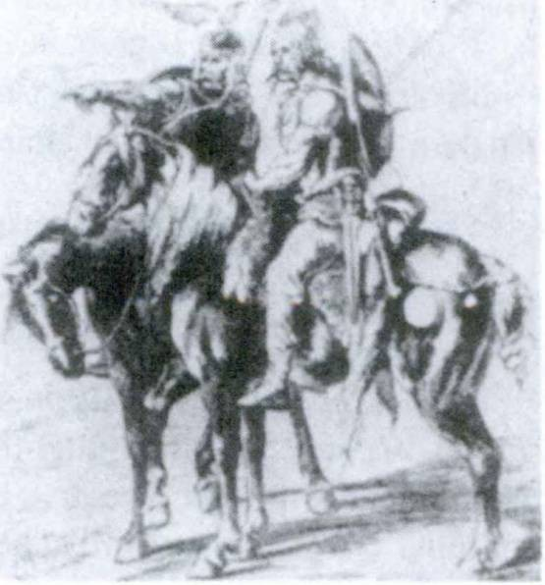FIRST YEAR LATIN 45

NOTE
The plural of hostis is often used to translate the English singular enemy. Collis is an exception to the rules for gender; notice that it is masculine.
RELATED ENGLISH WORDS
The gentiles ; hostile actions.

EXERCISE 43
- Give the gender and the gender rule for each word in the vocabulary.
- Give the genitive plural of each word in the vocabulary.
- Decline (a) pars, (b) hostis, (c) gens.

PAX CHRISTI IN REGNO CHRISTI
(Motto of Pope Pius XI)

EXERCISE 44
- Tell what forms the nouns are;
- Translate:
  - pars hostium
  - propter caedem gentium
  - cum hostibus
  - in colle
  - post caedem Gallorum
  - in oppidis hostium
  - in collibus
  - rex gentium
  - post collem
  - gentibus
  - post caedem hostium HosTes RomAnorUm

46 FIRST YEAR LATIN

EXERCISE 45
Translate:
- on account of the welfare of the tribes
- part of the leaders and soldiers
- with the general of the enemy
- on account of the slaughter of the men
- on the hill
- with the enemy
- in the way
- the leaders of the tribes

EXERCISE 46
[Essential]
  - Translate:
  - Diagram Sentences 1, 2, 7, and 9:
- Duces Romanorum hostes in colle vicerunt. 2. Propter caedem militum bellum in Gallia est. 3. Sunt pericula in Gallia quod Galli hostes Romanorum sunt. 4. Christus est rex popu- lorum et salus hominum quod Deus est. 5. Pars hostium in silvis est, sed pars est in colle. 6. In Gallia sunt colies et silvae et oppida et viae. 7. Romani reges et gentes Galliae vicerunt.
- Propter salutem populi et pacem provinciarum Romani vias muniverunt. 9. Homines virtutem et veritatem laudant. 10. Post caedem hostium Caesar milites propter virtutem laudat.

EXERCISE 47
[Essential]
Translate:
  - Part of the enemy is in the towns, but part is on the hill.
  - On account of the slaughter of the leaders of the tribe, the Gauls do not praise Caesar. 3. Christ is the King of tribes and nations. 4. There are hills behind the town. 5. After a victory there is a slaughter of part of the leaders of the tribe. 6. Part of the enemy is in the hills and forests.

FIRST YEAR LATIN 47

EXERCISE 48
REVIEW
- How can you tell the difference between the nominative singular and the ablative singular of the first declension?
- Give the gender and the proper gender rule for: nauta lex Christus praemium homo veritas
- Translate, and give the rule for the case of the italicized words :
Christus, Filius Dei, gloriam et praemium amicis Dei dedit.

- REVIEW OF NOUNS LIKE LEX AND PARS
Review GrAmmAr, Nos. 45-63. Review vocabulary, page 36.

VOCABULARY
frater, fratris (fratrum) pater, patris (patrum) mater, matris (matrum) mons, montis, m.

brother father mother mountain

clamor, clamoris J shouting
princeps, principis J chief
[leading man
occiderunt they killed
NOTE
- The genitive plural of pater, mater, frater is put in parentheses to remind you that these words are exceptions to the rule for -ium words.
- Notice that mons is an exception to the gender rules.
RELATED ENGLISH WORDS
Paternal care; the crown prince; maternal affection; clamorous
demands; fraternal love.

48 FIRST YEAR LATIN

EXERCISE 49
- Give the rules for gender for masculine and feminine nouns of the third declension. Give the gender of the third declension nouns in the vocabulary.
- When are masculine and feminine nouns of the third de­ clension declined like lex? Like pars?

EXERCISE 50
Identify these forms:

1. oppidum | 4. amicorum | 7. principum
2. montium | 5. militum | 8. gentium
3. nautarum | 6. matrum | 9. clamdrum

EXERCISE 51
[Essential]
Z. Tell what case these nouns are;
- Translate;
- Give their nominative and genitive singular and their gender;
- Give the genitive plural of all italicized words:

- propter virtutem militum
- pax populdrum et gentium
- propter clamorem hostium
- post caedem patrum et matrum
- propter lucem et veritatem Christi
- cum imp er at ore Romandrum
- propter salutem fratrum
- in colie
- in montibus
- post ducem
- cum rege
- voces hominum
- cum parte militum
- cum Caesare

NOTE ON READING LATIN
When you read a Latin sentence you have to puzzle out the meaning. Perhaps you look for the subject and the verb and translate them into English and so gradually find out what the Latin means. But a Roman boy or girl did not have to do this; they could UNDERSTAND the Latin words at once and IN

FIRST YEAR LATIN 49

THE ORDER in which they were spoken or written. They read Latin just as you read English.
Now you can learn to read Latin that way too. It may take you a long time, but if you start now in the right way you will eventually be able to read Latin WITHOUT EVER THINK­ ING OF ENGLISH WORDS. But it takes a lot of the right kind of practice. A football coach makes a boy hold a ball in a certain way, throw it in a certain way—over and over again— until the boy learns how to do it naturally, quickly, and correctly. So you too must practice the right way of reading Latin.
Now here is the way to practice reading Latin.
- First read each Latin sentence slowly and thoughtfully, trying to understand it. At first you won’t understand a thing. But do this each time anyway.
- Then work out in translation all the words and phrases you didn’t understand. At first you will have to work out the whole sentence.
- Then REREAD the sentence several times, trying to put the MEANING into the Latin and to understand the Latin with­ out thinking of English words. Do this over and over again until you UNDERSTAND the Latin in the Latin order. It will help to read the sentence aloud and to put as much meaning into your voice as possible. (Be sure to pronounce the words correctly I)
If you do this regularly NOW, Latin later on will be much easier and you will have the satisfaction of reading it quickly and easily. Try out this method on Exercise 52.

EXERCISE 52

  - Fratres Estis
Christus est rex hominum sed est frater hominum, et Deus est rex hominum sed est pater hominum. Itaque homines sunt fra­ tres. Itaque bellum est caedes fratrum. Itaque Deus et Christus bellum non laudant.

50 FIRST YEAR LATIN

  - Caedes Galldrum
Romani partem principum Galldrum occiderunt. Itaque Deus clamorem matrum et patrum et fratrum in silvis et montibus Galliae audivit.
  - In Gallia
In Gallia sunt silvae et montes et colles. Sunt oppida in col- libus, sed pars gentium Galldrum montes et silvas incolunt.
  - Christus, Dux Hominum
Christus est dux hominum quod veritatem et legem et lucem hominibus dedit. Christus est “Via” et “Veritas.”

  - “Our Tainted Nature’s Solitary Boast”—Wordsworth
Maria est Mater Christi. Sed Christus est Deus quod Filius Dei Patris est. Itaque Maria est Mater Dei. Mariam, Matrem Dei, Christian! laudant. Maria est mater hominum quod Chris­ tus in cruce1 Mariam hominibus dedit. Itaque Christiani sunt filii et servi Mariae. Maria est Porta Caeli.

MILES CHRISTI SUM
(Motto of the Archbishop of Indianapolis)

EXERCISE 53
[Essential]
- He heard the shouting of the leading men. 2. They killed the chiefs of the tribe. 3. There are dangers in the mountains.
- The general praises the mothers and fathers of the soldiers.
- The brothers are with Caesar in Gaul. 6. They fortified the hills on account of the war. 7. The Romans constructed roads in the mountains.

x in cruce: on the cross.

FIRST YEAR LATIN SI

- THE DECLENSION OF FLUMEN
VOCABULARY

flumen, fluminis iter, itineris, n.
corpus, corporis, n,
vulnus, vulneris, n, agmen, agminis nomen, nominis
river
journey march route
body wound
column (of soldiers) army (on the march) name

RELATED ENGLISH WORDS
Corporal needs. An itinerant salesman. We nominated him for president.
To what declension do all the words in the vocabulary belong? To determine their genders study the rules, GrAmmAr, Nos. 51-52.
Without looking in the GrAmmAr see whether you can work out the declension of flumen from the following hints:
- Flumen is declined exactly like lex except in the nomina­ tive and accusative, singular and plural.
- In all neuter nouns the accusative is always like the nomina­ tive.
- The nominative singular of flumen you know from the vocabulary. The nominative plural is flumin-a.
ASSIGNMENT: Now compare your declension with the one in GrAmmAr, No. 64. Learn the declension of flumen and decline the words in the vocabulary.

- flumina
- in itinere
EXERCISE 54
1, Tell what forms these are;
- Translate:
  - propter nomen
  - in nomine Patris

52 FIRST YEAR LATIN

  - propter nomen Christi
  - nominum
  - nomen patris
  - nomine
  - fluminibus
  - in flumine
  - in agmine

- in the river
  - agmina
  - in nomine Dei
  - vulnera militis
  - vulneribus
  - iter hostium
  - vulnerum
  - corporibus

EXERCISE 55
Translate:
- on the march

- on account of the wounds
- on the journey
- in the column
- in the name of Mary
- in the body
- with the army
- after the journey
- the name of the river
- on account of the law
- with the generals
- the safety of the tribes
- on the mountain

EXERCISE 56
[Essential]
Translate:
  - Propter vulnera miles in agmine non est. 2. Imperator vulnera militum videt. 3. Sunt corpora in flumine. 4. In Gallia sunt flumina et silvae. 5. Romani in itinere sunt. 6. Sunt hostes in silvis et in montibus. Itaque in periculo sumus. 7. Caesar agmen hostium videt. 8. Christian! nomen Mariae laudant.
- Agmen hostium in flumine est. 10. Romani Christianos occi- derunt quod Christian! nomen Christi laudant.

EXERCISE 57
[Essential]
Translate:
1. There are bodies and swords in the river. 2. The column is in the mountains. 3. Christians pray in the name of Christ, the Son

FIRST YEAR LATIN 53

of God. 4. There are brothers and fathers in the army. 5. There are dangers on the journey because the enemy is in the hills.
- After the march they fortified the hill. 7. The route is in the mountains. 8. The sailors see the land and the sky. 9. The king prays on account of the welfare of the kingdom.

- REVIEW OF THE THIRD DECLENSION
ASSIGNMENT: Review GrAmmAr, Nos. 45-64. Review vo­ cabularies on pages 36, 39, 42, 44, 47, and 51.

VOCABULARY
mundus, i world
erat he, she, it was
erant they were
NOTE
Erat and erant (like est and sunt) sometimes mean there was
and there were.

Mundane affairs.
RELATED ENGLISH WORD

EXERCISE 58
- Give the genitive and gender and the gender rule;
- Give the accusative singular;
- Give the nominative plural;
- Give the genitive plural:
nomen miles virtus vox
rex caedes iter frater veritas pater princeps corpus mater flumen pars imperator
mons clamor hostis pax
agmen lux salus vulnus
dux homo collis gens

54 FIRST YEAR LATIN

EXERCISE 59
[Essential]
Translate:
- “Estis lux mundi” (Words of Christ to His disciples).
- Propter salutem hominum Christus erat in mundd. 3. Christus lucem et legem et salutem et veritatem hominibus dedit.
4. Caesar, imperator Romanorum, cum militibus in Gallia erat.
5. Christus est salus mundi. 6. Servi nomen regis laudant.
7. Agmen hostium in montibus erat. 8. Propter caedem prin- cipum non erat pax. 9. Propter vulnera milites in itinere non erant. 10. Deus, pater hominum, virtu tern laudat sed bella et caedem non laudat. 11. Dux voces servorum et clamorem mili- tum audivit. 12. Post bellum corpora erant in collibus et in fluminibus, et imperator clamorem matrum audivit. 13. Chris­ tian! fratres Christi et milites Christi sunt. 14. Romani partem principum Gallorum occiderunt. 15. Gentes et populi Galliae imperium Romanorum non laudant.

EXERCISE 60
[Essential]
Translate:
1. In the name of the king. 2. On account of the salvation of men. 3. On the journey. 4. In the mountains and the hills.
5. With the leading men of the tribes. 6. They see the light of the world. 7. After the slaughter of the leaders. 8. There were bodies in the road. 9. On account of the courage of the soldier.
- He praises the virtues of Christians. 11. In peace and in war. 12. He heard the voice of the general. 13. They killed part of the enemy. 14. They praise the laws of the tribe.
- Caesar gave rewards to the soldiers. 16. On account of the wounds of the chiefs. 17. The commander in chief heard the shouts of the fathers. 18. The column was in the river. 19. The mothers see the army. 20. On account of the welfare of the nation. 21. He heard the cries of the brothers. 22. God gave

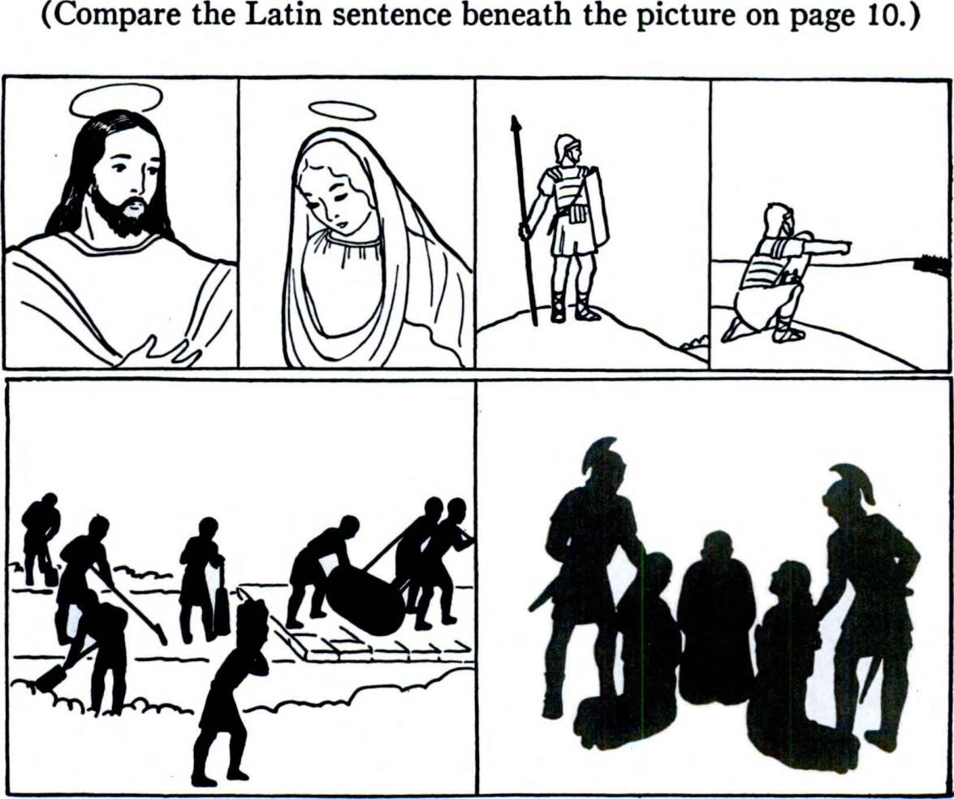FIRST YEAR LATIN 55

truth to men. 23. On account of the safety of the column.
24. On the march. 25. There was a route in the mountains.
26. Caesar did not give swords to the chief. 27. The Gauls gave the commander in chief a reward.

EXERCISE 61
Write a Latin sentence for each of these pictures:

LESSON 4: THE FOURTH DECLENSION

- THE DECLENSION OF PORTUS
Learn the declension of portus, us, GrAmmAr, No. 65, and the rule for gender, GrAmmAr, No. 66. Note that the -us is short in the nominative singular but long in other cases.

VOCABULARY

adventus, us
equitatus, us exercitus, us impetus, us metus, us
splritus, us
portus, us
arrival coming cavalry
army attack fear breath spirit harbor

senatus, us senate

NOTE
- The us in the vocabulary stands of course for the full geni­ tive form, e. g., adventus, us = adventus, adventus.
- Be sure to note the difference between portus, us and porta, ae.
- The Roman Senate was an aristocratic governing body somewhat like a combination of the United States Senate and the British House of Lords. In the time of the Republic the Senate was very powerful and really directed Roman policies. Under the emperors it had very little real power.
RELATED ENGLISH WORDS
The port of New York. The season of Advent. He gave the movement a strong impetus.

56

FIRST YEAR LATIN 57

EXERCISE 62
- Give the full genitive of the nouns in the vocabulary.
- Decline the words in the vocabulary (but adventus, equi- tatus, and metus only in the singular).
- Give the ablative singular of the words in the vocabulary.

EXERCISE 63
- Tell what forms these are; 2, Translate:

- post adventum Christi
- adventus Caesaris
- in portu
- portus provinciae
- cum equitatu
- in exercitu
- post equitatum
- exercitus
- in senatu
- in provincia
- senatus
- lex senatus
- propter metum
- amici senatus
- metus Caesaris
- impetum
- dux equitatus
- cum exercitu

EXERCISE 64
Translate:

- on account of fear of danger
- in the senate
- with Caesar’s army
- after the coming of Christ
- with the cavalry of the Gauls
- the attack of the enemy
- with the spirit of God
- in the harbor

- IN WITH THE ACCUSATIVE
The preposition in may take either the accusative or the abla­ tive case. (You have already been using it with the ablative.)
  - Whenever there is MOVEMENT or MOTION expressed by the in, the ACCUSATIVE is used.

In silvam venit. In hostes impetum fecerunt.
He came INTO the forest. They made an attack AGAINST
(UPON, ON) the enemy.

58 FIRST YEAR LATIN

  - When there is no idea of movement or motion, the ABLA­ TIVE is used.
In colle est. In silva est.
He is on the hill. He is in the jorest.

VOCABULARY

in, prep. w. abl.

in, prep. w. acc.

nunc, adverb
autem, conj., postpositive
fecerunt venit venerunt
[Pon” in into
against upon on
now however they made
he, she, it came they came

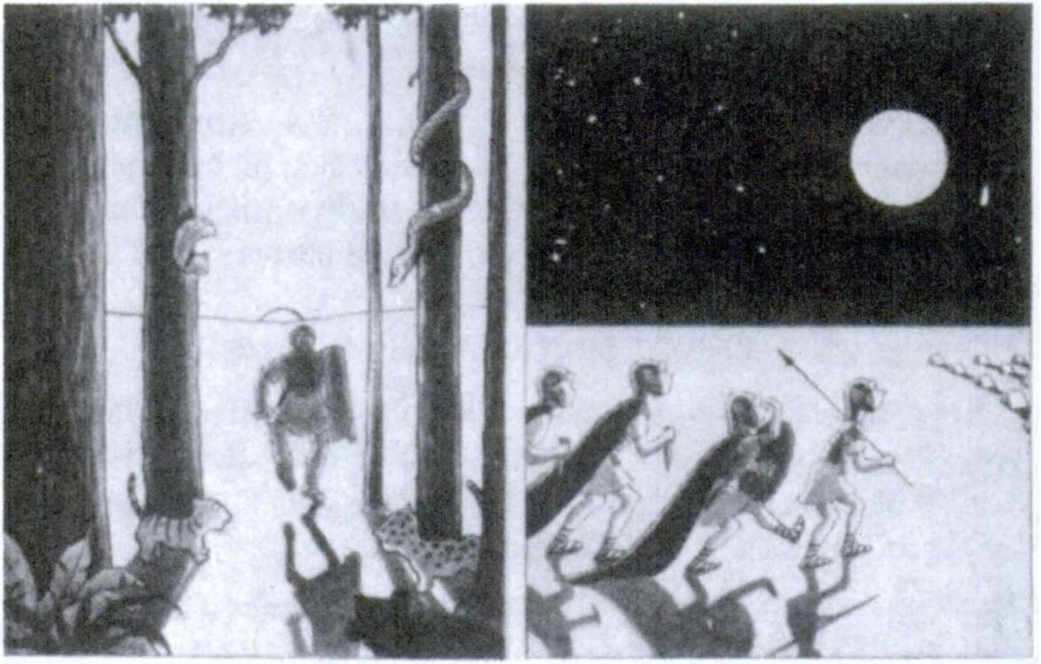

In SiLvAm VeniT. In HosTfs ImpeTUm FeCerUnT.

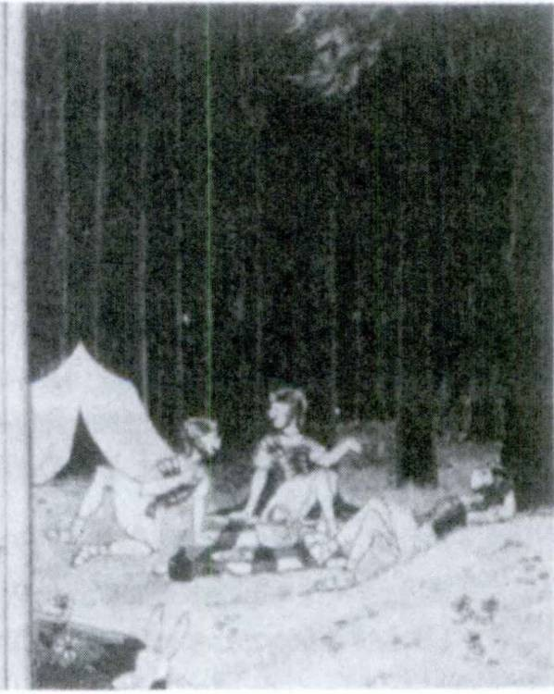FIRST YEAR LATIN 59

NOTE
Autem is postpositive. This means that it cannot stand first in a clause but must ALWAYS FOLLOW THE FIRST WORD OR PHRASE OF ITS CLAUSE. (See Sentence 4, Exercise 65.)

EXERCISE 65
[Essential]
Translate:
- Nunc sunt portus in Gallia. (Why is Gallia in the abla­ tive?)
- Post adventum Romanorum bellum erat in Gallia.
- Caesar cum equitatu in provinciam venit. (Why is pro- vinciam in the accusative?)
- Caesar autem cum exercitu non erat.
- Propter metum Romanorum Galli in silvas venerunt.
- Nautae portum vident.
- Senatus Caesarem laudat quod Romani hostes vicerunt.
- Impetum in hostes fecerunt.

In CoLLe EsT. In SiLvA SUnT.

60 FIRST YEAR LATIN

- Post adventum equitatus milites impetum in Gallos fece­ runt.
- Galli in colle erant. In Gallos autem Caesaris milites impetum fecerunt. Duces et principes Galldrum occiderunt et Gallos vicerunt. Post bellum, propter metum Caesaris, hostes impetum in Romanos non fecerunt.
- Galli senatum occiderunt.

EXERCISE 66
  - Tell what forms these are;
2. Translate:
- portibus 5. spiritu 9. portarum
- portus 6. portum 10. impetum
- corpus 7. portam 11. regum
- equitatu 8. portuum 12. metum

EXERCISE 67
CAEDES CHRISTIANORUM
Post Christi adventum lux veritatis in mundo erat, sed Romani amici Christi et veritatis non erant. Christiani autem amici Christi erant. Erant multi1 Christiani in imperio Romandrum. Erant in portibus et in oppidis provinciarum et in silvis et in montibus. Erant in exercitu et in equitatu et in senatu. Erant servi et milites; erant matres et patres, Galli et Romani. Propter metum autem Christi Regis et propter nomen Dei Christianorum Ro­ mani Christianos occiderunt. Post caedem Christianorum, Ro­ mani non erant amici et servi Dei. Christiani autem, quod Romani Christianos propter legem Christi occiderunt, nunc in Caelo sunt cum Maria et Christo et gloriam Dei Patris vident.
Answer these questions:
  - What did Christ give men ?
  - Did the Romans receive Christ’s truth at once?

1 multi: many.

FIRST YEAR LATIN 61

  - Were there many Christians in the Roman Empire ?
  - Where were they to be found?
  - What sort of persons were they ?
  - What did the Romans do to the Christians ?

EXERCISE 68
[Essential]
THE CONQUEST OF GAUL
The Gauls were not friends of Caesar and of the Senate. There* fore Caesar came into Gaul with the cavalry and the soldiers. The Gauls, however, on account of fear of Caesar, came into the forests and mountains. Caesar’s army was in the forests of the enemy, and there were dangers. The Romans, however, made an attack upon the enemy. They killed the leaders and the leading men of the Gauls. They conquered the cavalry and the army of the Gauls, and fortified the harbors and the towns and the hills of Gaul. And so the Senate now praises Caesar on account of the fame of the war and the courage of the soldiers. On account of fear of the soldiers the Gauls are now friends and servants of the Senate.

EXERCISE 69
GOD IS EVERYWHERE
“Deus spiritus est.” In Caelo et in terra est. Mundum videt. Homines videt. Milites et nautas et servos videt. Matres et patres et fratres et filios videt. Homines propter virtutem laudat sed propter caedem non laudat.

LESSON 5: THE FIFTH DECLENSION

ASSIGNMENT: Learn the declension of res, GrAmmAr, No. 69 and the rule for gender, GrAmmAr, No. 70.

VOCABULARY

res, rei

fides, fide!

acies, aciei spes, spei
posuerunt
f thing
\agair
f faith
i reliability
I faithfulness battle line hope
(they put they placed

NOTE
When posuerunt is modified by an in-phrase, the in ALWAYS takes the ablative.
RELATED ENGLISH WORDS
This is the real state of affairs. Fidelity to duty.

EXERCISE 70
- Decline acies throughout.
- Decline spes and fides in the singular only.

- in acie
EXERCISE 71
Z. Tell what forms these are;
- Translate:
- propter spem

  - rerum

    - propter fidem
    - rebus
- propter rem
- re
- post aciem
- aciebus

62

FIRST YEAR LATIN 63

EXERCISE 72
[Essential]
Translate:
1. Milites in acie erant. 2. Romani Christianos propter fidem occiderunt. 3. Milites spem victoriae in virtute posuerunt.
- Romani in aciem hostium impetum fecerunt. 5. Galli aciem Romanorum in colie vident. 6. In Christo est spes mundi.
- Deus Christianos propter fidem et virtutem laudat. 8. Milites rem vident.
EXERCISE 73
[Essential]
Translate:
  - Caesar was in the battle line. 2. They praise the reliability of the soldier. 3. The Senate does not praise the affair. 4. The Gauls made an attack on the battle line of the Romans. 5. They placed hope in God.
EXERCISE 74
REVIEW
- Give the genitive plural and the rule for:
hostis virtus homo gens
- Give the gender and rule for:

homo nauta
res mater
filius veritas
pax gens servus
equitatus praemium Romanus

LESSON 6: NOUNS WITH SPECIAL MEANINGS IN THE PLURAL

SOME LATIN nouns are used mainly in the plural but with a SINGULAR meaning:

castra, castrorum impedimenta, impedimentorum
camp baggage baggage train

Some Latin nouns have different meanings in the singular and plural:

gratia, ae

gratiae, gratiarum copia, ae
copiae, copiarum, /.

Learn also:
posuerunt agunt
favor
influence
grace (in Christian Latin)
thanks supply abundance
troops
forces (a military term)

they put they placed
they pitched (w. castra)
they give (w. gratias)

NOTE
  - Posuerunt means they pitched ONLY when it has castra for its object. Remember that when an in-phrase modifies posuerunt, the in always governs the ablative.
  - Agunt means give ONLY when it has gratias for its object.
  - Gratia is used in Christian Latin to mean grace, as in gratia Del, the grace of God.

64

FIRST YEAR LATIN 65
  - Silva, ae, as you know, means a forest; but it is generally used in the PLURAL and with the SAME MEANING as in the singular, like the English word woods.
  - Recall that the English singular enemy is often translated by the plural hostes.
RELATED ENGLISH WORDS
A copious flow of water; gratitude; a gracious manner; a comfortable position.

EXERCISE 75
[Essential]
Translate:
- Christians give thanks to God on account of the abundance of the grace of Christ.
- On account of fear of Caesar the tribes did not make an attack on the camp.
- There was a supply of swords in the camp.
- The commander in chief was in favor with the king on account of the victory.
- They made an attack on the camp.
- The forces of the enemy were not in the province.
- They put hope in the grace of Christ.
- There was war in Gaul on account of the slaughter of the leading men. Caesar came into Gaul with troops and cavalry and a baggage train. The forces of the enemy were on a hill. The Romans, however, pitched camp behind the hill. The Gauls on account of fear of Caesar did not make an attack upon the camp. The Romans, however, made an attack on the Gauls. The Gauls placed hope in the cavalry, but the Romans killed the cavalry of the Gauls and captured1 the hill. They captured1 the leaders and the camp and the baggage of the Gauls. After the war there was peace in Gaul and the Romans came into the province.

1 captured: ceperunt.

66 FIRST YEAR LATIN

EXERCISE 76
CASTRA ROMANORUM
A Roman army never spent a single night outside a fortified camp. Towards the end of the day’s march a detachment was sent ahead to mark out the site for the night’s encampment. The plots assigned to the various divisions of the forces were indicated by colored flags. A rampart was always erected and a ditch dug. The camp was generally square and had four gates. The Roman legionnaire was as much a builder and a laborer as a fighting man. It was no doubt partly to this continuous training that he owed his remarkable steadiness and endurance in the field. The camp depicted on page 67 is rather more elaborate and permanent, yet the nightly encampments were constructed in the same general way.
Videtis exercitum Romanorum in castris. Videtis milites et duces et imperatorem. Videtis gladids militum. Impedimenta non videtis, sed impedimenta sunt in castris. In castris est copia omnium1 rerum. Milites castra in colle posuerunt sed non in silvis. In castra agmen cum impedimentis venit. Hostes autem impetum in castra fecerunt, sed copiae Romanorum hostes vi­ cerun t. Nunc imperator milites et duces propter virtutem laudat, et duces propter victoriam gratias militibus agunt. Propter vic- toriam imperator in gratiam cum senatu venit.

EXERCISE 77
“VAE VICTlS!” (“WOE TO THE CONQUERED!”)
Galli erant hostes Romanorum. Itaque Romani cum copiis in Galliam venerunt et castra posuerunt. In castris erant milites et equitatus et servi et militum impedimenta. Copia gladiorum in castris erat. Erant acies in collibus et montibus et silvis. Galli in Romanos impetum fecerunt; Romani autem in Gallos impetum fecerunt. Romani spem victoriae in virtute posuerunt; Galli spem salutis in virtute posuerunt. Romani autem Gallos vicerunt;

1 omnium: of all.

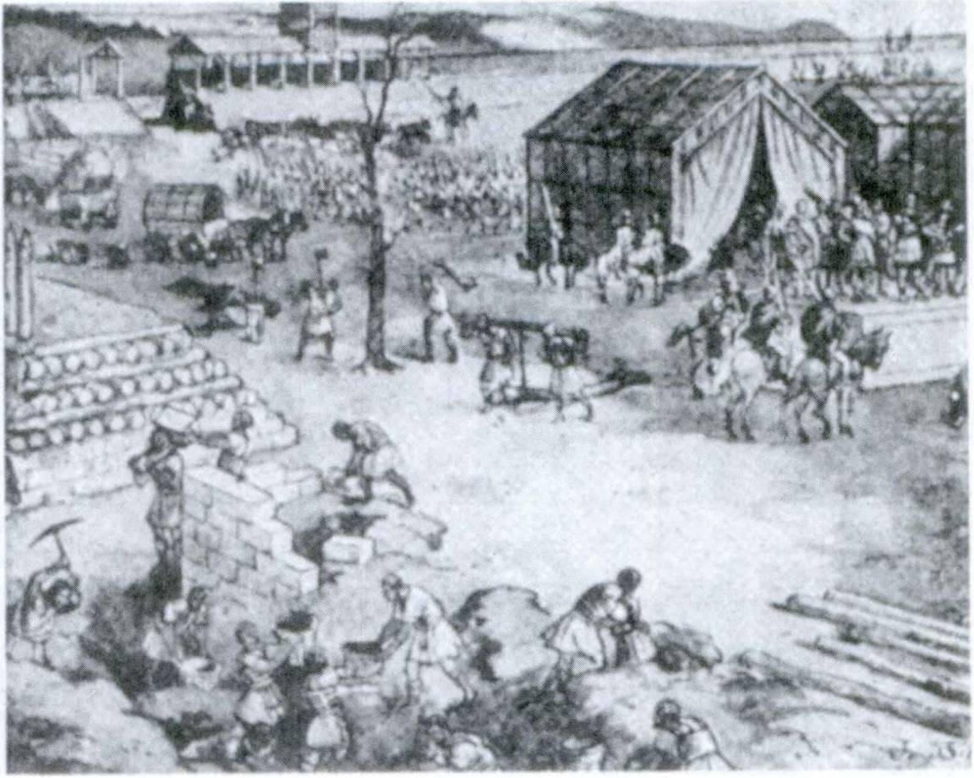FIRST YEAR LATIN 67

CAsTrA RomAnorUm

partem principum et ducum Galldrum occiderunt; portus et oppida Galldrum ceperunt.1 Itaque Galli copiam gladidrum et servorum Romanis dederunt. Post bellum erat pax in Gallia, sed erant castra Romanorum in Gallia et Galli servi Romanorum erant. Imperator Romanorum erat Caesar. Senatus propter vic- toriam et militum virtutem Caesarem et exercitum laudat, et Romani Caesar! gratias agunt.

EXERCISE 78
BROTHERS IN CHRIST
Propter Dei gratiam Christian! sumus. Itaque fratres sumus propter legem Christi: “Estis fratres.”

1 ceperunt: they captured.

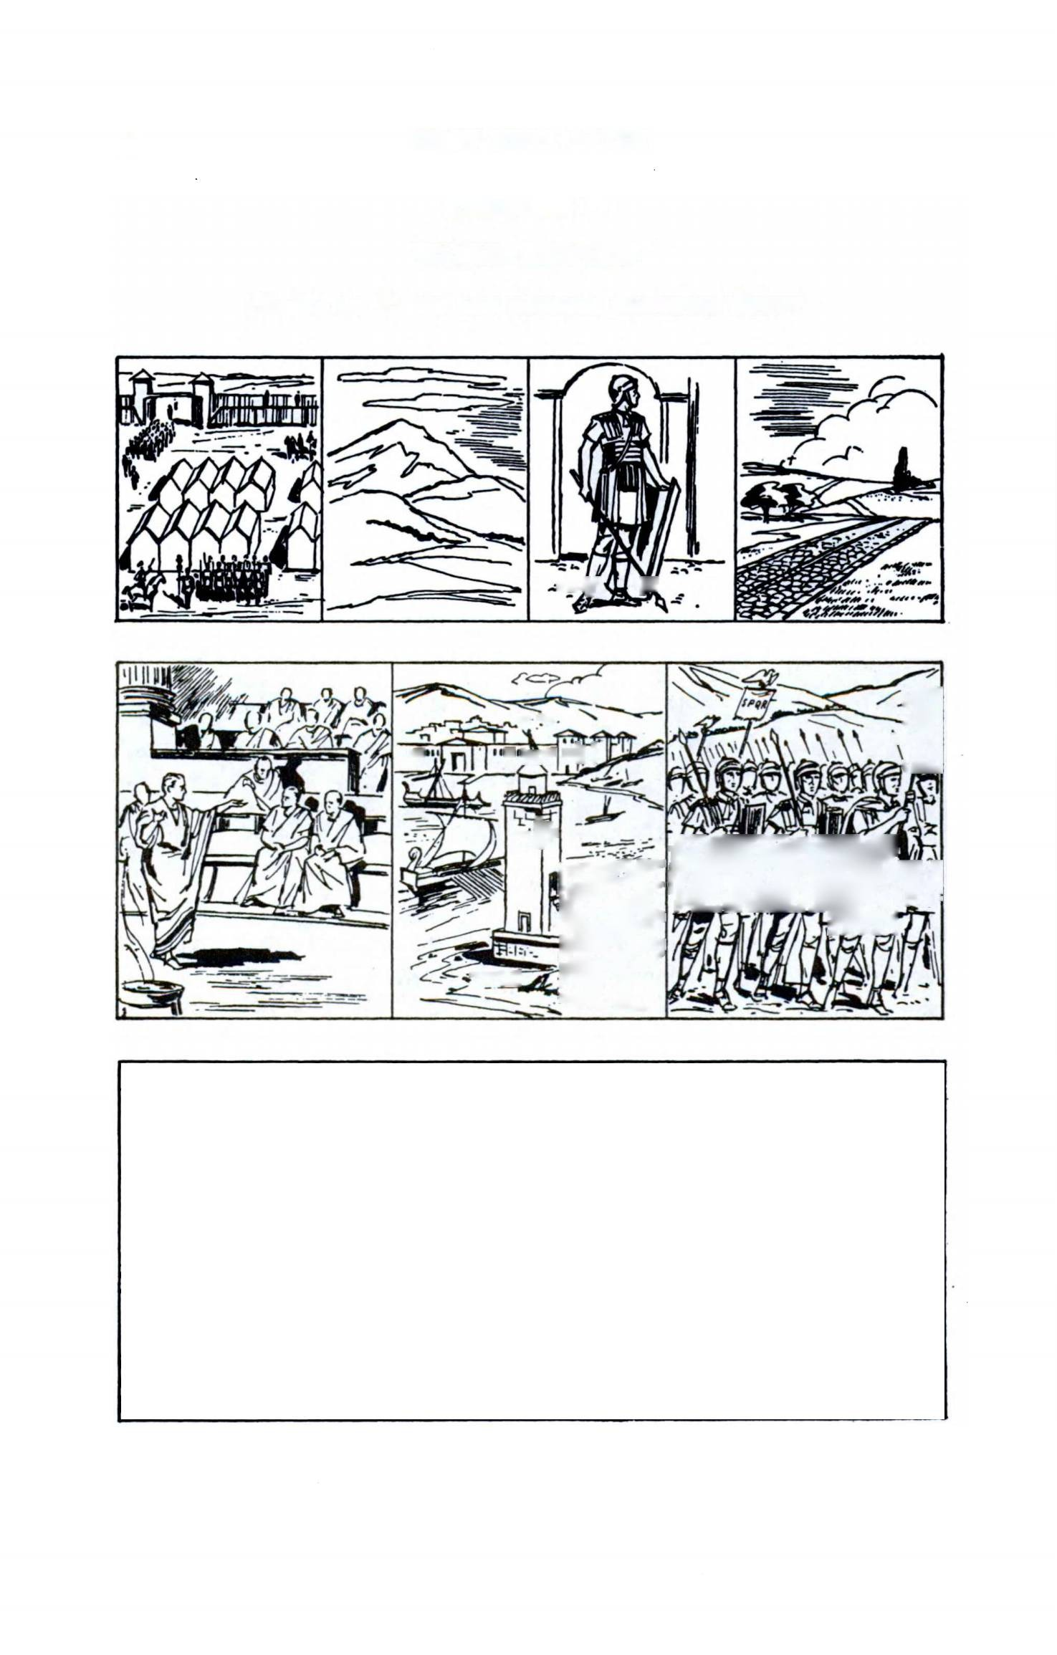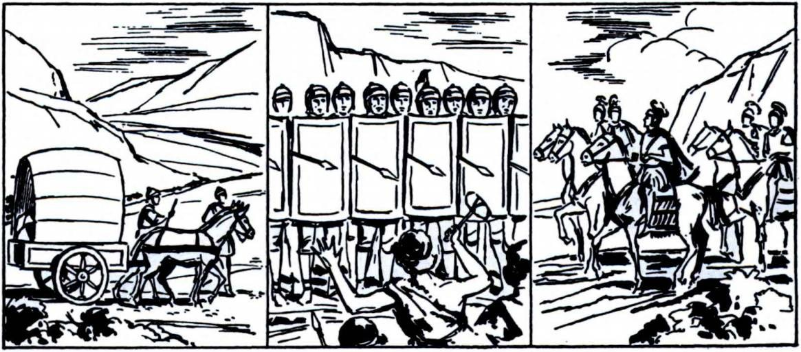68 FIRST YEAR LATIN

EXERCISE 79
WORD REVIEW
Name in Latin the objects pictured here:

 |  |  | k-x« {j jw | *

 | r- •..  - M »i ’A'** | "III' | 'T
 | J '-P |  | Wgt
 | LT | IB

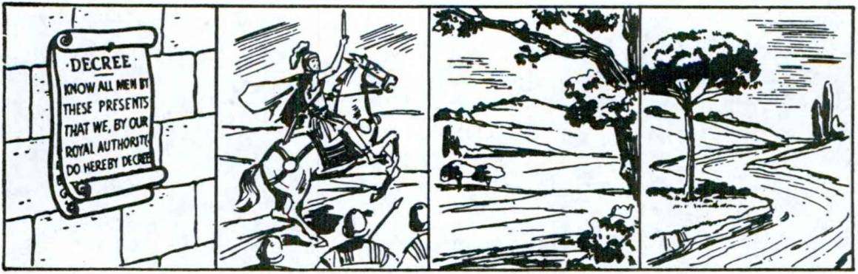FIRST YEAR LATIN 69

EXERCISE 80
WHO IS CHRIST?
Christus, Filius Dei, est filius Mariae. Itaque homo et Deus est. Christus Rex hominum est quod Deus est. In Christo est salus hominum, quod, propter salutem hominum, in mundum venit. Est “Lux Mundi” quod hominibus veritatem dedit. Itaque Christian! gratias Deo et Christo agunt, et Christum, Regem et Imperatdrem, laudant.

REVIEW OF UNIT ONE

EXERCISE 81
Give the
- genitive singular;
- meaning;
- gender and gender rule;
- accusative singular;
- genitive plural and its meaning:

1. vulnus | 12. bellum | 23. | terra | 34. | miles
2. Christianus | 13. hostis | 24. | gens | 35. | populus
3. res | 14. agmen | 25. | rex | 36. | praemium
4. pars | 15. Gallus | 26. | filius | 37. | virtus
5. provincia | 16. mater | 27. | silva | 38. | vox
6. nomen | 17. flumen | 28. | collis | 39. | nauta
7. frater | 18. regnum | 29. | amicus | 40. | via
8. copia | 19. Romanus | 30. | mons | 41. | imperator
9. perlculum | 20. pater | 31. | victoria | 42. | gladius
10. porta | 21. iter | 32. | homo | 43. | lex
11. corpus | 22. dux | 33. | servus | 44. | portus

EXERCISE 82
Give the
  - genitive singular;
  - meaning;
  - gender and gender rule;
  - accusative singular;
  - ablative singular:

- lux
- Caesar
- tides
- mundus
- Deus
- adventus
- impetus
- gloria
- exercitus
- caedes
- spes
- metus
- veritas
- gens
- acies
- clamor

70

  - Translate;
FIRST YEAR LATIN 71
EXERCISE 83

[Essential Drill]

  - Explain the use of the italicized words:
1. Deus, pater hominum, in Caeld est. 2. Deus legem hominibus
dedit. 3. Propter salutem hominum Christus homo in terra erat.
4. Christus est lux mundi. 5. Christus, Filius Dei, est rex gentium et populorum. 6. Post adventum Christi veritas erat in mundo. 7. Spiritus Dei in Christo erat. 8. Regnum Christi est regnum Caeli. 9. Christian! in nomine Christi orant. 10. Maria in regno Caeldrum cum Christo gloriam Dei nunc videt. 11. Maria, Mater Dei, est Porta Caeli. 12. Caelum est praemium virtutis.
13. Deus fidem Christianorum laudat. 14. Fratres estis. 15. Ami­ cus est amici servus. 16. Milites pacem laudant. 17. Roma non est in Gallia, sed provincia Romandrum est in Gallia. 18. Galli Galliam incolunt. 19. Nautae portus vident. 20. Romani vias in provinciis muniverunt. 21. Christian! caedem principum hostium non laudant. 22. Caesar imperium Galliae Gallis non dedit. 23. Imperator clamorem et voces hostium audivit.
24. Propter vulnera milites iter non fecerunt. 25. Propter metum dux regem laudat. 26. Propter bellum erant milites et copia gladiorum in oppido. 27. Hostes in montibus et collibus erant.
28. Corpora militum in silvis erant. 29. Partem equitatus in flumine occiderunt. 30. Senatus et principes exercitui propter victoriam gratias agunt. 31. Romani spem in virtute posuerunt.
32. Caesar cum copiis et impedimentis in castra venit. 33. Propter gratiam Caesaris principes Galldrum servos Romanis dederunt.
34. Hostes erant post aciem Romandrum. Equitatus autem in
aciem venit. Itaque Romani hostes vicerunt et occiderunt. 35. In silvas Galliae Caesar venit. Principes autem Galldrum rem vi- derunt.1 Itaque impetum in agmen Caesaris fecerunt. 36. Milites in acie drant quod in periculo sunt.

1viderunt: they saw.

UNIT TWO

LESSON 7: ADJECTIVES OF THE FIRST AND SECOND DECLENSIONS
- THE DECLENSION OF MAGNUS, A, UM
Adjectives, like nouns, are declined in Latin. But they have THREE GENDERS and therefore are declined IN EACH GENDER.
The adjectives are grouped into two main classes:
- Those which use the endings of the FIRST and SECOND declensions.
- Those which use the endings of the THIRD declension.
The adjective magnus, magna, magnum belongs to the first and second declensions. You already know all its endings. See whether you can write out its declension without looking in the GrAmmAr. First study these hints:
- The stem is magn- (magn-us).
- The masculine is exactly like servus.
- The feminine is exactly like terra.
- The neuter is exactly like bellum.
- Put the genders in three columns like this:

MAsCULine Feminine
magn-us magn-a
etc. etc.
NeUTer magn-um etc.

After you have written out both the singular and plural, com­ pare with GrAmmAr, No. 72. You now know the declension of all adjectives in -us, -a, -um.

ASSIGNMENT: Memorize the declension of magnus, a, um,
GrAmmAr, No. 72.

72

FIRST YEAR LATIN 73
VOCABULARY

magnus, a, um

altus, a, um
bonus, a, um longus, a, um malus, a, um multus, a, um
sanctus, a, um primus, a, um
great large
high deep good
long bad
much (pl., many) holy
saint
first

RELATED ENGLISH WORDS
The welfare of the people should be the primary concern of statesmen. The magnitude of the task. Altitude.

- AGREEMENT OF ADJECTIVES
ExAmpLes
magnam gentem, a large tribe (as object) nautae boni, good sailors
servos maids, the bad slaves (as object) in fluminibus aids, in the deep rivers
In the first example:
- Gens is FEMININE (sox); therefore magn- has a fem- inine ending.
- Gentem is ACCUSATIVE SINGULAR feminine; there- fore magnam is in the ACCUSATIVE SINGULAR feminine.
Explain the other examples in the same way.

RULE: ADJECTIVES AGREE WITH THEIR NOUNS IN GENDER, NUMBER, AND CASE.

74 FIRST YEAR LATIN

EXERCISE 84
Translate:
- in alto flumine 8. cum multis militibus
- cum magno exercitu 9. in magno periculo
- post magnum bellum 10. in altis montibus
- cum sancta Maria 11. cum homine bono
- in longa via 12. post longum iter
- cum hominibus bonis 13. propter multa vulnera
- cum magnis copiis 14. cum servo malo
THE POSITION OF ADJECTIVES
Examine the position of the adjectives in the exercise above. Some follow the noun, some precede. Those that precede are generally adjectives answering the questions How large? How long? How high? How many? How small? These are adjectives of QUANTITY like multus and magnus.

RULE: ADJECTIVES OF QUANTITY GENERALLY
PRECEDE THEIR NOUNS.

Those that follow answer the question What kind ?, like malus, bonus, etc. These are adjectives of QUALITY.

RULE: ADJECTIVES OF QUALITY GENERALLY FOLLOW THEIR NOUNS.

Note. In Christian Latin sanctus generally precedes its noun:
Sancta Maria, Holy Mary

- with many soldiers
- in the high mountains
EXERCISE 85
Translate:
- on account of the holy law of God

FIRST YEAR LATIN 75

- with a good man
- large bodies
- with the first Christians
- bad laws
- the deep rivers (as object)

- the long way
- on account of a great fear of the Romans
- great shouting
- Saint Mary

EXERCISE 86
[Essential]
Translate:
  - Multi Christian! in prima acie erant. (Why is acie abla­ tive?) 2. Sancta Maria drat. 3. Longum agmen in altos montes venit. (Why is montes accusative?) 4. Nauta malus non drat.
5. Dux bonus magnam virtutem militum laudat. (Explain the position of bonus and magnam.) 6. In longo agmine multi milites et impedimenta sunt.

EXERCISE 87
Translate:
1. Good leaders praise peace. 2. The bad kings killed many Christians. 3. The long column was in the forests, but the first battle line was on the high mountains. 4. On account of the great fame of Rome, many men praise the laws of the Romans.
5. There are large mountains and deep rivers in America.1 6. We Christians are servants of Holy Mary.

- PREDICATE ADJECTIVES
Adjectives may modify a noun directly, as we have seen in such expressions as:
in alto flumine, in the deep river
homo bonus, a good man
These are called attributive adjectives.

1 America: America, ae

76 FIRST YEAR LATIN

But adjectives may also be linked to their noun by means of a linking verb like sum, I am, as:
Deus est bonus. God is good.
Leges sunt malae. The laws are bad.
Estis sancti. You are holy.
Such adjectives are called PREDICATE ADJECTIVES.
The rule of agreement is the SAME for attributive and predi­ cate adjectives.
Predicate adjectives are put in diagrams in the same way as predicate nouns.
VOCABULARY

angustus, a, urn reliquus, a, um
tutus, a, um Romanus, a, um Christianus, a, um
narrow remaining the rest of
safe Roman Christian

RELATED ENGLISH WORDS
Relics of the Saints; a good tutor.

EXERCISE 88
[Essential]
Complete these sentences:
- The way is narrow. Via est
- God is good. Deus est
- The soldiers are safe. Milkes sunt------------- -
- The camp was Roman. Castra erant
- The soldiers were Christian. Milites erant
- The laws were bad. Leges erant
- A part of the enemy was remaining. Pars hostium erat
- You are holy. Estis
- The river was deep. Flumen erat..................

FIRST YEAR LATIN 77

- The Gauls were first. Galli erant
- He was holy. Erat
- The victories of the enemy were not many. Victoriae hosti- um non erant
- We are safe. Sumus
- The Gauls’ swords were large. Gladii Galldrum erant
- The leader was bad. Dux erat
- The road was long. Via erat
- God is holy. Deus est
- The sailors were safe. Nautae erant

“SALUS POPULl SUPREMA1 EST LEX.”—Cicero2
From this is derived the motto of the State of Missouri:
SALUS POPULl SUPREMA1 LEX ESTO4 * * * 8

- USE OF PRO
The preposition pro ALWAYS takes the ABLATIVE. In ex­
pressions of PLACE, pro means in front oj.
Pro exercitu, in front of the army
Pro, especially with nouns naming persons, frequently means
on behalf of, for.
Maria pro hominibus drat.
Mary prays for (on behalf of) men.
Pro rege impetum fecerunt.
They made the attack for (on behalf of) the king.

1 supremus, a, um: highest.
2 Marcus Tullius Cicero (106-43 B.C.) was Rome’s greatest orator. He was a lawyer of exceptional ability and a prominent politician. His orations have been models of style for two thousand years and strongly influenced the great French and English orators of modern times. He is also well known for his letters and essays.
8esto: let be.

78 FIRST YEAR LATIN

VOCABULARY

pro, prep. w. abl

inopia, ae

dominus, I

murus, I frumentum, i legid, legidnis, /.
in front of (before) on behalf of (for)
scarcity want
(
master Lord1
wall
grain (pl., crops) legion

RELATED ENGLISH WORDS
Arguments pro and con; a dominating personality; mural
decorations.

Gloria Patri et Filio et SpirituT Sancto.2

EXERCISE 89
[Essential]
Translate:
- Legiones Romanae pro castris erant. 2. Sancta Maria pro hominibus malls et bonis drat. 3. Multi Galli pro portis cas- trorum erant. 4. Principes pro muro alto erant. 5. Milites Romani pro muro oppidi magni castra posuerunt. 6. Christian! pro amicis orant. 7. Pro rege bond milites impetum in hostes fecerunt. 8. Erat magna inopia frumenti in Gallia. 9. Reliqui milites Christiani in prima acie pro silvis erant. 10. Servi dominum bonum laudant.

1 In Christian Latin Dominus, Lord, is used when referring to God or Christ.
2 Sit, be, is understood in the Latin. Supply it in the English translation.

FIRST YEAR LATIN 79

EXERCISE 90
[Essential]
Translate:
Erat magna inopia frumenti in castris Romanis quod Galli Romanis copiam frumenti non dederunt et frumenta in Gallia non erant. Galli non erant amici Romanbrum. Itaque Caesar cum copiis et impedimentis in Galliam venit. Agmen Caesaris longum erat. Via in angustis et altis montibus erat. Itaque Galli impetum in longum agmen fecerunt, sed Gallos legiones Romanae vicerunt. Itaque in oppidum tutum venerunt reliqui Galli. Romani autem castra pro muro alto posuerunt. Prima acies Caesaris pro castris erat. Galli autem propter magnum metum Caesaris impetum in castra Romana non fecerunt. Itaque Romani impetum in Gallos fecerunt et Gallos vicerunt. Multos Gallos et magnam partem principum Galliae occiderunt. Post victoriam Caesaris erat pax in Gallia. Itaque Galli magnam frumenti copiam Romanis dederunt, et non erat inopia frumenti in castris Romanis.

SANCTUS, SANCTUS, SANCTUS, DOMINUS DEUS EXERGITUUM!
(A Title of God in the Old Testament)

EXERCISE 91
[Essential]
Translate:
1. In front of the large camp is a deep river. 2. The walls of the town are high. 3. Caesar was a great general. 4. There was a great scarcity of grain. 5. There were many legions with Caesar in Gaul. 6. Holy Mary prays for men. 7. Christ the Lord prays on behalf of the world. 8. Roman slaves do not praise the mas­ ters. 9. There are great crops in Gaul.

80 |  | FIRST YEAR LATIN
 |  | EXERCISE 92
 |  | [Essential Review]
 | 2. | Translate;
 | 2. | Explain position and agreement
of the italicized words:
- Agmen longum erat. 2. Reliqui Galli tuti non erant.
- Milkes Christiani pro imperatdre bond impetum in hostes fecerunt. 4. Via angusta erat. 5. Longum agmen in montes altos venit. 6. Prima legio in acie erat. 7. Magna frumenti inopia in reliquis gentibus erat. 8. Homines mail pro reliquis hominibus non drant. 9. Sunt multa flumina in Gallia. 10. Do- minus, homo bonus et sanctus, servis frumentum dedit. 11. Le- giones Romanae in acie pro muro alt6 erant.

IN NOMINE DOMINI
(Motto of the Bishop of Boise)

EXERCISE 93
Add the correct endings to the adjectives in the following phrases and translate:
  - propter leges mal
  - cum ducibus bon
  - propter magnmetum
  - in magnluce
  - pro rege Roman
  - pro hominibus bon
  - cum multnautis
  - propter veritatem Christian
  - propter magnvirtutem
  - in castra Roman
  - in longvia
  - propter magncorpus

FIRST YEAR LATIN 81

Domini est terra!
Magna est gloria Domini!
—-Adapted from the Roman Breviary1

EXERCISE 94
Translate:
- cum Caesare, imperatdre Romano
- propter salutem populi Romani
- in altis montibus
- post magnam caedem
- propter multa vulnera
- propter salutem reliquarum gentium
- pro Sancto Nomine
- in alto flumine

1 The Roman Breviary is a Latin work usually published in four volumes. It contains the Psalms, lives of the Saints, and various other selections and prayers. Every Roman Catholic priest is required to read certain sections each day.

LESSON 8: ADJECTIVES OF THE THIRD DECLENSION

  - THE DECLENSION OF GRAVIS, E
The second group of adjectives contains all those that use endings of the THIRD declension. Most of these adjectives are like gravis, e.
ASSIGNMENT: Learn the declension of gravis in GrAmmAr,
No. 78. Notice that:
- The ablative singular ends in -i.
- The neuter plural nominative and accusative end in -ia.
- The genitive plural ends in -ium.

RULE: ALL ADJECTIVES WITH -IS, -E IN THE NOM- INATIVE SINGULAR ARE DECLINED
LIKE GRA VIS, E.

VOCABULARY
heavy

gravis, e

brevis, e communis, e difficilis, e facilis, e
fortis, e nobilis, e omnis, e
severe serious short
common difficult easy
brave strong noble
renowned
all every

82

FIRST YEAR LATIN 83

RELATED ENGLISH WORDS
Life is brief. The good of the community. Fortified positions. God is omnipresent. A grave matter.

NOTE
Remember that ALL adjectives follow the rule for agreement given on page 73.

EXERCISE 95
- Decline in all genders: (a) facilis, (b) nobilis, (c) omnis,
(d) brevis.
- Decline in the neuter: (a) communis, (b) fortis, (c) gravis,
(d) difficilis.
- Put the following in
  - the ablative singular,
  - the nominative plural,
  - the genitive plural:

- homo fortis
- omnis Christianus
- dux nobilis
- breve iter
- via difficilis
- bellum grave

- Put the following groups in
  - the accusative singular,
  - the ablative singular:

- salus communis
- omnis Gallia
- res gravis
- metus gravis
- oppidum nobile
- omnis spes
- vulnus grave
- via facilis
- nomen nobile

- Complete and translate:
  - in via difficil g.
  - cum omncopiis h.
  - pro rege nobil i.
  - pro amico fort j.
  - pro duce nobil k.
  - post bellum grav. 1.

propter metum grav. cum omnequitatu cum militibus fort propter vulnera grav..
propter salutem commun post oppidum nobil

84 FIRST YEAR LATIN

EXERCISE 96
[Essential]
Complete and translate:
- Dominus Christus, Rex hominum, erat fort et nobil
- Spes Galldrum erat brev
- Dux nobilin prima acie erat.
- Pro castris milites forterant.
- Omnspem salutis in virtute posuerunt.
- Christian! in nomine Christi omnspem salutis posu­ erunt.
- Propter rem grav Caesar in Galliam venit.
- Propter salutem communomnes Galli in provinciam impetum fecerunt.
- Propter montes et silvas via erat difficil
- Propter virtutem Galldrum res non erat facil

EXERCISE 97
[Essential]
Translate:
1. The danger was serious. 2. You are brave. 3. On account of the common salvation of men, Christ came into the world.
- The way was difficult. 5. All men praise great courage.
6. There were strong soldiers and renowned leaders in the Roman army. 7. The journey was not easy. 8. The mountains are large and high. 9. Every general praises courage and faithfulness.
- Caesar was a great and renowned general. 11. The victory was not easy. 12. The route was short. 13. Roman swords were heavy. 14. The affair was serious. 15. Christ is a noble lord and a brave leader; therefore all good and holy men praise Christ the Lord. 16. The Roman laws were severe. 17. The long and deep rivers of America1 are renowned.

1 America: America, ae.

FIRST YEAR LATIN 85

  - ADJECTIVES GOVERNING GASES
He is eager for power. Mary is full of grace.
The province is next to the Gauls.
In these sentences the prepositional phrases for power, of grace, to the Gauls, modify the adjectives eager, full, next. These prepo- sitional phrases which modify adjectives are often translated into Latin by the genitive or dative or ablative WITHOUT A PREP- OSITION. THE PROPER CASE TO BE USED IS DETER-
MINED BY THE ADJECTIVE. Thus cupidus always takes the genitive case. It makes no difference whether the English is eager FOR power or desirous OF power—cupidus ALWAYS has the GENITIVE case. Likewise, finitimus, next (to), always has the DATIVE. Plenus, however, takes either the genitive or the ablative.
The sentences written above must be translated:
Imperii cupidus est.
Maria est gratia (gratiae) plena. Provincia Gallis finitima est.
When an adjective of this kind is given in the vocabularies, it will always be followed by an abbreviation to indicate the case to be used. Be sure to learn this when you learn the adjective.

VOCABULARY

cupidus, a, um; w. gen.

|eager
j
[ desirous

plenus, a, um; w. gen. or abl. full

finitimus, a, um; w. dat.

similis, e; w. gen. or dat.
neighboring next
like similar

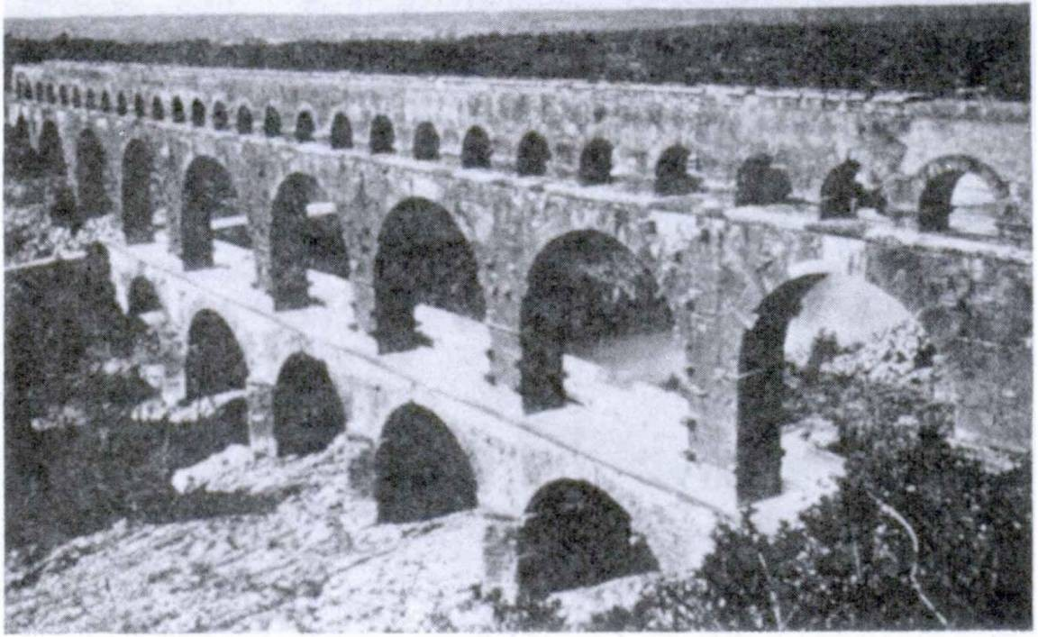86 FIRST YEAR LATIN

NOTE
These adjectives are sometimes used WITHOUT a modifying phrase as: gentes finitimae, neighboring tribes,
RELATED ENGLISH WORDS
The cupidity of the miser; a plenary indulgence.

EXERCISE 98
[Essential]
Translate:
1. Galli gloriae cupidi erant. 2. Filius similis patris est. 3. Galli finitimi erant provinciae. 4. Maria est gratia plena. 5. Gallia plena Romandrum erat. 6. Oppidum plenum erat militum et gladidrum. 7. Provincia plena est omnium rerum bonarum.
8. Caelum est plenum gloriae Dei. 9. Cupidi sumus omnium rerum bonarum. 10. Finitimi Galliae erant. 11. Sancti homines Christo similes sunt.

Pons RoManUs

FIRST YEAR LATIN 87

EXERCISE 99
Complete these sentences:
- The camp is full of swords. Castra plena sunt
- The enemy were eager for victory. Hostes cupidi erant

- The tribes were next to Gaul. Gentes erant finitimae

- The Gauls were not like the Romans. Galli non erant similes
- They killed the leaders of the neighboring tribes. Duces gentiumocciderunt.
- A sailor is not like a soldier. Nauta non est similis
- The Gauls are desirous of war. Galli cupidi sunt

  - THE DECLENSION OF JESUS
VOCABULARY
Jesus, u Jesus
et . . . et both and
quid what?
prima luce at dawn
urbs, urbis city
pons, pontis, m. bridge standard
signum, i signal
sign
eques, equitis horseman (pl., cavalry)
NOTE
1. Quid is used in asking questions:
Quid est in urbe? What is in the city?
Quid videtis? What do you see?
2, Luce is the ablative of lux; prima (from primus, a, um) agrees with it. Prima luce literally means with or at the first light; hence, at dawn.

88 FIRST YEAR LATIN

- The plural of horseman is horsemen, which is the same as
cavalry; hence the meaning for equites given in the vocabulary.
- Jesus is declined:

Nom. Gen. Dat.
Jesus Jesu Jesu

Acc. Jesum
Abl. Jesu
RELATED ENGLISH WORDS
The urban population; an equestrian statue.

OMNIA PRO JESU
(Motto of the Bishop of Tucson)

EXERCISE 100
[Essential]
Translate:
Nomen Jesu est Sanctum Nomen. Est nomen nobile et spei plenum. In nomine Jesu omnes Christian! drant; Jesum omnes laudant; Jesu omnes gratias agunt; Jesum omnes in Caeld cum Maria vident. In nomine Jesu primi Christian! Romanos vice- runt. Propter Jesum Deus Pater primis Christianis praemium victoriae dedit. Itaque Jesus Christus est et Dominus et Rex omnium hominum.
EXERCISE 101
[Essential]
Translate:
1. Christian! et Jesum Christum et Mariam laudant. 2. Roma est urbs et magna et nobilis. 3. Caesar et gloriae et imperii cupidus erat. 4. Prima luce equites fortes impetum in reliquos hostes fecerunt. 5. Propter pericula gravia et multa militum vul- nera Romani iter breve in provinciam fecerunt.

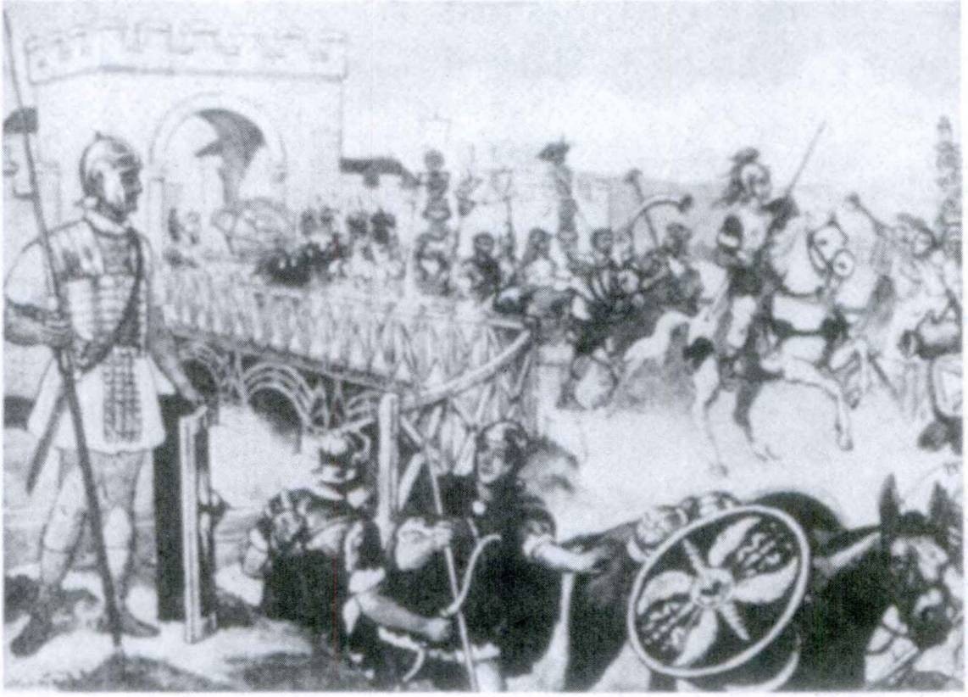FIRST YEAR LATIN 89

AGMen RoManUM
The soldier in the left foreground is ‘modeling’ the standard Roman outfit. The long pilum which he holds is much like the modem javelin used in track compe­ tition; his gladius—the two-edged sword for hand-to-hand fighting—hangs from his shoulder. He is protected by helmet, breastplate, and shield. He would thus be prepared for actual service in the field; on the march the helmet was carried
in the pack and the shield was generally inclosed in a bag to protect it.

EXERCISE 102
Translate:
Quid videtis in pictura P1 In pictura videtis agmen Romanum. Agmen longum est, sed videtis partem agminis. Videtis signa legidnum et gladios militum. Pars agminis est in ponte. Equites autem non sunt in ponte. Videtis imperatorem. Primus venit. In agmine sunt impedimenta. In impedimentis est copia fru- menti et omnium rerum. Videtis urbem et mu rum altum.

1 pictura, ae: picture.

90 FIRST YEAR LATIN

EXERCISE 103
[Essential]
Translate:
1. There are many bridges on the long and deep rivers of America.1 2. The Roman soldiers killed many Christians on ac­ count of the name of Jesus. 3. There are great and renowned cities in America.1 4. Christians put all hope and faith in the Lord Jesus Christ. 5. Both sailors and soldiers praise God.
6. The city of Rome is large and renowned. (Do not use the genitive for of Rome; names of cities are put in apposition to urbs.) 7. The general gave the signal at dawn, and so the cavalry made an attack on the enemy and killed a large part of the leading men of the tribe. 8. You see the standards of the legions. 9. The wounds of the brave soldiers are many and seri­ ous. 10. The enemy killed the Roman horseman. 11. They forti­ fied the bridges. 12. What do the Christians praise?

SIGNUM CRUCIS2
In nomine Patris et Filii et Spiritus Sancti.
Amen.3

READING NO. 3
A LATIN QUIZ PROGRAM
Quid est victoria?
—Est praemium virtutis.
Quid est bellum ?
—Est caedes fratrum.
Quid est miles ?
—Est murus4 imperii.

1 America: America, ae.
2 crux, crucis: cross.
3 Amen is a Hebrew word meaning “So be it!” The congregation, or the server in the name of the congregation, answers Amen to show that the people are united with the prayer of the priest.
4 In this sentence murus may be translated bulwark.

MASTERY REVIEW VOCABULARY NO. 1
[Units One and Two

copia, ae
FIRST DECLENSION NOUNS LIKE TERRA, AE
supply abundance
(

copiae, copiarum, f.

Gallia, ae gloria, ae

gratia, ae

gratiae, gratiarum inopia, ae
Maria, ae nauta, ae porta, ae provincia, ae Roma, ae
silva, ae1 terra, ae
via, ae victoria, ae
f troops
[forces (a military term)

f fame [glory
favor influence
grace (in Christian Latin)
thanks
scarcity want
(
Mary sailor gate province Rome
forest earth land
{
(road [way
victory

1 Generally used in the plural in Latin with same meaning as in the singular.
91

92 FIRST YEAR LATIN

SECOND DECLENSION NOUNS LIKE SERVUS, 1
amicus, I friend
Christianus, I Christian
Christus, I Christ
Deus, Dei God
dominus, I j master Lord*
filius, I son
Gallus, I a Gaul
gladius, I sword
mundus, I world
murus, l wall
populus, i people nation
Romanus, I a Roman
servus, I slave
servant

NOUNS LIKE BELLUM, I
bellum, I war
caelum, I sky
heaven1 2
frumentum, I grain (pl., crops) command
imperium, i power
empire
oppidum, I town
periculum, I danger
praemium, I reward

1 In Christian Latin Dominus, Lord, is used when referring to God or Christ. ’ When Caelum is used to mean the Christian heaven the c will be capitalized.

regnum, i

signum, i
FIRST YEAR LATIN 93
kingdom royal power
standard signal sign

NOUNS LIKE THE PLURAL OF BELLUM
castra, castrorum camp
impedimenta, impedimentdrum baggage baggage train

THIRD DECLENSION
MASCULINE AND FEMININE NOUNS LIKE LEX, LEGIS
Caesar, Caesaris Caesar

clamor, clamoris

dux, ducis eques, equitis
frater, fra tris (fratrum)2 3
homo, hominis imperator, imperatoris
legio, legionis, /. lex, legis
lux, lucis
mater, matris (matrum)2 miles, militis
pater, patris (patrum)2 pax, pacis
[ shouting
j
[shout
leader
horseman (pl., cavalry)1 brother
man
f commander in chief
j
[general
legion law light mother soldier father peace

1 The plural of Norseman is horsemen, which is the same as cavalry; hence the meaning for equites given in the vocabulary.
3 The genitive plural of frater, mater, and pater is put in parentheses to remind you that these words are exceptions to the rule for -ium words.

94 FIRST YEAR LATIN

princeps, principis rex, regis
salus, salutis

veritas, veritatis virtus, virtutis
vox, vocis
chief leading man
king safety welfare
(
salvation
truth
{courage virtue
J voice
{cry

MASCULINE AND FEMININE NOUNS LIKE PARS, PARTIS

caedes, caedis collis, collis, m. gens, gentis hostis, hostis1 mons, moptis, m. pars, partis pons, pontis, m. urbs, urbis
slaughter hill
tribe
enemy (in war)
mountain Part bridge city

NEUTER NOUNS LIKE FLUMEN, FLUMINIS

agmen, agminis corpus, corporis, n.
flumen, fluminis iter, itineris, n,
nomen, nominis vulnus, vulneris, n.
| column (of soldiers) I army (on the march)
dody
river
journey march route
name wound

1The plural of hostis is used to translate the English enemy unless ONE soldier of the enemy is meant.

FIRST YEAR LATIN 95
FOURTH DECLENSION NOUNS LIKE PORTUS, US

adventus, us

equitatus, us
exercitus, us
impetus, us
metus, us
portus, us
senatus, us1 spiritus, us
arrival coming
cavalry army attack fear harbor senate (breath
(
spirit

FIFTH DECLENSION NOUNS LIKE RES, REl

acies, aciei tides, tide!
res, rei spes, spei
battle line
r faith
J reliability
{faithfulness
f thing [affair
hope

1The Roman Senate was an aristocratic governing body somewhat like a combination of the United States Senate and the British House of Lords. In the time of the Republic the Senate was very powerful and really directed Roman policies. Under the emperors it had very little real power.

96 FIRST YEAR LATIN

ADJECTIVES OF THE FIRST AND SECOND DECLENSIONS
LIKE MAGNUS, A, UM

altus, a, um

angustus, a, um bonus, a, um Christianus, a, um
cupidus, a, um; w. gen.

fmitimus, a, um; w. dot.

longus, a, um magnus, a, um
malus, a, um multus, a, um
plenus, a, um; w. gen. or abl.
primus, a, um reliquus, a, um Romanus, a, um sanctus, a, um tutus, a, um
| high (deep narrow
good Christian (eager
desirous
{neighboring next
long (great (large
bad
much (pl., many) full
first (remaining
the rest of
Roman (holy
I saint
safe

ADJECTIVES OF THE THIRD DECLENSION
LIKE GRA VIS, E

brevis, e communis, e difficilis, e facilis, e
short common difficult easy

FIRST YEAR LATIN 97

fords, e brave
strong
heavy

gravis, e
severe serious

nobilis, e noble
renowned

omnis, e
fall
i
[every

similis, e; w. gen. or dat. |
I similar

PREPOSITIONS WITH THE ACCUSATIVE
in into

in, prep. w. acc.

post, prep. w. acc.

propter, prep. w. acc.
against upon on
(after
[ behind
on account of

PREPOSITIONS WITH THE ABLATIVE

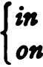cum, prep. w. abl.

in, prep. w. abl.

pro, prep. w. abl.
with

in front of (before) on behalf of (for)
{

98 FIRST YEAR LATIN

CONJUNCTIONS

autem, conj., postpositive1
et, conjunction
et . • . et

itaque, conjunction2

quod, conjunction
sed, conjunction

however and
both . . . and
therefore and so
because but

non, adv.
nunc, adv.
ADVERBS

not now

Jesus, u3 prima luce4 quid5

OTHER WORDS

Jesus at dawn what?

1 Autem is postpositive. This means that it cannot stand first in a clause but must always follow the first word or phrase of a clause.
2 Itaque is used at the beginning of a sentence as an introductory adverb.
8 Jesus is declined: Jesus, Jesu, Jesu, Jesum, Jesu.
4Luce is the ablative of lux; prima (from primus, a, um) agrees with it. Prima luce literally means at the first light; hence, at dawn.
® Quid is used in asking questions: Quid est in urbe?« What is in the city?
Quid videtis? What do you see?

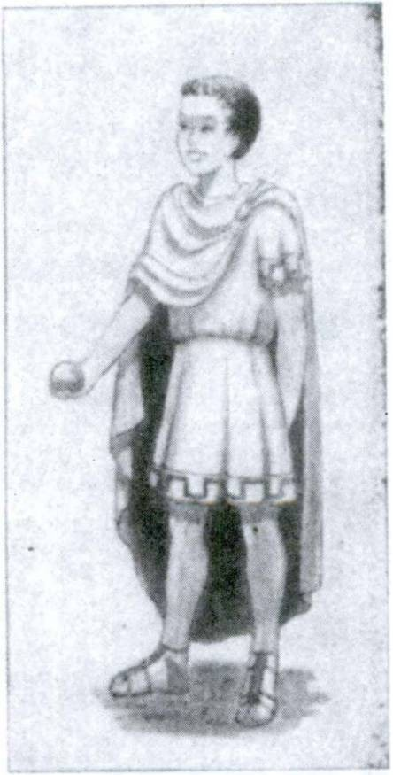

UNIT THREE
LESSON 9: THE FIRST CONJUGATION

INTRODUCTION
If you closed your eyes and “tuned in” on all the conversation going on in a room between classes you might hear something like this:
“He was running down the side line . . . dove for him but . . .
saw a swell show last night at . . . we’re going over to Charlie’s house tonight . . . did it in ten minutes . . . she said . . . don't care what ...”
All are saying something, and all, without realizing it, are using VERBS. We could not say anything at all unless we had verbs.
They are the strong words of language because they express ACTION. And if you stop to think about it, they are amazing words, grammar’s quick- change artists, because in sentence after sentence they appear and re­ appear with different spellings and in different combinations. Let us study their changes.
- VERBS CHANGE THEIR FORM TO EXPRESS DIFFER­
ENT TIME.
I played ball yesterday. I am playing ball.
I shall play ball tomorrow.
In each of these sentences the verb expresses the same action (playing), but there is a difference in each sen-
FILIUs DUcIs

99

100 FIRST YEAR LATIN

tence. What is it ? The action is shown as happening at different TIMES. Played expresses PAST time; am playing expresses PRESENT time; shall play expresses FUTURE time. THE KIND OF TIME EXPRESSED BY A VERB IS CALLED ITS TENSE.

IN BOTH ENGLISH AND LATIN, VERBS CHANGE THEIR FORM TO EXPRESS TENSE.

- VERBS CHANGE THEIR FORM TO EXPRESS DIF- FERENT PERSONS.
I play ball.
He plays ball.
Again there is a difference between play and plays, but not in the time expressed. They are both PRESENT tense. The change here shows PERSON. Play is used with the first person, I; plays with the third person, he. (You cannot say “He play ball” unless you are a native of Borneo and speak pidgin Eng- lish.)

IN BOTH ENGLISH AND LATIN, VERBS CHANGE THEIR FORM TO SHOW PERSON.

- VERBS CHANGE THEIR FORM TO EXPRESS DIF- FERENT NUMBERS.
He plays ball. They play ball.
Here the tense (present) and the person (third) are the same in both sentences. This change is to show NUMBER. Plays is the third person SINGULAR (one); play is third person PLURAL (more than one).

FIRST YEAR LATUM 101

IN BOTH ENGLISH AND LATIN, VERBS CHANGE THEIR FORM TO SHOW NUMBER.

Verbs also have MOOD and VOICE, but these will be ex­ plained later. For the present we shall study the indicative mood, active voice. You need only remember that the indicative mood is used in ordinary statements and questions.

- PRINCIPAL PARTS: THE FIRST CONJUGATION
When we studied the nouns we saw that it was very important to know the GENITIVE because this case gives us the STEM.
Now, the Latin verb uses SEVERAL stems, and to know these we must learn the PRINCIPAL PARTS OF A VERB. THE PRINCIPAL PARTS are the four main forms on whose STEMS all the other forms of the verb are built up. The principal parts of a regular verb are:
- The first person singular
present indicative active: laudd, I praise
- The present infinitive active: laudare, to praise
- The first person singular
perfect indicative active: laudavi, I praised
- The perfect participle passive: laudatus, having been praised
We saw that nouns were divided into groups called declensions. Now, regular verbs are divided into FOUR main groups and these are called CONJUGATIONS. There is a MODEL verb for each group. The conjugation to which a verb belongs is shown by the ending of the SECOND principal part, the PRESENT INFINI­ TIVE ACTIVE: laudare.

ALL VERBS WHOSE PRESENT INFINITIVE ACTIVE ENDS IN -ARE BELONG TO THE FIRST CONJUGATION.

102 FIRST YEAR LATIN

EXERCISE 104
From this group of present infinitives, pick out the verbs which belong to the first conjugation:

- laudare
- monere
- pacare
- audire
- oppugnare
- dicere
- occupare
- munire
- parare

NOTE
Most verbs of the first conjugation form their principal parts by changing the -d of the first principal part to -are, -avl, -atus, thus:
laud-d, laud-are, laud-avi, laud-atus par-d, par-are, par-avl, par-atus

EXERCISE 105
Give the principal parts of these fir st-conjugation verbs:
occupo oppugno oro

- PRESENT INDICATIVE ACTIVE OF LAUD6
The PRESENT TENSE expresses action in PRESENT TIME. Study the meanings in GrAmmAr, No. 162.
The PRESENT TENSE is always formed on the PRESENT STEM. The present stem is found by dropping the ending -are of the infinitive, thus:
Infinitive: LAUD-ARE Present STEM: LAUD­
ASSIGNMENT: Study the present tense of laudo with its meanings in GrAmmAr, No. 162. Notice the following:
  - Except in the first person singular the ENDINGS BEGIN with a. (The first conjugation is the ^-CONJUGATION.)
  - You know already that the Latin verb expresses persons
(I, you, he-she-it, we, they) in its ENDING. If you drop the a

FIRST YEAR LATIN 103
from the endings you have the following table of FINAL PER­ SONAL SIGNS:
SinGULAr PLUrAL
- (I) -- -mus
- (you) -s -tis
- (he, she, it) -t (they) -nt
(Generally 6 or m is a sign of the first person singular, /.)
  - The present tense has three forms in English.
    - You praise
    - You are praising
(showing that the action is GOING ON)
    - You do praise (used (1) in questions;
e. g., Do you praise ?
      - for emphasis;
e. g., You do praise.
      - in negative sentences.
e. g., You do not praise.)
ALL THESE are expressed in Latin by the SAME form: laudas.
Laudas. You praise.
Laudas. You are praising.
Quid laudas? What do you praise?
Laudas! You do praise!
Non laudas. You do not praise, are not praising.

VOCABULARY

laudd, I, tr.
occupo, 1, tr.

oppugno, /, tr.

oro, 1, tr.

pard, 1, tr.
Praise seize
attack assault
beg pray prepare
get ready

104 FIRST YEAR LATIN

NOTE
- Whenever the principal parts are not printed in full in the vocabulary, the verb forms its parts regularly like the model for its conjugation. Thus occupo is like laudd: occupo, OCGU- PARE, OCGUPAVl, OGGUPATUS, 2, tr. IN ALL TESTS AND RECITATIONS GIVE THE FULL PRINCIPAL PARTS.
- The abbreviation tr, stands for TRANSITIVE and shows that the verb takes a direct OBJECT in the ACCUSATIVE case. Always learn from the vocabulary whether a verb is TRANSI­ TIVE or INTRANSITIVE.
RELATED ENGLISH WORDS
He lauded the President’s program. American soldiers occupied
many islands in the Pacific.

EXERCISE 106
- Give the principal parts of the verbs in the vocabulary.
- Tell why they are like laudd.
- Conjugate them in the present indicative active. To do this:
  - Find PRESENT STEM (drop -are of infinitive).
  - Add the endings of laudd, i. e,, -o, -as, -at, etc.

EXERCISE 107
- Tell what forms these are;

- Give three
English
translations for each form:

- orant 3.
- oppugnant 4.

occupas oratis drat
- paramus
- occupat
- occupamus
- oras
- paro

EXERCISE 108
Add the required personal signs:

  - They are preparing war.
  - He is attacking the camp.
  - You do praise God.
Bellum para Castra oppugna Deum lauda...

FIRST YEAR LATIN 105

  - They pray for (their) friends. Pro amicis ora.
  - We prepare swords. Gladios para
  - I praise Christ. Christum laud

EXERCISE 109
Translate:
- He is praying. 2. You are preparing. 3. What does he praise? 4. We are praying. 5. They seize towns. 6. They are attacking the town. 7. They praise virtue. 8. He prepares swords. 9. She prays. 10. What do they praise?

- AGREEMENT OF VERBS
Maria orat. Mary prays.
Romani Caesarem laudant. The Romans praise Caesar.
The subject of the first sentence is Maria. Maria is third person and singular. THEREFORE the verb is third person and singular. (Note the final personal sign -t.)
The subject of the second sentence is Romani. Romani is third person and plural. THEREFORE the verb is third person and plural. (Note the final personal sign -nt.)

RULE: A FINITE VERB AGREES WITH ITS SUB- JECT IN PERSON AND NUMBER.

EXERCISE 110
/. Add the required personal signs;
- Translate:
- Romani Caesarem lauda
- Caesar legidnem primam non lauda
- Hostes bellum para
- Dux nobilis urbem et portum occupa
- Milites castra oppugna

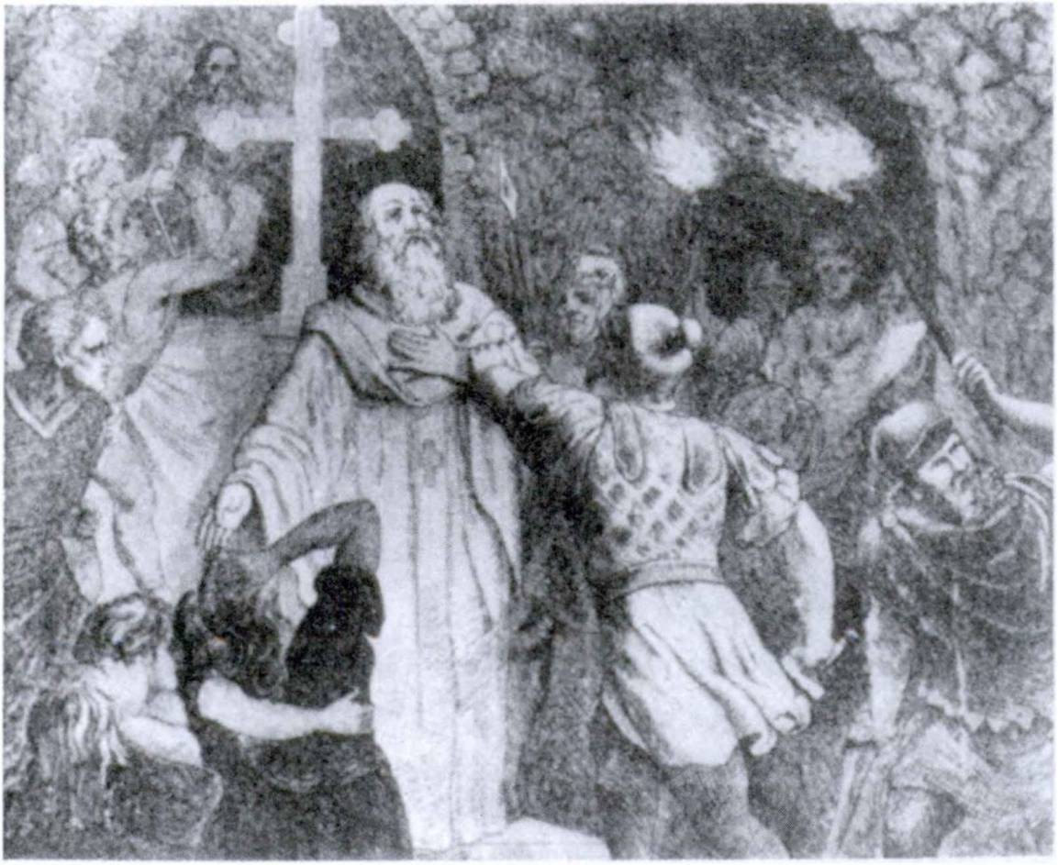106 FIRST YEAR LATIN

RomAni AmiCi CHrisTiAnorUm non erAnT.

EXERCISE 111
[Essential]

PRAY ALWAYS!
Translate:
Omnes homines boni drant sed homines mall non drant. Christian! in nomine Christi orant. Rex bonus pro regno et militibus drat. Dux bonus pro militibus drat. Et milites et nautae propter belli pericula orant. Et patres et matres pro filiis orant. Filii pro patribus et matribus orant. Amici pro amicis orant. Christus pro omnibus hominibus drat.
Cum1 dr am us, Deum laudamus. Omnes Christian! Deum, pa-

1 Cum is here a conjunction. Translate when.

FIRST YEAR LATIN 107

trem omnium hominum, laudant, quod multas res bonas homi- nibus1 parat. Milites post victoriam et salutem Deum laudant; patres et matres Deum propter pacem et filidrum salutem laudant.

EXERCISE 112
[Essential]
Translate:
Reges et duces mall bellum parant. Rex malus, gloriae et regni cupidus, gladids et legidnes parat. Castra gladiorum et frumenti plena parat. Urbes et oppida finitima oppugnat et oc- cupat. Milites regis mall et silvas et colles occupant. Cupidi sunt victoriae sed non pacis. Deus autem militibus et regibus malls praemia non parat!

EXERCISE 113
[Essential]
Translate:
Estis homines boni. Itaque pacem et virtutem laudatis et pro omnibus hominibus oratis. Bellum non paratis quod non estis gloriae et victoriae cupidi. Urbes finitimas non oppugnatis; op­ pida gentium finitimarum non occupatis; gladids et legidnes non propter bellum sed propter pacem paratis.

EXERCISE 114
Translate:
1. Christian! pro omnibus hominibus oramus. (With what does Christian! agree?) 2. Milites fortes laudas. 3. Urbem non oppugnas. 4. Copiam gladiorum paras. 5. Christian! Spiritum Sanctum laudamus. (With what does Christian! agree?) 6. Ho- minem fortem et sanctum omnes laudatis. (With what does omnes agree?)

1 When to will not translate the dative into good English use for.

108 FIRST YEAR LATIN

EXERCISE 115
[Essential]
Translate:
- Roman generals praise the courage and reliability of brave soldiers. Brave Roman soldiers prepare a supply of swords. They storm cities and towns. They seize hills and mountains and bridges. They are the “bulwark (murus, i) of empire.” In the courage of the brave legions is all hope of victory and safety.
- You are all Christians. Therefore do you all praise Jesus Christ, the Son of God, and Mary, the Mother of Christ. You pray for all men, for soldiers and sailors, for leading men and slaves. You pray in the name of Jesus Christ, and you praise the Father and the Son and the Holy Spirit.
- We are praising Caesar because he is a great and brave gen­ eral. (Great in this sentence does not mean large but famous or outstanding. Therefore it is not an adjective of quantity here.)
- The leader is attacking the camp.
- They are preparing war.
- We praise peace, but we do not praise war.
- The leaders are getting grain and swords ready. (Are getting
... ready = one Latin word!)

EXERCISE 116
[Essential Review]
- Give the genitive plural of: (a) collis, (b) frater, (c) prin- ceps, (d) gravis.
- Give the reasons for the endings you used in Question 1.
- Translate; parse portls: Milites pro portls sunt.

- IMPERFECT INDICATIVE ACTIVE OF LAUDO
The imperfect tense in Latin expresses action as GOING ON in PAST time. For example: “I was eating dinner between six and seven yesterday evening.” I could say, “I ate dinner between

FIRST YEAR LATIN 109

six and seven yesterday,” but the verb ate would not express the CONTINUANCE of the action. Was eating is translated into Latin by the IMPERFECT tense.
ASSIGNMENT: Study the meanings given in GrAmmAr, No. 163 and learn laudabam, etc. Note that:
- The imperfect of a verb is formed on the PRESENT STEM.
- The ending has the a of the first conjugation.
- The FINAL PERSONAL SIGNS are the same as for the present tense.
- The ending contains a TENSE SIGN: ba (e.g., laud-a- BA-t), which is ALWAYS THE SIGN OF THE IMPERFECT
TENSE. (The Latin verb is thus a sort of CODE which you can learn to decipher.)

pugno, 1, intr.

superd, 1, tr.

porto, 1, tr.
VOCABULARY
fight overcome conquer
surpass
carry

centurid, centurionis numerus, I
a centurion1 number

RELATED ENGLISH WORDS
He gave a large tip to the porter. Some boys are pugnacious by nature. Every century has its saints. Roman numerals. Import and export taxes.

Oppugno
RELATED LATIN WORD

1A centurion was a Roman army officer in charge of 100 men. The rank was similar to that of our captain.

110 FIRST YEAR LATIN

EXERCISE 117
ff 1. Give the principal parts of the verbs in the vocabulary.
- Give their present stems.
- Conjugate them in the present indicative.
- Conjugate them in the imperfect indicative.

EXERCISE 118
- Tell what forms these are;
- Translate:

It
CenTUrio
- portabat
- drabant
- occupabant
- pugnabant
- laudabas
- laudabat
- superabant
- superabat
- laudabam
- laudabamus
- pugnabat
- laudabant
- portabant
- parabant

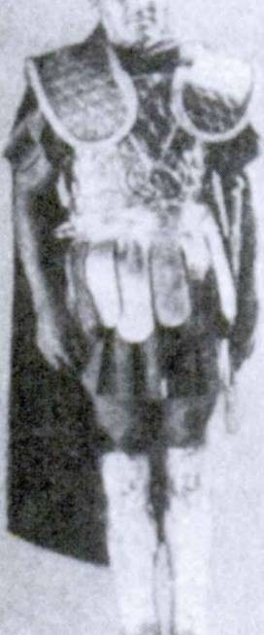
EXERCISE 119
  - Point out the imperfects by identifying the tense sign;
  - Point out the third-person plural verbs by identifying the final personal sign;
  - Translate:
Note. All Latin words which end in -nt are VERBS in the THIRD PERSON PLURAL.

1. oppugnabant | 7. superant | 13. paramus
2. portat | 8. super at | 14. occupant
3. pugnant | 9. occupabat | 15. orabat
4. parabat | 10. portant | 16. laudabatis
5. pugnat | 11. portabant | 17. oppugnabat
6. laudabant | 12. laudas | 18. parabas

FIRST YEAR LATIN 111

EXERCISE 120
[Essential]
    - Add the correct final personal signs;
    - Translate:
- Equites fortes cum magno hostium numero pugnaba
- Christian! Christum, regem omnium gentium, laudaba
- Centuriones f rumen turn non portaba
- Altus mons colles superaba............
- Populus Romanus victorias legidnum reliquarum lauda­
ba
- Christian! boni pro fratribus oraba
- Equitatus Romanus Gallos virtute1 2 3 4 5 superaba
- Magnus centurionum numerus in prima acie pugnaba

EXERCISE 121
[Essential]
Translate:
- The slaves were carrying the grain into the towns. 2. The Roman legions were fighting with the tribes of Gaul. 3. The cavalry were conquering a large number of Gauls. 4. The cen­ turion was fighting in the first battle line. 5. Caesar was over­ coming the enemy.

EXERCISE 122
  - Identify the final personal signs;
  - Translate:

- laudabam
- portabat
- laudabatis
- orabat
- super at
- parabat
- portat
- superant
- oppugnabat
- pugnabat
- laudabas
- pugnabant
- portant
- occupabat
- parabant

1 Translate: in courage.

112 FIRST YEAR LATIN

EXERCISE 123
[Essential Review]
- What is the gender of: (a) centurid, (b) legio, (c) mons? Give the rule.
- Give the nominative plural of: (a) legio, (b) virtus,
(c) corpus, (d) gravis.
- Translate; parse servis:
Centuriones servis gladios non dederunt.

- FUTURE INDICATIVE ACTIVE OF LAUDO
The future tense expresses action that WILL take place. Study the meanings in GrAmmAr, No. 164. Learn the model verb. You need not learn the meanings given in the parentheses. Note that :
- The future tense is formed on the PRESENT STEM.
- The ending has the a of the first conjugation.
- The final personal signs are the same as for the present and the imperfect tenses.
- The ending contains a tense sign, bi (e.g., laud-a-BI-t), which is the sign of the future in the FIRST and SECOND conjugations.

VOCABULARY
do, dare, dedi, datus, 1, tr,
voco, 1, tr, interim, adverb mors, mortis
hiberna, hiberndrum
NOTE

give call
meanwhile death
winter quarters

- Do forms its perfect stem differently from laudd. There­ fore you must memorize the principal parts. It is also peculiar in this, that the a which begins the endings is short throughout the indicative except in the second person singular present in­ dicative active (das).
- Hiberna, like castra, is declined only in the plural.

FIRST YEAR LATIN 113

RELATED ENGLISH WORDS
A mortal wound. Some animals hibernate during the winter. A vocation to the priesthood.
RELATED LATIN WORD
Maria vocem Christi audivit.

EXERCISE 124
- Conjugate the verbs of the vocabulary in the present, im­ perfect, and future tenses of the indicative active.
- Conjugate in the future indicative active: (a) paro, (b) oc* cupo, (c) superb, (d) porto, (e) pugno, (f) orb.

EXERCISE 125 r
  - Tell what forms these are;
  - Translate:

superabit | 7. dabis | 13. laudabimus
laudabo | 8. laudabis | 14. vocabunt
dabo | 9. pugnabimus | 15. superabit
parabunt | 10. laudabit | 16. pugnabunt
laudabunt | 11. laudabitis | 17. dabitis
occupabitis | 12. vocabis | 18. vocabit

EXERCISE 126
[Essential]
Translate:
- Omnibus gentibus Deus veritatem dabit. 2. Interim im- perator centuriones in hiberna vocabit. 3. Deus homines sanctos post mortem in Caelum vocabit. 4. Principes reliquarum gentium propter mortis metum frumentum Romanis dabunt. 5. Servi frumentum in hiberna portabunt. 6. Centurio principes in hiberna vocabit.

114 FIRST YEAR LATIN

EXERCISE 127
[Essential]
Translate:
- We shall praise God in heaven. 2. Bad kings will prepare for war. (Omit jor in Latin.) 3. You will praise Rome. 4.1 shall praise the Lord God of Hosts. (Hosts = armies.) 5. God will give great rewards to all good men. 6. Caesar will call the soldiers into the winter quarters. 7. After the death of Caesar, the Gauls were servants of the Romans. 8. Meanwhile the centurion will call the legions into the battle line.

EXERCISE 128
[Essential Review]
1. Translate, and explain the case of imperator:
Caesar erat imperator Romanorum.
- What is the gender of: (a) mors, (b) rex, (c) veritas? Give the rule.
- Give the ablative singular of: (a) mors, (b) centurid,
(c) gravis, (d) senatus, (e) regnum, (f) vox, (g) fides.

- QUESTIONS

VOCABULARY
ubi, adv. where?
quis, pronoun who?
quid, pronoun what?
cur, adv. why?
locus, I {pl.t loca, loco rum) place unfavorable
alienus, a, um another's
foreign

NOTE
- The abbreviation adv. stands for adverb.

FIRST YEAR LATIN 115

- Locus becomes a neuter noun in the plural: loca. When locus is modified by an adjective the preposition in may be omitted with the ablative case.
In an unfavorable place, loco alieno

RELATED ENGLISH WORDS
The politician has alienated many of his friends. A local elec­ tion. Some aliens are deported by the government.

INTERROGATIVE ADVERBS AND PRONOUNS IN QUESTIONS
Questions may be asked in Latin by using interrogative ad­ verbs or pronouns just as in English.
Ubi es? Where are you?
Quis pugnabat? Who was fighting?
Quid paras? What are you preparing?
Cur Caesarem laudas? Why do you praise Caesar?

EXERCISE 129
[Essential]
Translate:
- Quis Caesarem post caedem principum Galliae laudabit?
- Cur senatum vocas? 3. Ubi sunt hibema hostium? 4. Quis Deum non laudat? 5. Ubi sunt copiae Romanae? 6. Cur loco alieno castra posuerunt? 7. Cur urbes alienas occupat? 8. Cur gentes alienae bellum parabant? 9. Cur omnia loca occupabat?

EXERCISE 130
Translate:
  - Why were the soldiers fighting in an unfavorable place?
  - Who will surpass the great general Caesar? 3. What were they preparing? 4. Who is seizing foreign harbors and cities?
- Where will they fight at dawn ? 6. A man eager for fame does not praise another’s courage.

116 FIRST YEAR LATIN

/. Translate;
EXERCISE 131
[Essential]

- Write Latin answers for all the questions to which no answers are given:
  - Cur Deum laudamus?
Ans. Deum laudamus quod Deus bonus est et Dominus Caeli et terrae.
  - Cur Romani cum Gallis pugnabant ?
Ans. Romani cum Gallis propter caedem centurionum pugnabant.
  - Cur Caesarem Romani laudabant?
  - Cur Christian! Spiritum Sanctum laudant?
  - Cur Christian! Mariam laudant ?
  - Cur oramus in nomine Jesu Christi ?
  - Quis magnam frumenti copiam portabat ?
Ans. Servus magnam frumenti copiam portabat.
  - Quid parat dux bonus ?
Ans. Dux bonus parat gladios et frumenti copiam.
  - Quis pro duce bond pugnabit ?
  - Quis servum vocabat?
Ans. Dominus servum vocabat.
  - Quis erat imperator Romandrum in Gallia?
  - Quis magna praemia hominibus bonis dabit?
  - Quid in bello occupant duces boni?
  - Quis est Christus ?
  - Quis drat pro omnibus hominibus?
  - Ubi nunc drat Maria?
Ans. Maria nunc drat in Caelo.
  - Ubi est Deus?
Ans. Deus est in Caelo et terra et omni loco.
  - Ubi Caesar pugnabat?
  - Ubi sunt impedimenta Romanorum?
  - Ubi Deus praemium hominibus sanctis post mortem dabit ?

FIRST YEAR LATIN 117

- THE INTERROGATIVE PARTICLE -NE
When no interrogative adverb or pronoun is used, questions may be asked by putting the most emphatic word (generally the VERB) first and adding -NE.
Was he praising Caesar? Laudabatne Caesarem?
Do you fight for the king? Pugnasne pro rege?
Were they friends of the Romans? Erantne amici Romano rum?

oratio, orationis semper, adv.
slcut, conj.
in principio
VOCABULARY
speech prayer
always as
in the beginning

in saecula saeculorum
-ne
world without end forever
particle used in questions

NOTE
Oratio means prayer only in Christian Latin.
RELATED ENGLISH WORDS
The priest reads the orations after the Kyrie Eleison.
RELATED LATIN WORD
Marla pro omnibus hominibus drat.

ASSIGNMENT: Review neuter nouns of the third declension in the Mastery Review Vocabulary (pages 91-98).

EXERCISE 132
[Essential Drill]
Translate:
1. Pugnabantne semper Romani? 2. Parabantne f rumen turn post longum iter? 3. Montes et silvas et flumina Galliae lauda-

118 FIRST YEAR LATIN

bids. 4. Pugnabantne in itinere Romani cum Gallis? 5. Erantne post bellum multa corpora in fluminibus et silvis? 6. Suntne impedimenta et legiones in agmine? 7. Laudabasne nomen Mariae? 8. Propter vulnera longum iter non fecerunt. 9. Su- peratne exercitus Romanus Gallos? 10. Orabantne semper ho­ mines sancti? 11. Legem et veritatem Christi semper laudabo.
12. Datne imperator signum? 13. Dantne Romani copiam frumenti Gallis post orationem principis? 14. Vocabitne prima luce centurio equites? 15. Orantne Christian! in nomine Christi?
- Feceruntne semper Galli impetum in agmina Romandrum?
- Eratne magnus pons in alto flumine? 18. Oppugnabantne Galli hiberna? 19. Victoriam et gloriam Christi laudabamus.
20. Laudabatne imperator centuridnem propter magnam virtutem et multa vulnera? 21. Dantne reges magna praemia amicis?
22. Occupabitne colies? 23. Interim, propter gratiam Caesaris,
Galli frumentum in hiberna portant. 24. Orabatne nauta propter vulnerum metum? 25. Parabatne dux frumentum et gladios?
26. Christum, Regem gloriae, laudabimus. 21, Quis loca occu- pabat? 28. Pugnabatne equitatus in silvis? 29. Portabantne servi magnum gladiorum numerum? 30. Propter metum vul­ nerum et mortis, nautae et milites in bello semper orant. 31. Deus orationes multorum Christianorum audivit. 32. Pugnabantne equites loco alieno et angusto ?

ORATIO CHRISTIANA “DOXOLOGIA”
A doxology is a prayer in which “glory” is offered to the Blessed Trinity. Of the many doxologies which date from very early Christian times the following is most familiar:
Gloria Patri et Filio et Spiritui Sancto,1
Sicut erat in principio et nunc et semper et in saecula saecu- lorum. Amen.

1 Sit, be, or may ,,, be, is understood in the first line. Supply be in translation.

FIRST YEAR LATIN 119

EXERCISE 133
Translate:
1. Do you always praise the names of Jesus and Mary ? 2. Shall we praise God in heaven? 3. Christians pray always, as Christ advised1 His2 friends. 4. On account of the prayers of Christians, God will give grace to many men. 5. On account of the general’s speech, the chiefs of the tribes will prepare (for) war. 6. In the beginning of the war the Romans were conquering the enemy.
7. Are there many long and renowned rivers in America?3 8. Was the journey long and difficult? 9. On account of the many serious wounds of the soldiers, the army made4 a short march into winter quarters. 10. Was the route full of dangers? 11. Were the columns of Caesar safe in Gaul? 12. Will God call all good men into heaven after death? 13. Was the place unfavorable?
14. What were the Roman slaves begging (for) ?5 15. Was there a large number of slaves in the Roman Empire? 16. Were the Romans conquering all the tribes of Gaul? 17. The slaves were carrying the body of the chief. 18. Will American6 sailors and soldiers seize foreign harbors and cities? 19. A Roman column was assaulting the camp. 20. Meanwhile, where were the re­ maining Gauls fighting?

1 advised: monuit.
2 his: Suus, a, um.
3 America: America, ae.
4 made: fecit.
5 Omit jor in Latin.
- American: Americanus, a, um.

LESSON 10: THE PRESENT, IMPERFECT, AND FUTURE INDICATIVE ACTIVE OF MONE6

The principal parts of regular verbs of the second conjugation are formed by dropping the -ed of the first person present in­ dicative and adding -ere, -ui, -itus.1
mon-eo, mon-ere, mon-ui, mon-itus hab-ed, hab-ere, hab-ui, hab-itus
Many second-conjugation verbs, however, are irregular in their principal parts. These will be written out in full in the vocabu­ laries and must be memorized. But the present infinitive active ALWAYS ends in -ERE (with the first e long!).

ALL VERBS WHOSE PRESENT INFINITIVE ACTIVE ENDS IN -ERE BELONG TO THE SECOND CONJUGATION.

moned, 2t tr.
VOCABULARY

warn advise

timed, timere, timui, 2, tr.
terreo, 2, tr.
habed, 2, tr.
arma, armdrum
fear terrify have arms

NOTE
- Timed has no fourth principal part.
- Arma is a neuter plural of the second declension.
RELATED ENGLISH WORDS
A timorous soul; a timid person; rearmament.

1 When the verb is intransitive, the fourth principal part ends in -itum.
120

FIRST YEAR LATIN 121

Now that you know the model laudo, moneo is quite easy:
- Find the stem by dropping the ending of the present in­ finitive active, thus: monere, STEM: mon-.
- Add -eo for the first person present indicative active.
- For the other endings use the endings of the first conjuga­ tion but change the first a of the endings to e.
ASSIGNMENT: Write out the present, imperfect, and future of moneo without looking in the book. Then compare with the model, GrAmmAr, Nos. 16S, 168, and 171. Learn the model.

EXERCISE 134
- Why do the verbs in the vocabulary belong to the second
conjugation ?
- Give the full principal parts of these verbs.
- Write the third person singular and third person plural of the present, imperfect, and future of these verbs.

EXERCISE 135
[Drill on Present Tense]
1, Tell what forms these are;
- Give three English meanings for each form:

timet | 5. monetis | 9. monemus
moneo | 6. monet | 10. monent
mones | 7. habet | 11. terret
terrent | 8. timent | 12. habent

EXERCISE 136
[Drill on Imperfect Tense]
/. Tell what forms these are;
2. Translate:

1. monebant | 5. timebant | 9. monebas
2. terrebat | 6. monebatis | 10. monebat
3. monebam | 7. monebamus | 11. terrebant
4. habebant | 8. timebat | 12. habebat

122 FIRST YEAR LATIN

EXERCISE 137
[Drill on Future Tense]
- Tell what forms these are;
- Translate:
- monebunt 4. monebitis 7. habebit
- timebo 5. monebit 8. terrebunt
- monebis 6. monebo 9. timebimus
EXERCISE 138
Translate:
  - Times. 2. Ducem monebit. 3. Hostes terrebat. 4. Fratrem
monebant. 5. Imperium habent. 6. Populum terrent. 7. Partem habebat. 8. Equitatum timebitis.
EXERCISE 139
    - Fill in the required personal signs; 2, Translate:
- Clamor hostium milites Romanos non terre, quod Romani fortes sunt.
- Multi homines in pace fortes sunt; in bello autem hostes timebu
- Servi propter metum dominum monebu
- Metus Dei homines maids terre
- Propter gratiam Caesaris Galli Romanos moneba.
- Omnes homines vulnera et mortem time
- Legiones magnam armdrum copiam habeba

EXERCISE 140
[Essential]
Translate:
1. Omnes homines res difficiles timent. 2. Propter rem gravem centuriones imperatorem monebunt. 3. Clamor hostium locis difficilibus et angustis legiones terret. 4. Rex malus res alienas habet. 5. Populus Romanus pericula gravia et res difficiles non timebat. 6. Multae gentes arma non habent.

FIRST YEAR LATIN 123

EXERCISE 141
[Essential Review]
- Give the nominative plural of: (a) legio, (b) flumen,
(c) corpus, (d) centurio, (e) facilis.
- Translate: They are eager for victory and renown.
- Translate; explain the case of castra:
Frumentum in castra portabat.

EXERCISE 142
[Honor Work] PEARL HARBOR
The enemy were always preparing (for) war because they
were eager for empire and fame and victory. However, they were fearing the American1 forces; they were fearing the American1 sailors and soldiers. The leading men of the enemy were warning and terrifying the nation: “The Americans2 are eager for empire. They have a large supply of arms and a large number of sailors and soldiers. They will attack the harbors and the towns. And so we shall prepare a supply of arms and of all things. We shall fight with the legions of the enemy and we shall conquer.” And so they were preparing (for) war.
In America,3 however, there was peace. The American1 people were not eager for war; the generals were not desirous of the glory of war. Not many leading men were warning the Senate and the people.
On December 7, 1941,4 the enemy made an attack on Pearl5
Harbor. They killed many sailors and soldiers. There was war! Now, however, we are conquering the enemy; we are terrifying the tribes of Japan.6 Brave sailors and soldiers are fighting for
1 American: Americanus, a, um.
2 Americans: American^ Americanorum.
3 America: America, ae.
4 December 7, 1941: ante diem septimum Tdus Decembres, 1941.
5 Pearl: Margaritarius, a, um.
6 Japan: Japonia, ae.

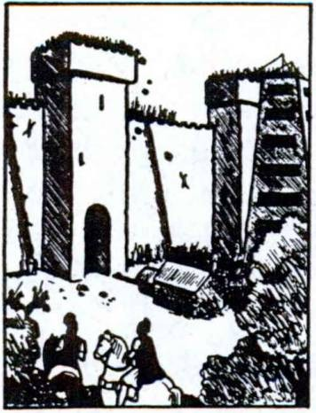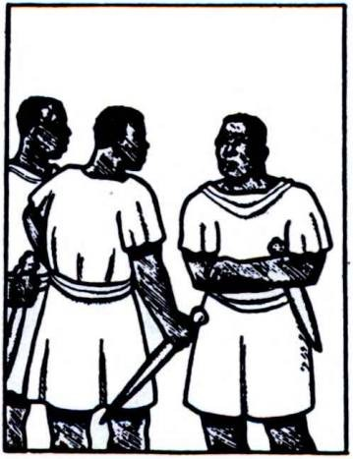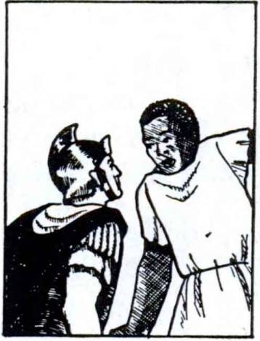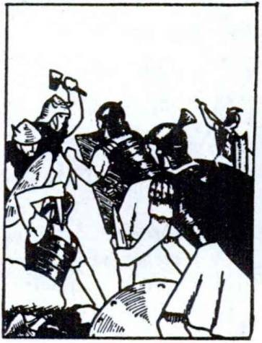124 FIRST YEAR LATIN

America. They are fighting in places unfavorable and full of great dangers; but they are eager now for victory, the reward of courage. They will conquer the enemy!

EXERCISE 143
Complete these sentences with a Latin verb describing the action in the pictures:
  - Romani urbem
  - Servi gladios
  - Caesar servum
  - Equites hostes
  - Servus principem
  - Romani cum Gallis

1 2 3

4 5 6

LESSON 11: PERSONAL PRONOUNS

- Pronouns of the FIRST person are those which refer to the SPEAKER OR WRITER. In English they are: I (ME), WE (US).
- Pronouns of the SECOND person are those which refer to the person spoken TO. In English they are: YOU (THOU, THEE, YE).
- Pronouns of the THIRD person are those which refer to the person or thing spoken or written ABOUT. In English they are: HE (HIM), SHE (HER), IT, THEY (THEM).

PRONOUNS OF THE FIRST PERSON

ASSIGNMENT: Learn the declension of ego, I, and nos,
we, GrAmmAr, No. 123. Study the English meanings carefully.

ego, mei nos, nostri
VOCABULARY
I
we

video, videre, vidi, visus, 2, tr.
saepe, adv.
see often

NOTE
Video forms its principal parts differently from the model
moned. Memorize all the parts given here.

RELATED ENGLISH WORDS
An inflated ego. Napoleon was egotistical. Visual aids. The shepherds saw a vision of angels.
ASSIGNMENT: Review the forms of sum, present tense, GrAmmAr, No. 346.
125

126 FIRST YEAR LATIN

EXERCISE 144
- Tell what forms these are; 2, Translate:
- videt S. mihi 9. nos
- mei 6. videbat 10. vident
- videbimus 7. nobis 11. videbit
- ego 8. videbant 12. me

EXERCISE 145
[Essential]
An ImAGinArY LeTTer from A CenTUrion NAmeD MArCUs, ServinG wiTH CAesAr in GAUL, To His MoTHer
Translate:
Marcus Centurid Romanus Matri Salutem Dat.1
Ego nunc cum exercitu in Gallia sum. Magnus exercitus in Gallia est quod Galli cum Romanis pugnant. Caesar, homo fortis, est imperator omnium legidnum. Caesarem ego laudo quod dux bonus est—omnia2 videt; omnia2 parat.
Ego in periculo nunc non sum. Nos in castris sumus. Hostes castra Romana non oppugnant quod fortes non sunt. Galba3 mecum in castris est. Homo bonus est et mihi amicus.
Nos saepe pugnabamus cum Gallis et superabamus. Itaque nunc multi Galli servi sunt et nobiscum in castris sunt. Nobis frumentum dant. Impedimenta in castra portant et multas res nobis parant.
Post primam victoriam me Caesar in castris propter virtutem

1 Roman letters frequently opened with the greeting salutem dat, gives
greeting, and closed with vale, farewell (good-by).
2 Adjectives are sometimes used as nouns. Omnia is so used here and means
all things or everything.
8Galba, ae: Galba (a Roman proper name).

FIRST YEAR LATIN 127

MArCUs

et iidem laudabat.1 Prima luce hostes in nos impetum fece- runt. Et ego et Galba in prima acie pugnabamus, et multi Galli nobiscum pugnabant, sed nos non terrebant, non superabant. Caesar nos vide- bat. Itaque Caesar nos prop­ ter virtutem laudabat. Mag- nam gloriam ego nunc habeo, et post bellum Caesar mihi magnum praemium dabit. Laudasne filium? Vale!2

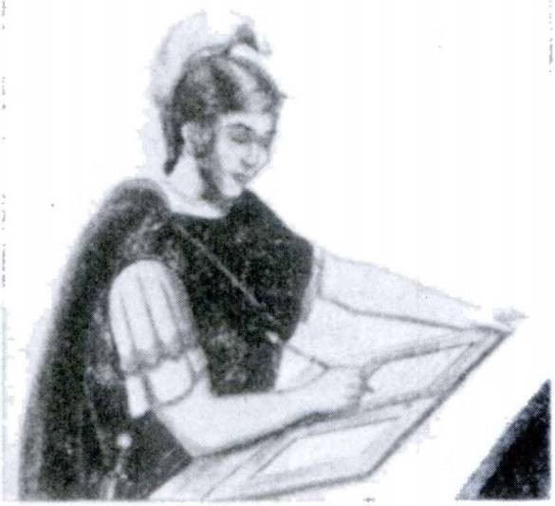
EXERCISE 146
  - Express all the italicized pronouns;
  - Translate:
1. He is warning me. 2. We shalJ warn the Senate and the lead­ ing men. 3.1 am seizing the hill, but Caesar is seizing the bridge.
- He sees us. 5.1 praise the Holy Spirit. 6. They are fighting on my behalf.3 7. He is fighting with me. 8. The Gauls were giving us rewards. 9. Will he give me a reward? 10. They were fighting with us. 11. The Christians are praying for me. 12. Holy Mary prays for us. 13. We shall see the Father and the Son and the Holy Spirit in heaven. 14. Many brave soldiers are fighting with me. 15. Does God give us grace?

1 Polybius, a Greek historian writing in the second century b. c., speaks thus of the encouragement given young soldiers in the Roman army: “After a battle in which some of them have distinguished themselves, the general calls an assembly of the troops, and bringing forward those whom he considers to have displayed conspicuous valor, first of all speaks in laudatory terms of the courageous deeds of each and of anything else in their previous conduct which deserves commendation, and afterwards distributes . . . rewards.”—From Grant Showerman: Rome and the Romans. By permission of The Macmillan Company, Publishers.
2 See Note 1 on page 126. ’Translate: on behalj of me.

128 FIRST YEAR LATIN

PRONOUNS OF THE SECOND PERSON
ASSIGNMENT: Learn the declension of tu, you, and voa, you, GrAmmAr, No. 124. Study the English meanings carefully. Notice that the English uses the SAME forms for the singular and plural while the Latin has different forms.

VOCABULARY
tu, tul you (sing.)
vos, vestri you (pl.)
tened, tenere, tenui, tentus, 2, tr. hold
moved, movere, movi, motus, 2, tr. move

tamen, adv.

neque, conj.
nevertheless nor
and . . . not
RELATED ENGLISH WORDS

Napoleon possessed a tenacious and indomitable will. Motion
pictures.

REVIEW VOCABULARY
commander in chief

imperator, imperatoris
general emperor*

EXERCISE 147
      - Translate;
      - Express the italicized pronouns:
1. I shall give you (sing.) a reward. 2. The Lord fights for you (pl.). 3. God will give you (pl.) a reward, heaven. 4. I was warning you (sing.). 5. The master is calling you (sing.).
6. The Lord is with you (sing.). 7. You (pl.) will praise the victory of Christ. 8. You (sing.) will warn the leader. 9. Does the fear of death move you (sing.)? 10. We shall pray for you (pl.).
1 Imperator in nonmilitary language is to be translated as emperor.

FIRST YEAR LATIN 129

EXERCISE 148

AN EXAMINATION OF PROFESSED CHRISTIANS BY A ROMAN JUDGE1
The proconsul, the judge, is seated. A group oj Christians is brought in.
PROCONSUL (addressing the first of the group). Esne tu Chris- tianus ?
CHRISTIAN. Ego Christianus sum.
PROCONSUL (addressing a second Christian). Et tu—esne tu Christiana?
SECOND CHRISTIAN. Christiana et2 * 4 ego sum. Omnes nos Chris­
tian! sumus.
PROCONSUL. Quid? Vos omnes Christian! estis? FIRST CHRISTIAN. Sumus.
PROCONSUL. Cur vos deos Romandrum non laudatis ?
FIRST CHRISTIAN. NOS deos Romandrum non laudamus quod ver!8 non sunt.
PROCONSUL. VOS moneo! Si* deos Romandrum laudabitis, praemia vobis dabo—(threateningly) sed . . .
SECOND CHRISTIAN. Metus mortis et vulnerum nos non movet. Nos laudamus Dominum Caeli et terrae, “Regem Regum et Im- peratorem Omnium Gentium.”5 * * Christus pro nobis orabat.* Gratia Christi in nobis est. Itaque quid nos terrebit? Te non timemus.
PROCONSUL (scornfully). Christus! Quis est Christus? Ro­ mani Christum occiderunt quod malus homo erat.

1This is an imaginary account, but much of it has been suggested by actual trials as recorded in the authentic Acts of the early martyrs.
1 Et here means also.
- veins, a, um: true.
4 si: if.
5 These words were actually said at Carthage by a Christian martyr named
Speratus. Satuminus was the examining official.
•At the Last Supper Christ expressly prayed for all believers: <rYet not for these [the Apostles] only do I pray, but for those also who through their word are to believe in Me” (John 17:20-21).

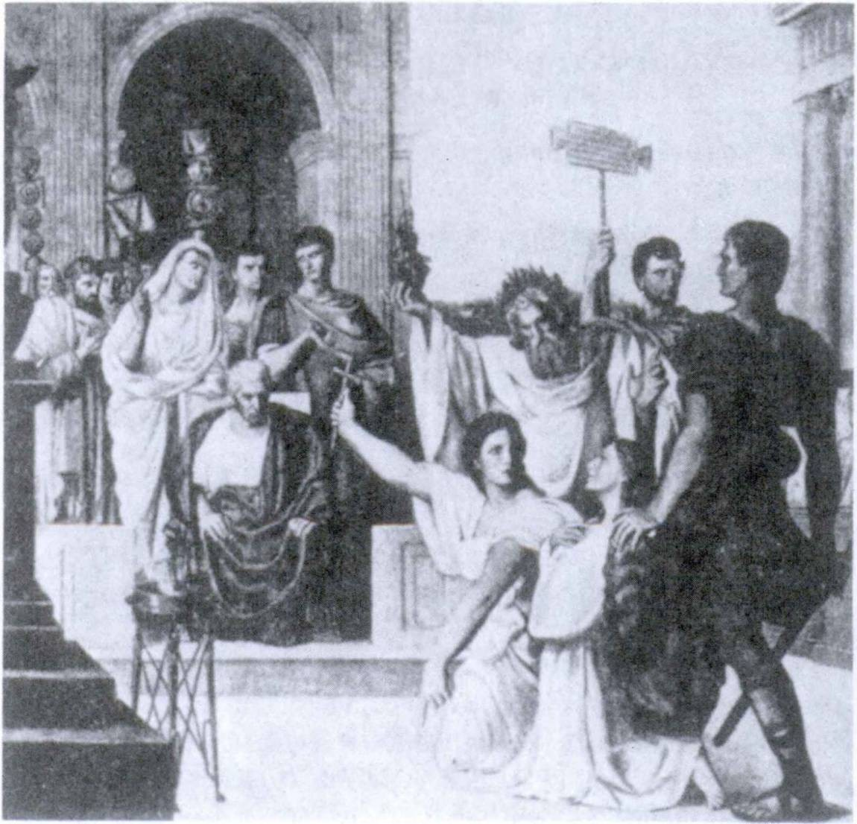130 FIRST YEAR LATIN

“Christus* nos in Caelum vocat.”

FIRST CHRISTIAN. Christus est Filius Dei et tamen frater om­ nium hominum.
PROCONSUL (impatiently). Cur vos imperatorem Romanum non laudatis?
FIRST CHRISTIAN. NOS semper imperatorem Romanum lauda- mus sed caedem hominum sanctorum non laudamus neque lau- dabimus. Tamen pro imperatore semper oramus et orabimus. Nos Christian!—sicut Christus nos monebat—pro omnibus homi- nibus, pro regibus, principibus, militibus, servis oramus.
PROCONSUL. VOS tamen moneo! Post mortem (sarcastically)
quid vos habebitis?

FIRST YEAR LATIN 131

FirsT CHrisTiAn. TU nos non movebis. Fidem et veritatem Christi nos tenemus et semper tenebimus. Christus est salus hominum. In Christo est spes omnium gentium. Post mortem magnum praemium nobis dabit; nos cum Christo in Caelo Patrem et Filium et Spiritum Sanctum videbimus in saecula saeculorum.
THe OTHer CHrisTiAns. Amen!
ProConsUL. Ubi est Deus Christianorum? Ego Deum Chris- tianorum non videbam neque video.
SeConD CHrisTiAn. In omni loco est sed nunc nos Deum non videmus. Deus corpus non est. Tamen post mortem tu videbis, neque tibi praemium dabit.
ProConsUL (angrily/ Mehercule!1 Monetisne vos me? Metus Dei Christianorum me non terret neque terrebit. (Solemnly.) Ego autem imperium habeo! Vos terrebunt militum Romanbrum gladii!
CHrisTiAns. Gladius nos non terret neque imperium mundi. Imperium autem Dei nos terret et movet. In Deb est salus.
ProConsUL (firmly). Estisne omnes Christian!? CHrisTiAns (loudly). Nos sumus Christian! omnes.
ProConsUL. Itaque omnes hos2 Christianos “gladio animad­ vert! placet.”3
CHrisTiAns. Deb gratias! Pro te orabimus. (The Christians are taken away.) Christus nos in Caelum vocat I

EXERCISE 149
[Essential Review]
- What is the rule for accent in Latin?
- Indicate the accent in these words and explain: (a) laudabat,
(b) impedimenta.
- Translate: There are dangers in the forest.

1 Mehercule!: By Hercidesl (a common Roman exclamation).
2 hos: these.
3 This is a technical legal phrase. “It is decreed that all these Christians be punished by the sword.”

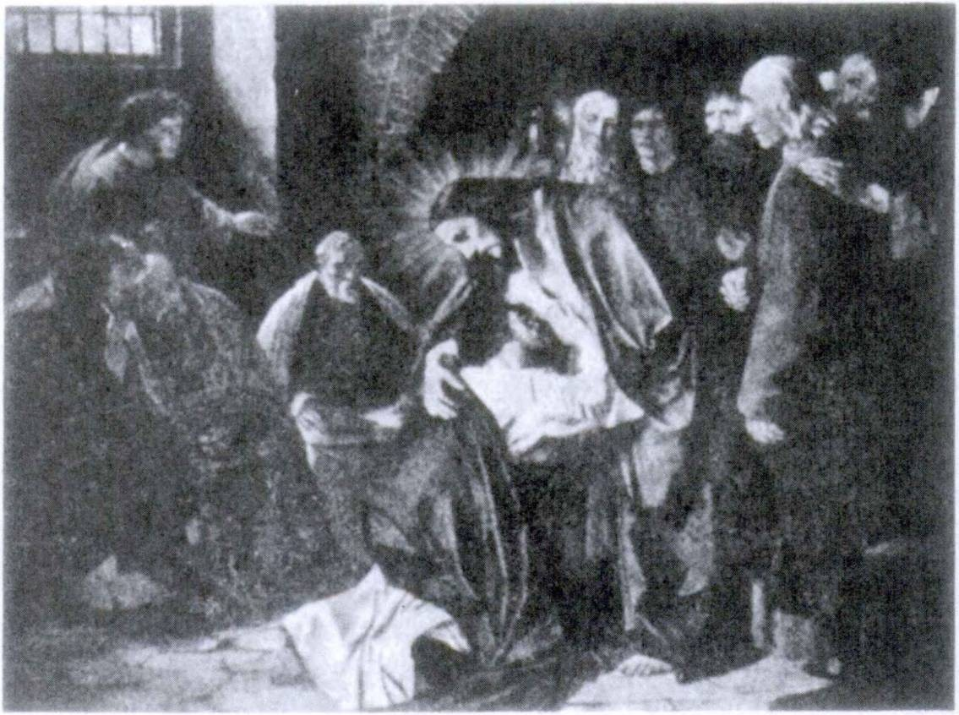132 FIRST YEAR LATIN

DominUs MeUs,1 eT DeUs MeUs1

PRONOUNS OF THE THIRD PERSON
When used as the personal pronoun of the third person, is, ea, id has the meaning Ae, she, or it. Since Latin pronouns must agree in GENDER and NUMBER with the Latin words to which they refer, a masculine or feminine Latin form is often translated by the English it.
He saw the army and jeared ft. Vidit exercitum et timuit eum.
ASSIGNMENT. Learn the declension of is, ea, id, he, she, it and ei, eae, ea, they, those, GrAmmAr, Nos. 128-129. Study the English meanings carefully. Note that the plural can be formed by adding the endings of magni, ae, a to the stem e-. Study the rule for agreement of pronouns in GrAmmAr, No. 479.

1 meus, a, um: my. (These were the words uttered by St. Thomas when he saw the risen Savior.)

FIRST YEAR LATIN 133

is, ea, id
VOCABULARY
he, she, it

sustineo, sustinere, sustinui, sustentus, 2, tr.
fines, finium, m.

NOTE
Fines is a plural noun of the third declension.
sustain withstand territory

Teneo; finitimus.

RELATED LATIN WORDS

EXERCISE 150
- Tell what forms these are;
- Translate:

1. sustinebat | 3. videbat | 5. sustinebant 7. | sustinent
2. sustinet | 4. habebant | 6. sustinebit 8. | habemus

- Translate;
EXERCISE 151
[Essential]

- Point out the words to which the italicized pronouns refer and explain the agreement:
1. Caesarem laudabas. Itaque is tibi praemium dabit. 2. Caesar agmen hostium non videt. Monebisne eum? 3. Maria sancta erat. Itaque Deus ei praemium dedit. 4. Hostes in hiberna im- petum fecerunt. Milkes autem fortes impetum edrum sustinebant.
- Maria est Mater Dei. Itaque earn Christian! laudamus.
- Amicus est in periculd. Itaque pro eo drabimus. 7. Hostes op- pidum occupant. Tenebuntne id? 8. Hostes bellum parant, sed impetum eorum sustinebimus. 9. Caesar duces Galldrum in hiberna vocat; sed ei non sunt amici senatus et populi Romani.
- Matres bonae sunt. Virtus earum magna est. Nos eas semper laudamus, et Deus eis magna praemia dabit. 11. Caesar est im- perator Romanus, sed senatus virtu tern ejus non laudat.

134 FIRST YEAR LATIN

12. Caesar oppidum Galldrum occupabit, sed tu eds non mone- bis. 13. Multi homines sancti sunt. Eis Deus praemia dabit.
14. Christus est filius Mariae et nunc in Caeld cum ea est. 15. Mi- lites semper in periculo sunt. Itaque pro eis dramus. 16. Caesar in castris est. Ei servus gladium dat. 17. Omnes Galli in armis sunt. Spem victoriae in virtute posuerunt. Equites edrum fortes sunt. Copia frumenti in oppidis edrum est. Et pontes et colies tenent. Ea Caesar audivit; eds tamen non timet.

/. Translate;
EXERCISE 152

- Express all the italicized pronouns:
Warning. Remember that the pronoun must agree in gender
and number with the Latin word to which it refers.
1. The Senate praises Caesar because he fights for the Roman people in the territory of the Gauls. 2. The roads are good. The Romans constructed them. 3. Caesar was fighting with the Gauls in their territory. He was seizing their towns and cities. The Gauls were not withstanding his attacks. 4. We praise Christ and Mary, His mother. She was holy. God gave her a great reward. All holy men will see her and her Son in heaven. They will all pray with her for us. 5. The Gauls were not friends of the Romans. The Gauls were not giving them grain, and they were not praising them. The Gauls were fighting with them. 6. Christ is the light of the world and the salvation of all men. We praise Him now on earth, and with Him we shall praise God in heaven forever.
7. We praise the Roman legions on account of their victories. They were fighting for the Senate and the Roman people. The Gauls were fighting with them but they conquered the Gauls. Caesar was their commander in chief and was praising them on account of their courage and reliability. Therefore the Senate gave them great rewards. 8. The enemy are carrying grain and arms into the town. Will they hold it? 9. The Gauls are preparing a camp. In it they will fight for the common welfare of Gaul. Never­ theless they will not hold it. Caesar will overcome them and seize

FIRST YEAR LATIN 135

it. 10. The winter quarters of the Romans were in the territory of the enemy. The enemy were attacking and were seizing them.
- The Gauls often made an attack on the Roman columns, but the Romans were withstanding their attacks.

SUSTINEO ALAS1
(Motto of the Technical Ground Command of the U.S. Army Air Corps)

DIRECT REFLEXIVE PRONOUNS
We pray for OURSELVES.
A good man does not praise HIMSELF.
In these sentences the pronouns himself and ourselves REFER BACK to the subject; that is, they stand for the SAME person (or persons) as the SUBJECT.
A PRONOUN THAT. REFERS BACK TO THE SUBJECT OF ITS OWN CLAUSE IS CALLED A DIRECT REFLEXIVE.
The oblique cases (the genitive, dative, accusative, and abla­ tive) of the regular pronouns which you have learned, ego, nos, tu, vos, are used as the DIRECT REFLEXIVES of the FIRST and SECOND persons.
We pray for ourselves. Pro nobis oramus.
But when a pronoun of the THIRD PERSON refers back to the subject of its own clause, the proper form of sui must be used instead of is, ea, id.
A good man does not praise himself. Homo bonus se non laudat.
ASSIGNMENT: Learn the declension of sui, GrAmmAr, No. 127. Notice that each form can mean himself, herself, itself, or themselves according to the MEANING of the word to which it refers.

1 ala, ae: wing.

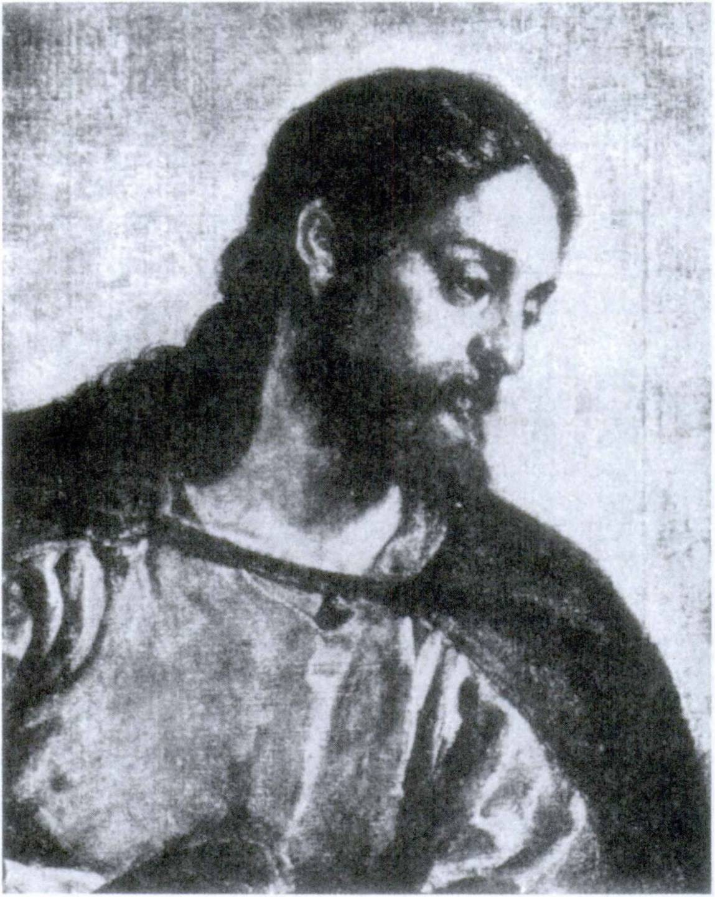

Jesus Christus, Deus et Homo
Christ is the model of all Christian virtues. “Come,” He said, “follow Me.” We follow Him by imitating His virtues and thus becoming, as the Saints did, “other Christs.”

FIRST YEAR LATIN 137
Ei se laudabant. They were praising themselves. Marla se non laudat. Mary does not praise herself. Caesar se laudabat. Caesar was praising himself. Legid se laudabat. The legion was praising itself.

sui
etiam, adv.
VOCABULARY
himself herself itself themselves
also

enim, conj., postp. for

EXERCISE 153
Translate:
  - We often pray for ourselves. 2. He prays for himself.
- You pray for yourself. 4. They pray for themselves. 5. They praise him. 6. The legion prays for itself. 7. I pray for myself.
8. He sees them. 9. You pray for yourselves. 10. She does not praise him. 11. She prays for herself. 12. We have the grace of God in us.
EXERCISE 154
[Essential]
Translate:
1. Holy men do not praise themselves. 2. Mothers praise not themselves but their sons. (Omit their in translating.) 3. Men often do not see themselves as we see them. 4. Christians often pray for themselves and for all men. For God gives them and all men grace on account, of their prayers. 5. Caesar was not praising himself. 6. The legion also was praising itself. 7. Now Mary does not pray for herself but for us, for she is in heaven and is also the mother of all men. 8. The Gauls often killed themselves after the victories of the Romans.

138 FIRST YEAR LATIN

EXERCISE 155
[Essential]
VIRTUS ROmANA ET VIRTUS CHRISTIANA
The Romans had many virtues and the best of the Romans were upright and idealistic men. Among these was the famous Roman orator and politician, Marcus Tullius Cicero. But they were not Christians and therefore the great Christian virtue of humility was unknown to them. They did not, of course, have our personal devotion to Christ nor our loving submission to God. Their ideal was a natural one, good in many ways, but far inferior to the supernatural ideal which shines forth in our Master and our Model, Jesus Christ
- Translate;
- Point out the words to which the italicized pronouns refer and explain your translation of these pronouns:
Marcus Tullius Cicero, orator1 magnus et bonus, veritatem et virtutem saepe laudabat. De2 * 4 virtute “Virtus propter se” inquit,8 “laudatur.”* In orationibus homines bonds saepe laudabat, maids autem non laudabat. Multa pericula sustinebat; mortem et gladios non timebat; nomen popull Romani semper laudabat.
Cicero tamen Christianus non erat. (Post ejus mortem5 Chris- tus in terram venit.) Itaque Cicero, gloriae cupidus, se saepe laudabat. Omnes Romani saepe se laudabant. Senatus se lauda­ bat. Etiam imperatores et duces Romani se laudabant. Homi­ nes sancti autem non se sed Deum laudant, sicut Maria, Mater omnium Christianorum, se non laudabat. Ea post Annuntia- tionem6 orabat :

1 orator, oratoris: an orator (Cf. oratio).
3 de, prep. v. abl.: concerning.
8 inquit: he said.
4 laudator: is praised.
B Cicero lived 106-43 b. c.
* Annuntiatio, Annuntiationis: the Annunciation by the Angel Gabriel.

FIRST YEAR LATIN 139

Magnificat1 anima2 mea Dominum
.... quia3 fecit4 * 6 mihi magna .... et sanctum nomen ejus (est).
Cicero et omnes Romani spem in se posuerunt. Christian! autem spem non in se sed in gratia Christi ponunt.®
Cicero multa et gravia pericula sustinebat quod et bonus erat et gloriae cupidus. Christiani autem pericula sustinent quod Christum secum habent. Christiani enim Jesum Christum in se “portant.” Itaque nomen Christianorum erat etiam “Christo- phori.”®

1 magnificat: doth magnify.
2 anima mea: my soul.
8 quia = quod.
4 fecit: he has done.
6 ponunt: place.
6 Christophorus is from a Greek word meaning “Christ-bearer.” Our name Christopher is derived from this.

LESSON 12: PRESENT SYSTEM ACTIVE OF THE THIRD CONJUGATION
- PRINCIPAL PARTS OF THE THIRD CONJUGATION
The principal parts of verbs of the third conjugation must be memorized from the vocabularies. There is no general rule for their formation.
The present infinitive active, however, always ends in -ere
(with the first e short!). This is the sign of the third conjugation.
How then can you tell the difference between the second and the third conjugation?
EXERCISE 156
Tell what conjugation each of these infinitives belongs to:

1. defendere | 5. gerere | 9. dare
2. parare | 6. pugnare | 10. movere
3. monere | 7. sustinere | 11. mittere
4. ducere | 8. instruere | 12. terrere

2. PRESENT INDICATIVE ACTIVE OF MITT&
ASSIGNMENT: Study the model for the present indicative active in GrAmmAr, No. 166. Note that:
  - The final personal signs are the same as for the other con­ jugations.
  - The third person plural has U in the ending.

VOCABULARY

duco, ducerc, duxi, ductus, 3, tr.

gero, gerere, gessi, gestus, 3, tr.

lead guide
carry carry on
wage (w. bellum)

140

FIRST YEAR LATIN 141

defendo, defendere, defend!, defensus, 3, tr. instruo, instruere, instruxi, instructus, 3, tr. mitto, mittere, misi, missus, 3, tr.
fortiter, adv.

defend
draw up equip
send
bravely strongly

RELATED ENGLISH WORDS
What is the difference between a missive and a missile? It is safer to build viaducts over railroad tracks. St. Francis Xavier was a great Catholic missionary. St. Francis Borgia was the Duke of Gandia before he became a Jesuit.
RELATED LATIN WORDS
Christus est dux omnium hominum. Caesar erat fortis.

EXERCISE 157
- Why do all the verbs in the vocabulary belong to the third conjugation ?
- Conjugate mitto and duco throughout the present; give three meanings for each form.
- Give the third person, singular and plural, present of:
(a) gerd, (b) defendo, (c) instruo.

EXERCISE 158
- Pick out the third perSons plural by the final personal signs;
- Translate, giving three meanings for each form:

1. defendunt | 7. gerunt | 13. mittimus
2. mittis | 8. ducit | 14. instruunt
3. defendit | 9. instruit | 15. mittitis
4. mittunt | 10. defendimus | 16. defendis
5. ducunt | 11. mitto | 17. ducimus
6. mittit | 12. gerit | 18. geris

142 FIRST YEAR LATIN

EXERCISE 159
[Essential]

A SHORT SHORT-STORY—A ROMAN “SPOTTER”
  - Miles Romanus hostes videt. Hostes autem eum non vident.
  - Miles servum in castra mittit.
  - Servus Caesarem in castris monet. “Hostes in flumine sunt; periculum nobis est!”
  - Caesar duces et centuriones vocat.
  - Centuriones milites vocant. Eds pro castris instruunt.
  - Caesar milites ducit. “Hostes nos terrebimus! Fortiter pugnabimus!
  - Interim hostes militem Romanum vident. Is autem se fortiter defendit.
  - Vident hostes legionem et Caesarem. Metus Caesaris eos terret. “Caesar est! Superabit nos! Periculum est!” Principes hostium copias instruunt. Se defendunt.
  - Romani rem fortiter gerunt et hostes superant. Hostes se Caesari dant.
  - Caesar milites et hostes in castra ducit; omnes milites Instruit et laudat.
EXERCISE 160
[Essential]
Translate:
1. The Roman legions defend themselves bravely because they are eager for the glory of war. 2. Caesar is leading the army into the territory of the enemy; the enemy sees and fears him. 3. The Romans always wage war bravely with the enemy. 4. The cen­ turion is drawing up the legion in front of the wall. 5. Does he send centurions to the neighboring tribes? 6. Caesar carries a sword. 7. The Romans often carry on war with the neighboring peoples and tribes. 8. Is the slave guiding the column into a nar­ row and difficult place? 9. The general is strongly warning the Senate. 10. The king is equipping an army; we, however, shall conquer him and his army.

FIRST YEAR LATIN 143

IMPERFECT INDICATIVE ACTIVE OF MITTO
The endings of the imperfect in the third conjugation are
EXACTLY like those of the SECOND conjugation.
ASSIGNMENT: Learn the model, GrAmmAr, No. 169.

VOCABULARY
vinco, vincere, vici, victus, 3, tr. conquer seek
petd, petere, petivi, petltus, 3, tr. beg
request drive
pello, pellere, pepuli, pulsus, 3, tr. repulse
rout
litterae, litterarum letter (i. e.> an epistle)
dispatch
NOTE
Litterae is a plural noun of the first declension (like copiae).

RELATED ENGLISH WORDS
A petition presented to Congress; a victorious general.

RELATED LATIN WORD
Imperatives propter victorias laudamus.

EXERCISE 161
Conjugate in the imperfect indicative active: (a) vinco,
(b) mitto, (c) petd, (d) defendd.

EXERCISE 162
- Pick out the third person singular forms by the final personal signs;
- Translate:

1. pellit | 3. instruebat | 5. petebant
2. gerebant | 4. vincebant | 6. pellunt

144 FIRST YEAR LATIN

7. petunt | 13. mittebat | 19. vincit
8. pellebam | 14. mittebam | 20. ducebant
9. mittebas | 15. petebat | 21. gerebat
10. mittebamus | 16. mittebant | 22. vincebat
11. pellebant | 17. vincunt | 23. instruebant
12. ducebat | 18. mittebatis | 24. pellitis

EXERCISE 163
1. Add the correct final personal signs to the verbs; 2, Translate:
  - Galli bellum cum Romanis gereba.. sed eos non vin-
ceba
  - Galli post victoriam Caesar is pacem peteba
  - Christus mundum vinci
  - Ego hostes in pontem pelleba
  - Hostes milites pro castris instrueba
  - Mittebane Caesar litteras?
  - Rex pacem peteba
  - Milites fortes hostes pellu

EXERCISE 164
Translate:
1. Propter metum Romanorum Galli bellum cum eis gerebant. Romani autem semper vincebant. 2. Nos frumentum petebamus. Vos frumentum non mittebatis. 3. Legiones Romanae hostes semper vincunt. 4. Caesar Gallos pellit.

EXERCISE 165
Translate:
1. The general was sending a dispatch and was begging (for) a supply of rations1 and swords. 2. We were often routing the enemy. We were often conquering them. Nevertheless they were carrying on the war and defending themselves bravely. 3. They

1 rations: frumentum, I. Grain was the main provision of a Roman army.

FIRST YEAR LATIN 145

were driving the first battle line into a deep river. 4. The general is sending a letter. A slave will carry1 it into the province.

- FUTURE INDICATIVE ACTIVE OF MITT&
The future indicative active of the third conjugation is quite different from that of the first and second. The personal signs are the SAME, but there is NO TENSE SIGN and the VOWEL of the ending changes.
ASSIGNMENT: Study the model, GrAmmAr, No. 172, care­ fully.

VOCABULARY

pond, ponere, posul, positus, 3, tr.

contendo, contendere, contend!, 3, intr.

ago, agere, egi, actus, 3, tr.

ibi, adv.

de, prep. w. abl.

NOTE

Put place set
pitch (w. castra)

contend hasten
drive do act treat
there concerning about

- Pond means pitch only when it is used of a camp. When an in-phrase is used to modify pono, in always takes the ABLA­ TIVE.
- Contendo has no fourth principal part.
- Ago is not the helping verb do, as in “I did love” or “I
do fight”; it is an independent verb, as in “I did it.”

1 Use porto.

146 FIRST YEAR LATIN

EXERCISE 166
Translate:
- mittent 7. mittet

13.

aget

- mittetis
- contendit
- contendebat
- mittes
14.
15.
ponit ponebat

- mittemus
- ponebant
- agit

agebat ponunt mittam
16.
17.
18.
agam contendebant contendunt

EXERCISE 167
[Essential]
Translate:
1. Vos legidnes in castra mittetis. 2. Litteras de multis rebus mittemus. 3. Romani cum Gallis semper contendunt. 4. Ubi Ro­ mani castra ponent? 5. Ego frumentum non mittam. 6. Mit- tesne servos? 7. Ibi castra ponent. 8. Reliqui Galli prima luce in montes contendent. 9. Spem salutis in virtute ponet. 10. Eos in flumen agam. 11. Senatus de re gravi aget.

EXERCISE 168
Translate:
1. We shall pitch the camp there. 2. They will treat with the tribe about peace. 3. He will hasten with all the troops into the town. 4. They will contend with the Gauls. 5. They will put faith in the courage of the remaining legions.

LESSON 13: PRESENT SYSTEM ACTIVE OF THE FOURTH CONJUGATION

To form the principal parts of regular verbs of the fourth con­ jugation, drop the -io of the first person singular present indica­ tive and add -Ire, -ivi, -itus (notice the long I). Thus:
aud-id, aud-ire, aud-ivi, aud-Itus
ASSIGNMENT: Study the present tense of audio, GrAm­
mAr, No. 167.
To find the endings of the imperfect and future indicative of the FOURTH conjugation put an i before the endings of the THIRD. Instead of the endings -ebam, -ebas, etc., the fourth has -iebam, -iebas, etc.; instead of -am, -es, etc., it has -iam,
-ies, etc. See if you can write out the imperfect and future of audio without looking in the GrAmmAr.
ASSIGNMENT: Learn the models, GrAmmAr, Nos. 170 and 173.

audio, 4, tr.

munid, 4, tr.
VOCABULARY
hear fortify
construct (w. viam or vias)

venio, venire, venl, ven turn, 4, intr.
convenio, convenire, convent, conventum, 4, intr.
per, prep. w. acc.
NOTE
come
come together assemble through

Venio (as is clear from its meaning) is intransitive; i. e., it cannot take an object in the accusative case. The fourth prin­ cipal part of INTRANSITIVE verbs is written -um, not -us (ventum). This will be explained later.

147

148 FIRST YEAR LATIN

RELATED ENGLISH WORDS
Munitions of war. The Senate convened to discuss the treaty. The 1944 Democratic convention nominated Roosevelt and Tru­ man. The auditorium was packed.
RELATED LATIN WORD

Adventus

- audiunt
- munit
- audis
- venit
EXERCISE 169
[Present Tense]
Translate:
- audio
- muniunt
- auditis
- conveniunt

- audit
- veniunt
- audimus
- convenitis

EXERCISE 170
[Imperfect and Future Tenses]
Translate:

1. audiam | 8. venietis | 15. audiet
2. audiebatis | 9. audiam | 16. audiebam
3. venies | 10. convenient | 17. venient
4. audiebamus | 11. audient | 18. veniebas
5. audies | 12. veniam | 19. conveniebant
6. veniet | 13. audietis | 20. veniebat
7. audiebas | 14. veniebant

EXERCISE 171
[Drill]
Translate:
1. Metus vos terret. 2. Senatus conveniet. 3. Impetum susti- nebant. 4. Portum vident. 5. Equitatum timebunt. 6. Castra ponunt. 7. De victoria contendent. 8. Oppidum muniunt.
  - Centurionem vocabit. 10. Se defendit. 11. Exercitum in

FIRST YEAR LATIN 149

Galliam mittet. 12. Per silvas veniebant. 13. De re agebant.
14. Vocem audit. 15. Spiritus Dei eum ducit. 16. Bellum gere- bat. 17. Adventus Caesaris vos terrebit. 18. Deum laudat.
19. Collem occupabit. 20. Copias instruit. 21. Vos eds supera- bitis. 22. Urbem oppugnabat. 23. Oratis. 24. Arma parabant.
25. Ego servos non habebam. 26. Vos monebo. 27. Pontem tene- bunt. 28. Signum portabunt. 29. Fortiter pugnant. 30. Gladios dabit. 31. Ego hostes vincam. 32. Castra movetis. 33. Pacem petam. 34. Equites pellitis. 35. Orationem audiebant.

EXERCISE 172
Translate:
1. Duces oppida et pontes saepe muniunt. 2. Pars hostium per silvas venit; pars autem eorum per provinciam venit. 3. Audisne voces servorum? 4. Romani propter communem salutem longas vias per provincias muniebant. 5. Clamorem equitum audie- bamus. 6. Imperator in senatum veniet. Orationem ejus senatus audiet. 7. Duces et principes Galldrum in oppidum convenient.
8. Prima luce senatus in locum tutum conveniet. De re gravi aget. 9. Interim Caesar cum omnibus copiis per provinciam veni- ebat. 10. Equites Caesarem de ejus periculo monebant. Itaque castra munit.
EXERCISE 173
Translate:
1. They are assembling in the camp. 2. The Romans were con­ structing long roads. 3. They were fortifying the bridges.
- They will come together at dawn. 5. Are the Romans coming
into the territory of the enemy? 6. Do they hear the cries and shouting of the cavalry? 7. Will the column come through the province? 8. The leaders of the tribe were assembling in the mountains. 9. Will they defend the Roman law? 10. The light and truth of Christ guide me. 11. They were hearing the speech of the chief. 12. After the arrival of Caesar the Gauls were fortifying the towns. 13. The general was praising the centurions

ISO FIRST YEAR LATIN

on account of their courage and faithfulness. 14. The enemy were bravely defending themselves. 15. There were slaves in the hills. 16. Part of the leading men are now assembling.
17. The Gauls will fear the cavalry after the slaughter of the chiefs. 18. They came into favor with the king on account of the victory. 19. They were treating with the commander in chief about peace. 20. The army was coming through the forest.
21. They will pitch the camp there. But Caesar will attack it.
22. We shall pray in the name of Jesus Christ. Therefore God will give us grace. 23. We praise the holy wounds of Christ. 24. We shall seek peace and salvation through Christ. 25. You will come into Gaul and you will see deep rivers and great mountains, towns and large cities. You will see brave and renowned chiefs. There is an abundance of grain in the cities. You will praise Gaul and the Gauls.

EXERCISE 174
DE SENATU
Translate:
In senatu Romano sunt multi homines nobiles et fortes. Sena­ tus Populusque1 Romanus imperium multarum gentium et pro- vinciarum habet. Senatus saepe convenit. In senatum reges gen­ tium alienarum saepe veniunt. Pacem saepe petunt; saepe copiam armorum et frumenti petunt. Principes Romani saepe in sena­ tum veniunt. De rebus gravibus et de salute populi Romani saepe agunt. De legibus, de bellis, de provinciis agunt. Omnes gentgs aliGnae senatum timent.

1 Populusque = et Populus. Senatus Populusque Romanus (usually abbrevi­ ated: SPQR) was the official title of the Roman government. It regularly takes a singular verb.

LESSON 14: PRESENT SYSTEM INDICATIVE OF SUM

- PRESENT, IMPERFECT, AND FUTURE INDICATIVE
OF SUM
ASSIGNMENT: Review the present indicative of sum, GrAmmAr, No. 346. Learn the imperfect and future indicative, GrAmmAr, Nos. 347 and 348. Note that:
  - The final personal signs are the same as in the four con­ jugations.
  - The third person plural of the future is erunt.

VOCABULARY
sum, esse, fui, futurus, intr.

undique, adv.

telum, I
NOTE

am
from all sides on all sides dart

Sum has no PASSIVE; therefore it has no perfect participle passive. The future active participle is given as the fourth prin­ cipal part. We shall study these participles later.
ASSIGNMENT: Review the list of adjectives on pages 96 and 97, and the rules of agreement, GrAmmAr, Nos. 474 and 477.

EXERCISE 175
[Essential]
Translate:
- Rome was a large and renowned city. 2. The enemy were on all sides. 3. Many rivers of Gaul were deep and long. 4. Will you be brave? 5. There are mountains on all sides. 6. The Ro­ man camp was full of swords and darts. 7. We shall be with God in heaven. 8. We were eager for the grace of God. 9. You
151

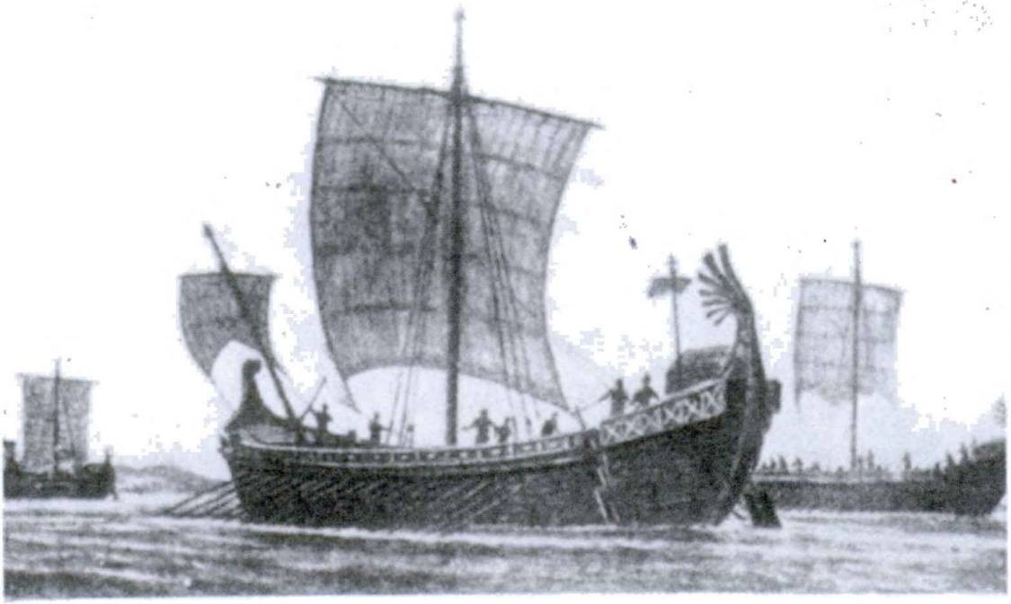152 FIRST YEAR LATIN

are Christians and sons of God. 10. I am a soldier of Christ.
11. The way is narrow and difficult. 12. The mountains of Gaul are high. 13. Caesar’s journeys were often long and difficult.
14. You will be safe on account of the grace of God. 15. Christ is a good and noble leader. 16. The Romans were eager for fame.
17. Are you like Christ? 18. There will be many holy men in heaven. 19. The Gauls are next to the province. 20. The glory of Rome will always be great. 21. We are Christians and God’s servants. 22. Many kings were bad. 23. The remaining soldiers were safe. 24. Were you in the first battle line? 25. I was not with Caesar. 26. Not all Christians are like Christ. 27. There are many and large cities in the province.

EXERCISE 176
Translate:
1. Propter metum hostium in castris Caesaris sumus. 2. Undi- que erat clamor hostium. 3. Erat periculum grave in provincia.
4. Galli semper sunt cupidi imperii. 5. Omnes homines cupidi sunt gloriae. 6. Erantne tela in castris ? 7. Undique erant montes

RomAn SHips

FIRST YEAR LATIN 153
et silvae. 8. In Caelo cum Christo erimus. 9. Erantne montes alti et difficiles ? 10. Caesar erat imperii cupidus. 11. Estne Chris tus filius et Mariae et Dei ? 12. Estne Maria gratia plena ? 13. “Vos autem omnes fratres estis.” (Words of Christ to His disciples.)
14. Eratne Chris tus in mundo propter nos? 15. In silvis non eramus. 16. Caesar in prima acie erat. 17. Ero fortis. 18. Eram in Gallia cum exercitu. 19. Esne eques? Esne miles? 20. Omnes homines sancti Christo similes sunt.
- COMPOUNDS OF SUM
VOCABULARY
absum, abesse, afui, afuturus, intr.; abv (a) w. abl. jam
’ ' [am distant
longe, adv. I .
[fry far
NOTE
Absum is a compound of the preposition ab and the verb sum. Therefore it is conjugated like SUM. The place away from which something is, is expressed by the preposition ab (a before con­ sonants), from, and the ablative. Thus:
Caesar was away from the camp. Caesar a castris aberat.

RELATED ENGLISH WORD
Many members of Congress were absent.

Via longa erat.
RELATED LATIN WORD

EXERCISE 177
Translate:

1. Hiberna ab oppidd Galldrum non longe aberant. 2. Caesar longe aberat a castris. 3. Hiberna non longe absunt a Caesare.

1S4 FIRST YEAR LATIN

- Legiones aberunt. 5. Caesar aberat. 6. Roma longe abest a nobis. 7. Deus a nobis non longe abest. 8. Bellum et mortis periculum longe a Caelb absunt.

EXERCISE 178
Translate:
1. I am away from the camp. 2. He was not far away from the town. 3. They were far away from the river. 4. The river is not far distant from the forest. 5. Gaul is far away from you.

LESSON 15: THE PERFECT SYSTEM ACTIVE

  - THE PERFECT ACTIVE STEM
The perfect system of the indicative active includes the perfect, pluperfect, and future perfect tenses.
These are all formed on the PERFECT ACTIVE STEM.
The perfect active stem is found by dropping the ending -i of the third principal part:

laudav-I monu-i mis-i audiv-I fu-i
stem: laudav- stem: monu- stem: mls- stem: audiv- stem: fu-

  - THE PERFECT INDICATIVE ACTIVE
The PERFECT tense expresses a past act. There are three forms in English:
- I praised.
- I did praise (used in questions, in negative statements, and for emphasis).
- I have praised (action completed in present time; called the PRESENT PERFECT).
For all these, Latin has one form: the PERFECT INDICA­ TIVE ACTIVE.
The perfect indicative active of ALL LATIN VERBS, REGU­ LAR AND IRREGULAR, is formed by:
- Finding the perfect stem from the third principal part;
- Adding the endings shown in the model, GrAmmAr, No. 174.
Note that the final personal signs are the same as in the present system except in the first person and second person singular, laudav-i and laudav-istl.
155

156 FIRST YEAR LATIN

ASSIGNMENT: Learn the conjugation of laudavi, monui, misi, audivi, and fui, GrAmmAr, Nos. 174, 177-179, and 349.

colloco, 1, tr.
VOCABULARY

place station

maned, manere, mans!, mansurus, 2, intr.
compleo, complere, complevl, completes, 2, tr.; w. abl.

cedd, cedere, cessi, cessurus, 3, intr.

atque (ac), conj.
NOTE
remain fill (with)
give way yield
and

When compleo is modified by a wx7A-phrase, this wx7A-phrase is translated by the ablative without a preposition. Hence the notation w. abl.
He filled the camp with grain. Castra frumento complevit.

RELATED ENGLISH WORDS
Mexico ceded California to the United States. The destroyer has its full complement of men.
RELATED LATIN WORDS
Maria est gratia plena. In locum tutum venit.

Z. Give the perfect stem;
EXERCISE 179

- Give the third person singular and plural of the perfect indicative active, and translate each three ways:

1. laudo | 7. porto | 13. habeo | 19. duco
2. occupo | 8. do | 14. video | 20. gero
3. oppugno | 9. voco | 15. teneo | 21. vinco
4. pard | 10. moneo | 16. moved | 22. peto
5. pugno | 11. timed | 17. sustineo | 23. pello
6. supero | 12. terreo | 18. defendo | 24. pond

FIRST YEAR LATIN 157

25. contendo | 28. venid | 31. | sum | 34. | maned
26. audio | 29. convenio | 32. | absum | 35. | compleo
27. munio | 30. ago | 33. | colloco | 36. | cedo

EXERCISE 180
  - Tell what forms these are;
  - Translate:
- viderunt 13. compleverunt 25. mittimus
- cesserunt 14. audivimus 26. collocat
- audivistis 15. oppugnaverunt 27. fui
- mansit 16. fuisti 28. portaverunt
- terruerunt 17. laudavi 29. collocaverunt
- cessit 18. vicit 30. superaverunt
- fuit 19. petiverunt 31. misi
- monuimus 20. paraverunt 32. vocaverunt
- complevit 21. fuimus 33. fuerunt
- muniverunt 22. laudavisti 34. collocabat
- manserunt 23. collocavit 35. sustinuerunt
- miserunt 24. monuerunt 36. defenderunt

EXERCISE 181
[Essential]
A DREAM OF JUDGMENT
This was my dream. I was in the midst of light, a light bril­ liant and intense, so intense that it seemed to penetrate and re­ veal the depths of the soul. And I was aware of a Presence at the very center of the light and I knew with a strange inner conviction that there stood the Angel of Judgment. After a breathless moment, I became aware of other presences, felt rather than saw them. Were they angels? Were they souls? Then the Angei spoke in a voice like the sound of many waters, like no voice ever heard upon earth
THe VoiCe of THe AnGeL. Quis es ?
SeConD VoiCe (harsh and unpleasant). Ego rex sum. Regnum et imperium Rdmanorum in terra tenui.

158 FIRST YEAR LATIN

VoiCe of THe AnGeL. Petisne nunc praemium et gloriam ?
SeConD VoiCe. Ego petd. Ego magnam gloriam in terra habul et semper habebo. Me omnes homines laudaverunt. Imperator magnus fui. Multa bella fortiter gessi. Dux bonus, omnes res paravi; frumentum et arma paravi; castra et oppida munivi; milites instruxi et collocavi. In me milites spem semper posuerunt. Ego saepe in prima acie cum militibus pugnavi. Ego eds per montes et silvas duxi. In Gallia et in omnibus provinciis cum hostibus contend!. Me metus hostium non movit neque terruit. Fines multarum gentium occupavi. Ego et multa oppida et magnas urbes oppugnavi. Provincias Romanas et earum urbes fortiter defend!. Hostes nominis Romani terrui atque impetus eorum fortiter sustinui. Equites et milites in eds mis!—hostes semper cesserunt. Hostes pepuli et in bellis eds superavi et vici.
THe VoiCe of THe AnGeL. Homo se fortiter laudatl
SeConD VoiCe. Propter me gentes provinciis finitimae legiones Romanas timuerunt; eae saepe principes in castra Rdmanorum de pace miserunt. Mecum principes et reges de pace egerunt. Mihi se dederunt. Principes Galldrum in castra vocavi. In castra convenerunt! Frumentum petivi. Magnam copiam in castra por- taverunt. Omnes homines me timuerunt. Omnes gentes nomen regis Romani audiverunt.
VoiCe of THe AnGeL. (There was a deeper earnestness in the voice.) Cur cum multis gentibus bellum gessisti? Cur eas pepu- listT, terruisti, vicisti ?
Vox ReGis. (And his voice seemed to swell as though he were
speaking in the Roman Senate.) Propter gloriam et salutem Senatus Populique1 Romani!
(Suddenly another voice broke in, harsh with malicious hatred.)
THirD VoiCe. Non! Non propter ea! sed quod cupidus fuit gloriae et imperii! Pacem non petivit, sed gladios et bella et caedem petivit. Flumina et silvas et oppida corporibus complevit; milites et nautas caedi dedit quod SIBI gloriam petivit. Praemium ei dabo EGO.
1 Populique = et Populi.

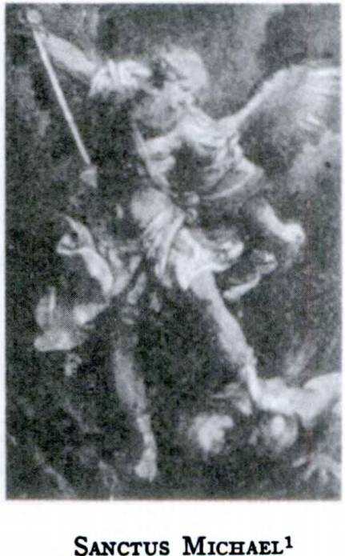FIRST YEAR LATIN 159

Vox ReGis (shaken and fearful).
Quis es tu ?
THirD VoiCe. Aaah! Me non vi- disti, sed non longe a te afui. Omnia vidi. Te autem non monui. (A shrill, diabolical laugh.) Tecum semper in terra fui—nunc mecum manebis in saecula saeculdrum!
(A black shadow passed swiftly across the light ... a shriek, and then again the peace and the bril­ liance. Then I knew that another had entered.)
VoiCe of THe AnGeL. Quis es? THe New VoiCe. Christianus sum.
VoiCe of THe AnGeL. Quid petis? Petisne gloriam cum Christo? CHrisTiAnUs. Deum et Christum petd. (Then silence.)
THe GUArDiAn AnGeL. Is se non defendet neque laudabit. Ego autem semper cum eo fui. Servus imperatoris Romani fuit. Legem autem Christi fortiter tenuit; in nomine Christi oravit. Imperator autem eum, quod Christianus fuit, in vinculis2 tenuit. Metus autem mortis et vulnerum eum non movit neque terruit. Spem In gratia Christi posuit et fidem semper tenuit. Itaque Romani
•Jum occiderunt.
(The light grew slowly more intense and a new voice, stronger and more tender, spoke:)
Intra3 in gaudium4 Domini tui.5
(Voces undique audivi:)
Gloria Patri et Filio et Spiritui Sancto sicut erat in principio et nunc et semper et in saecula saeculdrum. Amen.
The vision faded.
1 Sanctus Michael: St. Michael the Archangel.
2 vinculum, I: chain.
3 intra: enter!
4 gaudium, i: joy.
5 tuus, a, um: your.

160 FIRST YEAR LATIN

EXERCISE 182
[Essential]
Translate:
- Caesar stationed soldiers on the bridge and in front of the camp. 2. Christ did not remain on earth. 3. They filled the walls with men. 4. Caesar prepared a supply of grain. 5. The Romans did not often yield to the enemy. 6. Where have you been?
- The Senate often praised Caesar on account of his victories.
- Caesar did not fear danger and death. 9. There were many Romans in Gaul. 10. Did the Romans overcome the Gauls?
11. Did they treat with the chief about peace? 12. The leading men of the Gauls assembled at dawn. 13. The cavalry did not yield, but withstood the attack bravely. 14. Who conquered the Gauls and seized their cities and towns? 15. The Gauls did not praise Caesar, but they feared him. 16. Have you seen Rome?

- PLUPERFECT AND FUTURE PERFECT INDICATIVE ACTIVE

incito, 1, tr.

VOCABULARY

\ incite
j
[arouse

adjuvo, adjuvare, adjuvi, adjutus, /, tr.

servo, 1, tr.
\help
j
[aid
\guard
j
[keep

perturbo, 1, tr. jf confuse
[ disturb
incendo, incendere, incendi, incensus, 3, tr. < f set fire to
1 burn

turn, adv.

RELATED ENGLISH WORDS
f then
j
[af that time

Incendiary bombs. The general’s adjutant. He was very per turbed.

FIRST YEAR LATIN 161
ASSIGNMENT: Learn the models in GrAmmAr, Nos. 175-
176 and 180-185, for the pluperfect indicative active and the future perfect indicative active. Notice that the PERFECT stem is used and that the endings are the SAME in all conjugations.

EXERCISE 183
[Essential]
/. Translate;
- Explain the case of the italicized nouns:
- Principes gentes provincial finitimas incitaverant quod victoriae cupidi erant. 2. Interim equites reliquds Gallos per- turbaverant. 3. Christian! boni fidem et veritatem Christi serva- verant. 4. Imperator urbes et oppida incenderat. 5. Multi Galli legidnes Romanas adjuverant. 6. Dux hostium colies hominibus compleverat. 7. Equites agmen hostium perturbaverant. 8. Vir- tus Romam servaverat. 9. Caesar et colles et pontes prima luce occupaverat. 10. Senatus provinciam Caesari dederat.

EXERCISE 184
[Essential]
Translate :
1. The king had aroused the slaves. 2. God had helped them.
- They had kept the faith. 4. The cavalry had confused the enemy. 5. The slaves had burned the town. 6. They had called the leading men of Gaul into the Senate. 7. He had stationed the cavalry in the forest. The enemy made an attack on them.

EXERCISE 185
Translate:
1. The Senate praised Caesar. 2. The Gauls had always feared Caesar. 3. The cavalry terrified the enemy. 4. The soldiers had burned the crops. 5. The slaves had helped the enemy. 6. They kept the faith. 7. They did not yield. 8. They have held the city. 9. They moved camp. 10. He seized the bridge. 11. They

162 FIRST YEAR LATIN

had prepared many darts. 12. The slaves had had arms.
- They saw the Roman column. 14. They did not withstand the attack. 15. He defended himself. 16. They sent arms into Gaul. 17. The slaves had carried grain into the camp. 18. The Romans overcame the Gauls. 19. They had prayed for the king. 20. He has called the chiefs.

UNIT FOUR

LESSON 16: ADDITIONAL NOUNS AND ADJEC TIVES OF THE FIRST AND SECOND DECLENSIONS

  - DECLENSION OF PUER, AGER, AND VIR
There are, in the second declension, a few MASCULINE nouns that do not end in -us. These are:
PUER, PUERI, boy, and similar words; AGER, AGRI, field, and similar words; VIR, VIRI, man.
How can you tell that these words belong to the second declen­ sion ? Find the stems of puer, ager, and vir. NOTICE THE DIF­ FERENCE IN THEIR STEMS! Except in the nominative singular, all these words have the SAME ENDINGS AS SER- VUS, I. Now complete these declensions without looking in the GrAmmAr :

puer puer-i
etc.
ager agr-i etc.
vir vir-i
etc.

ASSIGNMENT: Study GrAmmAr, Nos. 41-43,
VOCABULARY

puer, pueri ager, agri vir, viri Italia, ae fortuna, ae
boy field man Italy fortune

ita, adv.

trans, prep. w. acc.
163

across

164 FIRST YEAR LATIN

NOTE
Homo means a human being, a man as opposed to an animal;
vir means a man as opposed to a woman or a child. Christus propter nos homines in mundum venit. Christ came into the world on account of us men.
Men here means the human race; Christ came for both men and women, hence homines.
Caesar erat vir fortis.
Caesar was a brave man.
Vir is used because Caesar is not a woman and has manly, virile qualities.
Hereafter use homo only when a human being or man in general is meant.
RELATED ENGLISH WORDS
A puerile remark. A virile character. The agrarian party. Lind­ bergh made the first solo transatlantic flight.

EXERCISE 186
Translate:
1. With good boys. 2. On behalf of noble men. 3. Into good fields. 4. A field full of boys. 5. In the fields. 6. With a brave man. 7. In a large field. 8. A boy similar to a brave man. 9. On account of the glory of brave men. 10. Through the fields of the Gauls. 11. The death of a brave man. 12. On account of the slaughter of mothers and boys. 13. The good fortune of a brave and noble man.

EXERCISE 187
[Essential]
Translate:
1. Viri Romani fortes erant et fortiter cum hostibus pugna vSrunt. Ita Romam servaverunt. Fortuna enim viros fortes ad- juvat. 2. Multi hostes trans montes in Italiam venerunt. Eds

FIRST YEAR LATIN 165

tamen Romani vicerunt. 3. Puer bonus est gloria matris. Omnes enim patres et matres pueros bonds semper laudant sed pueros malos non laudant. 4. Turn, post adventum exercitus Romani, erat magna frumenti inopia in Gallia. Romani enim frumenta in agris incenderant. 5. In Italia erant agri boni, viri nobiles, pueri boni. 6. Imperator Romanus cum omnibus copiis in agros hos- tium venit. Frumenta incendit; oppida et urbes oppugnavit; viros et pueros in castra duxit.

REVIEW QUESTIONS ON EXERCISE 187
The words to which these questions refer are italicized in Exercise 187.
Sentence 2: Give the rule for the agreement of eos. Sentence 5: Explain the translation of erant.

EXERCISE 188
This exercise reviews all the verbs of the first conjugation and drills on the present indicative.
Translate:
- All men praise good fortune. 2. Hannibal,1 a brave and re* nowned man, has come across the mountains and is seizing a large part of Italy. 3. Good boys often pray. 4. The boys are preparing arms. 5. They have come across the river into the fields and are burning the crops. 6. He is placing troops in the fields of the enemy. 7. Brave men are fighting for us. 8. He is Stationing men in the fields of Italy. 9. Thus do we brave sol­ diers keep the glory of the Roman name. 10. The boys are help­ ing the men in the fields. 11. Who is calling the boy? 12. Is the boy carrying a dispatch into Italy? 13. What are you giving the boy? 14. Did they overcome the Gauls? 15. What does the boy carry? 16. Who is inciting the tribes of Gaul? 17. We do not help bad men. 18. He is stationing the soldiers before the gate of the camp. 19. They are storming the cities of Italy.
1 Hannibal: Hannibal, Hannibalii.

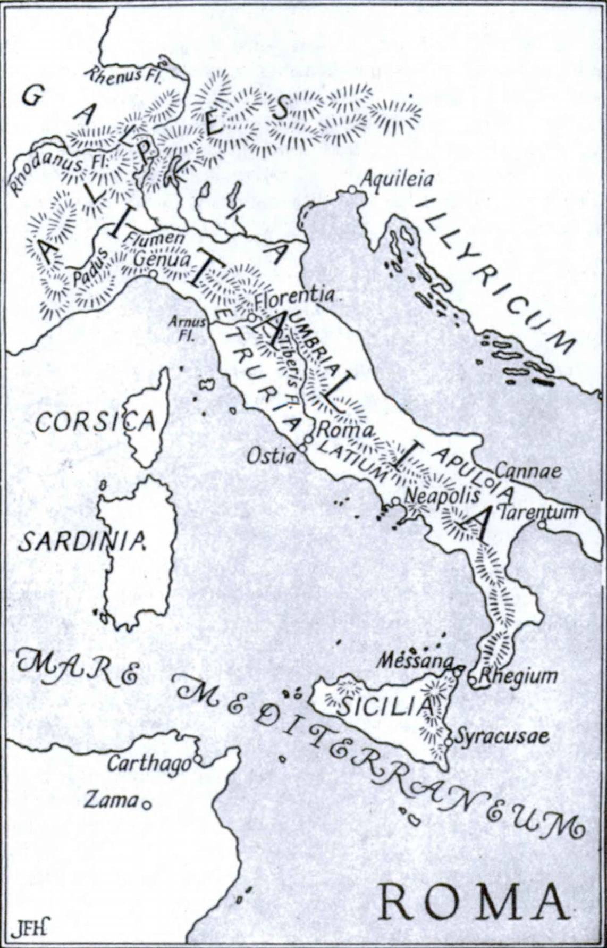

FIRST YEAR LATIN 167

READING NO. 4

DE ITALIA ET DE GALLIA
Italia est terra et magna et bona. Videsne Italiam in tabula ?x Estne Italia magna? Estne longa? In Italia erat Roma, urbs et magna et nobilis. Videsne Romam in tabula?1 Roma in flumine Tiber! est. Videsne flumen in tabula?1 In Italia erant multae et magnae urbes, flumina longa, montes alti. Erant etiam agri fru- mentdrum pleni. In agris Italiae Romani multa bella cum fini- timis gentibus gesserant et tandem2 omnem Italiam vicerant. Ita imperium Italiae Romani tenuerunt. In omnibus Italiae partibus omnes viri et pueri nomen Romanum et laudabant et defendebant.
Alpes3 sunt montes magni et alti. Videsne montes in tabula?1 Trans Alpes turn erant et Provincia Romana et Gallia. Multi imperatores trans montes in Italiam venerunt. Hannibal,4 vir fortis et nobilis, per montes difficiles cum omnibus copiis in Italiam venit et ita in Italiae agris cum Romanis bellum gessit. Turn Caesar legiones Romanas trans montes in agros Galldrum duxit. Napoleon etiam, imperator fortis, cum magnis copiis trans montes in Italiam contendit et omnem Italiam occupavit.
Roma, sicut in tabula1 vides, longe abest a Gallia. In Gallia erant etiam urbes et oppida et agri boni. Erant flumina et montes. Eos in tabula1 vides. Vides etiam fines Provinciae Romanae. Ejus imperium Caesar tenuit et cum Gallis bella gessit. Post vic­ torias Caesaris Romani imperium omnis Galliae tenuerunt.

MATER ITALIAE—ROMA
—Florus5

1 tabula, ae: map.
2 tandem, adv.: finally.
8 Alpes, Alpium: the Alps.
4 Hannibal, Hannibalis: Hannibal (a great Carthaginian general).
6 L. Annaeus Florus, a Roman historian.

168 FIRST YEAR LATIN
  - DECLENSION OF MISER AND INTEGER
There are, in the first and second declensions, a few adjectives whose masculine is like puer or ager.
LIKE PUER: miser, miser-a, miser-um, wretched
STEM: miser-
LIKE AGER: integer, integr-a, integr-um, fresh, uninjured
STEM: integr-
ENDINGS: The endings for miser and integer are exactly like those of magnus except in the nominative masculine singu­ lar, miser, integer.
ASSIGNMENT: Decline miser and integer without looking in the GrAmmAr. Then study GrAmmAr, Nos. 74-76.

VOCABULARY
miser, misera, miserum liber, libera, liberum

integer, integra, integrum

wretched free fresh
uninjured
whole

proelium, i battle
civitas, civitatis state
NOTE
The ablative of proelium is generally used without in in such expressions as: in many battles, multis proeliis.

RELATED ENGLISH WORDS
Lincoln liberated the slaves. A miserable fellow. The number one is an integer.
EXERCISE 189
Decline:
- servus miser 3. res misera
- legio integra 4. oppidum liberum

FIRST YEAR LATIN 169

EXERCISE 190
Translate:
1. With fresh forces. 2. For free men. 3. Against the wretched Gauls. 4. With fresh legions. 5. In a free state. 6. With the wretched slaves. 7. After the victory of free men. 8. On ac­ count of a wretched fortune. 9. On account of the glory of a free state.

DOMINUS ERIT TECUM IN OMNI TEMPORE1 ET LOCO.
—From the Following of Christ2

EXERCISE 191
[Essential]
Translate:
1. Viri nobiles et liberi civitatem Americanam3 servaverunt.
- Romani, wf fortes et liberi, Gallos miseros multis proeliis vicerunt. Romanos enim etiam fortuna adjuvit. 3. Duces legiones integras in prima acie collocant. 4. Romani oppida Galldrum oppugnaverunt; agros edrum occupaverunt; frumenta incende- runt; principes, duces, matres, patres, viros, pueros, occiderunt. Ita eos vicerunt. 5. Hannibal,4 vir fortis et nobilis, cum omnibus copiis trans montes in agros Italiae contendit. Cum eo Romani fortiter contenderunt. Urbes et oppida Italiae defenderunt. Post multa proelia et magnam caedem Romani eum superaverunt. Ita gloriam nominis Romani servaverunt.
1 tempus, tempons, n.: time.
2 The Following of Christ is a book of religious meditations and instructions composed by the educator Gerard Groote after his conversion and entry into religious life (about A. D. 1386), and either written down or at least edited by his disciple Thomas a Kempis (1379-1471). Next to the New Testament, the volume is the most famous and influential Christian religious work ever written.
- Americanus, a, um: American.
* Hannibal, Hannibalis: Hannibal.

170 FIRST YEAR LATIN

REVIEW QUESTIONS ON EXERCISE 191
The words to which these questions refer are italicized in Exercise 191
Sentence 2: Explain the use of viri.
Sentence 4: Give the rule for the agreement of edrum and eos. Explain.

monTAnI1 semper LlBERl (Motto of West Virginia)

EXERCISE 192
This exercise reviews all third-conjugation verbs and drills on the imperfect.
Translate:
1. He was leading fresh troops into the battle. 2. The chief was defending the wretched Gauls. 3. The Romans were con­ quering free states. 4. The Romans conquered the Gauls in many battles. 5. After the battle they were burning the crops and the towns. 6. The soldiers, brave and free men, were repulsing the enemy. 7. He was treating with the master concerning his wretched slave. 8. They were pitching camp after the battle.
9. The fresh legions were not yielding. 10. He was hastening into Gaul with fresh forces. 11. The slaves were not carrying arms.
12. The wretched Gauls were seeking peace. 13. Was he sending a dispatch into Italy? 14. After the battle he was drawing up the uninjured troops. 15. We Americans2 were defending a free state. 16. They were sending boys and men into the fields.
17. We Americans shall always be free.

1 montani, montanorum: mountaineer:.
2 From now on proper nouns and adjectives will ordinarily not be given in footnotes. If necessary, they may be found in the vocabularies in the back of the book.

FIRST YEAR LATIN 171

EXERCISE 193
Answer in complete Latin sentences:
- Suntne servi liberi?
- Estne civitas Americana libera?
- Erantne servi Romani miser! ?
- Esne vir liber?
- Esne puer miser ?
- Eratne Washingtonius vir fortis et nobilis ?

READING NO. 5

ROMA AETERNA
Rome first appeared in our history as a small country village on the Tiber. In the course of centuries of expansion, however, she built up a vast and well-organized empire. The city on the seven hills grew into a city of splendor and became the capital of the western world.
What was the secret of Rome’s success? The Romans certainly were practical men, gifted in organization. They were builders whose roads survived for centuries, whose monuments of masonry still stand today. All of these things and many others contributed to their success. But behind all there was the driving power of the Roman spirit. Throughout their history the Romans dis­ played a tenacity of purpose, a stubborn determination, that no odds and no disasters could overcome. There were many dark days in the history of Rome, but the Roman people never despaired. The great achievements of Rome’s heroes became part of the Roman tradition and the Roman spirit. No wonder then that the Romans became convinced that fortune had chosen Rome for an eternal destiny of power. This conviction they crystallized in the phrase Roma aetema, eternal Rome.
Translate:
Romani spem salutis et victoriae semper in virtute ponebant. In bellis omnia parabant; oppida et castra muniebant; milites et equites habebant; frumenti copiam parabant. Saepe duces et imperatores magni et nobiles erant. Sed non propter ea omnia

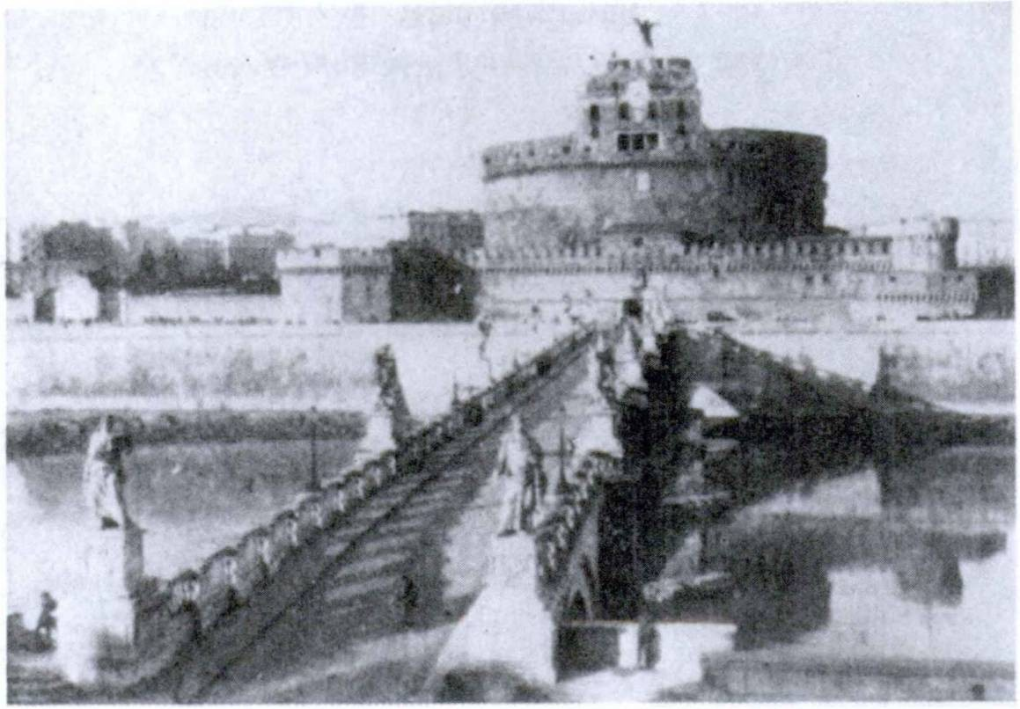172 FIRST YEAR LATIN

RomA AeTernA
Romani vicerunt. Multae enim gentes ea omnia habebant sed hostes non vicerunt. Romani tamen hostes multos et magnos vicerunt. Hostes saepe castra oppugnaverant, legidnes vicerant, agros et urbes occupaverant. Senatus Populusque1 Romanus tamen pacem non petivit. Principes in senatu de pace non egerunt. Vic- toriae et imperii et gloriae cupidi erant. Itaque Romani hostes semper vicerunt. Victoria erat Romanorum propter virtutem Ro- manam. Itaque gloria nominis Romani magna fuit et Romam aeternam2 et Romani et gentes alienae laudaverunt.

ROMA

Mater regumque3 ducumque

1 Populusque = et Populus.
2 aeternus, a, um: eternal.
3 regumque ducumque = et regum et ducum.

FIRST YEAR LATIN 173

POSSESSIVE ADJECTIVES OF THE FIRST AND SECOND PERSONS
The possessive adjectives of the FIRST PERSON are:
meus, a, um my
mine
noster, nostra, nostrum our ours
The possessive adjectives of the SECOND PERSON are:

tuus, a, um

vester, vestra, vestrum
your (when referring to
yours ONE person)
your (when referring to MORE
yours THAN ONE person)

- DECLENSION:
Meus, a, um and tuus, a, um are declined like magnus, a, um. Noster, nostra, nostrum and vester, vestra, vestrum are de­
clined like integer, integra, integrum.

EXERCISE 194
Decline: (a) tuus, (b) meus, (c) vester, (d) noster.

- AGREEMENT:
As adjectives the possessive adjectives AGREE WITH THE NOUN THEY MODIFY.
milites mei, my soldiers
propter virtutes tuas, on account of your virtues
rex noster, our king
in oppidd vestro, in your town

EXERCISE 195
Decline in singular and plural:
  - amicus meus 3. virtus tua
  - rex noster 4. oppidum vestrum

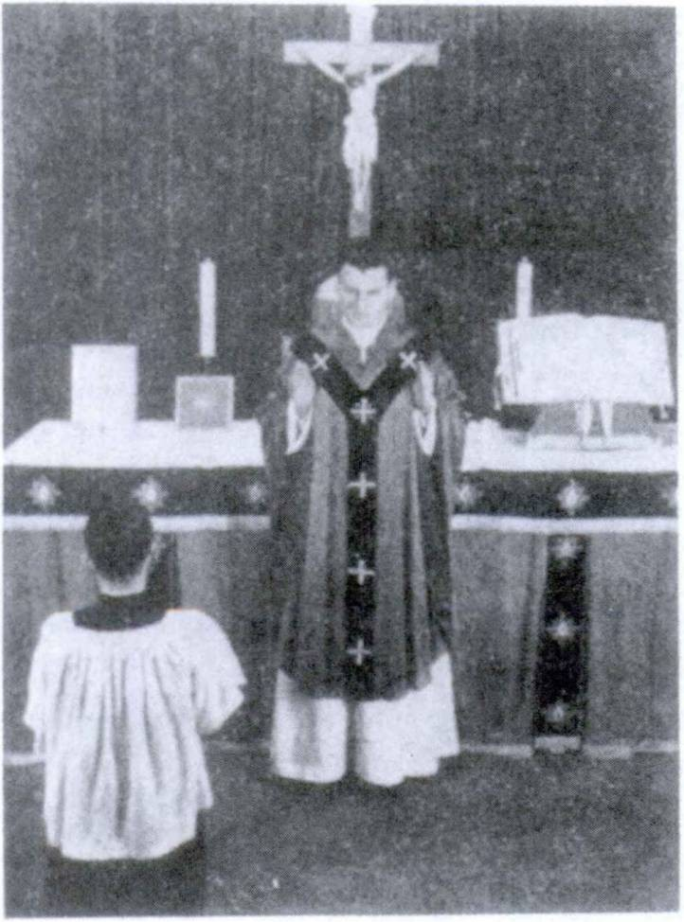174 FIRST YEAR LATIN

MOMENTS AT MASS NO. 1

Frequently during Mass the priest turns to the people and says:

DOMINUS VOBISCUM!
and the server, in the name of the people, answers:

ET CUM SPlRITU TUO!

FIRST YEAR LATIN 175

  - EXAMPLES OF USAGE:
Vos propter virtutes vestras laudo. I praise you for your virtues.
(I am speaking to MORE THAN ONE person; hence vos is used and so vestr- must also be used. Vestras is feminine accusative plural because it AGREES with virtutes.)
Matrem tuam laudo. I praise your mother.
(I am speaking to ONE person; hence tu- must be used. Tuam is feminine accusative singular because it AGREES WITH ma­ trem.)
Milites meds laudant. They praise my soldiers.
(ONE person is speaking; hence me- must be used. Meds is masculine accusative plural because it AGREES WITH milites.)

EXERCISE 196
Translate:
1. On account of your fortune. 2. In our fields. 3. With our brave men. 4. After my death. 5. In your state. 6. On account of the glory of our fathers.

EXERCISE 197
[Essential]
Translate:
1. Patres nostr I, viri et liber i et fortes, multis proeliis cum hostibus contenderunt. Ita civitatem nostram et defenderunt et servaverunt. Itaque nunc civitatem et nobilem et liberam habe- mus. 2. Vobiscum de salute militum vestrorum agemus. 3. Te propter caedem servorum miserorum non laudd neque virtiitem tuam laudo. 4. In primam aciem legiones meas integras mittam.
5. Oppida vestra et urbes vestras oppugnabimus. Frumenta in- cendemus. Pueros vestros et matres vestras terrebimus. Ita milites vestros vincemus. 6. Bellum difficile et periculdrum plenum est. Hostes trans montes veniunt. In agros vestros veniunt. Cum eis fortiter pugnabitis neque de pace cum eis agetis. Fortuna etiam vos adjuvabit.

176 FIRST YEAR LATIN

“MATER DEI EST MATER MEA!”
—St. Stanislaus Kostka1

EXERCISE 198
[Essential]
This exercise reviews all second-conjugation verbs.
Translate:
1. Our brave soldiers do not fear your attacks. 2.1 shall warn your commander in chief. 3. Our state shall always be free.
  - Our cavalry will terrify your soldiers. 5. We shall see your fields and your cities. 6. Our soldiers, brave and free men, were holding the hill. 7. We shall move our camp at dawn. 8. They will not withstand our cavalry. 9. I shall remain in my city.
10. You were filling the wall with your men. 11. Your slave is warning me. 12. Do you hear our cavalry? 13. Are you hold­ ing your camp? 14. Will our men withstand their attack? 15.1 do not fear your soldiers, for our brave men will withstand them.

READING NO. 6

THE SECOND PUNIC WAR
In the third century before Christ, Carthage, a city on the northern coast of Africa, was the center of a powerful empire. It was the one rival of the growing power of Rome in the western Mediterranean, and it was therefore inevitable that these two nations should meet in a final struggle for power. This struggle came in the Second Punic War (218-202), a war in which Roman courage and Roman endurance were tested to the utmost. Later generations of Romans were to look back to the hard years of this war as Americans look back to Valley Forge or Englishmen to the German Blitz of World War II.

1 Stanislaus Kostka was the son of a prominent Polish nobleman. Bom in 1550, he entered the Society of Jesus after having a vision of the Blessed Virgin with her Infant Son. He died while yet a novice in 1568.

FIRST YEAR LATIN 177
The war began when a Carthaginian army under Hannibal—one of the greatest generals of all history—attacked a Roman ally in Spain. At the very outset Hannibal conceived the daring and un­ expected plan of crossing the Pyrenees and the Alps and invading Italy from the north.
Translate:
Hannibal, vir fortis et nobilis, turn erat Carthaginiensium1 im- perator. Hostis populi Romani semper fuerat. Victoriae et im­ perii cupidus fuit. Itaque cum Romanis bellum fortiter gerebat.
Is cum magno exercitu in Hispania erat. Magnum numerum militum et equitum et elephantorum2 secum habebat. Cum omni­ bus copiis per Galliam contendit (nondum enim erat provincia Romana in Gallia). Per silvas magnas milites duxit. Trans flu- mina alta exercitum duxit. Alpes alti et magni montes erant. Via per eos difficilis et angusta fuit. Multae Gallorum gentes cum eo bellum gerebant. Is tamen Gallos multis proeliis pepulit et cum militibus et impedimentis et elephantis2 per montes in Italiam venit.
This was a terrible surprise to the Romans, who, meanwhile, had been planning an expedition to Africa. No one had expected Hannibal to transport such an army with its elephants and all
its equipment across the mountain barrier that guarded the north. As Hannibal stood on the southern slopes of the Alps and saw
Italy before him at last, he spoke to his exhausted and dis­ couraged men in some such fashion as this:
“Italia est! In Italia sunt agri boni et copia omnium rerum. Sunt etiam oppida et multae et magnae urbes. Eas Romani nunc tenent, sed nos Romanos superabimus. Urbes et agros tenebimus, etiam Romam occupabimus. Romani fortes sunt, sed nos etiam sumus fortes. Nos non superabunt. Itaque omnem victoriae spem in virttite ponemus! Fortuna etiam nos adjuvabit; fortuna enim fortes semper adjuvat. Post victoriam magna vbbis praemia dabd et magnam habebimus belli gloriam! ”

1 Carthaginienses, Carthaginiensium: Carthaginians.
2 elephantus, i: elephant.

178 FIRST YEAR LATIN

QUESTIONS ON READING NO. 6
Answer in Latin:
- Quis fuit Hannibal?
- Eratne vir fortis?
- Ubi fuit?
- Quid secum habuit?
- Venitne in Italiam?

UNIT FIVE
LESSON 17: PRESENT SYSTEM PASSIVE OF THE FIRST CONJUGATION; AGENCY

ACTIVE AND PASSIVE VOICE

The boy throws the ball.
The boy is throwing the ball. The boy does throw the ball. Is the boy throwing the ball ? Does the boy throw the ball ?
All these sentences say or ask WHO IS DOING THE AC­ TION, i. e.f who is throwing. Hence, the verbs in all these sen­ tences are in the ACTIVE VOICE because the SUBJECT—the
boy—ACTS.

WHEN IS A VERB IN THE ACTIVE VOICE?
WHEN THE SUBJECT IS THE PERSON OR THING THAT DOES THE ACTION.

All the verbs you have studied so far have been in the ACTIVE VOICE.
Is the ball being thrown ? The ball is being thrown.
These sentences say or ask to what the action is being done. The verbs in these sentences are in the PASSIVE VOICE because the SUBJECT—the ball—RECEIVES THE ACTION.

179

180 FIRST YEAR LATIN

WHEN IS A VERB IN THE PASSIVE VOICE?
WHEN THE SUBJECT IS THE PERSON OR THING TO WHICH THE ACTION IS DONE.

EXERCISE 199
Point out the voice of the verbs in these sentences:
1. America is being praised by many nations. 2. Christ was crucified by Roman soldiers. 3. The martyrs kept the faith.
4. The faith was kept by the martyrs. 5.1 am praying. 6. When St. Augustine was dying, his own city was being attacked by the Vandals. 7. Will America be kept free? 8. Rome had been cap­ tured by the Gauls early in its history. 9. Is God being served by all men? 10. We have often been told of the exploits of our heroic pilots. 11. We have often heard of the heroism of our sol­ diers.

FINAL PERSONAL SIGNS IN THE PASSIVE
When we studied the present system ACTIVE we found the following final personal signs:

    - I
f -6
l-m

we -mus

    - you -s you -tis
    - he, she, it -t they -nt
Now, the present, imperfect, and future indicative active (of all conjugations) become PASSIVE by changing these final per­ sonal signs as follows:

-6 | to -or | -mus | to -mur
-m | to -r
-s | to -ris | -tis | to -mini
-t | to -tur | -nt | to -ntur

FIRST YEAR LATIN 181

EXAMPLES:
laudo, I am praising laudabam, I was praising laudas^you are praising laudat^ he is praising laudamus, we are praising laudatis, you are praising laudant; they are praising
becomes laudor, I am being praised becomes laudabar, I was being praised becomes laudaris, you are being praised becomes laudatur, he is being praised becomes laudamur, we are being praised becomes laudaminl, you are being praised becomes laudantur, they are being praised

EXERCISE 200
/. Translate the active form here given;
- Change the active form to the corresponding passive form :

ExAmpLe: Active Form | Meaning |  | Passive Form
laudd | I am praising |  | laudor
1. voco | 13. laudabit | 25. | collocabunt
2. terreo | 14. laudamus | 26. | muniunt
3. audiebam | 15. vincemus | 27. | laudatis
4. terrebam | 16. audiebamus | 28. | audiunt
5. laudabo | 17. monemus | 29. | mittimus
6. monebo | 18. laudabimus | 30. | laudamus
7. das | 19. laudatis | 31. | auditis
8. mones | 20. ponitis | 32. | laudant
9. agit | 21. perturbatis | 33. | laudas
10. sustinet | 22. adjuvabatis | 34. | moned
- mittit  - vincit | - monebunt  - ducebant | 35. | mitto

PRESENT SYSTEM PASSIVE OF THE FIRST CONJUGATION
ASSIGNMENT: Study the present, imperfect, and future indicative passive of the first conjugation, GrAmmAr, Nos. 243-
245. Notice that one form does not follow the rules given for final

182 FIRST YEAR LATIN

personal signs in Section 2. The exception is future tense, second person singular: laudabis becomes laudaberis.

VOCABULARY

administro, 1, tr.

appello, 1, tr.

confirmo, 1, tr.
manage attend to
address call (upon)
encourage strengthen

RELATED ENGLISH WORDS
The sacrament of confirmation. The president of the United States should be a good administrator.

REVIEW VOCABULARY
do, dare, dedi, datus, 1₉ tr. give
adjuvo, adjuvare, adjuvi, adjutus, 1, tr.
[aid
colloco, 1, tr. (place
[station
attack assault storm
{
EXERCISE 201
Give the third person, singular and plural, of the present, im­ perfect, and future indicative passive of the words in the vocabu­ lary. Translate each form given.

- administratur
- appellatur
- oppugnantur
- confirmatur
EXERCISE 202
Translate:
- collocatur
- laudaberis
- confirmabantur
- administrabantur

- adjuvantur
- appellabamur
- laudamur
- datur

FIRST YEAR LATIN 183

EXERCISE 203
  - Change to the passive;
  - Translate both passive and active forms:

- confirmo
- appellabam
- confirmabant
- dabat
- administras
- confirmat
- administrabat
- adjuvabit
- appellamus
- adjuvatis
- confirmabunt
- collocant
- confirmant
- dat
- collocabas

EXERCISE 20
Translate:
1. Maria appellabatur. 2. Provincia administrabitur. 3. Amici confirmantur. 4. Gallia administratur. 5. Romani confirma- bantur. 6. Mundus administratur. 7. Bella administrantur.
8. Deus Rex hominum appellatur. 9. Imperator appellabitur.
10. Pax confirmabitur. 11. Principes appellantur. 12. Virtus legidnum confirmabatur. 13. Spiritus Sanctus appellatur. 14. Res administrabatur. 15. Spes victoriae confirmatur. 16. Centuriones appellabuntur. 17. Viri fortes confirmabuntur. 18. Roma non oppugnabitur. 19. Terra et caelum laudantur. 20. Litterae ducis hosti dantur. 21. Nautae non adjuvabantur. 22. Hiberna op- pugnabantur. 23. Signum legionibus datur. 24. Gloria Deo dabi- tur. 25. Magnus servorum numerus ei dabatur. 26. Salus et Veri­ tas nobis per Christum dantur. 27. Praemia militibus dabuntur.
28. Victoria nautarum laudabitur. 29. Multi homines in colle col- locabuntur. 30. Gentes finitimae adjuvantur. 31. Pars militum in finibus hostium collocatur. 32. Pueri mali non laudantur.
33. Arma Caesari dabantur. 34. Oppidum oppugnabitur. 35. Po­ pulus Romanus adjuvabatur. 36. MilitSs in muro collocantur.
37. Fortuna bona laudabatur. 38. Propter gratiam Caesaris fru- mentum Romanis datur. 39. Nomen Dei semper laudabitur.
- Propter metum vulnerum et mortis, milites Deum appellant.
- Milites in ponte collocantur. 42. Jesus Christus, Dominus noster, laudabitur.

184 FIRST YEAR LATIN

EXERCISE 205
[Essential]
Translate:
- Pax saepe propter metum vulnerum et mortis laudatur.
- Erant viri fortes et liberi in exercitu Caesaris. Ei laudabantur; fortiter enim urbes et oppida oppugnaverunt. 3. Confirmabi- turne pax post proelia et bella et caedes? 4. In periculo Deus semper appellatur. 5. Omnes res fortiter administrabantur quod Caesar, vir fortis et nobilis, imperator erat Romanorum. 6. Aut1 Lincoln aut1 Washingtonius princeps fuit omnium ducum Ameri- canorum. Itaque ei laudantur et semper laudabuntur. 7. Cur pueri mail non laudantur? 8. Gloria Deo per Jesum Christum datur. 9. Milites et in silvis et in agris collocabantur; in eos hostes impetum fecerunt. 10. Rex malus non adjuvabitur.
11. Milites propter virtutem laudantur. Centuriones etiam prop­
ter virtutem et fidem laudantur. Duces et imperatdres res fortiter administrant. Itaque ei etiam laudantur. 12. Christian! boni et in pace et in bello legem Christi servant. Itaque eis magnum praemium in Caelo dabitur. 13. Vos estis American!. Et liberi et fortes estis. Itaque semper laudamini. 14. Duces non lauda­ bantur. Longe enim aberant a proeliis et castris.

EXERCISE 206
Translate:
1. The centurions are being addressed. 2. God will be called upon. 3. The affair is being managed. 4. Peace was being strengthened. 5. Soldiers are being stationed in the fields. 6. The cities are being stormed. 7. The soldier is being helped. 8. Grain will be given the soldiers. 9. Our friends will be encouraged.
10. Our soldiers were being helped. 11. The army is being strength­ ened. 12. Our faith will be strengthened. 13. The war is being managed. 14. You will be praised. 15. We are being encouraged.
- They were being helped.

1aut . . . tut: either ... or.

FIRST YEAR LATIN 185

THE ABLATIVE OF AGENT
When the verb is PASSIVE, the SUBJECT is the person or thing TO WHICH THE ACTION IS DONE. The PER- SON WHO DOES THE ACTION—the LIVING AGENT—is
expressed in Latin as in English by a PREPOSITIONAL PHRASE:
Deus ab hominibus laudatur.
God is being praised by men.
Bellum a duce administratur.
The war is being managed by the leader.
The preposition used is ab, by, which is generally written a before a word beginning with any consonant except h.
Ab (a) ALWAYS takes the ABLATIVE case. ab omnibus hominibus, by all men a duce, by the leader
ab hominibus, by men

ASSIGNMENT: Learn the rule, GrAmmAr, No. 764.
NOTE
Remember that you have already learned a different meaning and use for ab (a). When ab (a) is used in a prepositional phrase modifying ABSUM, it must be translated FROM. Thus:
Mons_a flumine longe abest.
The mountain is far away from the river.

VOCABULARY
conservo, 1, tr. f preserve
{spare
for (when for means because and introduces a REASON)

ab (a), prep. w. abl.
by (expressing agency)
from (w. absum)

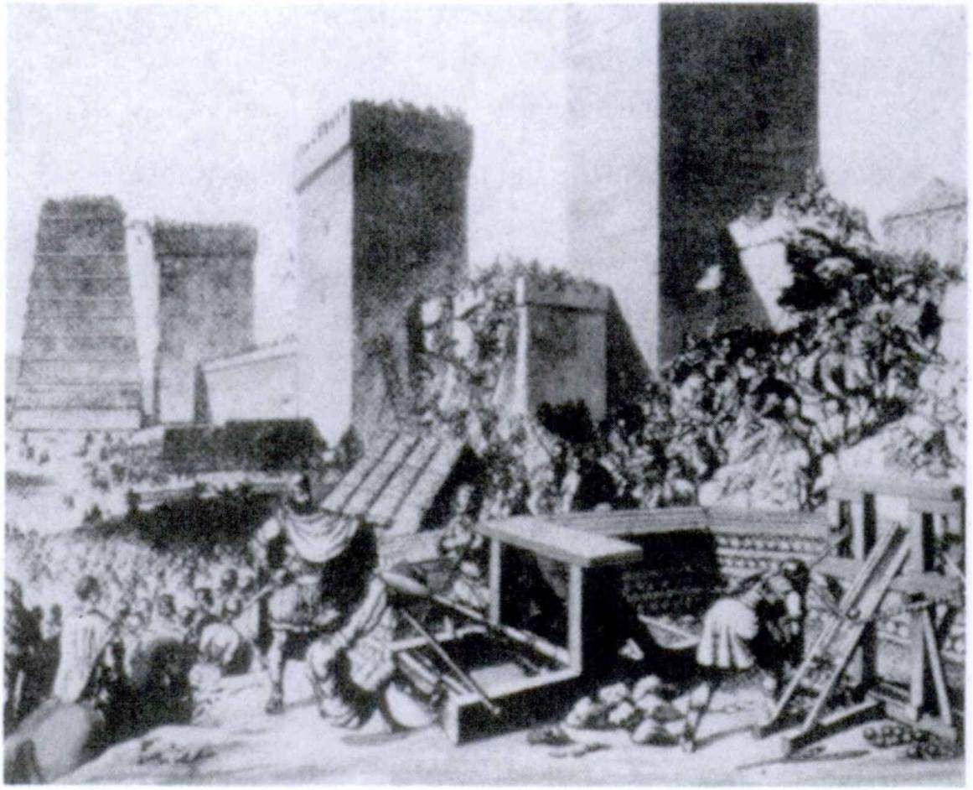186 FIRST YEAR LATIN

REVIEW VOCABULARY
voco, 1, tr. call
occupo, 1, tr. seize

EXERCISE 207
Complete these phrases with a whenever possible; otherwise use ab:
- By the king. rege.
- By the enemy. hostibus.
- By the cavalry. equitibus.

- By Mary. Maria.
- By all slaves. omnibus servis.
- By the leader of the enemy. hostium duce.

Oppidum a multibus oppugnatum est.

FIRST YEAR LATIN 187

EXERCISE 208
[Essential]
/. Translate;
2. Underline the ablatives of the agent: Warning. One sentence contains a “booby-trap.”
1. Pax a militibus saepe non conservatur, nam gloriae belli cupidi sunt. 2. Imperium a Caesare, viro forti et bond, admin- istrabitur. 3. Copia frumenti a servis non conservabatur. 4. Post proelium nos ab imperatdre cdnfirmabamur. 5. Laudanturne sancti homines a viris bonis? 6. Roma ab America longe abest.
- Silvae ab equitibus occupabuntur. 8. Laudatume Senatus Romanus a multis viris? .9. Omnes res a duce bond administra- bantur. 10. Centuriones ab imperatdre appellabantur. 11. Im- perator a senatu vocabitur.

EXERCISE 209
Translate:
1. Our free state will be preserved by free and brave men. 2. All the soldiers will be called into the battle by the commander in chief; for the number of the enemy is large, and they are eager for victory. 3. The faith was being kept by many renowned Christians. 4. Many foreign fields were being seized by the Roman soldiers. 5. The leaders of the Gauls were often called by Caesar. 6. The slaves were being called by the master. 7. The American state is being praised by all free men.

EXERCISE 210
Translate:
QUesTion. Administraturne mundus a Deo?
Answer. Mundus a Deo et conservatur et administrate. Nam Deus in prlncipio caelum et terram et omnes res propter nos homines fecit1 et est hominum Pater. Nos homines a Deo con-

1 fecit: he made.

188 FIRST YEAR LATIN

servamur, et nobis omnes res a Deo dantur. Veritas et salus nobis a Deo dantur; frumentum et omnium rerum copia nobis1 a Deo et parantur et conservantur. Itaque in mortis periculd a nautis Deus appellatur; in belli periculis a militibus appellatur; a matribus et patribus, a viris et pueris, a Christianis et ab omnibus hominibus semper et in omnibus locis appellatur. Nam Deus bonus est, et homines ab Ed semper adjuvantur et con- firmantur. Itaque Deus semper ab hominibus bonis et sanctis laudatur, nam Pater omnium hominum est.

EXERCISE 211
Translate:
Turn imperium populi Romani a Caesare occupabatur. Vir fortis erat, nam ab eo et hostes superabantur et amici confirma- bantur. Post ejus mortem pax ab imperatoribus Romanis per arma et legiones confirmabatur. Non omnes autem homines liber! erant, nam multi homines erant servi miseri. Pax Romana ab imperatoribus confirmabatur, sed libertas2 omnium hominum a Romanis non conservabatur.

EXERCISE 212
Translate:
Civitas Americana a militibus fortibus conservatur et semper conservabitur. Milites American! ab hostibus etiam fortibus non superabuntur. Viri American! propter virtutem et fidem a nobis et ab omnibus hominibus semper laudabuntur.

READING NO. 7

HANNIBAL IN ITALY!
Hannibal trans magnos et altos montes exercitum duxerat. Hostis populi Romani in Italia erat. Itaque Romani in magno

1 Translate for us.
2 libertas, libertatis: liberty {ci. liber).

FIRST YEAR LATIN 189

periculo erant. Exercitus Rd- manus in Hispania1 erat. Sci­ pio2 cum legionibus Romanis
in Gallia fuerat. Is autem ex- ercitum in Hispaniam1 misit et in Italiam contendit.
Galli partes Italiae Alpibus finitimas tenebant. Ei hostes erant populi Romani et saepe cum Romanis bellum gesse- rant. Itaque in edrum fines Hannibal exercitum duxit et
ab eis adjuvabatur. Ibi Sci­ pio,2 dux Romandrum, cum
Hannibale pugnavit sed Han­ nibal eum vicit. Romani ta- men pacem non petiverunt.

HAnniBAL in ITALiA esT!

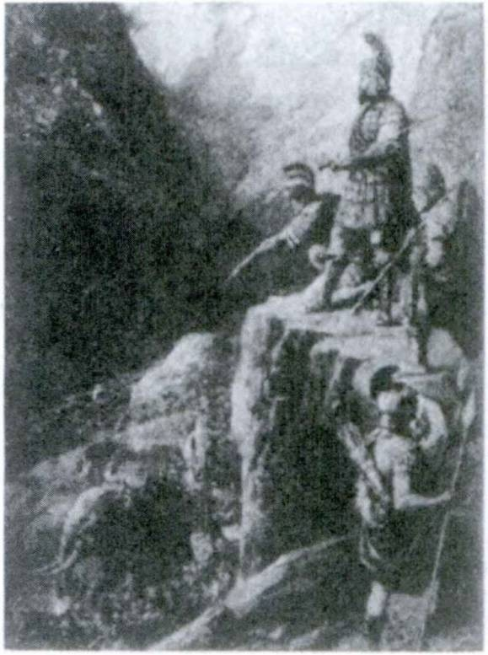Many of the Gauls who dwelt in northern Italy were now in insurrection around the Roman army. A second army sent out from Rome effected a juncture with Scipio, but the position of the legions remained critical. Scipio had been wounded in the first battle with Hannibal, and a lesser man, Tiberius Sempronius, was now in command. For political reasons Sempronius was eager to fight a pitched battle with the Carthaginian army. Hannibal understood the character of this man. On a cold and bleak De­ cember day a screen of Carthaginian horse, retreating by order, drew the Roman cavalry across the swollen river Trebia. Sempro­ nius thought his chance had come. He hurriedly sent his army through the icy waters of the Trebia.
Suddenly in the mist the Romans found themselves confronted by the main force of the enemy.
Itaque equites et Romandrum et hostium fortiter pugnabant.

1 Hispania, ae: Spain.
2 Scipio, Scipionis: Scipio (a Roman family name).

190 FIRST YEAR LATIN

Interim imperator Romanus copias in proelium mlsit. Elephant!1 et equites hostium equites Romanos terruerunt et superaverunt. Turn in milites hostium legidnes Romanae impetum fdcerunt. Milites Romani fortes erant et fortiter pugnabant. Tamen ab hoste superabantur. Turn pars militum hostium a tergo2 * * impetum in Romanos fecit? (These had been placed in ambush by Han­ nibal with orders to attack the Roman rear.) Itaque hostes undi- que impetum in Romanos fecerunt. Tamen pars Romanorum per hostes venit (this group was 10,000 in number) et tuta in oppidum Romanum venit. Galli et Carthaginienses* reliquos Romanos omnes occiderunt. Non multi Romani tuti in castra venerunt. Victoria Hannibalis fuit. Fortuna hostes, non Romanos, adjuverat.
Answer in complete Latin sentences of at least three words:
- Veneratne Hannibal trans Alpes?
- Ubi erant exercitus Romani ?
- Quis erat imperator Romandrum?
- Superaveruntne equites Romani hostes?
- Viceruntne Romani ?

EXERCISE 213
[Honor Work]

AN IMAGINARY SPEECH
Imagine that Rome is at war (and it generally was!). The political opponents of the government are criticizing the war policy of the administration and its generals. A spokesman for the government rises in the Roman senate and speaks:
Translate into Latin:
“The war is being managed by a brave leader. Before5 the war all things were being prepared by him; grain and arms were being

1 elephantus, i: elephant.
1 a tergo: from the rear.
- fecit: made.
- Carthaginienses, Carthaginiensium: the Carthaginians.
6 before: ante, prep. w. acc.

FIRST YEAR LATIN 191
carried into the towns of the province by the slaves; hills and bridges were being seized by the legions; the courage of the soldiers was being strengthened by the centurions. Now, in the dangers of war, the general of the Roman legions is praised by both Roman soldiers and the enemy. For he has frightened the enemy, and their fear is the glory of a Roman general. Why is he not praised by the Roman Senate? Why is he not helped by you all? GOOD men are now praising him and good men will always praise him.”
Reply to this speech:
Imagine that you are a leader of one of the parties opposed to the government. Write a short speech in Latin answering the arguments given above. USE WORDS AND CONSTRUC­ TIONS YOU KNOW. DON’T USE ANY CONSTRUCTION ABOUT WHICH YOU ARE DOUBTFUL.

LESSON 18: PRESENT SYSTEM PASSIVE OF THE SECOND CONJUGATION; ABLATIVE
OF MEANS

PRESENT SYSTEM PASSIVE OF THE SECOND CONJUGATION
ASSIGNMENT: Study the present, imperfect, and future indicative passive of the second conjugation, GrAmmAr, Nos. 246, 249, and 252. Notice that there is ONE change which does not follow the rules for final personal signs given in Section 2 of Lesson 17. Monebis becomes moneberis.

VOCABULARY

contineo, continere, continui, contentus, 2, tr.

obtineo, obtinere, obtinui, obtentus, 2, tr.

aut, conj.
aut . . . aut, conjs. Deque . . . neque, conjs. postea, adv.

restrain hold in
hold occupy
or
either ... or neither . . . nor afterwards

A container.
RELATED ENGLISH WORD

Post; ea.
RELATED LATIN WORDS

terreo, 2, tr.
REVIEW VOCABULARY

terrify

teneo, tenere, tenuT, tentus, 2, tr.
video, videre, vidi, visus, 2, tr.
hold see

192

FIRST YEAR LATIN 193

EXERCISE 214
- Write out the full principal parts of terreo.
- Give the third person, singular and plural, of the present, imperfect, and future indicative passive of all the words in the vocabulary. Translate each form given.

- continentur
- obtinebatur
- terreberis
- tenetur
- terrentur
EXERCISE 215
Translate:
- videtur
- obtinebitur
- terrebantur
- continebamini
- tenebuntur

EXERCISE 216
Translate:
1. Hostes ab equitibus Romanis saepe terrentur. 2. Impetus hos- tium a militibus fortibus sustinebitur. 3. Multi pueri in agris vide- bantur. 4. Viri nobiles et magni neque terrebuntur neque supera- buntur. 5. Collis militibus integris completur. 6. Reliqui hostes a Romanis undique tenebantur. 7. Postea signum a centurione movebitur. 8. Hostes propter metum gravem terrebantur. 9. Viri sancti mortis metu non terrebuntur. 10. Montes alti undique ab Helvetiis1 videntur. 11. Hostes undique continentur. 12. Locus clamore miserorum militum complebatur. 13. Postea imperium a Caesare obtinebatur. 14. Regnum a rege gloriae cupido saepe obtinetur. 15. Pons a militibus fortibus tenetur. 16. Galli pro- vinciae finitimi terrentur. 17. Propter metum mortis neque movebantur neque terrebantur. 18. Impetus sustinetur. 19. Le- giones Romanae non terrentur. 20. Romani a Gallis, viris for­ tibus, non terrentur. 21. Omnes milites in castris continebuntur.
22. Postea castra trans flumen movebuntur. 23. Puer terrebatur

1 Helvetii, Helvetiorum: the Helvetians (the inhabitants of ancient Switzer­ land).

194 FIRST YEAR LATIN

quod a patre et matre longe afuit. 24. Viri liberi non contine- bantur. 25. Oppidum frumenti plenum obtinebitur.

EXERCISE 217
[Essential]
Translate:
- The soldiers were being restrained by the commander in chief.
- The power is being held by Caesar. 3. The enemy are being terrified by the cavalry. 4. The Roman column will be seen by the Gauls. 5. The town will be either held by us or seized by the enemy. 6. The bridge is being held by the cavalry. 7. After­ wards the royal power will be held by him. 8. We shall be ter­ rified neither by the soldiers nor by the cavalry. 9. They were being held in by the cavalry.

THE ABLATIVE OF MEANS
We have seen that the living agent is expressed by ab (a) with the ablative.
The ablative WITHOUT A PREPOSITION is used to express:
  - The NON-LIVING AGENT.
Montibus continebantur.
They were held in by mountains.
(BUT: Ab hoste continebantur.
They were being held in by the enemy.)
Hostes vocibus militum terrebantur.
The enemy were being terrified by the cries of the soldiers.
  - The MEANS or INSTRUMENT with which something is done.
Romani telis hiberna defenderunt
The Romans defended the winter quarter (with darts.
j
[fry means of
ASSIGNMENT: Learn the rule, GrAmmAr, No. 765.

FIRST YEAR LATIN 195

EXERCISE 218
[Essential]
    - Translate;
    - Explain the italicized cases:
1. Christian! Deum et voce et virtute laudant. 2. Romani Chris­ tianos gladiis non vicerunt. 3. Res Romana armis et virtute con- servabatur. 4. Romani hiberna telis et gladiis semper defende- runt. 5. Virtus equitum fortium praemiis confirmabatur. 6. In­ terim centuriones litteris Caesaris monebuntur. 7. Helvetii1 mon- tibus altis et magno flumine undique continentur.

EXERCISE 219
All the prepositional phrases in these sentences are to be translated by the ablative of means.
Translate:
1. They defended the camp with darts. 2. The soldiers’ courage will be strengthened by the centurion’s speech. 3. They fought with swords. 4. The Roman state was being preserved by the courage of the Roman Senate and people. 5. The Romans fortified cities by means of walls.

READING NO. 8

HANNIBAL ANNIHILATES A ROMAN ARMY!
Victoria Hannibalis magna fuit. Senatus Populusque Romanus tamen pacem non petebat. Integras copias paraverunt. Arma et tela parabantur.
A new general, Gaius Flaminius, was now in command of the Roman forces. Hannibal crossed the Apennines into Etruria, marched through terrain made almost impassable by the spring rains, and took up a strong position before Flaminius, who had planned to block the mountain passes, knew he had managed the crossing. Hannibal, to incite the Romans to fight on his own

1 Helvetii, Helvetionim: Helvetians.

196 FIRST YEAR LATIN

terms, marched past the Roman camp, pillaging and wasting the land all around. This was too much for the headstrong Flaminius. Though his army was inferior, he pursued the Carthaginians. The road along which the Carthaginians were marching enters, as it skirts Lake Trasimene, a narrow strip of plain enclosed by surrounding hills which come close down to the shore of the lake. Here Hannibal took up a strong position to await the pursuing Romans.
In colie Hannibal magnum numerum militum collocavit; equites autem in dextra1 et sinistra2 * parte collocavit. (Besides, a mist concealed his positions.) Itaque imperator Romanus, proelii et victoriae cupidus, exercitum Romanum in loca angusta duxit. Subito8 Romani hostes viderunt. Undique ab hostibus contine- bantur. Non erat spes salutis. Romani et telis terrebantur et ab equitibus perturbabantur. Turn hostes undique in Romanos im- petum fecerunt. Caedes Romandrum magna fuit. Locus clamore Romanorum miserdrum complebatur. Pars tamen Romanorum per hostes venit. Eds autem equites hostium postea occiderunt.
In this battle—& slaughter rather than a battle—the Romans lost an entire army, 15,000 killed and 15,000 captured. The Carthaginians lost only 1,500 men, and these mainly from their Gallic auxiliaries.
Victoria hostium magna fuit. Periculum Romanorum grave erat. Tamen etiam turn Romani de pace cum hostibus non ege- runt. Spem salutis in virtute ponebant.
As an officer in Caesar’s army was to say later, ‘‘Romans never ask terms of peace from an armed foe.” Such was the invincible spirit of Rome.

1 dexter, dextra, dextrum: right.
2 sinister, sinistra, sinistrum: left.
8 subito, adv.: suddenly.

LESSON 19: PRESENT SYSTEM PASSIVE OF THE THIRD CONJUGATION

PRESENT SYSTEM PASSIVE OF THE THIRD CONJUGATION
The rules for changes in the final personal signs apply also to the present system indicative PASSIVE of the THIRD conjuga­ tion.
ASSIGNMENT: Learn the model verbs, GrAmmAr, Nos. 247, 250, and 253.

VOCABULARY
trado, tradere, tradidi, traditus, 3, tr.
dimitto, dimittere, dimisi, dimissus, 3, tr.
occidd, occidere, occidi, occisus, 3, tr.
sine, prep. w. abl.
fere, adv.

hand over send away dismiss kill
without almost

REVIEW VOCABULARY
defendo, defendere, defend!, defensus, 3, tr.
duco, ducere, duxi, ductus, 3, tr.

pello, pellere, pepuli, pulsus, 3, tr.

vinco, vincere, vici, victus, 3, tr.

ago, agere, egi, actus, 3, tr.

defend
lead guide drive
repulse
rout conquer drive
do
act treat
give (w. gratias)

197

198 FIRST YEAR LATIN

NOTE
The phrase gratias ago means I give thanks or I thank and takes an indirect object.
Tibi gratias agimus. We thank you (We give thanks to you).

EXERCISE 220
Give the third persons, singular and plural, present, imperfect and future indicative passive of all the verbs in the vocabulary.

- tradebatur
- dimittebatur
- occiduntur
- ducentur
EXERCISE 221
Translate :
- ponuntur
- dimitteris
- occidebantur
- incenditur

- pelluntur
- ducitur
- vincebatur
- tradebantur

EXERCISE 222
  - Change to the passive;
  - Translate both active and passive forms:

- tradam
- dimittebat
- occldunt
- defenditis
- dimittit
- tradet
- occidemus
- ponebas
- tradit
- dimitto
- occides
- ducent
- incendit
- pellebant
- sustinetis

EXERCISE 223
Translate:
  - Principes hostium senatui traduntur. 2. Gallus occiditur.
- Homo malus a senatu occidetur. 4. Italia a Romanis defen- ditur. 5. Galli et pellentur et occidentur. 6. Agmen in fines hostium ducitur. 7. Gratiae Deo aguntur. 8. Equites in gentes finitimas dimittebantur. 9. Vos in Galliam mittimini. 10. Roma defendetur. 11. Servi saepe occiduntur. 12. Omnes fere gentes finitimae vincuntur. 13. Agmen a Caesare ducitur. 14. Hostes tamen vincentur. 15. Urbs hostibus non tradetur. 16. Equites in

FIRST YEAR LATIN 199
gentes reliquas dimittuntur. 17. Castra tells defendebantur.
18. Romani neque pellentur neque occidentur. 19. Reges gloriae cupidi cum gentibus finitimis bellum saepe gerunt. 20. Frumenta in agris saepe incenduntur.

EXERCISE 224
Translate:
- The enemy’s cavalry was being killed by darts. 2. The Senate is being dismissed. 3. Almost all the swords and darts will be handed over by the leaders of the Gauls. 4. Almost all the tribes of Gaul were being conquered by the Romans. 5. Our cities and towns are being defended by brave soldiers. 6. The army will be led into Gaul by the general. 7. The enemy’s cavalry will be repulsed by our cavalry. 8. The Gauls were fighting without hope. 9. Thanks are being given to the Senate.

- ABLATIVES OF AGENCY AND MEANS COMPARED
Study these differences between the ablative of agency and the ablative of means:
THE ABLATIVE OF THE AGENT:
  - ALWAYS has the preposition ab (a) in Latin.
  - ALWAYS expresses a LIVING AGENT (a person, soldiers, Caesar, lions, an army, etc.).
  - ALWAYS has the preposition by in English.
Deus a Christiams laudatur. God is (being) praised by Christians.

THE ABLATIVE OF MEANS:
- NEVER has a preposition in Latin.
- Generally expresses a THING (a sword, courage, shouting,
etc.).
- Generally has by or with in English.
Servi tells (glad id) occidebantur.
The slaves were being killed by darts (with a sword).

200 FIRST YEAR LATIN

EXERCISE 225
[Essential]
- Translate;
- Explain the italicized forms:
Warning. One sentence conceals several “booby-traps.”
1. Silvae saepe in bello ab hostibus incenduntur. 2. Roma virtute legidnum conservabatur. 3. Centuriones in omnes fere gentes finitimas a Caesare dimittuntur. 4. Copiae Romanae a Gallis non pelluntur. 5. Virtus militum spe victoriae semper con- firmatur. 6. Post proelium principes hostium a Rdmanis saep£ occidebantur. 7. Principes a Caesare non dimittentur. 8. Telis occiditur. 9. Miles Romanus hostem videt. Eum /effj occidit.
10. Milites undique ducentur; castra in colie ponentur; arma et frumentum in castra portabuntur.

EXERCISE 226
[Essential]
- Translate;
- Explain the italicized forms:
Warning. Some of these sentences have the ablative of means; some have the ablative of agency.
1. All things were being attended to by the general. 2. They fortified the camp with a wall. 3. He killed the leading men with a sword. 4. Peace was being strengthened by the courage of the legions. 5. They were being defended by Roman cavalry. 6. The city was being handed over by the Gauls. 1. He conquered the enemy by the courage of the Roman soldiers. 8. The leading men are being sent away by the Roman general.
READING NO. 9

SCIPIO INVADES AFRICA!
Hannibal continued to win victories in the open field, but he could not break the spirit of Rome. Gradually the superior re­ sources of the Romans and their dogged determination began to tell The Carthaginians withdrew their forces from Italy and

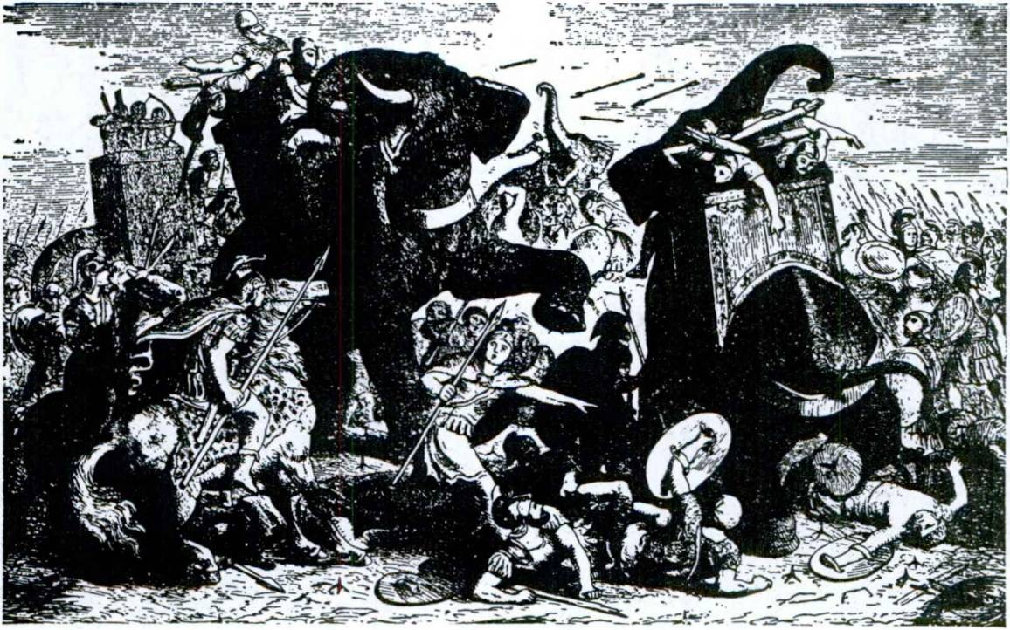FIRST YEAR LATIN 201

HAnniBAL eLepHAnTos HABeBAT.

Sicily, and at last Publius Cornelius Scipio, son of the Scipio who had first faced Hannibal in northern Italy, led an invasion of Africa itself. (This was in 204 B. c.; the war had opened in
218 B. c.) The final battle of the war was fought at Zama in northern Africa, probably in the spring of 202 B. C.
Hannibal magnum militum numerum habuit sed non ita multos equites. Scipio non ita multos milites habebat, multos autem equites. Hannibal etiam elephantos1 habebat. (There were said to be about eighty.) Romani elephantos non habebant.
Hannibal planned to drive his elephants in an opening charge against the Roman foot soldiers to throw them into disorder. The Carthaginian cavalry, stationed on the flanks, was meanwhile to retreat and draw the superior cavalry of the Romans off the field, thus leaving Hannibal free to attack the disordered legions with numerically superior infantry.
How did Scipio meet this attack?
(Continued on page 204)

1 elephantus, I: elephant.

LESSON 20: PRESENT SYSTEM PASSIVE OF THE FOURTH CONJUGATION; ACCOMPANIMENT

PRESENT SYSTEM PASSIVE OF THE FOURTH CONJUGATION
The rules for final personal signs in the passive apply also to the fourth conjugation.
ASSIGNMENT: Study GrAmmAr, Nos. 248, 251, and 254.

audio, 4, tr.

munio, 4, tr.
REVIEW VOCABULARY

hear fortify
construct (w.
viam or vias)

venio, venire, veni, ventum, 4, intr.
convenio, convenire, conveni, conventum, 4, intr.

EXERCISE 227
Translate:
come
come together assemble

- auditur 4. munientur 7. audietur
- muniuntur 5. audior 8. muniebatur
- audiebatur 6. muniebantur 9. audiuntur

EXERCISE 228
[Essential]
  - Translate;
  - Explain the construction of the italicized words:
1. Castra a Romanis semper muniebantur. 2. Quid a vobis audi- tur? 3. Cum Caesare per monies in Galliam veni. 4. Urbs a rege victoriae cupidd munitur. 5. Christo, Filid Dei, gratias agi- mus. 6. Interim et colles et pontes a legionibus muniebantur.
- Fuit metus in castris quod clamor hostium audiebatur.
202

FIRST YEAR LATIN 203

- Pueris malls praemia non dabuntur. 9. Ubi est Roma?
10. Filius saepe est patris similis. 11. Gentes jinibus hostium finitimae saepe copiam armorum petunt. 12. Fuitne Lincoln Washingtonid similis? 13. Legidnes integrae in hostes mittuntur.
14. Clamor nautarum reliqudrum audiebatur. 15. Maria est gratia plena. 16. Silvae perlculdrum plenae sunt. 17. Propter hostium metum legidnes pro portis instruebantur. 18. Urbs murd munitur. 19. Quis pro rege pugnabit? 20. Impedimenta magna erant. 21. Post bellum fuit pax. 22. Caesar fuit Romandrum im- perator. 23. Loca angusta et difficilia fuerunt. 24. Roma a Gallia longe abest. 25. Oppidum militibus complebatur. 26. Miles similis duel non erat. 27. Romani Romam virtute et armis sem- per defenderunt. 28. Cur iter per montes non fecerunt? 29. Mi- lites undique tela in hostes miserunt. 30. Dux regnum occupavit.

ABLATIVE OF ACCOMPANIMENT
Do not confuse the ABLATIVE OF MEANS with the ABLA- TIVE OF ACCOMPANIMENT:
When with expresses association, pointing out the person or thing in company with which something is or is done, the AB- LATIVE WITH CUM MUST BE USED. This is called the ABLATIVE OF ACCOMPANIMENT.
He came with the Roman.

Cum Romano venit.
(i. e., He came IN COMPANY WITH the Roman.)
The swords are in the camp with the darts.
Gladii in caatria CUM TELIS aunt,
(i. e., They are TOGETHER WITH the darts.)
(BUT: He is being killed with a sword.
Gladio occlditur.)
(>. e., He is being killed BY MEANS OF A SWORD. The sword is the instrument or means.)
ASSIGNMENT: Learn the rule for accompaniment in GrAm-
mAr, No. 772.

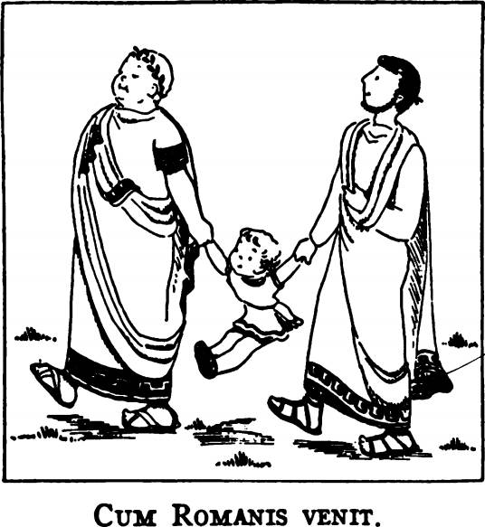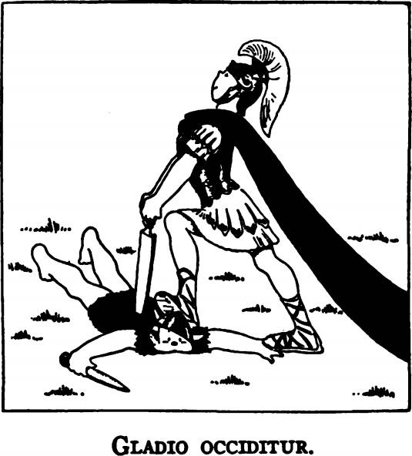204 FIRST YEAR LATIN

EXERCISE 229
Some of the with-phrases in these sentences are to be translated by the ablative of MEANS, some by
the ablative of ACCOMPANIMENT. Translate:
1. They fought with swords. 2. Caesar was fighting with the Gauls. 3. The cavalry was in the camp with the soldiers. 4. The camp was being fortified with a wall. 5. Mary is in heaven with God. 6. They terrified the cavalry with (their) shouting.

READING NO. 10

THE BATTLE OF Z AM A—HANNIBAL’S LAST STAND
Et Hannibal et Scipio milites instruxerunt. Virtus et spes mili- tum orationibus imperatorum confirmabantur. “Spem in virtute ponemus! Fortiter pugnabimus! Aut vincemus aut vincemur!”
Hannibal lined up his eighty elephants in front of his main army. In the first line behind them he placed his 12,000 mer­ cenary troops, men drawn from many lands and held together by devotion to their great leader. In the second line he stationed 15,000 new Carthaginian levies. Behind these he held in re-

FIRST YEAR LATIN 205
PHASES I and II Legidnes

Romanae

Eguites

Romani

Equites
hostium

Elephant! (Mercenaries and auxiliaries I New Carthaginian levies
- | — | — | — | E | -

Equites Romani

Equites hostium

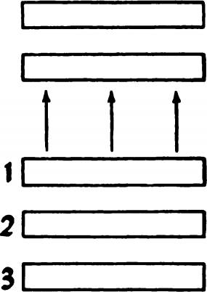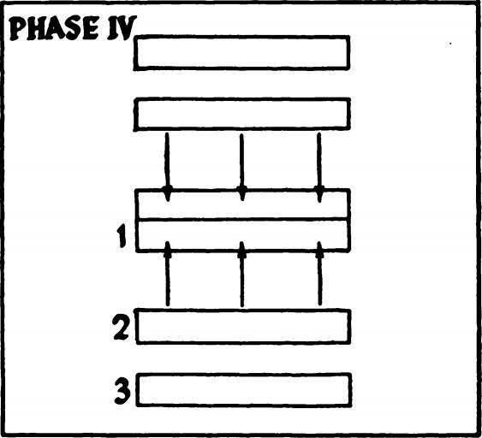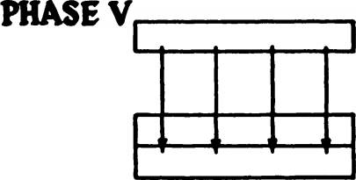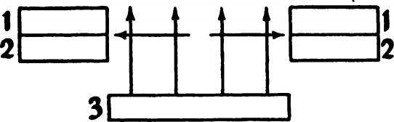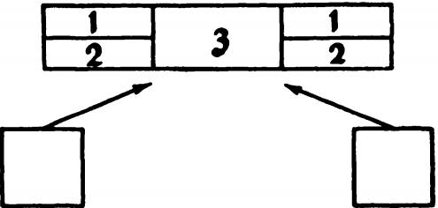1 20,000 veterans

PHASE III

PHASE VI

206 FIRST YEAR LATIN

serve 20,000 veteran troops to strike the final blow for victory. The cavalry were massed on either flank. (See diagram: Phases I and II.)
Hannibal signum dedit. Elephant!1 2 in aciem Romanam mitte- bantur. (See diagram: Phases I and II.)
Scipio, however, had arranged his men so as to leave lanes between his troops. The soldiers thus easily shifted to allow the elephants to run harmlessly between them.
Itaque elephant!1 neque Romanos terruerunt neque aciem per- turbaverunt. (See diagram: Phases I and II.)
Interim equites Romani in equites hostium impetum fecerunt. Hostes autem impetum non sustinuerunt. Itaque equites hostium cesserunt.
Thus both cavalries rushed off the field as Hannibal had probably planned. (See diagram: Phases I and II.)
Turn prima acies hostium in Romanos ab Hannibale mitte- batur. (See diagram: Phase III.) Res gladio gerebatur. Et Ro­ mani et hostes fortiter pugnabant. Voces et clamor hominum undique audiebantur. Multi et hostes et Romani telis et gladiis occidebantur. Milites tamen Romani impetum sustinebant. Itaque et Scipio et Hannibal integros milites in proelium misenmt. (See diagram: Phase IV.)
Romani autem a militibus integris non superabantur. Itaque hostes in magno periculo erant.
Both armies were now in great confusion and both attempted to re-form. Hannibal pushed his third line of veterans to the front and rejoined battle. (See diagram: Phase V.) The battle raged on through long and bloody hours. Finally the Roman cavalry, having left off pursuit, probably according to instruc­ tions, returned to the field.
Turn equites Romani a tergo’ impetum in hostes fecerunt. (See diagram: Phase VI.) Itaque hostes a Romanis undique contine-
1 elephantus, i: elephant.
2 a tergo: from the rear.

FIRST YEAR LATIN 207

bantur. Magna erat caedes hostium miserdrum. Romani enim omnes fere hostes aut occiderunt aut ceperunt.1 (Hannibal, how­ ever, escaped capture and fled from the field.)
Post proelium hostes pacem petiverunt. Ita, post multas hos­ tium victorias et magnam Romandrum caedem, Romani hostes virtute et armis vicerunt.

ceperunt: (they) captured.

LESSON 21: THE PERFECT SYSTEM OF THE INDICATIVE PASSIVE

The perfect, pluperfect, and future perfect tenses passive are COMPOUND tenses in Latin. They are formed by using the PERFECT PARTICIPLE PASSIVE as a predicate adjective with the verb sum, am.
The PERFECT indicative passive is compounded of the per­ fect participle passive (the fourth principal part in -us) and the present indicative of the verb to be.
The perfect participle passive is declined like magnus, a, um and agrees with the subject of the sentence, just like a predicate adjective. Explain all the underlined endings in these examples:
Ego laudatus sum. I was praised.
Tu laudatus es. You were praised.
Maria a Ghristianis laudata est. Mary was praised by the Christians.
Nos laudati sumus. We were praised.
Vos laudatl estis. You were praised.
Milkes laudatl sunt. The soldiers were praised. Matres laudatae sunt. The mothers were praised. Flumina laudata sunt. The rivers were praised.
In forming the PERFECT SYSTEM OF THE PASSIVE
in all conjugations follow this rule:
- Take the PERFECT PARTICIPLE PASSIVE of the verb (the fourth principal part of transitive verbs).
- Add, as a separate word, the required form of the verb sum.
ASSIGNMENT: Study the model verbs, GrAmmAr, Nos. 255-266.

208

FIRST YEAR LATIN 209

vehementer, adv,
exploro, 1, tr.
VOCABULARY

greatly violently
reconnoiter find out
press

premo, premere, press!, pressus, 3, tr,

retined, retinere, retinul, retentus, 2, tr,

compare, 1, tr.
Press hard
hold back keep
get prepare

EXERCISE 230
Conjugate in the perfect system indicative active: (a) con- servo, (b) retineo, (c) premo, (d) munid.

EXERCISE 231
Give the perfect participles passive (the fourth principal part) of:

1. laudo | 17. paro | 32. | pond
2. moneo | 18. vinco | 33. | munid
3. supero | 19. appello | 34. | colloco
4. habeo | 20. peto | 35. | confirmd
5. porto | 21. do | 36. | incendo
6. defendo | 22. ago | 37. | adj u vo
7. occupo | 23. administro | 38. | video
8. duco | 24. moved | 39. | pello
9. gero | 25. voco | 40. | perturbo
10. oppugno | 26. comparo | 41. | obtineo
11. trado | 27. retined | 42. | cdnservo
12. audio | 28. occido | 43. | incito
13. terreo | 29. exploro | 44. | servo
14. instruo | 30. dimitto | 45. | contineo
15. mitto | 31. sustineo | 46. | premo
- compleo

210 FIRST YEAR LATIN

EXERCISE 232
Conjugate sum in the (1) present indicative, (2) imperfect in­ dicative, (3) future indicative.

EXERCISE 233
Add the proper endings to the participles and translate:
Note. Remember that in a compound tense the perfect parti­ ciple passive agrees in number and gender with the subject of the sentence.
- Vos laudatestis.
- Oppidum traditest.
- Principes re tentsunt.
- Copia frumenti comparatest.
- Omnia loca exploratsunt.
- Hostes presssunt.
- Tu laudates.
- Nos laudatsumus.
- Voces auditsunt.
- Nautae retentsunt.
- Exercitus superatest.
- Castra motsunt.

EXERCISE 234
Add the proper form of the verb sum:
- You have been praised. Vos laudat!
- They have been conquered. Victi
- You have been warned. Tu monitus
- The courage of the soldiers has been strengthened. Virtus militum confirmata
- All the places had been reconnoitered. Omnia loca explorata

- We had been held back. Nos retenti
- It has been prepared. Comparatum
- The camp has been fortified. Castra munita<

FIRST YEAR LATIN 211

EXERCISE 235
[Essential]
Translate:
1. Vos laudati eratis. 2. Tu monitus es. 3. Equites superati sunt. 4. Pons incensus est. 5. Frumentum portatum est. 6. Cas- tra defensa sunt. 7. Omnia fere loca occupata erant. 8. Ei pulsi sunt. 9. Duct! sumus. 10. Ea gesta sunt. 11. Oppidum oppugna- tum erat. 12. Arma eis tradita sunt. 13. Audit! estis. 14. Vehe- menter territi eramus. 15. Milites instructi sunt. 16. Litterae missae sunt. 17. Mons hominibus completus erat. 18. Tela parata sunt. 19. Victi sumus. 20. Appellati eratis. 21. Pax petita est. 22. Frumentum eis datum est. 23. Actum est.
24. Res administrata est. 25. Castra mota erant. 26. Centurio- nes vocati erant. 27. Galli pressi sunt. 28. Copia telorum com- parata erat. 29. Duces retenti sunt. 30. Occisi sunt. 31. Montes explorati erant. 32. Principes dimissi erant. 33. Impetus sus- tentus erat. 34. Spes in virtute posita est. 35. Oppidum muni- tum est. 36. Legiones ibi collocatae sunt. 37. Omnes res compa- ratae erant. 38. Pax confirmata est. 39. Territi sumus. 40. Fru- menta in agris incensa sunt. 41. Adjutus sum. 42. Pulsi estis.
43. Visus es. 44. Pulsus est. 45. Vehementer perturbatus eram.
46. Obtentum est imperium. 47. Lex conservata non est. 48. Gentes finitimae incitatae erant. 49. Legid prima pressa est. 50. Sig­ num servatum erat. 51. Undique content! sumus. 52. Pressi sunt.
EXERCISE 236
[Drill]
Translate:
1. I was praised by Caesar. 2. You were warned by the slave.
- We were conquered by the enemy. 4. A large number of slaves was had by the Romans. 5. Grain had been carried into the winter quarters. 6. The town had been bravely defended.
7. The hills were seized by the cavalry. 8. The Romans were led by a brave general. 9. War had been waged with the Gauls.

212 FIRST YEAR LATIN

10. The city had been attacked. 11. We were handed over to the enemy by the leader. 12. The speech was heard by the chiefs. 13. You had been terrified by the darts. 14. The legions were drawn up by Caesar. 15. The letter was sent by the chief.
16. The wall was filled with men. 17. Arms had been gotten.
18. We were not conquered. 19. God had been called upon.
20. Peace was sought. 21. The swords were given to the soldiers.
22. The enemy was driven into the forest. 23. The war was managed by a brave general. 24. The camp had been moved into a safe place. 25. The centurions had been called by the general. 26. The enemy was routed by darts. 27. All things had been got ready. 28. The king had been held back. 29. The leaders had been killed by swords. 30. All the places had been reconnoitered. 31. The slaves were dismissed. 32. The attack was withstood by the battle line. 33. The camp had been pitched there. 34. The camp was fortified with a wall. 35. A horseman had been stationed on the bridge. 36. Peace had been strengthened. 37. The grain had been burned by the Romans.
38. They were helped by both slaves and free men. 39. Soldiers had assembled. 40. He had been seen by the horseman. 41. The cavalry were repulsed. 42. The first battle line was disturbed.
43. The royal power was held by a good man. 44. The state had been preserved by brave men. 45. The legion was sent into the camp. 46. The faith has been kept by many Christians. 47. The soldiers were restrained by the leaders.

EXERCISE 237

OMNIA BELLA SIMILIA SUNT
Translate:
- Propter bellum gladii et tela a Romanis comparata erant; hodie1 etiam multa et magna arma ab Americanis comparantur.
- In castris Romanorum saepe fuit magna omnium rerum in- opia; in castris Americanis etiam saepe est rerum inopia.

1 hodie, adv.: today.

FIRST YEAR LATIN 213

- In bellis Romanorum omnia loca ab equitibus saepe explo- rata sunt; in bellis autem hodiernis1 omnia loca ab aviatoribus2 explorantur.
- Turn hostes ab equitatu saepe press! sunt; hodie8 hostes ab armigeris4 premuntur.
- Bellum Gallicum5 a Caesare administratum est. Quis bellum commune hodie3 administrat ?
- Caesar, imperator Romanorum, propter victoriam laudatus est. Laudabunturne duces American! propter victoriam ?

READING NO. 11

PICTURES FROM THE PAST
An ImAGinArY InTerview wiTH A CenTUrion
The professor cleared his throat. We waited expectantly. “Gentlemen,” he said, “I have invited you here tonight to see the first demonstration of my electrical wave detector. This machine cannot only gather and combine into a picture the waves being sent off from any part of the earth at the present time, but it can detect even the smallest remnants of waves which, sent off at some past time, are yet vibrating in the uni­ versal medium of all electrical waves. However, this is not an explanation of a theory but a demonstration of success. Watch carefully. I set this control for time (with growing excitement we watched him turning the dial), and this (he began moving a larger dial on the huge machine) for space. Now, I throw the power switch (A large screen or mirror became suddenly illumined with splotches of changing colors.) This should put our picture at approximately 58 B. c. somewhere in southern Gaul.” “I have not yet,” he added apologetically, “succeeded in ex­ actly correlating my controls with the longitudes and latitudes
of the earth’s surface.” As he was speaking, the screen had

1 hodiernus, a, um: modern.
2 aviator, aviatoris: airman.
8 hodie, adv.: today.
* annigerum, i: tank.
6Gallicus, a, um: Gallic.

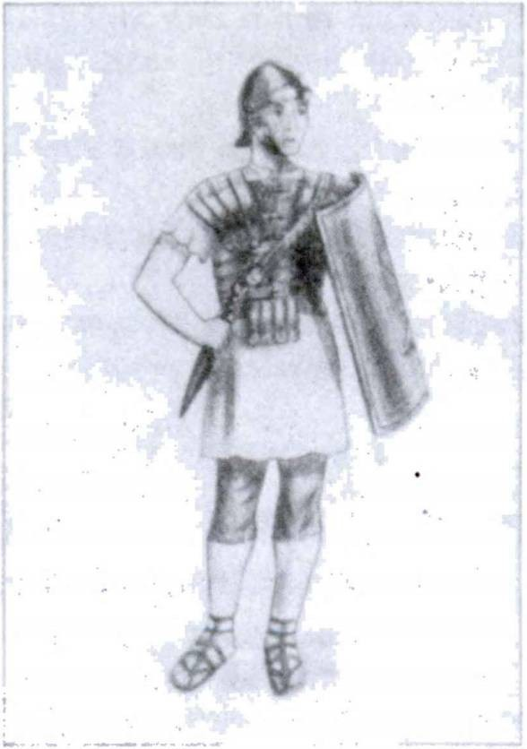214 FIRST YEAR LATIN

focused into a very realistic picture of a wild forest. The move­ ment of a breeze through the trees was quite discernible. There was a gasp of astonishment, but the professor held up his hand. “Now,” he said, “I set the sound control.” A roar of static rose from a speaker to the left of the screen, then settled down to the quiet sounds of a forest—no, there was something else—growing louder—the sound of horses and the clang of metal. Then, before our amazed eyes, a troop of cavalry rode onto the scene. The leader, a bronzed, sturdy man who rode his horse with the assur­ ance of long custom, halted, and gazed off to the left. In the silence that followed we heard something else—distant cries, a shouting as if a whole army were in an uproar—then, yes, the centurion (he looked just like a picture of a centurion I had seen in a high-school Latin book) turned his head in our direction. He became paralyzed with amazement. But the professor was almost leaping with excitement. “He sees us! It works! It works!” He rushed to the machine and began pulling several levers. “Perhaps,” he muttered, “perhaps the sound can be reversed too, but then, ...” He stepped back and cleared his throat.

FIRST YEAR LATIN 215
“Estisne vos” (yes, the professor had been a good Latin student in high school), “estisne vos milites Romani ?” (We held our breath. Slowly the paralysis of surprise passed, and we saw the centurion open his mouth. yes, then we heard):
CenTUrio. Nos equites Romani sumus. Vos autem . . . Professor (excitedly interruping him). Ubi estis?
C. In Gallia sumus. In agris hostium sumus. Nunc, sicut vide- tis, in magnis silvis sumus.
P. Quis imperator vester est ?
C. Caesar, vir et nobilis et fortis, imperator noster est. Bellum ab eo fortiter administrate.
P. Bellum ? Geriturne bellum ?
C. Ita. Cum Gallis legiones Romanae nunc pugnant. (He pointed off to the left.) Auditurne a vobis clamor et hostium et Rdmandrum ?
P. Paraveruntne Galli bellum ? Erantne cupidi belli ?
C. Ita. Victoriae et belli gloriae cupidi erant. Itaque ante1 bellum arma et tela a Gallis parata sunt. Virtus edrum a ducibus et principibus confirmata est. Oppida et urbes ab eis munitae sunt. Frumentum in oppida et a Gallis et ab eorum servis por- tatum est. Ita omnes res paratae erant.
P. Quid autem nunc agunt Galli ?
C. Telis et armis oppida et agros defendunt. Colles et pontes ab eis occupantur, nam bellum nobiscum gerunt.
P. Et Caesar? Quid is ante1 bellum egit?
C. Castra in colie ab eo posita sunt. Frumentum in castra a servis portatum est. Arma et tela etiam ab eo parata sunt. Equi­ tes a Caesare in fines hostium dimittebantur. Omnia loca ab eis explorata sunt. Castra nostra muro munivimus. Caesar virtutem et spem militum oratione et praemiis confirmavit.
P. Vincenturne Galli a vobis ?
C. Ita. (He roared with laughter.) Galli fortiter pugnant, sed nos non vincent. Nos armis et virtute eos vincemus. Romani

1 ante, prep. w. acc.: before.

216 FIRST YEAR LATIN

enim neque vincuntur neque de pace cum hostibus agunt. En!1 (He pointed towards the shouting.) Jam2 nunc a militibus Ro­ manis Galli et terrentur et occiduntur. Caedes! Urbes (with a sweeping gesture), oppida, colies, silvae, portus, agri ab exercitu Romano occupabuntur. Imperium omnis Galliae a Caesare ob- tinebitur! Gladiis (his voice became harsh) rem geremus! Multi Galli a nobis occidentur. Frumenta ab equitibus Romanis in- cendentur; pontes et oppida a legionibus incendentur. Post bel- lum frumentum et servi et arma a Gallis nobis tradentur. Ita pax in Gallia confirmabitur. Victoria nostra erit! (He tossed up his head proudly.) Victoria! Ah!
P. Quid autem vos nunc agitis ?
C. In proelium a Caesare mittimur. Ecce nos post aciem hos- tium sumus. Per silvas longa via venimus et . . . (Suddenly there was the high piercing note of a trumpet, once—and again.) Signum est! Signum a Caesare datur! (He threw up his arm.) In hostes!
The whole troop rushed madly off the scene towards the left.
I shivered for the Gauls. The cry of panic rose and mounted, shrill, of men in ultimate pain. Then the professor switched off the power. We sat there long in silence.

1 en: behold.
2 jam, adv.: already.

MASTERY REVIEW VOCABULARY NO. 2
[Units Three, Four, and Five]

FIRST CONJUGATION
VERBS LIKE LAUDO
adjuvd, adjuvare, adjuvi, adjutus, 1, tr.1 help
aid
administro, 1, tr. manage
attend to
appello, 1, tr. address
call (upon)
colloco, 1, tr. place
station
compare, 1, tr. get
prepare
confirmo, 1, tr. encourage
strengthen
conservo, 1, tr. preserve
spare
do, dare, dedi, datus, 1₉ tr^ give reconnoiter

explord, 1, tr.

incito, 1, tr.

laudo, 1, tr.
occupo, 1, tr.

oppugno, 1, tr.
find out
incite arouse
praise seize
attack assault storm

1Adjuvo and do form their perfect stems differently from laudo. Therefore you must memorize the principal parts. Do is also peculiar in that the a which begins the endings is short throughout the indicative except in the second person singular present indicative active, das.
217

218 FIRST YEAR LATIN

oro, 1, tr.

1, tr.

perturbo, 1, tr,

porto, /, tr,
pugno, 1, intr.

servo, 1, tr.

superd, 1, tr.

voco, 1, tr.

beg pray prepare
get ready
{
I
I
confuse disturb carry
fight guard keep
overcome conquer surpass
call

SECOND CONJUGATION
VERBS LIKE MONEO
compleo, complere, complevi, completes, 2, tr.; w. abl.1
contineo, continere, continui, contentus, 2, tr.

habeo, 2, tr.
maned, manere, mans!, mansurus, 2, intr.

moneo, 2, tr.

moved, movere, movi, motes, 2, tr.

obtineo, obtinere, obtinul, obtentus, 2, tr. retineo, retinere, retinui, retentus, 2, tr. sustineo, sustinere, sustinul, sustentus, 2, tr.

fill (with)

restrain hold in
have remain
warn advise move
[hold
[ occupy hold back keep
sustain withstand

1When compleo is modified by a w:iA-phrase, this w:7A-phrase is translated by the ablative without a preposition. Hence the notation "v. abl**

FIRST YEAR LATIN 219

teneo, tenere, tenui, tentus, 2, tr. hold
terreo, 2, tr. terrify
timed, timere, timui, 2, tr.1 fear
video, videre, vid!, visus, 2, tr. see

THIRD CONJUGATION
VERBS LIKE MITTO
drive do

ago, agere, eg!, actus, 3, tr.

cedo, cedere, cessT, cessurus, 3, intr.

contendo, contendere, contend!, 3, intr.

defendo, defenders defend!, defensus, 3, tr.

d!mitto, dimittere, d!m!s!, dlmissus, 3, tr.

duco, ducere, dux!, ductus, 3, tr.

gero, gerere, gess!, gestus, 3, tr.

incendo, incendere, incend!, incensus, 3, tr. •

Instruo, instruere, Instrux!, Instructus, 3, tr. ■

mitto, mittere, mis!, missus, 3, tr.
occldo, occidere, occ!d!, occlsus, 3, tr.

pello, pellere, pepul!, pulsus, 3, tr.
act treat
give (w. gratias)
give way yield
’ strive contend hasten
defend send away dismiss lead
guide
carry carry on
wage (w. bellum)
set fire to burn draw up
equip
send kill
drive repulse rout

1 Timeo has no fourth principal part.

220 FIRST YEAR LATIN

petd, petere, petlvi, petitus, 3, tr.

pono, ponere, posui, positus, 3, tr.1

premo, premere, press!, pressus, 3, tr.

trado, tradere, tradidi, traditus, 3, tr.
vinco, vincere, vic!, victus, 3, tr.
seek beg request
put place set
pitch (w. castra)
press press hard
hand over conquer

audio, 4, tr.

FOURTH CONJUGATION
VERBS LIKE AUDIO

hear

convenio, convenire, conveni, conventum,
4, intr.

munid, 4, tr.

venio, venire, veni, ventum, 4, intr.
come together assemble
fortify
construct (w. viam
or vias)
come

IRREGULAR VERBS
absum, abesse, afui, afuturus, intr.; ab (a)
w. abl.2
sum, esse, fui, futurus, intr.3

J am away
[ am distant am

1 Pond means pitch only when it is used of a camp. When an :n-phrase is used to modify pono, the in always takes the ABLATIVE.
2Absum is a compound of the preposition ah and the verb sum. Therefore it is conjugated LIKE SUM. The place away from which something is, is expressed by the preposition ab (a before consonants), from, and the ablative.
8 Sum has no PASSIVE; therefore it has no perfect participle passive; the future participle active is given as the fourth principal part. We shall study these participles later.

FIRST YEAR LATIN 221

NOUNS OF THE FIRST DECLENSION

fortuna, ae Italia, ae
litterae, litterarum1

fortune Italy
letter (i. e., an epistle)
dispatch

NOUNS OF THE SECOND DECLENSION (MASCULINE)
ager, agri field
locus, i (pl,, loca, locorum)2 * place
numerus, i number
puer, pueri boy
vir, viri8 man

NOUNS OF THE SECOND DECLENSION (NEUTER)

arma, armdrum4 hibema, hibernorum5 * * proelium, I®
telum, i
arms
winter quarters battle
dart

1 Litterae is a plural noun of the first declension (like copiae).
2 Locus becomes a neuter noun in the plural: loca. When locus is modified by an adjective, the preposition in is frequently omitted with the ablative. In an unfavorable place, loco alieno.
8 Vir means a man as opposed to a woman or a child. Homo means a human being, a man as opposed to an animal.
4 Arma is a neuter plural of the second declension (like castra).
8 Hiberna, like castra, is declined only in the plural.
®The ablative of proelium is generally used without in in such expressions as: m many battles, multis proeliis.

222 FIRST YEAR LATIN

NOUNS OF THE THIRD DECLENSION

centurio, centurionis civitas, civitatis fines, finium, m.2 mors, mortis
a centurion1 state territory death

oratio, drationis f speech [Prayer2

ADJECTIVES OF THE FIRST AND SECOND DECLENSIONS

alienus, a, um

integer, integra, integrum

liber, libera, liberum miser, misera, miserum
unfavorable another’s foreign fresh
uninjured whole free
wretched

PRONOUNS

ego, mei is, ea, id
meus, a, um
I
he, she, it
[wy j
[mine

nos, nostri we

noster, nostra, nostrum quid
quis
[our
j
[ours
what? who?

1A Roman army officer in charge of one hundred men. The rank was similar to that of our captain.
2 Fines is a plural noun like partes.
8 Oratio means prayer only in Christian Latin.

FIRST YEAR LATIN 223

8U1

tu, tui tuus, a, um
vester, vestra, vestrum vos, vestri

himself herself itself themselves
you (sing.)
your (when referring to
yours ONE person)
your (when referring to MORE
yours THAN ONE person)
you (pi.)

cur, adv. etiam, adv. fere, adv.
fortiter, adv.

ibi, adv.
interim, adv.

ita, adv.

longe, adv.

postea, adv. saepe, adv. semper, adv. tamen, adv.
turn, adv. ubi, adv. undique, adv.
vehementer, adv.

ADVERBS
why? also almost
bravely strongly
there meanwhile so
(
thus
far
by far afterwards often always nevertheless then
at that time
where?
from all sides on all sides greatly
violently

224 FIRST YEAR LATIN

CONJUNCTIONS

atque (ac), conj,
aut, conj,
aut . • . aut, conjs. enim, conj,, postp, nam, conj,
neque, conj.

neque . . . neque, conjs,
sicut, conj.
and or
either ... or for
for1
nor
and . . . not neither , , , nor as

PREPOSITIONS

ab (a), prep. w. abl,

de, prep. w. abl,

per, prep. w. acc. sine, prep. w. abl, trans, prep. w. acc.
by (expressing agency)
from (w. absum) concerning about
through without across

in principio

OTHER WORDS
in the beginning

in saecula saeculorum

-ne
world without end forever
particle used in questions

1 When for means because and introduces a REASON.

UNIT SIX

LESSON 22: THE PRESENT SUBJUNCTIVE; PURPOSE CLAUSES
INTRODUCTION
We have studied the INDICATIVE MOOD. We saw that it was used in ordinary STATEMENTS OF FACT and in DIRECT QUESTIONS.
We shall now study the SUBJUNCTIVE MOOD. This mood is used in many special constructions, both in main clauses and in subordinate clauses. Latin uses the subjunctive in sentences where the English uses auxiliary (or helping) verbs, such as may, might, should, and the like. But Latin also uses the subjunctive where English uses the indicative. The MEANING of the sub­ junctive, therefore, will have to be learned as we study the DIFFERENT LATIN CONSTRUCTIONS REQUIRING THE SUBJUNCTIVE.

THE PRESENT SUBJUNCTIVE ACTIVE
ASSIGNMENT: Study the present tense of the subjunctive in the four conjugations, GrAmmAr, Nos. 186, 194-196. Learn the meaning in purpose clauses. Note that (1) the vowels which begin the endings are not the usual ones in each conjugation,
(2) the final personal signs are regular.

- collocet
- det
- perturbet
- laudes
EXERCISE 238
[First Conjugation]
What forms are these f
- pugnent 9. laudet
- perturbemus 10. appellet
- occupent 11. confirmet
- perturbent 12. laudetis
225

226 FIRST YEAR LATIN

EXERCISE 239
[Second Conjugation]
What forms are these?
- moneas 4. habeat 7. teneat
- terreant 5. moneamus 8. moneatis
- sustineat 6. terreatis 9. obtineant

EXERCISE 240
[Third Conjugation]
What forms are these?
- mittamus 5. defendat 9. Instruant
- ducant 6. cedant 10. incendat
- pellat 7. ponatis 11. vincant
- petant 8. pellant 12. mittas

EXERCISE 241
[Fourth Conjugation]
What forms are these?

1. audiamus | 4. audias | 7. veniant
2. veniat | 5. conveniant | 8. muniat
3. muniant | 6. audiatis | 9. audiam

MOOD IN PURPOSE CLAUSES
He is fighting in order that he may defend the city.
Pugnat ut urbem def endat.
“He is fighting” is a MAIN clause.
“In order that” introduces a SUBORDINATE clause.
“In order that he may defend the city” is a SUBORDINATE clause. This subordinate clause expresses the PURPOSE of his fighting. It answers the QUESTION: “For what purpose is he fighting?” ANSWER: “In order that he may defend the city.”
A subordinate clause expressing PURPOSE is called a PUR­ POSE CLAUSE.

FIRST YEAR LATIN 227

RULE: A PURPOSE CLAUSE IS INTRODUCED BY UT (TN ORDER THAT’). THE VERB IN THE PUR- POSE CLAUSE IS PUT IN THE SUBJUNCTIVE.
A purpose clause is an ADVERBIAL clause. It expresses the PURPOSE of the action in the main clause, and so, like an ad­ verb, modifies the main verb.

(Subject)

defendat
(Verb)
( ) | pugnat
(Subject) | (TerdJ  ut  A >

urbem
(Object)

VOCABULARY
vita, ae life
| wall

vallum, I
[ rampart

amlcitia, ae friendship
fossa, ae ditch
celeriter, adv. swiftly
RELATED ENGLISH WORDS
Vital; amicable; vitamin; celerity.
RELATED LATIN WORD

Amicus

LAUDABO DEUM MEUM IN VlTA MEA.
—From the Roman Breviary

228 FIRST YEAR LATIN

- Translate;
EXERCISE 242

- Point out the MAIN clauses;
- Point out the SUBORDINATE PURPOSE clauses;
- Diagram Sentences 1 and 2:
  - Castra valid munit ut ea defendat. 2. Damusne praemia amlcis ut amicitiam confirmemus? 3. Fortiter pugno ut vitam meam conservem. 4. Hlberna fossa muniunt ut impetum hostium sustineant. 5. Equites celeriter veniunt ut frumenta incendant.

PRIMARY TENSES
The present, future, and future perfect in the INDICATIVE are called PRIMARY TENSES. When the verb of the main clause is in a PRIMARY tense, the PRESENT subjunctive must be used in a PURPOSE clause. In these sentences pugnat, pugnabit, and pugnaverit are PRIMARY tenses. Therefore defendat is in the PRESENT subjunctive.

Pugnat ut urbem defendat.
He is fighting in order that he may defend the city.

Pugnabit ut urbem defendat.
He will fight in order that he may defend the city.

Pugnaverit ut urbem defendat.
He will have fought in order that he may defend the city.

RULE: WHEN THE MAIN VERB IS IN A PRIMARY TENSE, USE THE PRESENT SUBJUNCTIVE
IN THE PURPOSE CLAUSE.

EXERCISE 243
In which sentences should the present subjunctive be used?
1. Pugnavit ut ....... 2. Pugnaveras ut 3. Veniet
ut......... ...... 4. Hostes terret ut....................... 5. Praemium eis dedit

FIRST YEAR LATIN 229

ut 6. Pugnat ut 7. Venio ut 8. Pugna- verit ut
We can express purpose in English in DIFFERENT ways: He fights in order that he may defend the city.
He fights that he may defend the city.
He fights in order to defend the city. He fights to defend the city.
All these MEAN the same thing and MAY be translated into Latin in the same way:
Pugnat ut urbem defendat.

EXERCISE 244
[Essential]
Translate each sentence in four different ways:
1. Milkes gloriae cupidi pugnant ut hostes vincant. 2. Pugna- buntne viri liberi semper ut civitatem nostram servent? 3. Arma a nobis parantur ut vitas nostras conservemus. 4. Castra valid et fossa muniunt ut impetum hostium sustineant. 5. Amicitiam cum omnibus gentibus confirmabimus ut pacem cum eis servemus.

EXERCISE 245
Translate:
1. They fight to defend the lives of good men. 2. He fortifies the hill with a rampart to hold it. 3. They are sending grain in order to strengthen peace. 4. They help the Romans in order to strengthen friendship with them.

In virtute posita est vera1 fellcitas.2
—Seneca8

1 verus, a, um: true.
2 fellcitas, felicitatis: happiness.
3 Lucius Annaeus Seneca, a Roman philosopher, essayist, and dramatist (died
A.D. 65).

230 FIRST YEAR LATIN

NEGATIVE PURPOSE GLAUSES
He fights in order that the enemy may not burn the city. He fights lest the enemy burn the city.
Pugnat ne hostes urbem incendant.
A purpose is expressed in the subordinate clause of these sen­ tences, but the purpose is NEGATIVE (NOT, LEST).

RULE: WHEN THE PURPOSE CLAUSE IS NEGA- TIVE, NE (TN ORDER THAT . . . NOT,’ ‘LEST’)
IS USED INSTEAD OF UT NON.

Notice that the meaning of ne is in order that . . .NOT.
Therefore in the example the English not is translated in the
word ne.
ASSIGNMENT: Learn the present subjunctive of sum, GrAmmAr, No. 352.

VOCABULARY

exspecto, 1, tr. novus, a, um diu, adv.
acriter, adv.

expugno, 1, tr.
wait for wait new
a long time long
bitterly eagerly storm
take by storm

RELATED ENGLISH WORDS
Great expectations The acrid smell of burning sulphur. I am
expecting a friend. Not so many years ago the radio was a novelty.
RELATED LATIN WORDS
Diu pugnavimus. Oppidum oppugnavit.

FIRST YEAR LATIN 231

- Translate;
EXERCISE 246

- Point out the main clause;
- Point out the subordinate clause;
- Explain the tense in the subordinate clause;
- Diagram Sentences 1 and 2:
1. Frumentum in castra a servis portatur ne inopia frumenti sit. 2. Continetne milites in castris ut copias novas exspectet?
- In agros hostium venit ut eos terreat. 4. Galli diu et acriter pugnant ne Romani frumenta incendant. 5. Virtutem militum oratione confirmat ut victoriae cupidi sint. 6. Praemia principibus dat ut amicitiam cum eorum gentibus confirmet. 7. Galli pugnant ne servi sint. 8. Centurid fratrem adjuvat ne hostes eum occidant. 9. Castra valid et fossa munit ne hostes ea expugnent.

EXERCISE 247
Translate:
1. They fight in order to conquer. 2. They assault the town in order to take it by storm. 3. They are coming to hear the speech.
- They are seizing the bridge to burn it. 5. They will come to see Rome. 6. They pray in order to be good. 7. They will fortify the town lest the enemy take it by storm. 8. They warn the chief in order to preserve his life. 9. He fights in order to be king.
- They are yielding lest there be a slaughter. 11. They station soldiers to defend the bridge. 12. They are handing over arms to strengthen peace. 13. They prepare arms to wage war. 14. He will come to kill the commander in chief. 15. He is coming to seek peace. 16. He will remain to wait for new legions.

EXERCISE 248
[Essential]
Translate:
  - God helps us in order that the enemy may not overcome us. 2. Mary prays for us that we may have the grace of God.

232 FIRST YEAR LATIN

3. I shall fight bravely and long to preserve your life. 4. He is fortifying the camp with a ditch to defend it. 5. We are waiting for Caesar lest the enemy conquer us. 6. Is he leading new legions into Gaul to take the cities (by storm)? 7. He is burning the crops in order that there may be a scarcity of grain in Gaul. 8. He is strengthening friendship with all tribes lest there be war.
9. They are coming to storm the town. 10. The enemy is pressing them hard. Therefore they will give way lest the enemy kill them.* 1
- They are assembling to hear the king.

EXERCISE 249
  - Identify and translate these forms;
  - Use each in a Latin sentence:

1. contendat | 8. pellat | 15. ducat
2. vincam | 9. exspectabit | 16. confirmat
3. timeant | 10. veniat | 17. appelles
4. expugnant | 11. veniet | 18. geris
5. laudet | 12. vincit | 19. occupent
6. vincet | 13. adjuvet | 20. occidant
7. pugnat | 14. defendant | 21. adjuvant

VITA SINE LITTERlS2 MORS EST.

NOTE ON TRANSLATION
Very often several meanings are given for a Latin word in the vocabularies. In translating you should choose the meaning that makes GOOD SENSE. For example, in the following sentences altus must be translated in different ways. Explain how you know which meaning to use.
- Hannibal copias trans montes alt os duxit.
- Hannibal copias trans flumina alt a duxit.

1 Them: U^nslate here by te.
1 Litteris here does not mean letters, i, e., an epistle, but literature or writing.

FIRST YEAR LATIN 233

EXERCISE 250
[Essential Review]
Translate and explain the case of the italicized words:
- Multi homines in Italiam veniunt ut Romam videant. 2. Ho­ mines celeriter conveniunt ut res novas et audiant et videant.
- Milites diu et fortiter pugnant ut victoriae gloriam comparent.
- Milites cum hostibus acriter contendunt ut eds pellant atque occidant. 5. Dominus malus a servis miseris laudatur ut vitam edrum servet. 6. Caesar, vir bonus et fortis, cum militibus in acie saepe pugnat ut edrum virtutem confirmet. 7. Castra valid et fossa a Romanis muniuntur ne hostes ea expugnent. 8. Duces militibus saepe et gratias agunt et praemia dant ut fortiter pugnent. 9. Suntne imperatores saepe gloriae atque victoriae cupidi ?
READING NO. 12

WOE TO THE WEAK!
Time. About 55 B. c.
PLACe. A town somewhere in Gaul. The gates are shut; a few Gauls are seen standing about. Suddenly horses are heard ap­ proaching. The guards at the gate are on the alert.
GUArD. Quis es?
VoiCe oUTsiDe THe GATe. Centurio Romanus sum. Venio ut cum principibus de re gravi agam.
GUArD. Eds vocabimus. (A slave is sent off. Several elderly and distinguished Gauls return. The gates are opened. A Roman cen­ turion and several horsemen ride in.)
PrinCipes. Cur venitis ? Quid petitis ?
CenTUrio. Venimus ut copiam frumenti petamus. Est fru- inenti inopia in castris nostris. Itaque Caesar nos mittit ut frumentum comparemus.
PrinCipes. Nos autem non magnam frumenti copiam habemus neque sunt frumenta in agris.
CenTUrio (firmly). Dabitis tamen nobis. Estisne amici popull

234 FIRST YEAR LATIN

“FrUmenTUm PeTimUs.”
Romani ? Nobis frumentum dabitis . . . ut amici semper sitis populi Romani.
PrinCipes. Nos etiam ho­ mines sum us. Pueri et matres et . . .
CenTUrio (interrupting and speaking slowly and threaten­ ingly). Gens vobis finitima frumentum nobis non dedit. Jam oppida et urbes eorum expugnantur et incenduntur; pueri et viri occiduntur; ma­ tres in castra ducuntur ut servae1 sint. Vos tamen amici

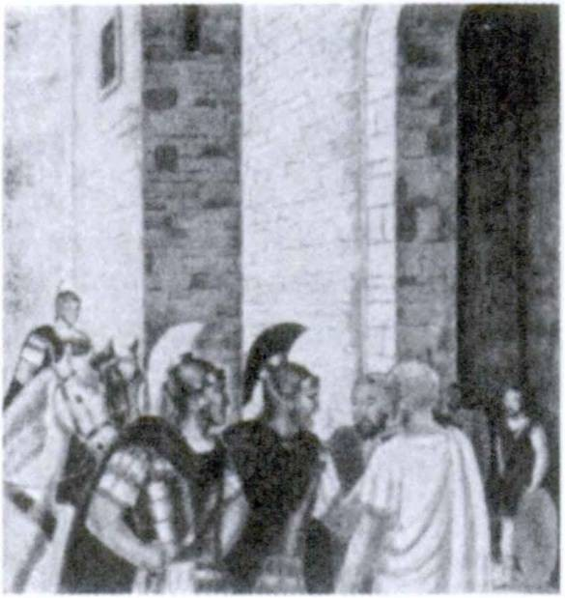(ironically) estis populi Romani! (Interim multi Galli convene- runt. A murmur of resentment runs through the crowd. The chiefs look about uncertainly.)
PrinCipes. Nos amici Caesaris et populi Romani semper fuimus. Etiam equites misimus. Cum eo bellum non gessimus. Pacem cum Caesare et populd Romano semper servavimus.
CenTUrio (insolently). Itaque cur exspectatis? Frumentum nunc petimus!
PrinCipes (in despair). Copiam autem non habemus!
VoiCes from THe CrowD. Non dabimus! Pugnabimus! (The crowd moves menacingly towards the centurion. He whirls his horse about and charges through the opening. The gates slam shut behind him. There is a long silence.)
PrinCeps (fearfully). Veniet Caesar!
(Such scenes were common not only in Caesar9s wars with the Gauls but in all wars when the might of arms crushed the rights of the innocent and the weak.)

1 serva, ae: o female slave.

LESSON 23: THE IMPERFECT SUBJUNCTIVE ACTIVE

  - IMPERFECT SUBJUNCTIVE ACTIVE OF THE FOUR CONJUGATIONS
ASSIGNMENT: Learn the imperfect subjunctive, GrAmmAr, Nos. 187,197-199.
Note. Here is an easy way to remember the imperfect subjunc­ tive: ADD THE REGULAR FINAL PERSONAL SIGNS (-m,
etc.) TO THE PRESENT INFINITIVE. For example:
    - laudare + -m = laudarem
    - laudare + -s = laudares, etc,

VOCABULARY

tribunus, I consilium, i concilium, l legatus, l
latus, a, um
facile, adv.
tribune plan counsel
council envoy lieutenant
wide easily

NOTE
Tribunus is often used with the genitive militum. Tribunus militum (literally, a tribune of soldiers) is to be translated a military tribune. The military tribune was an officer a rank above the centurion.
RELATED ENGLISH WORDS
The American Legation. The latitude and the longitude of the earth. The papal legate. His manner was facile. Control of the

235

236 FIRST YEAR LATIN

air facilitates military victories. Practice can produce remarkable
facility.
RELATED LATIN WORD
Iter per provinciam facile erat.

- exspectaret
- pararet
- appellarent
- oppugnarent

- haberet
- obtinerent
- moneretis
- terrerent

- pe terent
- gereret
- mitterem
- premeret
EXERCISE 251
[First Conjugation]
What forms are these?
- oraret
- laudarem
- pugnarent
- laudaremus

EXERCISE 252
[Second Conjugation]
What forms are these?
- moneremus
- moveret
- sustinerent
- teneret

EXERCISE 253
[Third Conjugation]
What forms are these?
- mitteremus
- mitteres
- traderent
- cederent

- portaret
- superarent
- exspectarent
- laudaretis

- monerem
- viderem
- terreret
- complerent

- gererent
- incenderet
- Instruerent
- contenderet

  - audiremus
  - veniret
EXERCISE 254
[Fourth Conjugation]
What forms are these?
  - munlret 5. munirent
  - audiretis 6. convenirent

FIRST YEAR LATIN 237

7. audirem | 9. conveniretis | 11. | audirent
8. audires | 10. venirent | 12. | conveniret

EXERCISE 255
[General]
What forms are these?
- vincit 6. sint 11. videret
- expugnet 7. audiret 12. portarent
- pelleret 8. contenderent 13. sitis
- veniet 9. veniam 14. audiat
- exspectemus 10. oppugnat 15. portet

SECONDARY TENSES
The imperfect, perfect, and pluperfect indicative are SEC­ ONDARY TENSES.
When the main verb is in a SECONDARY tense, use the IMPERFECT subjunctive in the purpose clause.

Pugnavit ut castra occuparet.
He fought in order that he might seize the camp. He fought that he might seize the camp.
He fought in order to seize the camp. He fought to seize the camp.

RULE
PURPOSE CLAUSES ARE INTRODUCED BY UT
(NEGATIVE: NE);
USE THE SUBJUNCTIVE;
USE THE PRESENT SUBJUNCTIVE WHEN THE MAIN VERB IS PRIMARY;
USE THE IMPERFECT SUBJUNCTIVE WHEN THE MAIN VERB IS SECONDARY.

238 FIRST YEAR LATIN

Pugnabat ut castra occuparet.
He was fighting in order that he might seize the camp.

Pugnaverat ut castra occuparet.
He had fought in order that he might seize the camp.

EXERCISE 256
[Essential]
- Translate;
- Parse the italicized words;
- Diagram Sentence 1:
- Caesar legiones novas et integras saepe exspectavit ut hostes facile vinceret. 2. Galli oppidum valid alto et fossa lata muniverunt ne Romani id expugnarent. 3. Legatus centuriones et tribunos militum appellavit ut fortiter et diu pugnarent.
- Duxitne Hannibal omnes copias trans lata flumina et per montes altos ut cum Romanis in Italia bellum gereret ? 5. Jesus Christus, Dei Filius, in mundum venit ut vitam et salutem nobis daret. 6. Galli saepe legatos in castra Caesaris miserunt ut pacem et amicitiam peterent. 7. Concilium saepe ab imperatoribus vocatur ut de re gravi in concilio agant. 8. Dux legatis praemia dedit ut consilium laudarent.

EXERCISE 257
[Drill]
Translate:
1. They fought in order to conquer. 2. They assaulted the town in order to take it (by storm). 3. They seized the bridge to burn it. 4. They came to hear the plan. 5. They came to see Rome. 6. They prayed in order to be good. 7. They fortify the town lest the enemy storm it. 8. They warned the chief in order to spare his life. 9. He waged war in order to seize the royal power. 10. They are yielding lest there be a slaughter. 11. They stationed horsemen to defend the hill.

FIRST YEAR LATIN 239

- They handed over the arms in order to preserve peace.
- They prepared arms in order to wage war. 14. The chiefs were dismissed lest the tribes wage war. 15. He came to kill the king. 16. The soldiers were drawn up to defend the city.
17. He waited for Caesar in order to conquer the enemy. 18. He came to seek peace. 19. They assembled to hear the speech.
20. He remained to wait for the chief.

EXERCISE 258
[Essential]
Translate:
1. The Romans fortified the camp with a wide ditch lest the enemy should easily take it (by storm). 2. Caesar, in the council, often strengthened the courage of the lieutenants and military tribunes in order that they might fight bravely. 3. They fought bitterly lest the enemy storm the town. 4. After a war were the chiefs and leaders of the enemy often killed by Caesar? 5. The lieutenant held the soldiers in the camp lest the enemy should see the plans. 6. Caesar stationed soldiers on the bridge lest the enemy should come across the wide river.

READING NO. 13

DE FRATRUM FORTIUM MORTE
A STorY BAseD on THe ReporT of THe AffAir MADe BY CAesAr.
In hoc1 proelio multi equites occisi sunt; in2 * eis vir fortis et nobilis, Piso Aquitanus. Is amicus erat Populi Romani. Ejus frater in proelio vulneratus8 erat et ab hostibus premebatur. Non erat spes salutis. Piso id vidit; vidit fratrem; vidit hostes. Tamen in hostes contendit ut fratrem adjuvaret. Ab hostibus autem circumventus4 est atque occisus est. Turn frater Pisonis morte
1 hoc: this,
2 in here means among.
8 vulnerd, 1, tr,: wound.
4 circumvenio: surround.

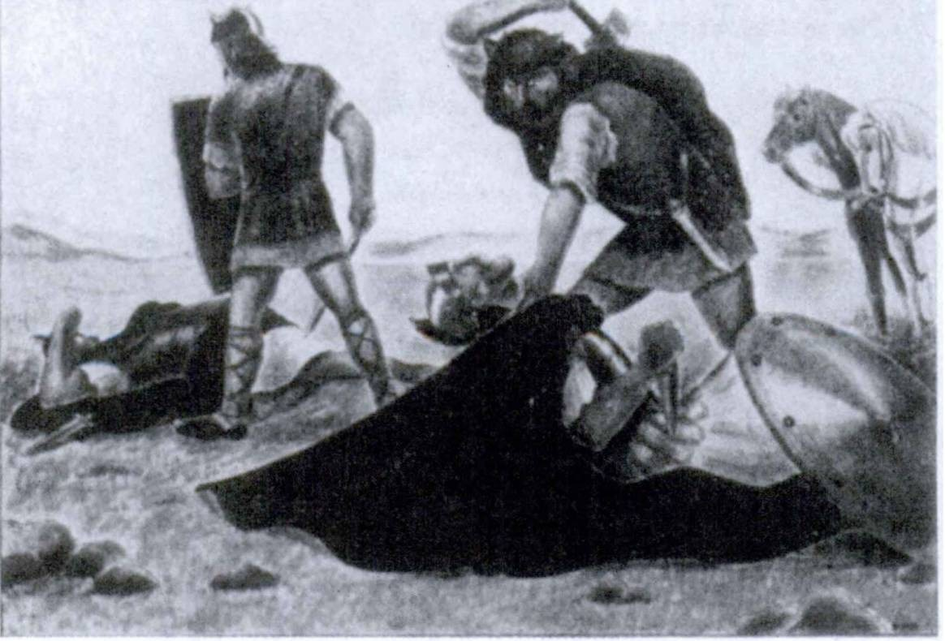240 FIRST YEAR LATIN

1

ACriTer PUGnAverUnT

ejus vehementer motus est et in hostes contendit. Acriter pugna- vit; tamen is etiam ab hostibus occisus est. Ita occisi sunt fratres fortes et boni. Laudamusne eds ?
Answer in complete Latin sentences:
- Quis fuit Piso Aquitanus?
- Quis ab hostibus premebatur ?
- Quis in hostes contendit?
- Cur in hostes se misit ?
- Estne Piso Aquitanus occisus?
- Estne frater ejus occisus ?

FIRST YEAR LATIN 241

EXERCISE 259
[Review]
- Name the primary and secondary tenses of the indicative.
- Give the rule for the ablative of means.

ADJECTIVES USED AS NOUNS; IMPERFECT SUBJUNCTIVE OF SUM
ASSIGNMENT: Study the use of adjectives as nouns (GrAmmAr, Nos. 845-848) and the imperfect subjunctive of sum, (GrAmmAr, No. 353).

VOCABULARY

labor, laboris ordo, ordinis, m.
obses, obsidis, c,
inter, prep, w, acc,

statim, adv,

NOTE
effort toil
rank (of soldiers)
hostage between among
at once immediately

Obses is marked c (= common gender); that is, it may be either masculine or feminine, as hostages were men and women. However, use it as masculine unless it clearly refers to women.

RELATED ENGLISH WORDS
Line the men up in order. Hard labor. Interstate commerce.

REVIEW VOCABULARY
sum, esse, fui, futurus, intr. am
absum, abesse, afui, afuturus, intr,; J am away
ab (a) w, abl, [am distant
ab (a), prep. w. abl. \from (“'• absum)
[by (agency)

242 FIRST YEAR LATIN

IDIOM STUDY
Inter is a preposition which governs the accusative. It means between or among. Study its idiomatic use with REFLEXIVE PRONOUNS and DO.

Obsides inter nos damus.
(Literally, We are giving hostages among ourselves.) We are exchanging hostages.

Obsides inter vos datis.
(Literally, You are giving hostages among yourselves.) You are exchanging hostages.

Gentes Galliae obsides inter se dant.
(Literally, The tribes of Gaul are giving hostages among themselves.) The tribes of Gaul are exchanging hostages.
Therefore do, dare, dedi, datus, 1, tr.₉ with inter and the proper REFLEXIVE pronoun means exchange.

PROPTER TE OMNIA AGO ET SUSTINEO.
—From the Following of Christ

EXERCISE 260
[Essential]
- Translate;
- Explain the use of the italicized words:
1. Laudaturne Deus ab omnibus sanctis? 2. Galli saepe obsides inter se dederunt ut pacem confirmarent. 3. Fortes propter metum non cedunt. 4. Caesar, vir fortis, omnia fortiter egit.
- Caesar multa bella gessit ut imperator et princeps esset.
- Adjuvatne Deus fortes? 7. Nostri fortiter et acriter semper pugnant ut liberam civitatem nostram conservent. 8. Fortes

FIRST YEAR LATIN 243

fortuna adjuvat (a Roman proverb). 9. Nostri cesserunt ne magna caedes esset. 10. Omnia virtute ago ut bonus servus Christi sim. 11. Legatus in agros statim contendit ne longe a proelio abesset. 12. Sancti labores graves propter Christum sustinent. 13. Hostes equites in aciem statim miserunt ut ordines nostrorum perturbarent. 14. Principes obsides inter se dabant ut pax in Gallia esset. 15. Principes Galliae semper inter se de impend omnis Galliae contendebant. 16. Erat iter et difficile et angustum inter montes et flumen. 17. Duces inter se in concilio de re gravi agunt.

LABOR OMNIA VINGIT.
(Motto of the State of Oklahoma)

EXERCISE 261
[Essential]
Translate:
- Meanwhile cavalry were sent by the general into the terri­ tory of the enemy to find out their plans. 2. The Romans often fortified the camp with a wall lest the Gauls take it (by storm.)
- The Gauls strengthened peace by means of hostages. 4. Caval­ ry were immediately sent against the enemy in order to disturb their ranks. 5. They often exchanged hostages that they might preserve peace and friendship. 6. A council assembled in the town at once in order that the chiefs might treat among them­ selves about peace and war.

EXERCISE 262
[Review]
  - What is the rule for the ablative of means?
  - What is the rule for the ablative of the agent?
  - Name the primary tenses of the indicative.

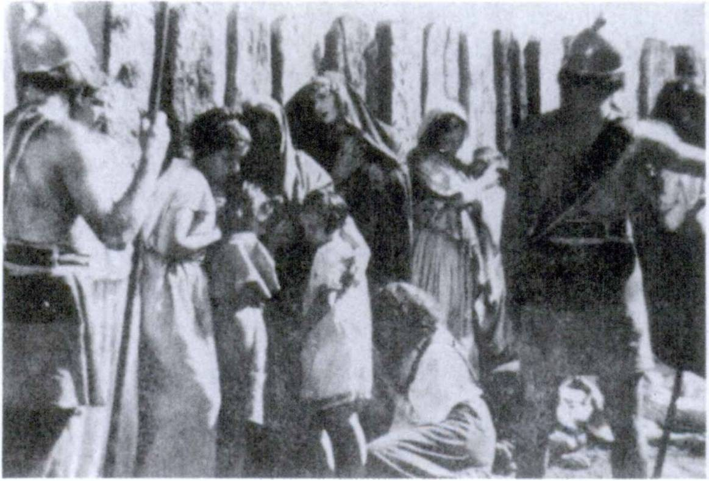244 FIRST YEAR LATIN

OBsiDes

READING NO. 14

DE OBSIDIBUS
Galli obsides inter se saepe dederunt ut amicitiam et pacem con- firmarent. Itaque per obsides amicitia confirmata est atque ita pax in Gallia est confirmata. Galli saepe obsides etiam Romanis dede­ runt ut fidem confirmarent. Romani autem obsides Gallis non dederunt, nam, omnis Galliae imperii cupidi, gentes Galliae armis et virtute vicerant. Itaque Galli Romanos timebant et cum eis bella saepe gesserunt ne obsides eis darent.
Obsides autem pueri et viri et matres et patres erant. Saepe etiam erant filii principum et regum Galldrum. Liberi autem non erant obsides. Eos enim Romani in castris et hibernis et oppidis tenebant ut propter edrum salutem Galli pacem servarent. Itaque obsides saepe miseri erant. Nam, si1 post pacem Galli

1 si: if.

FIRST YEAR LATIN 245

bellum cum Romanis gesserunt, Romani omnes edrum obsides occidebant ut postea1 Galli propter metum fidem servarent. Ita Galli caede obsidum saepe territi sunt et bellum cum Romanis saepe non gesserunt ut obsidum vitas conservarent.
Answer in complete Latin sentences:
- Cur Galli inter se obsides dederunt?
- Cur Galli Romanis obsides dabant?
- Erantne obsides liberi ?
- Ubi tenebantur obsides a Romanis ?
- Erantne obsides saepe miseri? Cur?

“DUCIS IN CONSILIO POSITA EST VIRTUS MILITUM”
—Publilius Syrus

1 postea, adv,: afterwards.

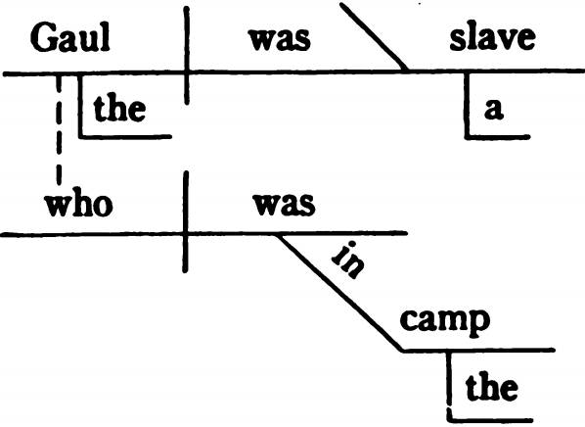

LESSON 24: RELATIVE CLAUSES; THE USE OF AD

- QUI, QUAE, QUOD
The RELATIVE PRONOUN in English is:
  - WHO (whose, whom) for PERSONS;
  - WHICH for THINGS;
  - THAT for PERSONS or THINGS.
The RELATIVE PRONOUN introduces a SUBORDINATE ADJECTIVE CLAUSE.
The Gaul—who was in the camp—was a slave. Those—who fight bravely—do not always win.
The MAIN clauses are:
The Gaul was a slave. Those do not always win.
The SUBORDINATE clauses are:
who was in the camp who fight bravely
These subordinate clauses are ADJECTIVE clauses because, like an adjective, they modify (describe) a noun (the Gaul) or a pronoun (those).

246

FIRST YEAR LATIN 247

In English the relative pronoun :
- May be EXPRESSED:
  - The Gaul—who was in the camp—was a slave.
  - The column—which was in the forest—was long.
  - The column—that was in the forest—was long.
- May be IMPLIED:
  - The Gaul—I saw—was a slave.
Note. Whom is understood after Gaul. The full sentence would read:
The Gaul—whom I saw—was a slave.
In Latin the relative pronoun—qui, quae, quod—is ALWAYS EXPRESSED.
- Gallus—qui in castris erat—servus erat.
- Agmen—quod in silvis erat—longum erat.
- Agmen—quod in silvis erat—longum erat.
- Gallus—quern vidi—servus erat.
Note. Quem is masculine singular because it must AGREE with its antecedent, Gallus, in GENDER and NUMBER. But quem is in the ACCUSATIVE case because it is the object of vidi, the verb in its own clause.

THE GENERAL RULE FOR THE AGREEMENT OF PRONOUNS (GRAMMAR, NO. 479) APPLIES
TO RELATIVE PRONOUNS ALSO.

The ANTECEDENT of a relative pronoun (i. e., the word to which the pronoun refers) is sometimes UNDERSTOOD in Latin when it would be in the nominative case. Express the antecedent when translating into English.
Qui fortiter pugnant, belli gloriam habent.
THOSE who fight bravely have the glory of war.

248 FIRST YEAR LATIN

ASSIGNMENT: Learn the declension of qui, quae, quod (GrAmmAr, No. 139) and the rule for the agreement of pronouns (GrAmmAr, No. 479).

qui, quae, quod auxilium, i
auxilia, auxiliorum memoria, ae
VOCABULARY

who (whose, whom) which
that help aid
reinforcements memory

memoria tened, tenere, tenui, tentus, 2, tr.
keep in memory remember

RELATED ENGLISH WORDS
The pilot turned on the auxiliary motor. They held a memorial
service.

EXERCISE 263
Supply the correct form of the relative pronoun:
- Caesar, who was a great general, conquered the Gauls. Caesar,imperator magnus fuit, Gallos vicit.
- The Gauls whose leaders Caesar killed were not friends of the Romans.
Galli duces Caesar occidit amici Romanorum non fuerunt.
- Caesar, whose victories we all praise, was a great general. Caesar,victorias omnes laudamus, imperator mag­
nus fuit.
- God, to whom we give thanks, is our Father. Deus,gratias agimus, Pater noster est.
- The soldiers to whom Caesar gave rewards were brave. MilitesCaesar praemia dedit fortes erant.

FIRST YEAR LATIN 249
- Caesar, whom the Romans praised, was a great general. Caesar, Romani laudaverunt, imperator magnus
fuit.
- The Gauls whom Caesar conquered fought bravely. GalliCaesar vicit fortiter pugnaverunt.
- The Gauls with whom Caesar fought were brave. Galli-cum Caesar pugnavit fortes erant.
- The war about which the Senate sent letters into Gaul was long and difficult.
Bellum desenatus litteras in Galliam misit longum et difficile fuit.
- The town that Caesar stormed was large. OppidumCaesar oppugnavit magnum fuit.
- The army with which Caesar came into Gaul was large. Exercitus-cum Caesar in Galliam venit magnus erat.
- The victory for which Caesar was eager was not easy. VictoriaCaesar cupidus erat facilis non erat.
- The Gauls burned the baggage that was in the camp. Galli impedimenta in castris erant incenderunt.

EXERCISE 264
[Essential]
Z. Translate;
- Explain the case and agreement of the italicized relative pronouns; •
- Diagram Sentencesl and 2:
1. Romani Christum, qui erat Filius Dei, occiderunt. 2. Maria, quam laudamus, Mater Dei est. 3. Gentes quae provinciae fini- timae erant legatos miserunt ut auxilium peterent. 4. Legid quae trans flumen fuerat in silvas statim missa est ut hostes pel- leret. 5. Bella quae patres nostri gesserunt memoria semper tenebimus. 6. Oppidum in quo frumentum erat a Romanis op- pugnabatur. 7. Imperatdres qudrum memoriam laudamus fortes erant. 8. Legatus obsides quds in castris tenebat occidit ut Gallos terreret. 9. Ego, qui Romanus sum, tibi non cedam. 10. Caesar

250 FIRST YEAR LATIN

auxilia in silvas statim misit ne hostes nostros vincerent.
- Legatus servum cui hostes gladium dederant occidit.
- Hiberna in qutbus Romani sunt angusta sunt. 13. Dabisne nobis, qui Galli sumus, frumentum? 14. Regem pro quo pugnavi omnes homines memoria tenebunt. 15. Romani eos quibuscum pugnaverant saepe occidebant. 16. Caesar, quo cum eram, mihi praemia dedit. 17. Qui legem Christi servant, sancti sunt.
18. Gentes in quorum fines Caesar venit fortiter cum ed pugna- verunt. 19. Legiones quas trans flumen latum prima luce videram a Caesare in castra ductae sunt. 20. Caesar imperium cujus cupidus erat obtinuit.

EXERCISE 265
[Essential]
Z. Translate;
- Explain the agreement and the case of all relative Pronouns in the Latin translation:
- The Romans always killed slaves who had helped the enemy.
- The mountains of Gaul, across which Caesar often led the Roman forces, were high. 3. Caesar often killed the leaders of the tribes with which he fought. 4. Caesar led the troops across many rivers which were long and deep. 5. Christ, who is the Son of God, was killed by the Romans. 6. The legion which was in the forest was fighting bravely. 7. The legion to which the Gauls gave grain was led into winter quarters. 8. The legion the centurions of which were brave conquered the enemy. 9. The legions which Caesar led into the province were brave. 10. The legion with which the Gauls fought was brave. 11. The soldiers whose courage Caesar praised are in winter quarters. 12. The soldiers to whom the general gave thanks had withstood many attacks of the enemy. 13. The Gauls often bravely defended the towns which the Romans stormed. 14. The territory of the enemy into which Caesar led all the Roman forces was full of dangers. 15. The affair concerning which Caesar was treating with the Gauls was serious. 16. The forest through which Caesar

FIRST YEAR LATIN 251

often led the Roman legions was full of dangers. 17. The Roman people on whose behalf Caesar fought was great and renowned.
- Caesar seized many cities from which Rome was far distant.
- The roads which were constructed by the Romans were long and safe. 20. The things on account of which peoples and tribes wage war are serious. 21. Caesar immediately gave the soldiers the grain which the slaves had carried into the camp. 22. Caesar conquered the soldiers with whom the enemy had filled the bridge. 23. I, who am a Christian, will always praise Christ and Mary. 24. We all praise Caesar, whose victories were many and great. 25. The Gauls were storming the camp which had been pitched in their territory. 26. Caesar held the power for which he had been eager. 27. To you who are enemies of the Roman name I shall give neither grain nor arms. 28. We soldiers who fight for Rome are eager for victory and fame. 29. The hill on which the Romans pitched the camp is high.

EXERCISE 266
Translate:
  - “Bis1 vincit qui se vincit in victoria.”—Publilius Syrus.
    - What is the antecedent of qui ?
    - Why is se used instead of eum ?
  - “Omnes enim filii Dei estis per fidem quae est in Christo Jcsu.”—St. Paul.
    - Explain the case of filii.
    - With what does omnes agree ?
  - Jesus Christus, qui pro nobis mortem semel2 * vicit, semper mortem in nobis vincit.
    - Give the rule for the case of mortem.
  - Templum8 Dei sanctum est, quod estis vos.—Adapted from St. Paul.

1 bis, adv.: twice.
2 semel, adv.: once.
8 templum, i: temple.

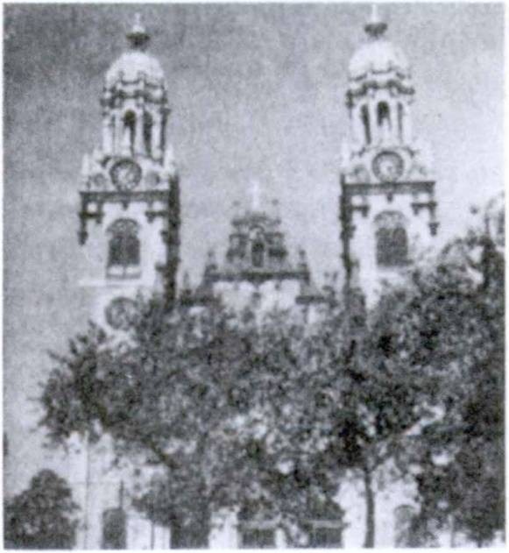2S2 FIRST YEAR LATIN READING NO. 15
THE MOST IMPORTANT “PER” IN THE HISTORY
OF THE LATIN LANGUAGE
Jesus Christ is our Savior. This means that all grace and salvation comes to us through Him. Without Him we can do nothing. He has brought us back to God through His death on the cross, and this is why today the cross sur­ mounts our churches and the crucifix stands above all our altars.
Per Jesum Christum gra- tiam Del habemus. Per Jesum Christum et per ejus mortem salutem et spem gloriae habe­
mus. Per eum in terra tuti sumus; per eum in Caelum post mor­ tem veniemus.
Therefore most of the public prayers of the Church today end with this or a similar formula: ’
. . . per Dominum nostrum Jesum Christum Filium tuum, qui tecum vivit1 et regnat2 in imitate3 Spiritus Sancti Deus per omnia saecula4 saeculdrum.4
The per which begins this formula is therefore the most im­ portant and significant per that has ever been written or spoken.

1 vivit: lives
2 regnat: reigns.
3 unitas, unitatis: unity.
4 saeculum, i: age.

FIRST YEAR LATIN 253

- THE USE OF AD
We have studied a number of prepositions, some governing the ablative case, others the accusative. The preposition in, for ex-
. ample, used with the accusative case after verbs of motion, means
into, in, onto, upon.
In flumen puls! sunt. They were driven into the river.
In castra contendit. He hastened into the camp.
Another preposition which takes the ACCUSATIVE is ad. This word has several meanings and uses.
- Ad is used with verbs of motion (and occasionally others
like pertined) to mean to or up to.
Ad flumen pulsi sunt. They were driven to the river. Ad castra contendit. He hastened (up) to the camp. Ea omnia ad helium pertinent.
AU those things pertain to war.

- Ad is used in expressions of time to mean to, until.
Ad noctem pugnaverunt. They fought until night.

- Ad sometimes also means at, both with verbs of motion and with other verbs.
Ad flumen pervenerunt. They arrived at the river.
Ad flumen castra posuerunt. They pitched camp at the river.

- Ad is used with certain adjectives to mean for. Ad omnia paratus. Prepared for all things. Ad helium utilia. Things useful for war.
- Ad is sometimes strengthened by the adverb usque, all the way. Usque can be frequently left untranslated.
Usque ad urbem contenderunt.
They hastened to. (all the way to) the city.

254 FIRST YEAR LATIN

ad, prep. w. acc.

usque, adv.
VOCABULARY

to until at
for (with adjectives)
all the way

pervenio, pervenlre, perveru, perventum,
4, intr.; in or ad w. acc.
pertined, pertinere, pertinui, 2, intr.; ad
w. acc.
paratus a, um; w. ad utilis, e; w. ad
nox, noctis
RELATED ENGLISH WORDS
arrive

pertain to stretch to
(
prepared (for) useful (for) night

A pertinent remark. No one doubts the utility of water power. China has never been able to utilize all its resources. The bat is a nocturnal animal. Usque is a Latin adverb.
RELATED LATIN WORDS

Venio; teneo; paro.

REVIEW VOCABULARY

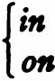in, prep. w. abl.

in, prep. w. acc.

porto, 1, tr.
moved, movere, movi, motus, 2, tr.

contendo, contendere, contend!, 3, intr.

in into
against upon onto on
carry move
strive contend hasten

FIRST YEAR LATIN 255
IDIOM STUDY
A verb is used impersonally when it has no DEFINITE SUB­ JECT. In English we use the indefinite IT as a subject for im­ personal verbs.
It rains.
In this sentence it does not refer to any definite thing.
In Latin many verbs are used impersonally in various con­ structions. When a verb is used impersonally it is always in the THIRD PERSON SINGULAR, and, in compound tenses, the participle is always NEUTER SINGULAR. For the present learn only these two common expressions:
Acriter pugnatum est.
(Literally, It was fought bitterly.)
There was bitter fighting,
(or) They fought bitterly.
Ad flumen perventum est.
(Literally, It was arrived at the river.)
They arrived at the river.
Always translate Latin impersonal verbs into GOOD ENG­ LISH. The Romans used many verbs impersonally which we can­ not so use in English.

EXERCISE 267
[Drill on the use of ad and in]
- Translate;
- Explain the meaning of the prepositions:
1. In fines hostium pervenerunt. 2. Ad flumen pervenerunt.
3. Ad flumen pugnaverunt. 4. Usque ad noctem pugnaverunt.
5. Arma ad bellum utilia sunt. 6. Prima luce ad castra perventum est. 7. Prima luce in castra pervenit. 8. Erat inopia omnium rerum in hibernis nostris. 9. Ad impedimenta acriter pugnatum est. 10. Milites ad omnia parati erant. 11. In locum tutum castra movit. 12. Frumentum in castra portabatur. 13. Duxitne milites in urbem? 14. Duxitne milites usque ad urbem?

256 FIRST YEAR LATIN
15. Milites Romani, ad mortem parati, pro portis instruct! sunt.
16. In silvas contendebat. 17. Ad silvas contendebat. 18. Eos in provinciam misit. 19. Eos ad provinciam misit. 20. In loca aliena milites duxit. 21. In hiberna legatum misit. 22. Ad Caesarem legatos miserunt. 23. Miles in pontem missus est.
24. Miles ad pontem missus est. 25. Caesar undique principes ad
se vocavit. 26. Ad flumen perventum est.

EXERCISE 268
[Essential]
Translate:
- Ad impedimenta acriter usque ad noctem pugnatum est.
- Legati in castra celeriter pervenerunt ut auxilium peterent.
- Mittesne litteras et legatos ad me? 4. Christian! propter Christum ad laborem et mortem parati sunt. 5. Omnia quae ad bellum pertinent ab hostibus nostris comparantur; itaque nos etiam ea quae ad bellum utilia sunt comparabimus. 6. Hostes, gloriae cupidi, usque ad castra nostra venerunt. 7. Duces de om­ nibus rebus quae ad militum salutem pertinent in consilid inter se agunt. 8. Milites ad laborem praemiis facile incitantur. 9. Prima luce ad fines hostium perventum est. 10. Ibi flumen latum erat, sed pons pertinuit ad urbem quam legatus tenebat. 11. Impera- tor omnes legatos et milites ad se statim vocavit. 12. Tribunds militum ad omnes civitates finitimas dimisit ut praemiis et ora- tidnibus amicitiam cum eis confirmarent.

EXERCISE 269
[Essential]
Translate:
1. They arrived at a river which was wide and deep. 2. There was bitter fighting1 at the river. 3. They hastened to Caesar to help him. 4. Did the Romans fight until night? 5. Are the sol­ diers prepared for battle? 6. Swords and arms are useful for

1 Use a Latin idiomatic expression.

FIRST YEAR LATIN 257

war. 7. They prepared everything which pertained to the jour­ ney. 8. They stationed soldiers on the bridge which stretched to Rome. 9. They hastened to the river to defend the bridge.
10. The fresh legions were sent against the Gauls by the lieu­ tenant. 11. They hastened to the hill and fortified it with a ram­ part and a ditch lest the enemy seize it.

WARNING!
Do not confuse ad and the dative of the indirect object. Ad, to, is used with VERBS OF MOTION. The indirect object is rarely used with verbs of motion.
He came to us. Ad nos venit.
He gave rewards to us. Nobis praemia dedit.

SEMPER PARATUS
(Motto of the United States Coast Guard)

EXERCISE 270
[Drill]
Translate:
1. They handed over the arms to the Romans. 2. They has­ tened to the Romans. 3. They gave hostages to the Romans.
- They carried grain to the army. 5. He called the lieutenants to
him. 6. He sent envoys to all the neighboring tribes.

EXERCISE 271
[Review]
  - Give the rule for the ablative of accompaniment.
  - Give the rule for the ablative of agency.
  - Name the secondary tenses of the indicative.
  - Explain the use of sanctl:
Omnes sancti Deum laudant.

258 FIRST YEAR LATIN

- RELATIVE CLAUSES OF PURPOSE

A RELATIVE CLAUSE is very frequently used in Latin in­ stead of an ut-clause to EXPRESS PURPOSE.
The rules for MOOD and TENSE are the same in relative clauses of purpose as in ut-clauses of purpose.
Equites misit qui consilia cognoscerent.
who should learn the plans,
in order that they might learn the plans,

He sent cavalry
in order to learn the plans,
that they might learn the plans, to learn the plans.

A relative clause of purpose should be used instead of an ut- clause whenever possible. It may be used whenever the relative pronoun can, WITHOUT CHANGING THE MEANING, be made to agree with a noun or pronoun in the main clause, thus:
- He sent envoys to seek peace.
Before translating into English, change to :
- He sent envoys WHO should seek peace.
Legatos misit QUI pacem PETERENT.
Sentences 1 and 2 MEAN THE SAME THING, but Sentence
2 shows how the sentence should be translated into Latin.
EXCEPTION. A relative clause of purpose cannot be used when the relative pronoun would have to agree with the SUB­ JECT of an ACTIVE MAIN VERB.
He came to see Rome. Venit ut Romam videret.
This cannot be changed to: He came who should see Rome.

A relative clause may be used to express purpose. Mood: SUBJUNCTIVE.
Tense: Same as in ut-clauses of purpose.

FIRST YEAR LATIN 259

VOCABULARY

deduco, deducere, deduxi, deductus, 3, tr.

cognosco, cognoscere, cognovi, cognitus, 3, tr.
nuntius, I natura, ae
-que, conj.
injuria, ae

NOTE

lead
lead away learn find out
messenger message nature and
injustice wrong

The conjunction -que is always added to the first word tha follows the and.
Maria sanctique Dei. Mary and the Saints of God.
Senatus Populusque Romanus. The Roman Senate and People.
If et were used these would be:
Maria et sancti Dei; Senatus et Populus Romanus.
You have now learned three words for and:
- et, which is the ordinary conjunction in Latin;
- atque, which is more emphatic and emphasizes the second part of the combination;
- -que, which joins things that are more closely associated.
RELATED ENGLISH WORDS
The injured party brought suit. Sherlock Holmes solved crimes by deduction. A papal nuncio.
RELATED LATIN WORD

Duco

Injuria non excusat1 injuriam.

1 excuso, 1, tr.: excuse.

260 FIRST YEAR LATIN

EXERCISE 272
[Essential]
- Translate;
- Diagram Sentences 1 and 2:
- Hostes servum in castra Ckesaris miserunt qui consilia ejus cognosceret. 2. Dux milites ad omnia paratos in aciem deduxit qui hostium copias sustinerent. 3. Nuntium ad te mittam qui de injuriis tecum agat. 4. Dux milites ad collem statim misit qui eum valid fossaque munirent. 5. Misitne rex ad Caesarem nun­ tium qui auxilium peteret? 6. Equites ad flumen misit qui loci naturam cognoscerent. 7. Propter injurias legatum misit qui obsides occideret.

“Deo autem gratias,1 qui dedit nobis victoriam per Dominum nostrum J esum Christum.”
—Vox Sancti Pauli

EXERCISE 273
[Essential]
Translate:
(Use a relative clause of purpose whenever possible.)
- They immediately sent envoys into the camp of Caesar to seek peace. 2. A messenger was sent to Caesar to beg help.
- In front of the gate he stationed soldiers who were prepared for everything. 4. Soldiers were stationed on the bridge to de­ fend it. 5. The chief came to seek grain. 6. He fortified the camp with a rampart lest the enemy storm it. 7. He sent a lieu­ tenant into Italy to lead away the new legions into Gaul.

EXERCISE 274
[Review]
  - What is the rule for the ablative of agency?
  - What is the rule for the ablative of means?

1 Ago or agimus is understood in this sentence.

FIRST YEAR LATIN 261

  - Name the secondary tenses of the indicative.
  - How are verbs used impersonally in Latin? Give an ex­ ample.

READING NO. 16
HOW A HOSTILE KING HONORED THE HEROIC PATRIOTISM OF MUCIUS SGAEVOLA
Porsenna1 regnum Etruscorum2 * 4 5 * obtinebat. Is erat vir fortis et imperii atque gloriae cupidus. Itaque cum Romanis de imperio Italiae contendit et Romam magnis copiis oppugnabat. Romani autem copiam frumenti non habebant et vehementer terrebantur. Erat autem in numero Romanorum vir fortis, Mucius Scaevola.8 Ab eo virtus Romanorum confirmabatur. Eis enim, “In castra Etruscorum,”2 inquit,* “contendam et Porsennam1 regem occidam. Ita Romam servabb.”
Itaque in eorum castra tutus pervenit. (However, he had never seen the King, and so by mistake he killed one of the court offi­ cials instead of Porsenna.) Itaque Etrusci eum ad regem duxerunt. Porsenna1 autem periculo vehementer motus est. Itaque Mucio,8 “Ad me venisti,” inquit,* “ut me occideres. Vitam meam petivisti. Id non sine auxilio neque sine consilib egisti. Si® de consiliis ves- tris me monueris, vitam tuam servabb et te dimittam.”
Mucius autem regi, “Omnes Romani,” inquit,* “ad mortem parati sunt. Periculo mortis non movebuntur. Multi mittentur in castra ad te qui te occidant. Non vitam sed civitatem nostram servabimus. Ego enim neque a te terreor neque metu mortis ter- rebor.”
Erat autem ibi ante® regem ignis.7 Turn Mucius, ut rex vir-

1 Porsenna, ae: Porsenna (a proper name).
2 Etrusci, Etruscorum: the Etruscans (a people who dwelt north of Rome).
8 Mucius (i) Scaevola (ae): Mucius Scaevola.
4inquit: he said. Inquit, as here, is always put after the first words of a direct quotation.
5 si: if.
- ante, prep. w. acc.t before.
7 ignis, is, m.: fire.

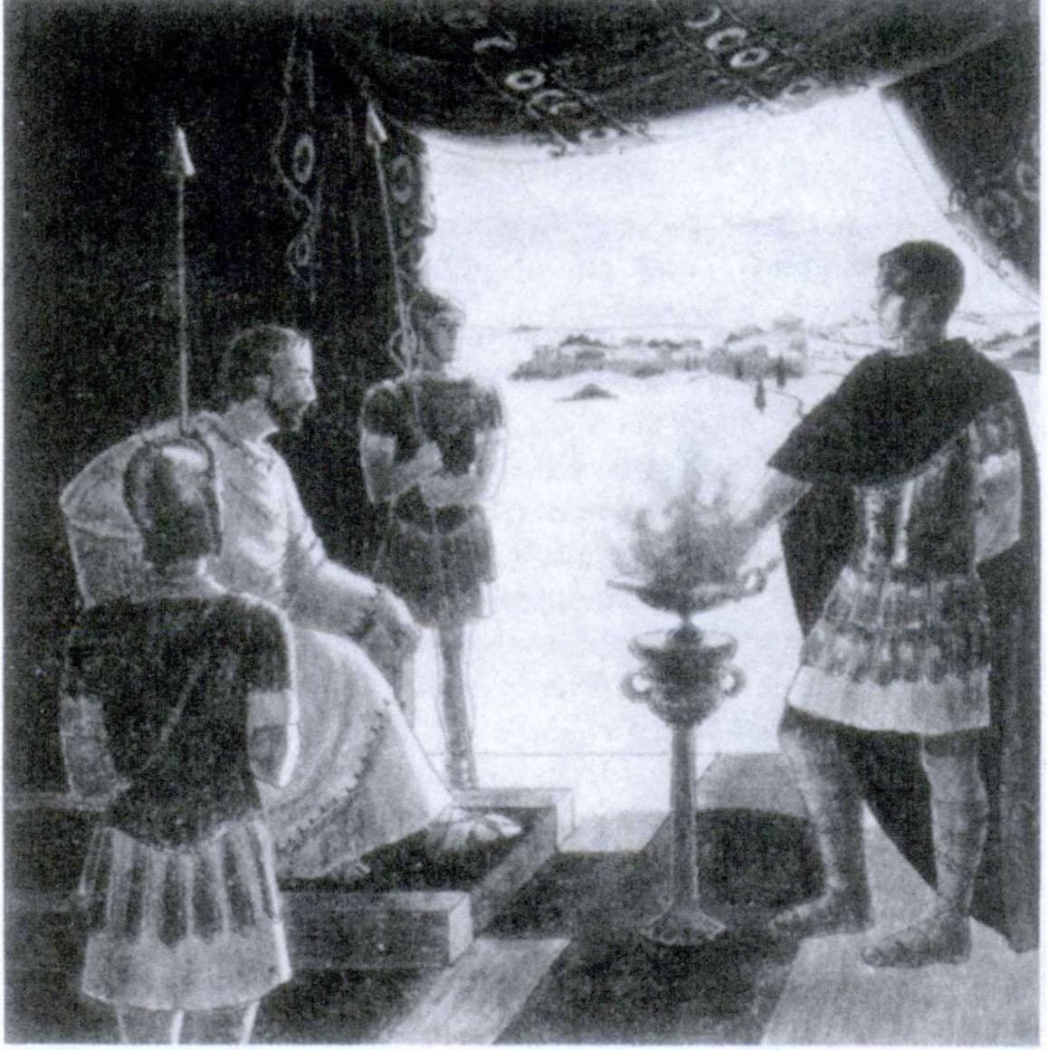262 FIRST YEAR LATIN

Mucius MANUM IN IGNE POSUIT.

tutem Romanam cognosceret, manum dexteram1 in igne2 statim posuit neque dolore3 superatus est. Porsenna autem virtute MUCH vehementer motus est. Itaque ejus et vitam conservavit et vir- tutem laudavit. Eum etiam in castra Romanorum dimisit. Post id rex legatos ad imperatorem Romanum misit qui pacem pete- rent. Ita civitas Romana virtute Mucii servata est.

1 manum dexteram: right hand.
2 ignis, is, m..* fire.
8 dolor, doloris: pain.

FIRST YEAR LATIN 263
4. PURPOSE CLAUSES INTRODUCED BY QUO
When a purpose clause contains a COMPARATIVE, quo is used instead of ut but not instead of ne. Quo in these clauses never changes its spelling. We shall study comparatives later. For the present remember only that the sign of a comparative is the adverb more or the ending -er. These are comparative ad­ verbs :
diutius, longer
facilius, more easily
He sent reinforcements that the legion might more easily conquer the enemy.
Auxilia mlsit quo facilius legio hostes vinceret.
But:
He sent reinforcements lest the enemy fight longer.
Auxilia misit ne diutius hostes pugnarent.
Note. The comparative stands regularly IMMEDIATELY AFTER the quo or ne.

MEMORIZE THE COMPLETE RULE FOR PURPOSE CLAUSES, GRAMMAR, NO. 546.

VOCABULARY
diutius, comparative adv.
facilius, comparative adv.

fonger
more easily

appropinquo, 1, intr.; w. ad or dat. j [ draw near to
[approach
vasto, 1, fr. j[lay waste
[ravage
custos, custodis guard
NOTE
1. Guards are usually soldiers. Therefore what gender is

custos ?

264 FIRST YEAR LATIN

- Appropinquo is intransitive. The English object of ap­ proach or draw near to is expressed in Latin by AD with the ac­ cusative or by the DATIVE. This is the meaning of the notation: “intr.; w. ad or dat.” in the vocabulary.
Hostes ad hlberna (hiberms) appropinquant.
The enemy draws near to the winter quarters.
(or) The enemy approaches the winter quarters.
RELATED ENGLISH WORDS
Modern war brings terrible devastation. The police took the criminal into custody. I am the custodian of this property.

Facilis; facile.

RELATED LATIN WORDS

EXERCISE 275
[Essential]
- Translate;
- Diagram Sentence 1:

1. Legatus custodes ad flumen statim collocavit quo facilius pontem defenderent. 2. Duces Romani agros Gallorum vasta­ bant ne diutius bellum gererent. 3. Caesar centuriones et tri­ bunds militum saepe appellabat quo diutius pugnarent. 4. Im- perator auxilium in primam aciem misit quo diutius et facilius milites hostes pellerent. 5. Equites ad murum appropinqua- verunt; milites autem portae appropinquaverunt.

EXERCISE 276
[Essential]
Translate:
1. They killed the guards that they might more easily approach the camp. 2. They killed the hostages that the enemy might not fight longer. 3. They drove the enemy into the town that they might more easily lay waste the fields. 4. The lieutenant gave re­ wards to the soldiers that they might fight longer. 5. They sta­ tioned guards on the bridge to defend it more easily. 6. They

FIRST YEAR LATIN 265

fortified the winter quarters with a rampart and a ditch that they might repulse the enemy more easily.
EXERCISE 277
[Review]
  - Parse the italicized words:
Reges saepe sunt gloriae cupidi.
  - Give the rule for the ablative of means.

ARMlS VlGIT; VITUS1 VIGTUS EST.
—Seneca writing of Alexander the Great

READING NO. 17
REPORT FROM THE FRONT
The radio has brought the great events of the world into our own parlors. Ringside and battlefront broadcasts keep us up with the news as it happens. Let us imagine that we are ancient Ro­ mans, seated in our home at Rome and listening to a broadcast direct from a winter quarters of Caesar’s army in Gaul.
“Your announcer is Quintus Titurius Mucius, with the Second Legion in their Belgian winter quarters. Your friends here have been enjoying a very quiet winter. The Belgians (clamores subitd2 per radiophoniam* a nobis audiutitur) . . . (Excitedly) Friends, this is it . . . Hostes appropinquant. Hibernis nostris appropin­ quant! . . . Usque ad portas celeriter appropinquant I Auditis clamorem et hostium et nostrdrum. Principes et duces, viri fortes, etiam cum eis appropinquant. Etiam Regem eorum video I Cus- todes nostros statim gladiis occidunt et eds qui in muro sunt tells occidunt quo facilius hiberna oppugnent. Nostri omnes sta­ tim ad arma vocantur. (Voces centurionum per radiophoniam*

1 vitium, i: vice.
2 subitd, adv,: suddenly.
8 radiophonia, ae: radio.

266 FIRST YEAR LATIN

audiuntur.) Tribuni militum muros hominibus complent! Equites per portas celeriter mittuntur. Acriter cum Gallis pugnant! . . . (Magnus clamor subito1 2 3 4 auditur.) Rex . . . Rex hostium tells occisus est! Nunc hostes pelluntur! Cedunt! Silvas petunt! Sed legatus noster, vir bonus et fortis, equites nunc mittit qui eds omnes occidant. Friends, it’s all over and may that be a lesson to them. Fortuna legidnes Romanas semper adjuvat.”

NOTE ON TRANSLATION
The English meanings given in the vocabularies for Latin words give only the basic or general meaning of the Latin. Fre­ quently in translating from Latin into English you should use some other English word, generally a synonym, which expresses the same MEANING as the Latin word but which sounds better in English. Remember your translations should always MAKE SENSE and be GOOD ENGLISH.
For example, you have learned that magnus, a, um means large or great. The Romans used magnus much more frequently than we do large or great. We would often use different adjectives in English to modify different nouns. Thus magna spes would be better translated by high hope than by large hope or great hope.
EXERCISE 278
See whether you can pick the best English adjectives from this list to translate magnus in the following phrases.
EnGLisH ADjeCTives: hard, bright, large, loud (to be used twice), extreme, extensive, bloody.
Example: magna spes
Translation: high hope

- magnus clamor
- magnus labor
- magna vox
- magna caedes
- magna inopia
- magnae silvae
- magnus numerus
- magna lux

1 tubito, adv.: suddenly.

UNIT SEVEN

LESSON 25: DIRECT QUESTIONS
INTRODUCTION
Ordinary-questions which are addressed directly to a person are called DIRECT QUESTIONS and are generally in the in­ dicative mood.
Direct questions, as we have seen, may be introduced by:
- Interrogative adverbs: Cur venisti? Why have you come?
- Interrogative particles: Videsne? Do you see?
- Interrogative adjectives and pronouns: Quid vldisti?
What did you see?

  - INTERROGATIVE ADVERBS
Questions may be introduced by INTERROGATIVE AD­ VERBS.
Ubi fuisti? Where were you?
Cur venit? Why did he come?
Since these words are adverbs, they are not declined and never change their spelling.

VOCABULARY
ubi where?
cur why? whence?
unde from what place?
where . . . from? whither?
quo where . . . (to)?
to what place?

267

268 FIRST YEAR LATIN

NOTE
Ubi and quo can translate the English where. Ubi can be used only when the where refers to place IN WHICH and im­ plies REST; quo can be used only when where refers to place TO WHICH and implies MOTION or direction. Unde can be used only of place FROM WHICH and implies MOTION or direction.
Ubi es? Where are you?
Quo contendis? Where are you hastening?
Unde venis? Where do you come from?

EXERCISE 279
Translate:
1. Ubi eras? 2. Quo contendis? 3. Unde venisti? 4. Cur Caesar bellum cum Gallis gessit? 5. Quo legatus a senatu missus est? 6. Cur sunt Christian! et ad labores et ad mortem parati? 7. Cur Galli saepe obsides inter se dederunt? 8. Cur victorias patrum nostrdrum semper memoria tenebimus? 9. Cur nos American! amicitiam cum omnibus gentibus cdnfirmamus?
10. Cur gratias Deo agimus? 11. Cur Romani hiberna valid fossaque muniverunt?

EXERCISE 280
Answer in complete Latin sentences as shown in Sentence 1:
(Consult map on page 166)
1. Ubi est urbs Roma? (Answer. Urbs Roma est in Italia.)
2. Ubi est flumen Tiberis? 3. Ubi sunt Alpes? 4. Ubi erat pro- vincia cujus imperium Caesar obtinebat? 5. Ubi erant Galli?
6. Ubi Caesar, imperator Romanus, cum Gallis bellum gessit?
7. Quo Caesar a senatu missus est ?

Per magnos labores ad magna praemia perveniemus.
—Adapted from the Roman Breviary

FIRST YEAR LATIN 269

EXERCISE 281
[Essential]
Translate:
1. Where were the guards? 2. Whence have you led the new forces? 3. Where have you hastened from? 4. Where will the lieutenant lead the legions? 5. Whither will you hasten? 6. To what place are you sending the envoys? 7. Why did you yield to the enemy? 8. Why did the Romans fortify the camp with a ditch and a rampart?

EXERCISE 282
[Review]
1. Give the complete rule for purpose clauses.

  - INTERROGATIVE PARTICLES

ASSIGNMENT: Study GrAmmAr, Nos. 502-503.

certus, a, um barbarus, a, um apud, prep. w. acc.
plurimum, adv.
VOCABULARY

certain sure
barbarian among
in the presence of
very much very
am strong

valeo, valere, valui, valitflrus, 2, intr.

cernd, cemere, 3, tr.

NOTE
am well
am influential distinguish see

Barbaras can, of course, be used as a noun to mean barbarian:
Barban puls! sunt. The barbarians were routed.

270 FIRST YEAR LATIN

RELATED ENGLISH WORDS
A valid argument; a valiant warrior.

EXERCISE 283
[Essential]
Translate, and give the “expected” answer in com- plete Latin sentences:
1. Valesne? 2. Num milites sine certa spe fortiter pugnant?
  - Nonne legidnes Romanae barbaros facile superaverunt?
  - Nonne viri qui fortes sunt apud barbaros plurimum valent?
  - Num amicus certus et fortis facile cernitur? 6. Nonne vir fortis in mortis periculd facile cernitur? 7. Nonne victorias legionum Romanarum laudabis? 8. Num Columbus sine magno labore ad terras novas pervenit? 9. Vidistine Romam? Veniesne in Italiam ut earn videas? 10. Nonne acriter pugnabimus ut civi- tatem nostram defendamus? 11. Nonne Caesar plurimum apud Romanos valebit? 12. Num imperatores apud Americanos pluri­ mum valent? 13. Nonne amici apud amicos plurimum valent?

EXERCISE 284
Translate:
    - Was the chief influential among the Romans on account of his faithfulness?
    - You won’t hand over the arms to the Romans, will you?
    - You will defend our free nation, won’t you?
    - The lieutenant said:1 “You see the battle line of the bar­ barians. They are prepared both for death and for victory. Surely you don’t fear them, soldiers! You are brave, are you not? You are Romans, are you not ? Will you fight bravely for the Ro­ man name? Are you not fighting with a sure hope of victory? Is not the cavalry prepared for battle? Haven’t we a large supply of arms and darts? What do you fear? Do you fear death? But men who are eager for glory are always prepared for either death

1 said: inquit (after first words of quotation).

FIRST YEAR LATIN 271
or victory. We are Romans; they are barbarians and Gauls. Bar­ barians will not conquer a Roman legion, will they? Is not Caesar our leader? Do not the barbarians also praise Caesar, do they not fear him ? They will fight without a sure hope of victory. They will not withstand your attack. They will yield. They will be routed. Your victory will be the glory of the Roman Senate and People.”
EXERCISE 285
[Review]
- Give the complete rule for purpose clauses.
- Give the rule of agreement for relative pronouns.

- THE INTERROGATIVE PRONOUN

Who are you ?
To whom did you give the sword ? What did you see?
Whose towns did he burn?
In these sentences who, whom, what, whose are INTERROGA- TIVES because they introduce a question. (Interrogo in Latin means I ask, I question.)
Who, whom, what, whose are PRONOUNS because they take the place of the person or thing to which they refer. They do not DIRECTLY modify a noun.
The Latin interrogative pronoun is QUIS, QUID, who, what.
ASSIGNMENT: Learn the declension of quis, quid in GrAm­
mAr, No. 140.
Study the translations of the examples given above:
Quis es?
Cui gladium dedisti? Quid vidisti?
Quorum oppida incendit?

272 FIRST YEAR LATIN

quis, quid
VOCABULARY

who? what?

ostendo, ostendere, ostendi, ostentus, 3, tr.
traduco, traducere, traduxi, traductus, 3, tr.; two accs. or acc. and trans w. acc.
clam, adv.
socius, i
show
lead across

secretly ally

NOTE
With traduco the thing OVER WHICH the direct object is led, is put either (1) in the accusative, or (2) with trans in the accusative.
Exercitum flumen traduxit. Exercitum trans flumen traduxit. He led the army across the river.
RELATED ENGLISH WORD
A society of nations.

AMICUS CERTUS IN RE INCERTA1 CERNITUR.
—Ennius

EXERCISE 286
[Essential]
Translate:
- Quibuscum pugnavit Caesar ? 2. Cui Galli obsides dederunt ?
- Qui erant Caesaris socii? 4. Legio se barbaris non ostendit ut dam in castra perveniret. 5. Quis plurimum apud Americanos nunc valet? 6. Quis exercitum flumen traduxit? 7. Quis exerci­ tum trans montes altos et flumina lata traduxit ut in Italia cum Romanis bellum gereret? 8. Quis legem sanctam et lucem veri- tfitis nobis dedit ? 9. Cui castra nostra ostendisti ?

1 incertus, a, um: uncertain, dubious.

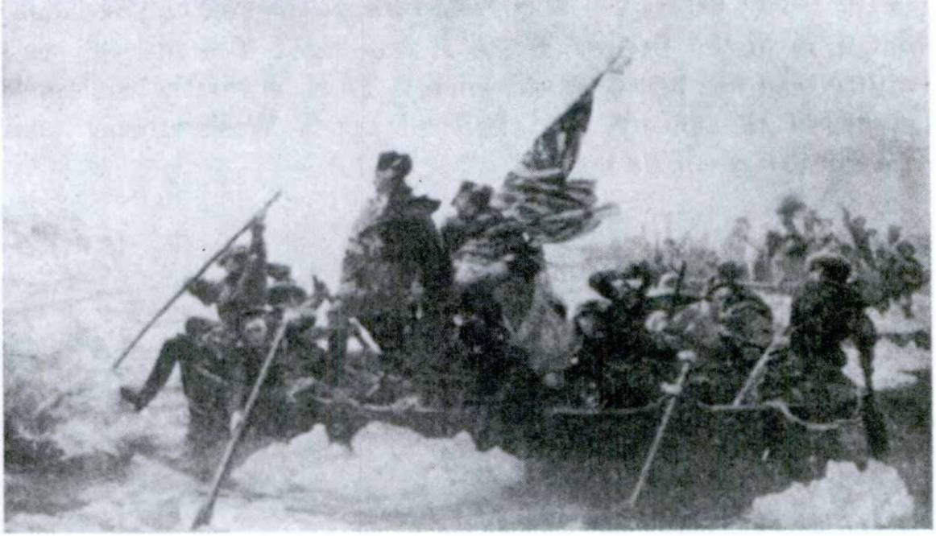FIRST YEAR LATIN 273

WAsHinGToniUs exerCiTUm TrAns fLUmen TrADUCiT.

EXERCISE 287
Translate:
(When the English may be either singular or plural translate both ways in Latin.)
1. To whom did you give the reward? 2. With whom were you? 3. Whom did you see? 4. Whose courage do you praise?
- What do you seek? 6. What (things) did you hear? 7. What did he show you? 8. Who came secretly into the camp? 9. Who are your allies? 10. For what are you prepared? 11. To whom did you send help ?

EXERCISE 288
[Honor Work]
Translate:
Washington,1 a brave and noble man whose courage we all keep in memory, was the American general in our first war. He

Washington: Washingtonius, i.

27 4 FIRST YEAR LATIN

led the troops across the river Delaware1 to conquer the Germans2 who were in the British3 army. It was night. The soldiers were neither seen nor heard by the enemy. Thus he swiftly and easily conquered the enemy. We shall all praise Washington’s4 plan and courage, shall we not ?
Answer in Latin:
- Quis fuit Washingtonius ?
- Qui eum laudant?
- Quibuscum bellum gessit?
- Cernebanturne ejus milites ab hostibus ?
- Quds vicit Washingtonius ?

EXERCISE 289
[Review]
- Give the rule for agreement of relative pronouns.
- When is quo used to introduce a purpose clause?
- Give the rule for the ablative of means.

- THE INTERROGATIVE ADJECTIVE

Which men did you see?
Quds virds vldisti?
Quds here modifies and agrees with virds. It is used, there­ fore, as an ADJECTIVE and not as a pronoun. It is an INTER­ ROGATIVE because it introduces a question.
The INTERROGATIVE ADJECTIVE in Latin is declined exactly like the relative pronoun.
But in the NOMINATIVE MASCULINE SINGULAR quis
is generally used as an adjective for which or what, qui for what sort of, what kind of.

1 Delaware: Delawarense, Delawarensis.
2 Germans: German!, Germandrum.
3 British: Britannicus, a, um.
4 Washington: Washingtonius, I.

FIRST YEAR LATIN 275

VOCABULARY
qul, quae, quod which?
what?

REVIEW VOCABULARY
voco, 1, tr.; two accs. call
call

appello, 1, tr.; two accs.

ostendo, ostendere, ostendl, ostentus, 3, tr.
nomen, nominis
IDIOM STUDY
Verbs of calling, naming, making, showing, etc.,
call upon address show
name

may take two

accusatives, one of the direct object, the other a predicate accusa­ tive.
Te amlcum voco.
I call you friend.

(Ego) voco te / amicum

Caesarem imperatdrem appellaverunt.
They called Caesar general.
But when nomen is used, nomen is in the ablative.
Caesarem nomine imperatdris appellaverunt.
They called Caesar by the name of general.
Caesar centuridnes nomine appellavit.
Caesar called upon the centurions by name.

EXERCISE 290
Translate:
- With which allies? 2. With the army of which king? 3. On account of what wrongs? 4. In which towns? 5. In what camp?
- Among which tribes? 7. Up to what river? 8. By what name did they call you? 9. What guards did he station? 10. What

276 FIRST YEAR LATIN

man called Caesar king? 11. In what place did he pitch camp?
12. To what messenger did he give the letters? 13. To which envoys did he send the letters? 14. Christ called us brothers.
15. For what are arms useful? 16. Which town are we approach­ ing? 17. What rivers are wide and deep? 18. What tribes are exchanging hostages? 19. To what town does the bridge stretch?
20. To what guard did he show himself? 21. To what king do they give thanks? 22. In what thing do they put hope?

EXERCISE 291
[Essential]
QUIZ ON AMERICAN HISTORY
Can you score 100% ?
1. Propter quas injurias nos bellum cum Japonibus gessimus?
- Quis nuntius quern omnes memoria tenemus per oppida con­ tends ut omnes adventum Britanndrum exspectarent ?
- Quis imperator Americanus trans flumen quod Delaware vo- camus exercitum traduxit ut ad castra hostium clam perveniret ?
- Cui genti1 gratias American! egimus propter auxilium quod in primo nostro bello ad nos misit ?
- Quis dux copias nostras in Bataan deduxit quo diutius cum Japonibus pugnaret ?
- In quo bello hostes urbem Washington incenderunt?
- Quern ducem milites “Stonewall” appellaverunt ?
- Qu! Galli prim! viderunt flumen quod Mississippi vocamus?

EXERCISE 292
[Essential]
Translate:
- Augustus primus imperator2 Romanus fuit. Augustus autem non regem sed principem se vocavit, nam Romani nomen rSgis timuerunt.
1 gens here means nation.
2 imperator here means emperor.

FIRST YEAR LATIN 277

- Omnes American! Washingtonium “Patrem Patriae”1 ap- pellaverunt. Washingtonius enim civitatem nostram defendit atque conservavit sicut patres filios defendunt atque conservant.
- Rex et imperator Germanorum se “Caesarem”2 * appellavit
Answer in complete Latin sentences:
- Quo nomine Augustus se vocavit?
- Quo nomine American! Washingtonium appellaverunt ?
- Quis rex “Caesarem” se appellavit?

READING NO. 18
A GALLIC CAPTIVE
A Gallic captive is brought before the legatus for questioning. The Roman camp is in the wilds of Belgium, a land of thick forests and fierce tribes. There have been rumors of rebellion against the Roman army of occupation. The legatus is leading a relief expedition and it is important for him to get full informa­ tion concerning the enemy.
LEGATUS. Quis es ? Unde venisti ? GALLUS (with grim laugh). Non cognovi.
LEGATUS. Ha! Non cognovist!! Nonne tu Gallus es ? GALLUS. Non cognovi.
LEGATUS. Ubi sunt copiae vestrae? Qu! sunt soci! vestri? GALLUS. Non cognovi.
LEGATUS. TU ad mortem ducerisl Num ad mortem paratus es?
GALLUS. Ita. Ad mortem paratus sum. Ea quae petis non tibi ostendam. (The legate summons the torturers. They torture the Gaul.)
LEGATUS (sarcastically). Id diu sustinebis, nam ad mortem paratus es.
GALLUS. Eheu! Eheu! Eheu!8
LEGATUS. Quid? Num times? Nonne fortis es? Nonne ad

1 pa tri a, ae: country, fatherland.
2 The word Kaiser is a German form for Caesar.
8 eheu, eheu: an interjection expressing grief or pain.

278 FIRST YEAR LATIN

mortem paratus? (The torturing stops; the Gaul lies exhausted on the ground.)
LEGATUS. Itaque nunc ad mortem duceris. GALLUS. Eheu! Eheu! Non! Non!
LEGATUS (smiling). Quid est? Num cognovisti? GALLUS. Cognovi.
LEGATUS. Quis plurimum apud gentes vestras valet? Quern principem et ducem vocatis?
GALLUS. Ambiorigem1 et Catuvulcum.2 LEGATUS. Qui sunt socii gentis tuae?
GALLUS. Omnes Galliae gentes atque German!. LEGATUS. German!!
GALLUS. Ita est! Copias trans flumen Rhenum traducunt et celeriter in fines nostros pervenient.
Legatus. Ubi nunc sunt copiae vestrae?
GALLUS. In silvis ad flumen castra posuerunt.
LEGATUS. Num copiam frumenti habent? Omnia frumenta quae in agris erant incendimus atque magna copia in hiberna portata est.
GALLUS. Ita. Magnam copiam habent. Socii inter se obsides
dederunt et ad nos frumentum miserunt. Habent etiam copiam armdrum et telorum. Nam expugnavimus hiberna Romana quae in finibus nostris posita erant.
LEGATUS. Quid? Num hiberna Romana expugnavistis? Quae castra? Num castra Romana expugnavistis?
GALLUS. Expugnavimus. Magna fuit caedes.
LEGATUS. Per deds immortales!3 Propter injurias agros vestros vastabimus; oppida incendemus; matres et patres et pueros oc- cidemus!
GALLUS. Milites nostri etiam ad bellum parati sunt. Eds non
vincetis.

1 Ambiorix, Ambiorigis: Ambiorix.
2 Catuvulcus, i: Catuvulcus.
3 per deos immortales: by the immortal gods.

FIRST YEAR LATIN 279

LeGATUs. Cur hiberna expugnavistis ? Nonne pax et amicitia fuit inter gentes vestras et Populum Romanum?
GALLUs. Ita, sed Romanos timemus. Semper frumentum pe- tunt; arma petunt; servos petunt; obsides petunt. Imperii et belli semper sunt cupidi. Vitas nostras et civitates nostras liberas defendimus.
LeGATUs (angrily). Quod in fide cum Populo Romano non mansistis, vos omnes occidemini! Et tu (he shakes his finger at the prostrate Gaul) primus ad mortem duceris. (He addresses the guards.) Statim ad mortem!

EXERCISE 293
[Review]
- Give the complete rule for purpose clauses.
- Give the rule for the ablative of means.
- Translate, and explain the translation of the italicized phrases:
  - He sent help to the first battle line.
  - They handed over their arms to the enemy.

LESSON 26: THE PERFECT SYSTEM ACTIVE OF THE SUBJUNCTIVE

    - PERFECT AND PLUPERFECT SUBJUNCTIVE ACTIVE
The perfect and pluperfect subjunctive of all LATIN VERBS, regular and irregular, are formed in the same way.

laudav- monu-

- Find the perfect stem

mis- audiv- fu-

- Add the endings shown in GrAmmAr, Nos. 200-207.

VOCABULARY

incold, incolere, incolul, 3, tr.

consisto, consistere, constiti, 3, intr.

inhabit dwell in
halt
take a position

- Give the perfect stem;
EXERCISE 294

- Give the third person, singular and plural, of the perfect and pluperfect subjunctive:

1. pervenid | 7. pertineo | 13. incolo
2. retineo | 8. ago | 14. compleo
3. administro | 9. cedo | 15. contineo
4. venid | 10. confirmd | 16. contendo
5. moneo | 11. consisto | 17. instruo
6. pello | 12. appropinquo | 18. comparo

280

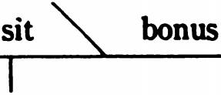
 | FIRST YEAR LATIN | 281
 | EXERCISE 295
 | What forms are these?
1. fuisset | 9. cognovissent | 17. constitisses
2. cognoverit | 10. exspectaverit | 18. . cesseris
3. incoluisset | 11. pervenisset | 19. audiveritis
4. miserim | 12. deduxisset | 20. monuissent
5. expugnavisset | 13. constitisset | 21. pervenerit
6. laudaverit | 14. vastavissent | 22. egissent
7. constiterint | 15. appropinquavisset | 23. Instruxissem
8. vicerint | 16. incoluerint | 24. misissemus

    - INDIRECT QUESTIONS; PRIMARY SEQUENCE
As we have seen, a question asked directly is called a DIRECT QUESTION.
Estne Deus bonus? Is God good?
Valesne? Are you well?
When a question, however, DEPENDS on a verb of ASKING, SAYING, THINKING, and the like, it is called an INDIRECT QUESTION.
Rogo sitne Deus bonus. I ask whether God is good.
Rogo valeasne. I ask whether you are well.
Sitne Deus bonus and valeasne are INDIRECT QUES­ TIONS because they depend on the verb rogo.
Indirect questions are NOUN CLAUSES because they are used as the OBJECT of a verb (rogo).

Deus

-ne

(Ego) rogo

282 FIRST YEAR LATIN

Indirect questions may be introduced by the same adverbs, adjectives, pronouns, and particles as direct questions, but:
-Ne and num in indirect questions mean whether (if).
Nonne is seldom used.
Qui is sometimes used for quis.
He asks whether Caesar conquered the Gauls.
Rogat num Caesar Gallos vicerit.
He asks who Caesar was.
Rogat quis Caesar fuerit.
He asks where, we are.
Rogat ubi simus.
The TENSE in indirect questions is determined by the rule: TENSE BY SEQUENCE.

THE MOOD IN INDIRECT QUESTIONS IS ALWAYS SUBJUNCTIVE.

ASSIGNMENT: Learn the general rule, GrAmmAr, Nos. 524-526.
IN PRIMARY SEQUENCE:
- Use the PRESENT subjunctive when the action of the verb in the indirect question happens AT THE SAME TIME as the action of the main verb.
Caesar asks whether the soldiers are fighting.
Caesar rogat num milites pugnent.
- Use the PERFECT subjunctive when the action of the verb in the indirect question happens BEFORE the action of the main verb.
Caesar asks whether the soldiers were fighting (fought).
Caesar rogat num milites pugnaverint.

FIRST YEAR LATIN 283
VOCABULARY
rogo, 1, tr. ask
quaero, quaerere, quaesivi, quae situs, 3,•tr. 1 f
quantus, a, um, inte•r^{x}ro^{x.}gJa⁻ tive ad]. j\ ,how large?. [/tow great?
munitio, munitionis fortification

genus, generis, n.
[ fond
[race

aqua, ae water

RELATED ENGLISH WORDS
The prisoner of war was interrogated. He was asked many questions. Modern wars require a great quantity of munitions. What is the genus of this tree? The Romans built many long aqueducts. Aquatic sports are much in favor at the Florida beaches. Rogation days.

Muni 6
RELATED LATIN WORD

Alcohol is called AQUA VITAE.

EXERCISE 296
- Point out the indirect question;
- Point out the introductory word;
- Explain the mood and tense in the indirect question;
- Diagram Sentences 1 and 5;
- Translate:
1. Rogat num copiam aquae habeamus. 2. Rogat num Caesar Gallos vicerit. 3. Quaeret ubi hostes constiterint. 4. Quaeret ubi copia aquae sit. 5. Rogat quis imperator sit. 6. Quaerit quos

284 FIRST YEAR LATIN

Caesar vicerit. 7. Rogabit valeantne milites. 8. Quaeret vicerit- ne Caesar barbards. 9. Rogat quae genera hominum Americam incolant. 10. Quaerit quae genera hominum Galliam turn inco- luerint. 11. Quaeret quantas munitiones hostes paraverint.
12. Rogabit quae munitionum genera nos paremus. 13. Rogat quae gentes Galliam incolant. 14. Quaerit quae gentes provinciam incoluerint.
EXERCISE 297
[Imitation]
Imitate the word order and structure of the model in translating:

MODEL: Rogo quos milites viderit.
I ask what soldiers he saw,
1. I ask what hostages he killed. 2. I ask what general he praised. 3. I ask what plans he has learned. 4. I ask what hills he has occupied.

MODEL: Rogat ubi milites sint.
He asks where the soldiers are.
1. I ask where the general is. 2. I ask where the enemy is.
- I ask where the fortifications are. 4. I ask where the winter quarters are.

EXERCISE 298
[Review]
  - Translate, and explain the translation of the italicized phrases :
    - They sent letters to the Senate.
    - They gave rewards to the slave.
  - Give the rule for the agreement of relative pronouns.
  - Translate; parse ad and pugnatum est: Ad flumen diu pugnatum est.
  - Give the complete rule for purpose clauses.

FIRST YEAR LATIN 285

READING NO. 19
[Essential]
WAR INFORMATION
It is of vital importance for a general to have the fullest pos­ sible information about the enemy before committing his troops to battle. Many military disasters have been due to ignorance either of the enemy’s force and disposition or of the detail of the battleground. When the Battle of Gettysburg opened, Lee’s scouts were away on a foraging expedition. The Union army was there­ fore able to reconnoiter and seize the most strategic points on the field and fight the action from chosen positions. Lee’s army was terribly defeated.
Today every resource is used to discover vital war informa­ tion. Hitler’s invasion of Poland was backed by scientific study of every pertinent detail. Even the weather conditions had been calculated. During the years preceding the invasion of Europe in World War II, Allied experts studied the minutest detail of the invasion coast of Fortress Europe. Planes, spies, maps, sci­ entists, travelers, refugees—all were used to place before the general staff the fullest possible information.
Military experts have always recognized the importance of such information. Caesar, too, though he lacked maps of modem technical excellence, as well as planes and swift-moving scouting cars, made extensive inquiries before launching a campaign. There were Roman spies, Gallic refugees, merchants—all of whom he consulted. The Roman army sent out cavalry and special scouts (expldrat ores) to study the terrain (ndtura loci) and the dis­ position of the opposing forces.
What then would a general wish to know?

Ante1 proelium imperator legatos et tribunos militum in con­ cilium vocat. In concilid quaerit quantum numerum et equitum et militum hostes habeant, ubi castra hostium sint, quantas para- verint munitidnes; num copiam aquae et frumenti habeant; quantam armorum copiam habeant. Quaerit etiam quae sint por-

1 ante, prep. w. acc.: before.

286 FIRST YEAR LATIN

ConCiLiUm
tus et flumina et montes in hostium finibus; quae genera hominum eas partes incolant; num omnia quae ad bellum pertinent paraverint; num fortes sint et cupidi belli gloriae; num acriter pugnent; quds duces habeant, num boni sint. Ante1 proelia im- perator equites mittit qui naturam loci expldrent et cognoscant ubi hostes consti- terint. Cognoscit num aciem instruxerint; num ad proeli- um sint parati.

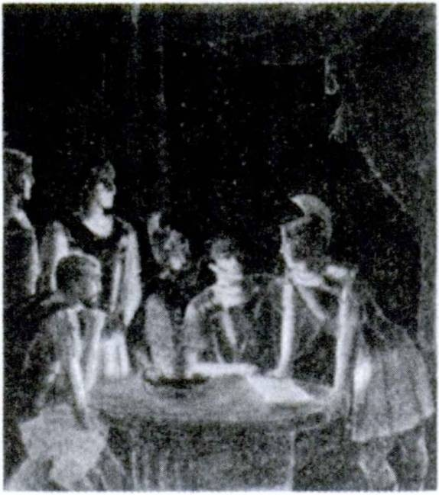Ita Caesar et omnes magni duces saepe hostes superaverunt quod omnia quae ad proelium pertinent cognoverant.

    - SECONDARY SEQUENCE
We have seen that the MOOD in indirect questions is always subjunctive and that the TENSE is determined by the rule: TENSE BY SEQUENCE. Review the general rule, GrAmmAr, Nos. 524-526.
IN SECONDARY SEQUENCE:
- Use the IMPERFECT subjunctive when the action of the verb in the indirect question happens AT THE SAME TIME as the action of the main verb.
Caesar rogavit num milites pugnarent.
Caesar asked whether the soldiers were fighting. 2
- Use the PLUPERFECT subjunctive when the action of

1 ante, prep. w. acc.: before.

FIRST YEAR LATIN 287

the verb in the indirect question happens BEFORE the action of the main verb.
Caesar rogavit num milites pugnavissent.
Caesar asked whether the soldiers had fought.

VOCABULARY
cogo, cogere, coegi, coactus, 3, tr.
verus, a, um

inquit

[ collect [force true
| he says
| he said

NOTE
Inquit is always used with DIRECT quotations; that is, with quotations enclosed in QUOTATION MARKS:
Christus, “Vos,” inquit, “fratres estis.”
Christ said, “You are brothers.”
This is a direct quotation because it contains the EXACT words used by Christ and is therefore enclosed in quotation marks. Notice that inquit does NOT stand before the quotation but is ALWAYS put after one or several words of the quotatioa
RELATED ENGLISH WORDS
A cogent argument. The eternal verities. A veracious witness. We cannot question the veracity of St. John.

RELATED LATIN WORDS
Veritas; ago.

EXERCISE 299
[Secondary Sequence]
- Translate;
- Explain the tense of the italicized words:
1. Legatus quaesivit quantam aquae copiam milites haberent.
- Legatus quaesivit ubi hostes constitissent. 3. Barbari quaesi-

288 FIRST YEAR LATIN

verunt quantam militum copiam Romani coegissent. 4. Barbari quaesiverunt ubi Romani castra posuissent. 5. Quaesiverat quae esset natura montis. 6. Quaesiverat quantum obsidum numerum legatus coegiwet 7. Quaerebat qui portus essent in eis locis.
- Quaerebant num hostes colies occupavissent. 9. Romanus, “Quaero,” inquit, “num Deus vester sit Deus verus.”

EXERCISE 300
Imitate the word order and structure of the model in translating:

MODEL: Genturio quaerebat num copia frumenti in castris esset.
The centurion was asking whether there was a supply of grain in the camp.
1. The military tribune was asking whether there was an abun­ dance of water in the winter quarters. 2. The lieutenant was asking whether there was a bridge on the river. 3. The bar­ barians were asking whether there were soldiers in the forest.

MODEL: Legatus quaesivit ubi Galli constitissent.
The lieutenant asked where the Gauls had taken up a position.
1. The leader asked where the enemy had stationed the guards.
- Caesar asked where the Gauls had prepared fortifications.
- The barbarians asked where Caesar had drawn up the troops.

EXERCISE 301
[Essential]
  - Translate;
  - Parse the italicized words:
1. Legatus, “Quaerd,” inquit, “qui sint socii vestri.” 2. Tri- bunus militum quaesivit quae hominum genera loca incolerent.
- Romani magnas munitidnes paraverunt quo facilius hostes

FIRST YEAR LATIN 289

pellerent. 4. Barbari impetum in agmen fecerunt ne milites cer- tum ordinem servarent. 5. Quaerd num Caesar plurimum apud Romanos valuerit. 6. Quaerit num amicus verus atque certus facile cern&tur. 7. Nonne Christian! Christum nomine regis ap­ pellant ? 8. Quaero num Christum regem atque Dominum vocetis.
- Rogavit quo principes convenissent. 10. Diu atque acriter pugnatum est in loco angusto et difficili ne hostes agmen flumen traducerent. 11. Legatum misit qui obsides clam ad castra dedu- ceret. 12. Dux rogavit quantam copiam aquae frumentique servi in hiberna portdvissent. 13. Eques duel ostendit ubi copiae hostium ednstitissent. 14. Quo principes copias coegerunt?
- Ei custodes occiderunt et usque ad castra nostra appropinqua- verunt. 16. Romani collem valid fossaque muniverunt quo diutius copias hostium sustinerent. 17. Quaerit cur gentes barbarae obsides inter se dederint. 18. Dux equitem celeriter misit qui auxilium peteret. 19. Imperator quaesivit num tribuni militum omnia comparavissent. 20. Rogat unde equitatus contenderit.

EXERCISE 302
[Essential]
Translate:
1. I asked where the enemy was. 2. They asked whether the chief led the barbarians across the river. 3. They asked whom we called king and emperor. 4. We asked what chief was influen­ tial among them. 5. We asked where the barbarians had taken up a stand.1 6. They ask what races of men inhabit Gaul now.
7. We ask what kinds of arms they have. 8. The lieutenant asked how great fortifications they had prepared. 9. We asked why they were fighting without a sure hope. 10. We asked where they had led the allies. 11. He asked whence they had come.
- They had secretly collected the hostages into a safe place.
- He asked whether they had seen the column of the enemy.
- He said, “Aren’t you a brave and sure friend?” 15. He ad­

1 take up a stand - take a position.

290 FIRST YEAR LATIN

dressed the centurions by name, that they might fight longer.
- He asked where there was an abundance of water.

EXERCISE 303
[Formal Review of Unit Seven]
  - How may direct questions be introduced in Latin? What mood is used?
  - What is the difference between ubi and quo ?
  - What is the difference between -ne, num, and nonne? Give Latin examples of each, and translate the examples of num and nonne several ways into English.
  - Decline the interrogative pronoun. Why is it a pronoun?
  - Decline the interrogative adjective qui.
  - When is quis used as an adjective?
  - Is qui ever used for quis ?
  - What construction do verbs of TRANSPORTING take?
  - What construction do verbs of CALLING, etc., take?
  - What are the endings of the perfect and pluperfect sub­ junctive active? What stem is used?
  - What are indirect questions?
  - What mood is used in indirect questions? How are they introduced ?
  - Can -ne, nonne, and num be used in indirect questions?
  - Is qui ever used for quis in indirect questions?
  - Give the rules for sequence.
  - What does inquit mean and how is it used ?
  - Give Latin examples illustrating the use of each subjunc­ tive tense in an indirect question.

READING NO. 20
BATAAN!
Vos omnes cognovistis quantas copias nostri milites in Bataan1 diu sustinuissent. Japones enim magnum et fortem impetum in

1 Bataan, indecl. noun: Bataan.

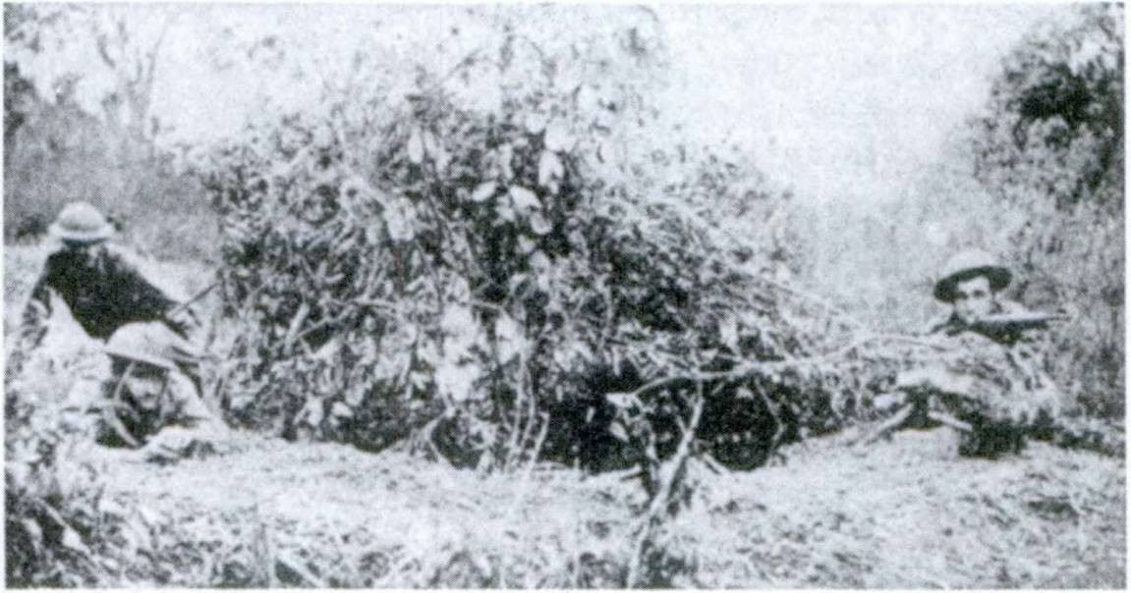FIRST YEAR LATIN 291

MUiTes AmeriCAni forTiTer pUGnAnT.

insulas1 Philippines2 fecerunt. Omnia armdrum et telorum genera quae nunc ad bellum utilia sunt habebant. Etiam magnum nume- rum omnium generum militum in insulas1 traduxerant. Quaesi- verant qui portus, quae loci natura, quae flumina essent. Omnia quae ad bellum pertinebant cognoverant. Itaque dux noster, vir magnus et fortis, omnes copias nostras in loca difficilia et angusta quae Bataan vocant deduxit quo diutius impetum hostium susti- neret. Munitiones celeriter paravit; custodes collocavit; milites instruxit; impetus hostium exspectavit. Undique nostri ab hosti- bus et loci natura continebantur neque erant multi milites Ameri­ cani in Bataan; tamen diu et acriter ibi pugnatum est. Nam nos­ tri fortes erant et gloriae nominis Americani cupidi erant. Multos impetus fortiter sustinuerunt; saepe hostes post magnam caedem pepulerunt.
Interim cognovimus quanto in periculo nostrae legiones essent et quaerebamus cur duces nostri magnam armdrum et militum copiam non mitterent. Ei tamen omnia pericula cognoverant. Itaque auxilia non miserunt ne hostes ea occiderent.

1 insula, ae: island.
2 Philippinus, a, um: Philippine.

292 FIRST YEAR LATIN

Tandem1 nostri, propter magnum hostium numerum, non diu- tius sustinuerunt. Itaque hostibus se dederunt atque arma tradi- derunt. Dux autem noster, “The President,” inquit, “of the United States ordered me to break through the Japanese lines and pro­ ceed from Corregidor to Australia for the purpose, as I understand it, of organizing the American offensive against Japan. A primary purpose of this is the relief of the Philippines. I came through and I shall return.”
Nonne virtutem militum fortium semper laudabimus atque me- moria tenebimus ? Gloria enim edrum gloria nostra est.

1 tandem, adv.: finally.

UNIT EIGHT

LESSON 27: THE VOCATIVE; IMPERATIVE MOOD
- THE VOCATIVE
You, 0 Lord, I praise.
We shall not help you, Caesar!
In these sentences O Lord and Caesar:
- Show the PERSON ADDRESSED OR SPOKEN TO.
- Are therefore in the VOCATIVE case—the case of the PERSON ADDRESSED.
- Are set off by commas because they are independent of the grammar of the rest of the sentence.
Te, O Domine, laudo.
Te, Caesar, non adjuvabimus.

ASSIGNMENT: Learn the rule for the formation of the vocative, GrAmmAr, No. 28.

ave! interjection
mora, ae
VOCABULARY

hail! delay

doceo, docere, docui, doctus, 2, tr. tollo, tollere, sustuli, sublatus, 3, tr. peccatum, I
teach inform
raise (up) take away mistake
sin (in Christian Latin)

293

294 FIRST YEAR LATIN

NOTE
Doced takes two accusatives when it means teach someone, something.
Christus nos viam salutis docet.
Christ teaches us the way of salvation.
However, doced can also be used with other constructions:
Gustos Caesarem docuit ubi hostes essent. (Indirect question.) The guard informed Caesar where the enemy was.
Legatus eum de omnibus rebus docuit. (De w. abl.)
The lieutenant informed him about all the things (the whole matter).

RULE OF POSITION: THE VOCATIVE IN LATIN GENERALLY DOES NOT STAND FIRST
IN THE SENTENCE.

EXERCISE 304
Give the vocative, singular and plural, for the following:

1. dux | 12. eques | 23. | mater
2. legatus | 13. Christus1 | 24. | puer
3. nuntius | 14. fra ter | 25. | Gallus
4. custos | 15. Christianus | 26. | senatus
5. Spiritus1 | 16. miles | 27. | rex magnus
6. barbarus | 17. Romanus | 28. | amicus bonus
7. socius | 18. tribunus militum | 29. | frater meus
8. Maria1 | 19. vir | 30. | dominus nobilis
9. Jesus1 | 20. homo | 31. | vir liber
10. centurid | 21. dominus | 32. | miles fortis
11. amicus | 22. filius | 33. | filius meus

1 Give the singular only.

FIRST YEAR LATIN 295

EXERCISE 305
Translate:
- Nonne gratias agemus, fratres mei, Domino nostro Jesu Christo, qui peccata mundi sustulit et nos veritatem docuit?
- Ave, Caesar! Docebo te ubi hostes castra posuerint.
- Vos, milites, sine mora pontem occupabitis ne barbari eum occupent. 4. Te, Fili Dei, laudamus. 5. Centurid, “Hostes, le­ gate,” inquit, “magnum clamorem sustulerunt et se nobis sine mora dederunt.” 6. In te, O bone Jesu, est spes omnium. 7. Hos­ tes, rex magne, virtute et armis vicimus. 8. Tibi, Deus, gratias ago; te, Deus, laudd; in te, O Deus, est omnis spes mea. 9. Tu, Domine, servabis nos. (From the Roman Breviary.) 10. Ave, Caesar, imperator et rex noster es! 11. Ave, Jesu Christe, qui pro nobis multos labores atque mortem miseram sustinuisti.

EXERCISE 306
[Essential]
Translate:
  - O good Jesus, in You we place all our hope and faith.
  - Thou, O God, hast taught us Thy ways. 3. My son, God will always defend you. 4. Soldiers, without delay we shall occupy the bridges and the hills. 5. O noble king, we have come to seek peace. 6. Hail, Mary! 7. The enemy raised up a shout on all sides to terrify us. 8. Hail, Caesar! To you do we all give thanks, for you have spared our lives. 9. Soldiers, we are held in on all sides by the enemy, who is eager for victory and glory.
10. General, I shall inform you where the enemy has pitched camp in order that you may attack it.

EXERCISE 307
[Review]
i . How are -ne, num, and nonne used (1) in direct questions ?
(2) in indirect questions?
- What is the difference between ubi and quo?

296 FIRST YEAR LATIN

- PRESENT IMPERATIVE ACTIVE
The imperative mood is used in giving commands.
Praise God! Lauda Deum! (Singular; addressed to ONE person.) Fight bravely! Pugnate fortiter!
(Plural; addressed to MORE THAN ONE.)
ASSIGNMENT: Study GrAmmAr, Nos. 208, 216-218. Note
that the imperative is formed on the PRESENT STEM, that it has a SINGULAR and a PLURAL form.

RULE OF POSITION; THE IMPERATIVE MORE FREQUENTLY STANDS FIRST IN
THE SENTENCE.

VOCABULARY
rego, regere, rexi, rectus, 3, tr. [direct
{rule

at, conj.
mens, mentis
but mind

dolor, doldris j pain
sorrow

miserere nobis adoro, 1, tr.
have mercy on us adore

RELATED ENGLISH WORDS
Congress regulates interstate commerce. A regent was appointed to govern for the boy king. Education produces mental habits. Dolorous.

Miser; ord; rex.
RELATED LATIN WORDS

FIRST YEAR LATIN 297

EXERCISE 308
Translate:
- Praise God, Christians! 2. Help me! 3. Hold the hill, soldiers! 4. Slaves, prepare grain. 5. Hand over your arms.
- Terrify the soldiers. 7. Wage war, O king. 8. Take away our sins. 9. Storm the town. 10. Fear God. 11. Seek help. 12. Carry the sword, slave. 13. Hear the leader. 14. Dismiss the chiefs.
15. Call upon God. 16. Wait for help.

MOMENTS AT MASS NO. 2
When the priest turns to the people at the Communion, he holds a host above the chalice and says:
Ecce1 Agnus2 Del, Ecce1 qui tollit peccata mundi!

EXERCISE 309
[Essential]
Translate:
- Rege, Domine, mentes nostras ut in Caelum contendamus.
2. Tolle, Domine, peccata nostra, toile doJores nostros! 3. In- strue, legate, milites pro porta at equites mitte in silvas. 4. Deus, qui omnem mundum regis, rege etiam mentem et corpus meum.
- Jesu, qui doldres graves pro nobis sustinuisti, miserere nobis 1
- Adjuva nos, Domine, ne hostis nos superet. 7. Defendite, legati, agros nostros! 8. Ostende nobis, serve, ubi hostes sint.
- Sancta Maria, ora pro nobis. 10. Adorate, Christian!, Deum
vestrum. 11. Doce me, Domine, vias tuas ut gratiam tuam semper habeam. 12. Timete Deum, Regem Caeli et terrae, Chris­ tian!! 13. Voca, legate, milites ad arma. 14. Colloca in prima acie legidnes integras quae equites pellant. 15. Porta, serve, frumentum in castra ne inopia sit. 16. Incendite oppida, op-

1 ecce: behold.
2 agnus, i: lamb.

298 FIRST YEAR LATIN

pugnate urbes, pellite equites, occidite milites, at vitas principum conservate! 17. Gratias, fratres mei, Deo agite! 18. Christus autem nobis, “Habete,” inquit, “pacem inter vos.” 19. “Timete Dominum, omnes sancti ejus.” (From the Roman Breviary.)
20. Christus, “Date,” inquit, “et dabitur vdbis.” 21. Christus, “Petite,” inquit, “et dabitur vdbis.” 22. Mane nobiscum, Do- mine.

AGE QUOD AGIS

EXERCISE 310
Translate:
1. Find out, lieutenant, what the plan of the enemy is.
- Soldiers, wait for the arrival of Caesar lest the enemy conquer us. 3. Keep in memory the courage of our fathers. 4. Arrive, cavalry, at the bridge at dawn. 5. Lieutenant, lead away the legion. 6. Approach the enemy swiftly. 7. Soldiers, lay waste the fields of the barbarians. Bum their crops. Attack their towns. Kill their hostages. Seize their towns, hills, bridges! 8. Call Caesar king and general. 9. Address the centurions by name.
- Be well. 11. Slave, show us where the enemy has stationed guards. 12. Centurion, lead the soldiers across the river and into the forest. 13. Ask the envoy why he has come. 14. Fight bravely for your king! 15. Inform us how large the army of the enemy is. 16. Raise up a shout and storm the city. 17. Guide, O Lord, my mind and my life. 18. Jesus Christ, have mercy on us. 19. Adore Jesus Christ, the Son of God.

EXERCISE 311
[Review]
Explain the italicized words:
- Caesar centuriones ndmine appellavit.
- Milites Caesar em imperatorem appellaverant.

FIRST YEAR LATIN 299

“VENITE AD ME.”
(Ita Christus omnes homines ad se vocat.)

READING NO. 21
A CHRISTIAN SERMON
Jesus Christus, sicut vos, Christian!, cognovistis, est et Filius Dei et frater noster. Propter nos enim et propter nostram salu- tem in mundum venit. Magnos labores et dolores graves pro nobis sustinuit. Mortem etiam miseram pro nobis sustinuit. Deus est qui mundum regit, qui terram et caelum fecit;1 attamen2 ad mortem pro nobis ductus est. Per ejus autem mortem vita atque salus nobis datae sunt. In mundum enim venit ut peccata nostra misera tolleret.
Nonne eum, filii mei, laudabimus atque adorabimus? Nonne
ei gratias agemus ? Nonne eum Dominum et Regem appellabimus ?
Spem vestram, O Christian!, in eo ponite ne hostis vos per-

1 fecit: (he) made.
2 When at and tamen are used together, they are written as one word.

300 FIRST YEAR LATIN

turbet. Legem ejus sanctam conservate ut gratiam Dei habeatis. Fidem servate ut Deus mentes vestras regat et vos viam salutis doceat. Tenete fortiter et semper veritatem Christi, qui est lux mundi. Orate et gratiam petite ne peccatum in vdbis sit. Adjuvate omnes fratres vestros sicut frater noster, Christus, nos adjuvit. Sustinete, fratres, sustinete fortiter injurias et dolores ut similes ei sitis qui mortem etiam pro vobis fortiter sustinuit. Is enim per doldrem et mortem ad gloriam pervenit; nos etiam per doldrem et mortem ad gloriam perveniemus.
Itaque, Christian!, contendite in Caelum ut cum sanctis Dei, cum Josepho et Maria, Patrem et Filium et Spiritum Sanctum laudetis in saecula saeculdrum. Amen.

- THE SUBJUNCTIVE IN WISHES AND
EXHORTATIONS
- Wishes. In wishes the present subjunctive in main clauses is to be translated by a verb with the auxiliary verb may. Utinam is often used as the sign of wishes in Latin; it need not be trans­ lated. The negative is ne. Notice that the compound verb (e. g., may . . . give) can be separated in English.
Deus det nobis pacem. May God give us Peace.
Utinam veniat. May he come.
Ne veniat. May he not come.
Adjuvet nos Deus. May God help us.

- Exhortations. In English we urge others to do something with us by using the auxiliary verb let, as “Let us give thanks.” Latin uses the first person plural of the present subjunctive, called the HORTATORY SUBJUNCTIVE, for exhortations. In trans­ lating such verbs, use the English form let us.
Veniamus. Let us come.
Gratias agamus. Let us give thanks.
Fortiter pugnemus. Let us fight bravely.

FIRST YEAR LATIN 301

ASSIGNMENT: Learn the rules, GrAmmAr, Nos. 511, 518. Review the present subjunctive of all four conjugations and of sum, GrAmmAr, Nos. 186, 194-196, 352.

EXERCISE 312
Translate:
1. Utinam veniat. 2. Pugnemus. 3. Comparemus arma. 4. De- fendamus pueros nostros. 5. Ne vincat. 6. Expugnet urbem.
- Teneant collem. 8. Conveniamus. 9. Incendamus frumenta.
- Vincant! 11. Ne cedamus. 12. Ne eds occidat! 13. Mit- tamus auxilium. 14. Ne exspectet.

EXERCISE 313
Translate:
  - May he fight bravely! 2. May they conquer the barbarians!
- May God give us a reward! 4. Let us call the soldiers. 5. Let us pray. 6. May they fear God! 7. May they not hold the bridge! 8. Let us hasten and see the king. 9. Let us withstand the forces of the enemy. 10. May God defend us! 11. May Thy kingdom come! 12. May God lead us into the kingdom of heaven! 13. Let us not yield. 14. Let us send them help.
15. May Caesar conquer! 16. May they rout the barbarians!
17. Let us hear the speech of the chief. 18. May he be brave!
19. May Christ remain with us! 20. May God help us! 21. May God strengthen us! 22. May God preserve us! 23. Let us not wait for his coming. 24. Let us remember his courage. 25. May he arrive safe! 26. May they be well! 27. May you be well!

EXERCISE 314
Translate:
1. “Domine, exaudi1 drationem meam, et clamor meus ad te veniat.” (From the Mass.) 2. “Deus autem pacis sit cum omnibus vobis. Amen.” (St. Paul.) 3. “Oremus.” (From the Mass.)

1 exaudio, 4, tr.: hear.

302 FIRST YEAR LATIN

- “Divinum1 auxilium maneat semper nobiscum.” (From the Roman Breviary.) 5. Regem martyrum2 * Dominum, venite, ado- remus. (From the Roman Breviary.) 6. Sanctus Paulus: “Ipse8 autem,” inquit, “Dominus pads det vobis pacem sempiternam4 in omni loco. Dominus sit cum omnibus vobis.”

EXERCISE 315
Identify these forms:

1. veniam | 3. laudet | 5. regat
2. vincet | 4. portent | 6. conveniant

EXERCISE 316
  - Translate;
  - Explain the italicized forms:
1. Veniat celeriter. 2. Vincat Christus Rex! 3. Valedmus.
4. Valeas. 5. Veniamus. 6. Venite, addremus. 7. Videamus
puerum. 8. Valete. 9. Ne pugnemus. 10. Adjuvemus omnes homines. 11. Petamus gratiam Dei. 12. Vocate milites ad arma.
13. Regat Christus mentes nostras. 14. Bonus sis.

READING NO. 22
A SCENE FROM THE FIRST CHRISTMAS
SCene : A country place in Judea. A group of country folk are gathered around a fire.
CHoir (softly in the distance).
Adeste,5 6 fideles,® Laeti,7 triumphantes,®
1 divinus, a, urn: divine.
2 martyr, martyris: martyr.
8 Ipse • . • Dominus: the Lord Himself.
4 sempiternus, a, um: everlasting.
5 adeste: be present.
6fidelis, e: faithful.
7 laetus, a, um: joyful.
8 triumphantes: triumphant.

FIRST YEAR LATIN 303

Venite, venite in Bethlehem. Natum1 videte Regem Angelorum,2 Venite, adoremus,
Venite, adoremus,
Venite adoremus Dominum.
(Enter the shepherds. Their faces are transformed and their eyes shining. The country folk look at them and speak.)
CoUnTrY FoLk. Quas voces audimus ? SHepHerDs. Auditis voces angeldrum.2 Audite!
CHoir (strong and clear). Gloria in excelsis3 Deo, et in terra pax hominibus bonae voluntatis!4
CoUnTrY FoLk. Nonne timuistis?
SHepHerDs. Non timuimus. Angell2 enim Dei sunt et magnum nobis signum ostenderunt.
CHoir (softly). Natum1 videte to end.
CoUnTrY FoLk. Quid ostenderunt? Dicite5 nobis! Quid vi- distis ?
SHepHerDs. Exercitum angelorum2 cum luce magna in caelis
vidimus. Regem regum et principem pacis, Jesum Christum, pu- erum cum Maria matre ejus vidimus. Gloriam Filii Dei in terra vidimus.
CoUnTrY FoLk (excitedly). Filius Dei! in terra! Deus homo?
Cur venit Deus in mundum ?
SHepHerDs. Christus in mundo est ut peccata nostra tollat, ut vitam victoriamque nobis det, ut in Caelum nos miserds homines ducat. Gloria Deo sit! In nomine Jesu Christi omnes homines spem salutis et pacis ponent. Itaque nomen ejus laudemus et Deo gratias agamus. (To audience.) Et vobis, amici nostri atque fratres, sit Dei pax et gratia!

1 natus, a, um: bom.
2 angel us, i: angel.
8 in excelsis: in the highest.
4 voluntas, voluntatis: will.
5 dicite: say, tell.

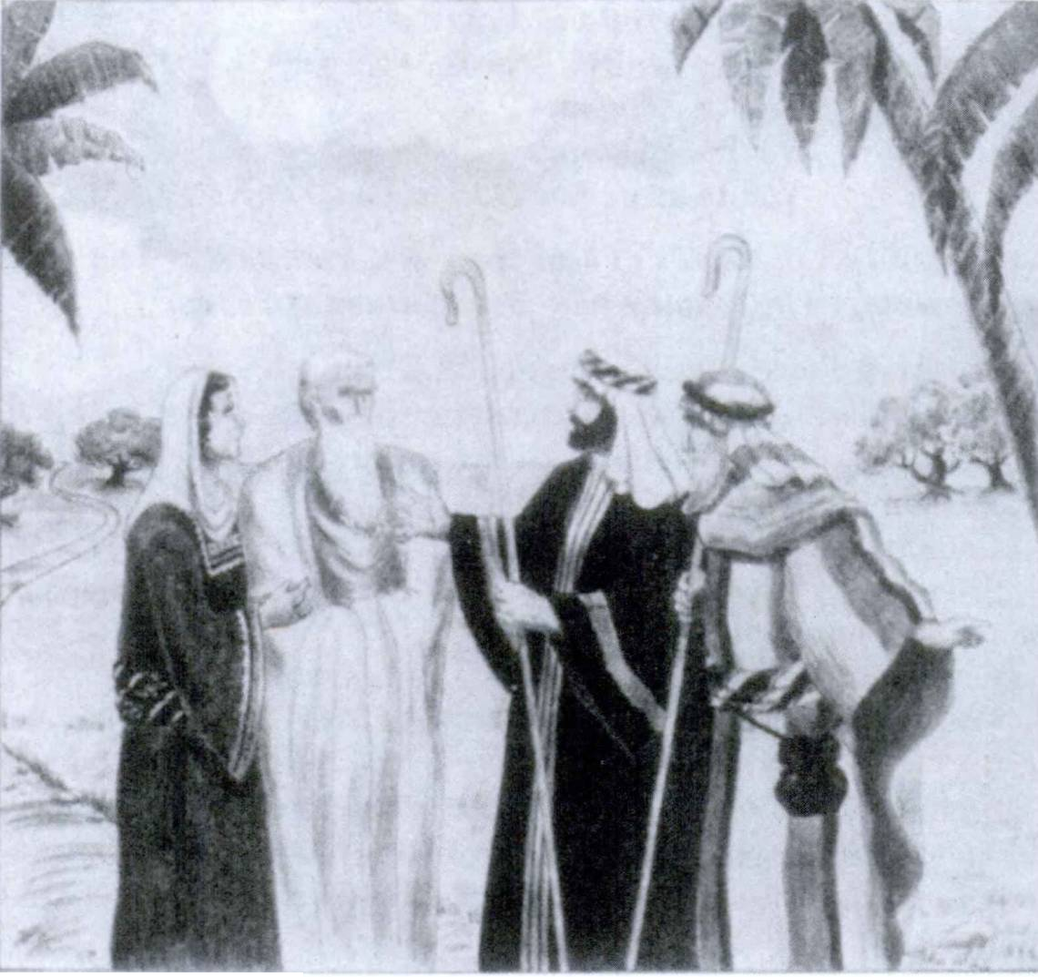304 FIRST YEAR LATIN

ExerCiTUm AnCeLorUm viDimUs.

CHoir (full and loud).
Christus natus1 est nobis; Christus datus est nobis;
Hodie2 venit Christus in mundum; Hodie2 venit salus mundi.
(The scene and the songs jade out together.)

1 natus, a, um: born.
2 hodie, adv.: today.

LESSON 28: SUUS AND SUI

- SUUS AND SUI AS DIRECT REFLEXIVES
We have seen that sui (sibi, se, se) is used for himself (him), herself (her), itself (it), themselves (them), when these words refer TO THE SUBJECT OF THEIR OWN CLAUSE. When so
used, sui is called a DIRECT REFLEXIVE.
Se laudat. He praises himself.

ASSIGNMENT: Review the declension and meanings of sui, GrAmmAr, No. 127. See also the previous lesson on reflexives, page 135.
Suus, a, um is the POSSESSIVE ADJECTIVE corresponding to sui. It is used to mean his (his own), her (her own), its (its own), their (their own), ACCORDING TO THE WORD TO WHICH IT REFERS. Since suus, a, um is an adjective, it agrees in gender, number, and case with the word which it MODI­ FIES. Like sui, suus, a, um is used to REFER TO THE SUB­ JECT OF ITS OWN CLAUSE (DIRECT REFLEXIVE).
Caesar suos milites laudavit.
Caesar praised his (own) soldiers.
Mater filium suum laudat.
A mother praises her (own) son.
Legio signum suum defendit.
The legion defends its (own) standard.
Milites imperatorem suum laudant.
The soldiers praise their (own) general.

When his, her, its, etc., do not refer to the subject of their own clause, ejus and edrum (the possessive genitives of is, ea, id) are to be used (EXCEPT IN SOME CASES TO BE SEEN IN THE NEXT SECTION).
305

306 FIRST YEAR LATIN

Centurid fortiter pugnavit. Itaque Caesar virtutem ejus laudavit.
The centurion fought bravely. And so Caesar praised his courage.
Caesar Gallos vTcit atque eorum duces occidit.
Caesar conquered the Gatds and killed their leaders.
NOTE
Just as forms of ego, nos, tu, vos are used as reflexives
of the first and second persons, so forms of metis, noster, tuus, vester are used as reflexives of the first and second persons.
Sui and suus are used for the THIRD PERSON ONLY.
We defend our own lives. Vitas nostras defendimus.

suus, a, um fuga, ae
VOCABULARY

his (own) her (own) its (own) their (own)
flight

dedd, dedere, dedidi, deditus, 3, tr.1

res publica, rei publicae

diligo, diligere, dilexi, dilectus, 3, tr,
give up surrender
state republic
love

NOTE
Where we say simply surrender in English, dedd must always be used with an ACCUSATIVE REFLEXIVE PRONOUN.
The Gauls surrendered to the Romans. Galli Romanis se dediderunt.
We surrendered to the Gauls. Gallis nos dedidimus. (Nos is accusative.)
Of course, dedd may have other objects.
We surrendered the arms to the enemy. Arma hostibus dedidimus.

RELATED ENGLISH WORDS
A fugitive from justice. We shall always defend our republic.

1 Dedd always takes an object in Latin.

FIRST YEAR LATIN 307

RELATED LATIN WORD

Do
EXERCISE 317
Distinguish:
- dedisti 2. dedidisti 3. dediderunt 4. dederun t

EXERCISE 318
[Essential]
  - Translate;
  - Explain the use of the italicized words:
1. Agros atque urbes suds defendebant. 2. Fortiter se defen- dunt. 3. Post Caesaris victoriam atque sudrum principum cae- dem, hostes se swaque omnia ei dediderunt. 4. Barbari post equitum sudrum caedem fuga salutem petiverunt. 5. Nonne me­ tres filids suds diligunt? 6. Barbari fuga montes petiverunt, at magnus eorum numerus in fuga ab equitibus Romanis occisus est.
- Galli legatos ad Caesarem miserunt qui auxilium peterent. Itaque Caesar ad eos misit equites qui fines eorum defenderent.
- Diligite, fratres mei, Deum. Deus enim pacem suam vobis dabit. 9. Laudavitne Caesar virtutem sudrum? 10. Etiam hostes saepe fortiter pugnaverunt. Itaque Caesar virtutem eorum laudavit. 11. Galli saepe equites ad Caesarem miserunt qui cum copiis ejus pugnarent. 12. Legatus nuntium de periculd suo ad Caesarem misit. Itaque Caesar statim omnes copias suds in fines barbardrum clam et celeriter deduxit.

EXERCISE 319
[Essential]
Translate:
1. Did the Romans often rout the barbarians and kill a great number of them? 2. The tribes of Gaul were exchanging hostages in order to strengthen peace and friendship among themselves.
3. Caesar stationed guards at the bridge in order that he might more easily defend his (men). 4. The lieutenant asked the slaves

308 FIRST YEAR LATIN

where their master was. 5. They fought long and bitterly be­ cause they were fighting for their lives. 6. They fortified the camp with a ditch and a rampart in order to defend themselves more easily. 7. Caesar was a great general. The Romans always kept his victories and courage in memory. 8. The general called the centurions and the military tribunes to him. 9. We will de­ fend our own cities and our own fields.

Chris tus nobis, “Sicut dilexit me Pater,” inquit, “et ego dilexl vos.”

EXERCISE 320
[Review]
Parse the italicized words:
- Legatus exercitum flumen traduxit.
- Legatus trans flumen exercitum traduxit.
- Veniamus ut Christum addremus.

READING NO. 23

A ROMAN LIEUTENANT ADDRESSES HIS MEN
Quanto in periculo, milites, simus, vos omnes cognovistis. In castris enim nostris est inopia frumenti et omnium rerum. Un- dique autem a barbaris continemur. Quantus sit numerus hostium, vos doceo; quanta autem sit eorum virtus, vos videtis. Nam hos- tes populi Romani usque ad castra Romana appropinquant. Cu- pidi victoriae et belli gloriae neque equites neque legiones nostras timent. Litteras ad Caesarem misimus, at servus cui lit- teras dedimus ab hostibus visus est atque occisus. Itaque neque auxilium exspectamus neque socios habemus.
Itaque quid, milites Romani, agemus? Num pacem petemus? Num ad hostes legatos mittemus qui de salute nostra agant? Num nos nostraque omnia hostibus populi Romani trademus?

FIRST YEAR LATIN 309

Ponite, milites, spem in virtute! Virtutem patrum nostrorum memoria tenete! M unite castral Impetus hostium sustinete! Copias hostium pellite, vincite, occldite! Pugnate usque ad mortem!
Imperator Romanus propter gloriam nominis Romani vos ad arma et mortem vocat!

- SUUS AND SUl AS INDIRECT REFLEXIVES
When a personal pronoun of the THIRD person is in a SUB­ ORDINATE PURPOSE clause or INDIRECT QUESTION
and REFERS to the SUBJECT of the MAIN verb, sui and suus (not is, ea, id or ejus, eorum) should be used. In this use sui and suus are called INDIRECT reflexives.
Caesar milites vocavit qui se defenderent.
Caesar called the soldiers to defend him.
Caesar equites misit qui legatos suos defenderent.
Caesar sent the cavalry to defend his envoys.

VOCABULARY
ante, prep, w, acc. before
praesidium, i garrison Protection
vero, postpositive1 in truth but

RELATED ENGLISH WORDS
Verily. Caesar’s wars antedate the birth of Christ.

IDIOM STUDY
- Do with in fugam means put to flight.
Caesar hostes in fugam dedit. Caesar put the enemy to flight.

1 Vero is postpositive; i.e., it never stands first in a clause.

310 FIRST YEAR LATIN

- With proper names the ablative nomine, by name, is fre­ quently used. Translate named.
Servus, nomine Titus, in hibemis erat.
A slave named (by name) Titus was in the winter quarters.

EXERCISE 321
[Essential]
  - Translate;
  - Explain the use of the italicized pronouns;
  - Diagram No. 1 (first sentence):
- Centurid servum, nomine Titum, ad Caesarem misit qul eum doceret quanto in periculo praesidia essent. Itaque Caesar statim exercitum suum deduxit atque equites misit qui eum de adventu suo docerent. 2. Galli, vero, oppida sua ante Caesaris adventum incenderunt ne praesidia in eis collocaret. 3. Legatus eum per nuntios ante proelium docuit quanto in periculo esset legid sua. 4. Romani vias muniverunt quo facilius copias suds in provincias deducerent. 5. Caesar novas legidnes in Galliam misit ne barbari suds superarent. 6. Barbari Romanos proelid pepulerunt ne el per fines suds exercitum ducerent. 7. Galli praemia Caesari miserunt ut gratiam apud eum haberent.
- Caesar, vero, milites suds flumen traduxit ut reliqua oppida expugnaret atque incenderet.

EXERCISE 322
[Essential]
  - Translate;
  - Explain the translation of the italicized words:
- The American people heard in how great danger their sol­ diers were in Bataan.1 But they did not send arms and reinforce­ ments because Bataan was far distant from their territory.
- Caesar sent reinforcements into the first battle line in order

1 Bataan: Bataan, indecl. noun.

FIRST YEAR LATIN 311
that they might help his legions. 3. They routed the barbarians lest they should burn their crops. 4. He showed them what his plans were. 5. Did Caesar give rewards to the slaves who were in his camp?
EXERCISE 323
[Review]
Parse the italicized words:
- Rogavit num Christus in mundum venisset.
- Num bellum atque caedem laudamus?

READING NO. 24

THE HAIL MARY

AVE MARIA GRATIA PLENA DOMINUS TECUM
BENEDICTA1 TU IN MULIERIBUS2
ET BENEDICTUS1 FRUCTUS3 VENTRIS4 TUI JESUS
sAnCTA MARIA MATER DEI
ORA PRO NOBIS PECCATORIBUS5 NUNC ET IN HORA6 MORTIS NOSTRAE. AMEN.
This beautiful prayer, which is known and loved by all Cath­ olics, has its origin in the records of the New Testament. The first

1 benedictus, a, um: blessed.
2 mulier, mulieris: woman.
a fructus, us: fruit.
4 venter, ventris: womb.
5 peccator, peccatoris: sinner.
6 bora, ae: hour.

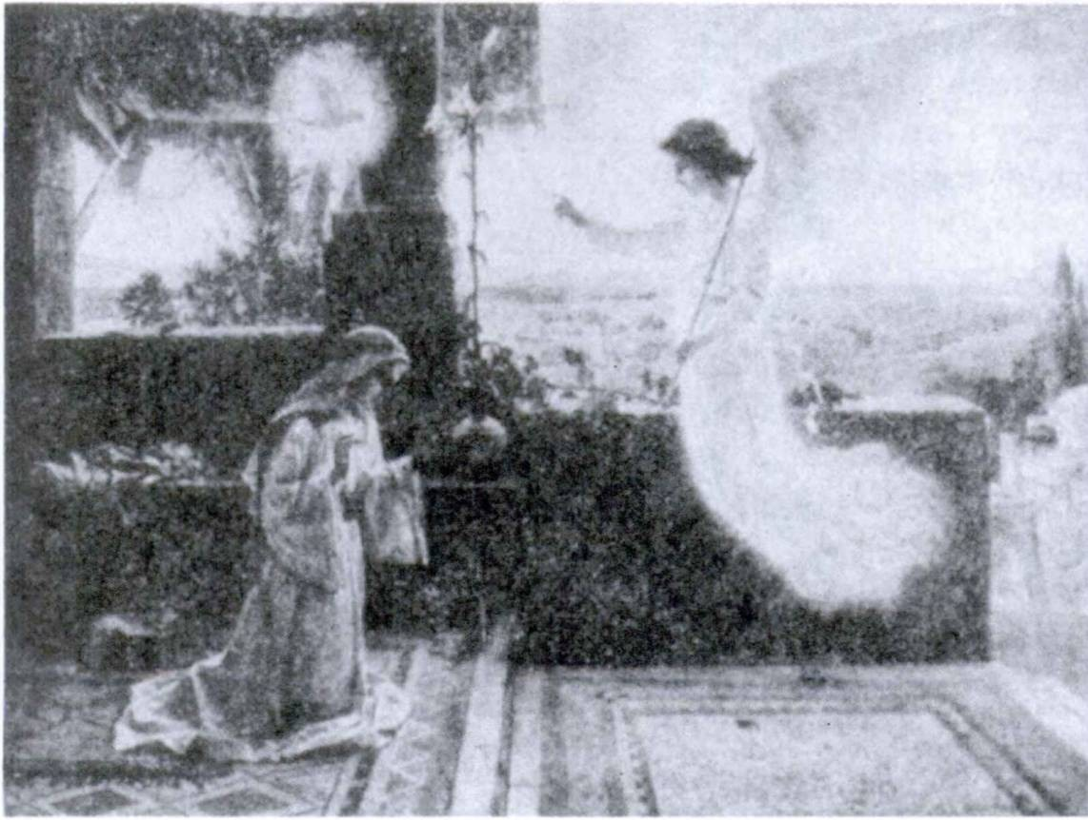312 FIRST YEAR LATIN

Ave GrATiA PLenA

words were spoken to Mary by the Angel Gabriel; the second section contains the greeting of St. Elizabeth. The following ac­ count is simplified from St. Luke.
Missus est angelus1 Gabriel a Deo in civitatem Galilaeae cui nomen [erat] Nazareth. Missus est ad Mariam. Maria autem drabat. Angelus1 ei,
“AVE GRATIA PLENA!”
inquit, “DOMINUS TECUM!
BENEDICTA2 TU IN MULIERIBUSI”3

1 angelus, i: angel.
2 benedictus, a, urn: blessed.
8 mulier, mulieris: woman.

FIRST YEAR LATIN 313

Mary was disturbed at the greeting, but the angel said:
“Do not be afraid, Mary, for thou hast found grace with God. The Holy Spirit shall come upon thee and the power of the Most High shall overshadow thee; and therefore the Holy One to be born shall be called the Son of God.” Mary answered, “Behold the handmaid of the Lord; be it done to me according to thy word.”
Then Mary went into the hill country to visit her cousin Eliza­ beth. Elizabeth autem Mariae,
“BENEDICTA,”1 inquit, “TU INTER MULIERES2 ET BENEDICTUS1 FRUCTUS3 VENTRIS4 TUI.”
Thus, the Angel Gabriel and St. Elizabeth composed the first part of the prayer. The word Jesus and the last part (Sdncta Maria, etc.) were added gradually by the devotion of Catholics. The Hail Mary, in the full form to which we are accustomed, ap­ pears first in the fifteenth or sixteenth century.
This beautiful scene of the Annunciation is commemorated also in the Angelus and in the first of the Joyful Mysteries of the Rosary.

1 benedictus, a, um: blessed.
2 mulier, mulieris: woman.
8 fructus, us: fruit.
* venter, ventris: womb.

LESSON 29: THE PASSIVE SUBJUNCTIVE

- PRESENT AND IMPERFECT SUBJUNCTIVE
PASSIVE

ASSIGNMENT: Learn GrAmmAr, Nos. 267-274. Note that the passive subjunctive is formed by changing the final personal signs exactly as was done in the indicative.
Review the rules for purpose clauses, GrAmmAr, Nos. 546-547.

parvus, a, um mds, moris, m.
manus, us, /.

causa, ae
VOCABULARY
{small
| little
f custom
I habit
(a band of men hand
cause

causa, preceded by gen. for the sake of

NOTE
- The ablative of causa is used as a preposition. It governs the GENITIVE and always stands AFTER the word it governs.
aquae causa, for the sake of water
pacis causa, for the sake of peace
- The ablative of mds (more) may be translated according to custom.
RELATED ENGLISH WORDS
Manual labor; manufactured goods.

Sancta Maria, Mater Dei, ora pro nobis!

314

FIRST YEAR LATIN 315

- Translate;
EXERCISE 324

- Explain the tenses in the subordinate clauses:
1. They came into the forest lest they be routed (seen; over­ come; conquered; terrified; held; put to flight; heard). 2. He sent a small band to fortify (seize; hold; defend; burn; assault; storm) the winter quarters. 3. He is warning the soldiers lest they be overcome (conquered; routed; put to flight; terrified; seen; held; killed). 4. He is sending the cavalry that the town may be more easily seized (burned; fortified; defended; as­ saulted; stormed; held).
EXERCISE 325
[Essential]
Z. Translate;
- Diagram Sentence 1;
- Parse the italicized words:
- Caesar suds nomine appellabat atque signum legionis manti tenebat ne sui ab hostibus in fugam darentur. 2. Caesar aquae causa ad flumen castra posuit quo jacilius atque diutius impetus hostium a suis sustineretur. 3. Imperator legiones clam in fines hostium deduxit ne ab hostibus viderentur. Statim impetum in Gallos fecerunt. Turn vero principes Galldrum belli causa manus cogebant, arma parabant, virtutem sudrum orationibus more suo confirmabant. 4, Caesar cum parva manu trans montes con- tendit ne a militibus suis in eorum periculo abesset. 5. Galli post proelium se suaque omnia Caesari dediderunt ut vitae ob- sidum sudrum a Caesare conservarentur. 6. Nonne nos Ameri­ can! ante bellum exercitum cogimus atque arma telaque paramus ne ab hostibus vincamur? 7. Portae incensae sunt, atque equites celeriter in oppidum missi sunt ut oppidum statim occuparetur. Turn barbari more suo clamorem sustulerunt atque se suaque omnia Romanis salutis causa dediderunt. Caesar vero vitas eorum non conservavit ne legati sui a barbaris occiderentur. Nam injuria atque caedes legatorum fuerant belli causa.

316 FIRST YEAR LATIN

EXERCISE 326
Translate:
  - May God be praised I 2. May the enemy be conquered!
- May the town be burned! 4. May the leader be warned!
5. May we be spared! 6. May guards be stationed! 7. May they be helped by God! 8. May the state be preserved 1 9. May my life be ruled by God! 10. May God be loved by all men!
11. May they be put to flight I 12. May our sins be taken away!
13. May we be taught by God! 14. May help be sent to us!
15. May he be always kept in memory! 16. May Mary be praised by all men! 17. May the grace of God be given to you all! 18. May rewards be given to brave men!

In manus tuas, Domine, Gommendo1 spiritum meum.

EXERCISE 327
Translate :
1. The barbarians according to their custom raised a shout lest they be killed by the lieutenant. 2. Christ came into the world that our sins might be taken away. 3. Let the state be preserved for the sake of our peace and our common welfare. 4. The Gauls burned their towns with their own hands lest they be seized by the Romans. 5. God will give grace to those who sustain great sorrows for the sake of peace. 6. Brave and free men will always fight that our state may be preserved. 7. They pitched camp at the river for the sake of water. 8. He waited for reinforcements lest he be hard pressed by the enemy. 9. He stationed a small band of men there lest the hill be seized by the barbarians.
10. Caesar informs us about the customs both of the Gauls and of his own soldiers.
1 commendo, 1, tr,: commend.

FIRST YEAR LATIN 317

EXERCISE 328
[Review]
Parse the italicized words:
- Propter quorum salutem venit Christus in mundum?
- Quem imperatdrem milites Romani appellaverunt?
- Quds gentes vicit Caesar?

- THE PERFECT SYSTEM OF THE PASSIVE
SUBJUNCTIVE
The perfect tenses of the passive subjunctive OF ALL LATIN VERBS, REGULAR AND IRREGULAR, are formed in the same way. They are COMPOUND tenses just as in the indicative. To form these tenses:
- Find the perfect participle passive.
- Add, as a separate word, the proper form of the verb sum.
ASSIGNMENT: Study GrAmmAr, Nos. 275-282. Review in direct questions, GrAmmAr, Nos. 660-662 and FirsT YeAr LATin, pages 281 and 286.

VOCABULARY

Scio, scire, scivi, scitus, 4, tr.
paco, 1, tr.
subito, adv.

probo, 1, tr.

Pacify suddenly
[approve
j
[ prove

relinquo, relinquere, reliqui, relictus, 3, tr. ] f leave
[leave behind

RELATED ENGLISH WORDS
Science. He is out on probation. He will not relinquish hi§ rights. The story is not probable.

Pax

RELATED LATIN WORD

318 FIRST YEAR LATIN

GUM, WHEN, in secondary sequence usually takes the sub­ junctive. Use the imperfect or pluperfect according to the gen­ eral rule, GrAmmAr, Nos. 531-533.
Gum equites in silvis pugnarent, Caesar mllites trans flumen traduxit.
When the cavalry were fighting in the forest, Caesar led the soldiers
across the river.
Caesar cum hostes vidisset, legidnes pro castris instruxit.
When Caesar had seen the enemy, he drew up the legions in front of the camp.

- Translate;
EXERCISE 329

- Explain the tenses in the subordinate clauses:
1. He knew why they had been routed (praised; overcome; called; warned; killed; terrified; seen; held). 2. They knew where they had been led (sent; collected; called). 3. He knows who was sent (sought; killed; praised; warned; called; over­ come; terrified). 4. He knew where they were being stationed (left; killed; drawn up). 5. He knows whether the fields are being laid waste (seized; defended). 6. He knows where they are being led (collected; called; moved; sent). 7. He knew why he was being praised (overcome; called; warned; feared; terrified; held; left).

EXERCISE 330
[Essential]
Translate:
1. Cum omnis Gallia pacata esset, Caesar praesidia in hibernis rellquit et in Italiam contendit. 2. Centurid ante proelium roga- vit quae consilia a Caesare probata essent. 3. Num seis quo legati miss! sint? 4. Cum agmen per loca difficilia et angusta duceretur, subito visa est acies barbardrum. 5. Scitisne num legio quae in castris fuerat a legato relicta sit ? 6. Cum frumenta

FIRST YEAR LATIN 319

ab equitibus incenderentur, milites castra valid fossaque muni- ebant. 7. Cum Christus Judaeis1 ostensus a Pilato2 esset, Ju- daei1 magnum clamorem sustulerunt: “Non habemus regem nisi8 Caesarem. Tollite! Crucifigatur !”4

EXERCISE 331
Translate:
When the legions had been left in winter quarters in Gaul and Caesar had hastened into Italy, the Gauls exchanged hostages and treated about war among themselves. When the plans had been approved in a common council, suddenly they attacked the winter quarters. The garrisons were in great danger. Therefore a messenger was sent to Caesar that help might be sent. Caesar knew how large the enemy forces were and where guards had been stationed. He immediately led his new legions into Gaul lest the winter quarters be taken (by storm). Suddenly his column was seen by the enemy. They were terrified and at once sent envoys to seek peace. Then they surrendered to him. Thus Gaul was pacified.

- THE ABLATIVE OF CAUSE
We have seen that the CAUSE OR REASON may be ex­ pressed in Latin in various ways:
- Propter:
They Were terrified on account of the arrival of Caesar.
Propter ad ven turn Caesaris territl sunt.

- Quod:
They were terrified because Caesar had arrived.
Territl sunt quod Caesar advenerat.

1 Judaeus, i: Jew.
* PHatus, i: Pilate.
8 nisi: except.
4 crucifigo, 3, tr.: crucify.

320 FIRST YEAR LATIN

- Nam; enim (postpositive):
They were terrified, for Caesar had arrived.
Territl sunt, nam Caesar advenerat.
The ablative without a preposition may also be used to ex­ press the CAUSE OR REASON (ABLATIVE OF CAUSE).
They were terrified at (because of, on account of, by) the arrival of Caesar.
Adventu Caesaris territl sunt.

ASSIGNMENT: Learn the rule, GrAmmAr, No. 781.
Note. The ablative of cause is frequently merely a special variety of the ablative of means. It is therefore sometimes very difficult to distinguish between these two types of ablatives.

Christe, audi nos!

EXERCISE 332
All the italicized ablatives may be classified as ablatives of cause.
Translate:
1. Socidrum victoriis sublati sunt. 2. Adventu Caesaris motl sunt. 3. Metu Caesaris territl sunt. 4. Oratione legati pertur- bati sunt. 5. Litteris regis motus est.

EXERCISE 333
All the italicized expressions are to be translated by the ablative of cause.
Translate:
1. They were violently disturbed on account of the slaughter of the leading men. 2. They were terrified because of the arrival of Caesar. 3. They were aroused at the wrongs of the Romans.
- They were violently moved by fear of the lieutenant.

FIRST YEAR LATIN 321

EXERCISE 334
[Essential Review]
Translate:
- Hail, Jesus Christ, who for the sake of our salvation didst come into the world and through sorrow and toil didst take away our sins. Thou hast taught us the truth. Thou hast taught us the way of salvation. Rule our minds and our lives. Thou hast taught us where true peace is. Let us love Him and adore Him. Jesus Christ, our Lord, have mercy on us!
- For the sake of peace Caesar left garrisons in the states which he had pacified. Then, however, Caesar hastened into Italy. When this1 had been learned by the Gauls, new plans were approved by them and they exchanged hostages that peace and friendship might be strengthened among them. But Caesar, when he had learned what plans had been approved by the barbarians, left Rome and suddenly arrived in the territory of the Gauls with a small band of men. Meanwhile the Gauls had retained the envoys whom Caesar had sent to them and had assaulted the winter quarters. Caesar immediately hastened to the winter quarters lest they be stormed by the barbarians. He arrived with a small band of men. When his column had been seen by the enemy, they made2 an attack on his men without delay. His men were hard pressed, but Caesar called upon them by name and held the standard of the legion with his hand lest they be routed. The enemy were put to flight. Caesar hastened with all his forces to their camp, but they, according to their custom, raised a shout and surrendered themselves and all their possessions to him. Caesar knew what had been the cause of the war. There­ fore he killed the hostages of the Gauls, that his envoys might not afterwards be held and killed by them. Thus had he de­ fended the state and, on account of his victory, the Roman Senate without delay praised him and gave thanks to him.
- A lieutenant, by name Labienus, was often praised by Caesar.
1 this: hoc.
2 they made: fecerunt.

322 FIRST YEAR LATIN

- May God give us His peace and always defend us!
- Jesus Christ, Son of God, have mercy on us!
- They were terrified at the arrival of Caesar.

EXERCISE 335
[Essential Formal Review]
  - Give the rules for the formation of the vocative. Give the vocative of: (a) Deus; (b) Jesus; (c) filius; (d) meus; (e) ami­ cus; (f) centurid.
  - How is the present imperative active formed? Give exam­ ples.
  - Give the rule for the volitive subjunctive. Give examples.
  - Give the rule for the hortatory subjunctive. Give examples.
  - What is the rule for the use of sui and suus as direct reflexives ?
  - What is the rule for the use of sui and suus as indirect reflexives ?
  - What are the direct and indirect reflexives of the first and second persons ? Give examples.
  - How do you translate: (a) surrender; (b) you surrender;
(c) he surrenders; (d) we surrender; (e) they surrender?
  - What does the phrase in fugam dare mean ?
  - Explain the use of the ablative causa.
  - Give the rule for cum, when.
  - Explain the ablative of cause. Give an example.

READING NO. 25

DAVID, REX
David,1 vir nobilis et fortis, sicut scitis, rex erat Israelitarum.2 Israelitae2 autem bellum cum Philisthinis3 gerebant ne agri sui ab eis occuparentur. Philisthini3 autem Bethlehem4 tenebant. Cas-
1 David: David.
2 Israelitae, Israelitarum: the Israelites.
8 Philisthini, Philisthinorum: the Philistines.
4 Bethlehem: Bethlehem.

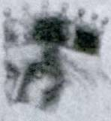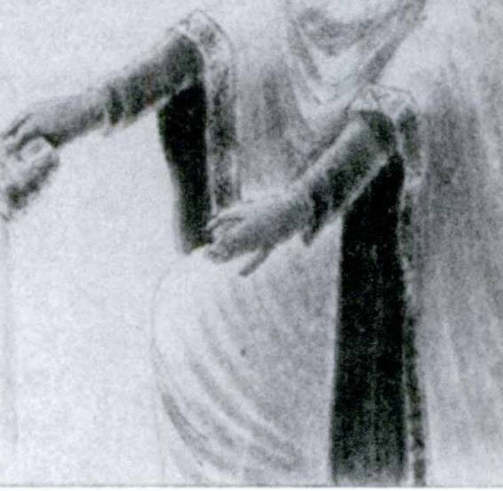FIRST YEAR LATIN 323

DAviD, Rex

tra enim ibi posuerant. David cum parva hominum manu erat in praesidid et non longe ab edrum castris afuit. Praesidium ibi col- locatum erat ut David et suds defenderet et cognosceret quae ab hostibus gererentur.
In castris autem Israelitarum1 erat magna aquae inopia. Prop­ ter id magnum dolorem et David et milites sustinebant. In Beth­ lehem autem, quod a Philisthinis tenebatur, erat aquae copia. Itaque David, “Si haberem,”2 inquit, “aquam de3 cisterna4 quae est in Bethlehem! ”
Cum vero ea a militibus audita essent, tres® fortes viri clam ad

1 Israelitae, Israelitarum: the Israelites.
2 si haberem: if only I had.
3 de, prep. w. abl., here means from.
4 cisterna, ae: cistern.
*tres, tria: three.

324 FIRST YEAR LATIN

castra hostium pervenerunt ut aquam ad regem portarent. Magnum erat periculum, tamen a custodibus hostium visi non sunt. Itaque aquam ad regem tuti portaverunt et ei dederunt.
Rex vero, cum aquam vidisset, edrum virtute et amicitia vehe- menter motus est. Per loca enim periculdrum plena in castra hostium pervenerunt ut ad eum aqua portaretur. Scivit rex quanto in periculo propter se fuissent. Itaque eis gratias egit sed aquam in terram Domino libavit.1
David enim, “The Lord,” inquit, “be merciful to me that I may not do this; shall I drink the blood of these men that went at the peril of their lives?”

1 libo, 1» tr.: pour out as a sacrifice (to).

UNIT NINE

LESSON 30: THE PERFECT PARTICIPLE PASSIVE

A PARTICIPLE is a VERBAL ADJECTIVE.
The enemyf having been swiftly repulsed, hastened into the mountains.
In this sentence HAVING BEEN REPULSED is a participle. It is an ADJECTIVE because it modifies the noun enemy.
It is a VERB because it expresses ACTION. Since it is a verb, it may be modified by an adverb (swiftly).
The fourth principal part of regular verbs in Latin is the PER­ FECT PARTICIPLE PASSIVE. It is declined like magnus, a, um.
laudo, laudare, laudavi, laudatus, a, um moneo, monere, monui, monitus, a, um mitto, mittere, misi, missus, a, um audio, audire, audivi, auditus, a, um

EXERCISE 336
Decline in full:
- laudatus, a, um 3. missus, a, um
- monitus, a, um 4. auditus, a, um

The perfect participle passive may be translated into English either by the long English form:
laudatus, a, um, having been praised
or the shorter English form:
laudatus, a, um, praised
Since the perfect participle passive is an adjective, it can modify any noun or pronoun in a sentence according as the sense re­ quires.
325

326 FIRST YEAR LATIN

Caesar multis nuntiis perturbatus novas legiones in Galliam duxit.
Caesar, having been disturbed (disturbed) by many messages, led new legions into Gaul.
f 1
Caesar collem ab equitibus occupatum vallo munivit.
Caesar fortified with a rampart the hill seized by the cavalry.

Propter legatos occisds Caesar oppida barbarorum incendit.
On account of the murdered envoys Caesar burned the towns of the barbarians.
Romani Gallis victis frumentum non dederunt.
The Romans did not give grain to the conquered Gauls.

Spiritus Sancte, Deus, miserere nobis!

NOTE
- When a verb is INTRANSITIVE, it can have only a NEUTER participle PASSIVE. In intransitive verbs, therefore, the fourth principal part is always given as neuter, as:
pugno, pugnare, pugnavi, pugnatum, 1, intr.
- When a verb is DEFECTIVE and has no perfect participle passive at all, the FUTURE PARTICIPLE ACTIVE (which we shall study later) is given as the fourth principal part:
cedo, cedere, cessi, cessurus, 3, intr.
Cedo has no perfect participle passive. The future participle active always ends in -URUS (cess-urus).
- When a verb has neither a perfect participle passive nor a
future participle active, only three parts are given, as:
contendo, contendere, contend?, 3, intr.

Review the ablative of cause, page 319.

FIRST YEAR LATIN 327

VOCABULARY

adduco, adducere, adduxi, adductus, 3, tr. commoveo, commovere, commovi, commotus, 2, tr. impedid, 4, tr.
auctoritas, auctoritatis

NOTE

lead to lead on alarm
arouse
hinder impede
authority influence

The perfect participle passive of impedid, IMPEDlTUS, is used of soldiers encumbered by full packs, of an army encum­ bered by a baggage train, and of places in which it is difficult to maneuver. Hence it may frequently be translated, according to the context, as encumbered or difficult.
RELATED ENGLISH WORDS
There was a commotion in the hall. He had an impediment in his speech.

Ad + duco; moved.
RELATED LATIN WORDS

EXERCISE 337
- Give the perfect participle passive;
- Give two English translations of the participle:

1. cognosco | 10. traduco | 19. terreo
2. exspecto | 11. ostendo | 20. video
3. deduco | 12. doceo | 21. ago
4. adduco | 13. tollo | 22. dedo
5. commoveo | 14. rego | 23. diligo
6. impedid | 15. obtined | 24. paco
7. vasto | 16. retined | 25. adjuvo
8. quaero | 17. sustineo | 26. administro
9. rogo | 18. teneo | 27. appello

328 FIRST YEAR LATIN

28. colloco | 41. | instruo | 53. contineo
29. comparo | 42. | mitto | 54. habeo
30. confirmb | 43. | occupo | 55. moneo
31. cbnservo | 44. | oppugno | 56. moveo
32. do | 45. | oro | 57. occido
33. exploro | 46. | paro | 58. pello
34. incito | 47. | perturbo | 59. peto
35. laudo | 48. | porto | 60. pond
36. defendo | 49. | servo | 61. premo
37. dimitto | 50. | superb | 62. trado
38. duco | 51. | voco | 63. vinco
39. gero | 52. | compleo | 64. audio
40. incendo
EXERCISE 338
[Essential]
  - Translate;
- Parse the italicized words;
- Diagram Sentences 1 and 4:
- Barbari, spe communis salutis adducti, equites in agmen Romanum miserunt. 2. Imperator milites caede equitum com- mot os bratione confirmavit quo diutius pugnarent. 3. Propter oppida occupata atque agros vastatos, Galli frumentum in hi- berria Rbmanorum non portabant. 4. Senatus Populusque Ro- manus, auctoritate litterisque Caesaris commotus, legidnes novas in provinciam sine mora misit. 5. Turn barbari servique in agmen nostrum impedimentis impeditum subito impetum undi- que fecerunt. 6. Galli, verb, multis proeliis superati atque a sociis relicti, in loca impedita et angusta contenderunt. 7. Nun- tius, “Milites nostri,” inquit, “impediti, hostes non statim in fugam dederunt.” 8. Centurio ad hiberna ab hostibus oppugnata auxilia deduxit. 9. Galli, omnium rerum inopia adducti atque adv ent u Caesaris commoti, legatos ad imperatorem Romanum miserunt qui pacem peterent. 10. Britanni et American!, a sociis suis adjuti, magnas copias in Galliam1 traduxerunt. 11. Galli,
1 Gallia, ae: France.

FIRST YEAR LATIN 329
a principibus ad bellum incitate atque spe victoriae sublate, castra nostra valid alto muneta oppugnaverunt. 12. Interim milites, praesidii causa in castris relict!, impetum hostium fortiter sustinebant. 13. Hostes autem copias suas ad flumen duct as in- struxerunt. 14. Multis nuntiis litterisque commdtus, Caesar legidnes novas in Italia coegit et qui eas in Galliam deduceret legatum misit. 15. Rex principes propter praemia ab eis sibi data laudavit.
Homo doctus in se divitias1 semper habet.
—Phaedrus

EXERCISE 339
  - Translate;
  - Parse the italicized words:
1. Imperator, vehementer commdtus, virtutem militum oratione cdnfirmavit. 2. Milites, a Caesare lauddti atque nomine appel­ late, impetum equitatus sustinuerunt. 3. Duces Galldrum, caede principum vehementer perturbati, arma ad bellum a se com- parata Romanis tradiderunt. 4. Dux, vir fortis, collem ab equi- tibus occupatum et valid et fossa munivit. 5. Barbari impetum in milites impedimentis impeditos fecerunt. 6. Caesar, periculo legatorum perturbatus, in fines barbardrum magnis itineribus cum omnibus copies contendit. 7. Litteris legati commdtus, Caesar principes Galldrum ad se vocavit atque quaesivit quantae gentes in armis essent. 8. Equites ad flumen collocate hostes in fugam dederunt atque ita magnam eorum partem telis ac gladiis occiderunt. 9. Legidnes ad fines hostium hibernorum causa collocatae servum ad Caesarem miserunt qui auxilia peteret.
10. Centuriones et tribuni militum a Caesare nomine appellate diutius copias hostium sustinuerunt. 11. Hostes, spe victoriae conjirmate, usque ad primam aciem nostram celeriter appropin-
1 divitiae, divitiarum: riches, wealth.

330 FIRST YEAR LATIN

quaverunt. 12. Nostri, spe auxilii cdnfirmdti, usque ad noctem pugnaverunt. 13. Imperator, vehementer commdtus, exercitum pro portis statim instruxit.
EXERCISE 340
[Essential]
Translate:
- When the enemy, having been routed by the legions, fled to the mountains,1 Caesar sent the cavalry to kill them. 2. The barbarians, alarmed by the arrival of Caesar, did not attack the hill seized by the Roman legion. 3. Led on by hope of victory and safety, the Gauls exchanged hostages and prepared arms to wage war with the Romans. 4. Moved by the authority and favor of Caesar, the Gauls carried grain into winter quarters. 5. They attacked our men, encumbered by the baggage train and held in by mountains. 6. The barbarians, having been overcome in many battles, surrendered themselves and all their possessions to the lieutenant. 7. Caesar, having been informed in how great danger the legions were, sent the cavalry to help them. 8. The general, having been informed what race of men dwelt there, led his army secretly across the river. 9. Men loved by God do not fear danger or death. 10. The town, having been taken by storm, was burned. 11. They left many bodies on the hill seized by the Romans. 12. On account of the devastated2 fields there was a scarcity of grain. 13. Caesar learned the plans approved by the barbarians in council before his arrival.

EXERCISE 341
[Review]
- What is the gender of manus ?
- What is the difference between ubi and quo?
- Translate: The barbarians surrendered to Caesar.
- Translate in two ways: They approached the camp.

1 Translate sought the mountains by flight.
2 devastate: vaito, 1, tr.

LESSON 31: HIC, HAEC, HOC

  - THE DECLENSION OF HIC, HAEC, HOC
There are words in all languages that merely POINT OUT the person or thing about which we are talking:
Which do you mean? I mean that one.
I mean this one.
Such words as THAT (pl. THOSE), THIS (pl. THESE) are called DEMONSTRATIVE PRONOUNS, i.e., “POINTING-
OUT” words. (Demonstro in Latin means I show, I point out.)
ASSIGNMENT: Study the declension of hie, haec, hoc,
this (pl. these), GrAmmAr, No. 133.

RULE FOR POSITION: HIC, HAEC, HOC GENER­ ALLY PRECEDES THE NOUN IT MODIFIES.

Z. Decline;
EXERCISE 342

  - Give the meaning of each case:

- hie homo
- hie vir
- haec via
- haec legio
- hoc regnum
- hoc flumen

EXERCISE 343
Z. Supply the correct form of hie;
2. Translate:
- cum tribund militum 5. pro. oppido
- per......... .... silvas 6. in. ponte
- in........... .. flumen 7. trans flumen
- propter . .......... rem 8. in. provincia
331

332 FIRST YEAR LATIN

- in............ . periculo 22. cum imperatore
- post........ .... bellum 23. in. mundum
- in............ . collibus 24. in. itinere
- propter .. .......... vulnera 25. per agros
- post........ .... montem 26. plenus rerum
- cum........ .... puero 27. ad. flumen
- in............ . agris 28. ad. castra
- sine........ .... viro 29. in........ . milites
- post........ .... victoriam 30. sine spe
- propter . .......... victorias 31. propter causam
- in........... .. montes 32. in. proelio
- cum....... ..... servis 33. de re
- propter . .......... metum 34. in. civitate

Sancte Joseph, ora pro nobis!

EXERCISE 344
Z. Put these phrases in the genitive and dative; 2, Translate:

- haec mora
- hoc peccatum
- haec res publica
- haec manus
- haec mens
- hie dolor
- hoc praesidium
- haec causa
- haec fuga
- hie mds

- USES OF HIC, HAEC, HOC
ASSIGNMENT: Study the uses of hie, haec, hoc, GrAmmAr, Nos. 793-794.
When hie is used as an adjective, the general rule for agree­ ment, GrAmmAr, No. 477, applies.
When hie is used as a pronoun, the general rule for agreement, GrAmmAr, No. 479, applies.

FIRST YEAR LATIN 333
VOCABULARY

contra, prep. w. acc.

a tergo a fronte
summus, a, um
| against
[ opposite (in the rear
from the rear
(in the front from the front
{highest greatest very great

RELATED ENGLISH WORDS
Contradiction ; summit; contrary.

EXERCISE 345
[Hie as an Adjective]
- Translate;
- Explain the agreement of the italicized words:
- Haec civitas libera nostra est; hi agri atque hae urbes nostrae sunt. Itaque pro hdc civitate libera contra hostes fortiter pugnabimus atque hos agros et has urbes semper sine mora de- fendemus.
- Multa et magna erant bella et victoriae patrum nostrdrum.
Nonne haec bella atque hae victoriae in hdc civitate semper memoria tenebuntur?
- Galli, a Caesare coacti, multos obsides ad eum miserant. Hos obsides Caesar, cum Galli bellum gererent, occidit. Hdc re perturbati, Galli milites novds celeriter coegerunt ut Romanos vincerent.
- Primi milites trans flumen venerant; reliqui in flumine erant. In hos milites ita impeditos barbari subito impetum a tergo fortiter fecerunt atque omnes fere occiderunt.
- Amici qui in rebus difficilibus nos adjuvant sunt veri et certi amici. Hos amicos diligamus.
- Caesar, cum hunc nuntium audivisset, litteras ad legatum

334 FIRST YEAR LATIN

misit. Legatus vero, his litteris vehementer commotus et impetu hostium territus, legiones castris continuit, at equites ad Caesarem misit.

EXERCISE 346
[Hie as a Pronoun]
/. Translate;
- Explain the agreement and reference of the italicized words:
- Erant in exercitu Caesaris equites alien!. Hos Caesar prop­ ter fidem edrum atque virtutem veram saepe laudavit.
- A tergo subito cernebantur equites hostium. Erant autem in prima acie legiones integrae. Itaque hae omnes fere impetus hostium sustinuerunt.
- Romani multos Christianos propter legem et veritatem
Christi occiderunt. Nonne horum memoriam semper laudabimus?
- German! vietdriae spe adducti regisque auctoritate coacti, omnes copias flumen traduxerant. Contra Gallos pugnabant; fru- menta et oppida occupata incendebant; principes atque reges Galldrum occidebant; omnes agros vastabant. Galli, vero, vehe­ menter commoti et territi, legatos ad Caesarem miserunt qui auxilium peterent. Caesar, cum haec omnia audivisset, statim cum omnibus copiis in fines Galldrum contendit ut Germanos trans flumen ageret.

EXERCISE 347
[Hie as an Adjective and as a Pronoun]
Translate:
- The enemy easily aroused the neighboring tribes to war, for these tribes were brave and eager for the glory of victory.
- Caesar fought with many kings and chiefs. These he often killed.
- The lieutenant pitched a camp in the fields of the bar­ barians. This camp, fortified by a ditch and a rampart, he bravely defended.

FIRST YEAR LATIN 335

- The centurion sent a letter to Caesar concerning this af­ fair. Caesar, alarmed by this letter, sent new legions into the province. These legions defended the province and drove the enemy across the river into their own territory.
- The barbarians suddenly made an attack on the legion from the rear. This legion easily withstood the attack.

“And they put above His head the charge against Him, written,
HIC EST JESUS REX JUDAEORUM.”1
—Matthew 27:37

EXERCISE 348
[Review]
Z. Translate;
2. Parse the italicized words:
- Vos amicos appello. 2. Legidnem flumen traduxit. 3. Multi Romani amicitiae causa cum exercitu Caesaris erant. 4. Bar­ bards in jugam dedit. 5. Fortiter pugndtum est.

1 Judaeus, i: a Jew.

LESSON 32: THE PREPOSITIONS
EX (£), AB (A), AND DE

In expressions of PLACE:
  - The prepositions EX (E) or DE with the ablative mean
OUT OF or FROM.
When the motion begins, the person or thing moving is IN­ SIDE THE PLACE:
De (ex) flnibus hostium venit.
He came from the territory of the enemy.
  - The preposition AB (A) with the ablative means AWAY FROM or FROM.
When the motion begins, the person or thing moving is NOT INSIDE the place:
Ab hoc loco venit.
He came away from (from) this place.

  - The preposition DE with the ablative may also mean
DOWN FROM or FROM.
The motion is DOWNWARDS.
De hoc monte venit. He came down from this mountain.

336

FIRST YEAR LATIN 337

Ex Loco

STUDY THESE EXAMPLES:
de muro, down from (from) the wall
e castris, out of (from) the camp a castris, away from the camp ex flumine, out of the river
a flumine, away from the river

VOCABULARY

discedd, discedere, discessi, discessurus, 3, intr.

navis, navis1

ex (e), prep. w. abl.

ab (a), prep. w. abl.

de, prep. w. abl.

cadd, cadere, cecidi, casurus, 3, intr.
NOTE
depart withdraw ship
out of from
away from from
down from from
fall

The forms a (for ab) and e (for ex) are never used before words beginning with a vowel or h.
RELATED ENGLISH WORDS
The secretary of the Navy takes care of naval affairs. The song ended in a beautiful cadence.

EXERCISE 349
[Essential]
Translate:
1. This soldier fell from the wall. 2. Caesar hastened out of the territory of the enemy. 3. He departed from the province. 4. He

1 The ablative may be either navi or nave.

338 FIRST YEAR LATIN

moved camp from this place. 5. The army came out of the forest. 6. This sailor who had been killed by a dart fell from the ship. 7. The cavalry were sent out of this camp. 8. The legion hastened down from this hill. 9. These barbarians made an attack from the hill. 10. They departed from this river.
- This army was led out of winter quarters. 12. They came out of this city. 13. The centurion fell from this bridge into the river. 14. This centurion was carried out of the river.
15. This soldier came away from the river. 16. These were led from the fields of the barbarians. 17. They were leading these hostages out of the town. 18. Caesar hastened from this city to Gaul. 19. This (man) hastened out of the territory of the Gauls.
- These brave soldiers did not withdraw from the battle line.

EXERCISE 350
[Essential]
- Translate;
2. Illustrate your translations with drawings or diagrams:
- Multi nautae, tells occisi, de navibus in aquam ceciderunt.
- Exercitum ex hostium agris trans flumen in provinciam tra- duxerat. 3. Legiones novas ex Italia in Galliam deduxit.
4. Caesar, cum haec audivisset, oppidum ex quo dux hostium milites duxerat oppugnavit. 5. Ad flumen diu atque acriter pugnatum est. 6. Omnes fere hostes, tells occisi, de muro ceci­ derunt. 7. Nonne in hoc proelio multi ceciderunt? 8. Prima luce hie legatus, nomine Labienus, castra ab hoc loco in collem movit. 9. Hi barbari de montibus in agmen impeditum subito impetum fecerunt. 10. Virtutem atque fidem horum militum nostrorum qui in his proeliis ceciderunt semper memoria tene- bimus. 11. Caesar auxilia ex castris in primam aciem misit.
- His litteris commotus, Caesar, cum agri barbardrum vastati essent et frumenta omnia incensa essent, exercitum ex finibus hostium per loca difficilia et impedita trans flumen in provinciam salutis causa deduxit.

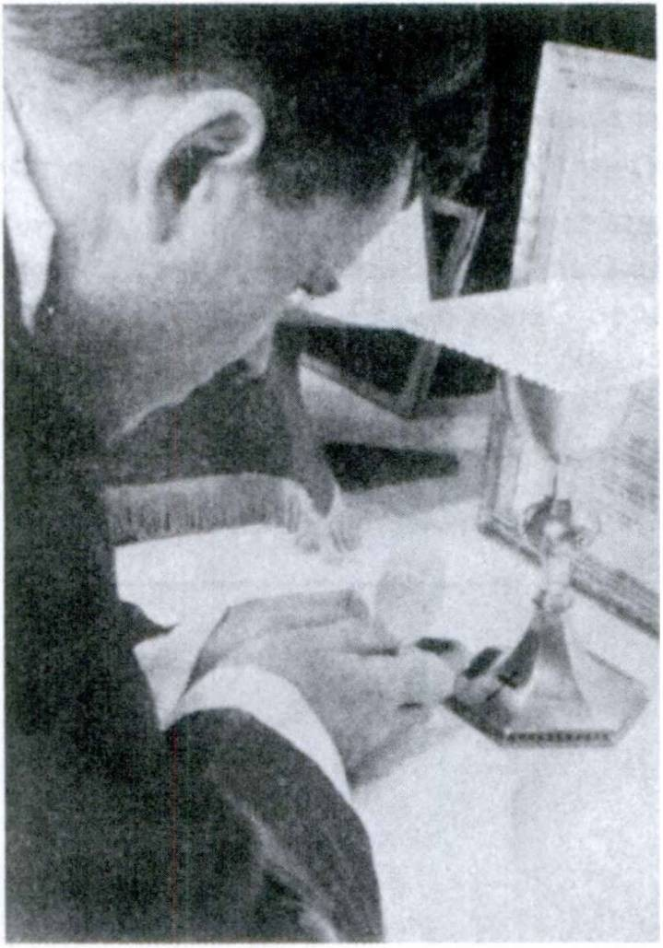FIRST YEAR LATIN 339

MOMENTS AT MASS NO. 3

At the most solemn moment of the Mass—when all are silent and waiting—the priest, bowing low over the altar, unites himself with the Eternal High Priest Christ and speaks, in His name, these sacred words:

HOG EST ENIM CORPUS MEUM

—and the Lord Jesus Christ is present on the altar.

340 FIRST YEAR LATIN

EXERCISE 351
[Review]
- Translate:
2, Explain the use of the italicised pronouns:
- Miles fuga silvas petivit ne hostes se occiderent. 2. Hostes more sud clamorem sustulerunt. 3. Barbari impetum in hiberna fecerunt. Itaque Caesar obsides edrum interfecit. 4. Galli ob­ sides inter se dant.

Sancta Agnes, ora pro nobis!

LESSON 33: ILLE AND IS

ASSIGNMENT: Study GrAmmAr, Nos. 134-135 and 795-798.
You have already learned the declension of is, ea, id.

VOCABULARY
i ea id (as a demonstrative)
’ ’ | Ke, she, it (as a personal pronoun)
ille, ilia, illud (as a demonstrative)
[ he, she, it (as a personal pronoun)
numquam, adv. never
. - . f besidespraet re adv
j
e a, . t
[furthermore
._ .- . [reason
x x
rat rati
io, onis {[manner

NOTE
Ratio is used in a great number of meanings; the vocabulary gives only the most general idea of them. Be sure to translate ratio into good English as the sense and context demand.
RELATED ENGLISH WORD
A rational explanation.

EXERCISE 352
Z. Supply the proper forms of: (a) ille, (b) is;
- Translate:
- cum........ .... nautis 7. pro. Christianis
- pro.......... .... porta 8. contra dominum
- in............ . provincia 9. cum filiis
- ex........... .. silvis 10. per Gallos
- propter . .......... victoriam 11. sine gladiis
- cum........ .....amico 12. in. murd
341

342 FIRST YEAR LATIN

apud. servos
in. oppido
de colie
in. ponte
ex. portu
. rei causa
. viris
- trans flumen
- propter vulnera
- propter salutem Romandrum
- propter inopiam rerum
- de causa belli
- propter legem
- de montibus

- ........... hominum 28. homini

Omnes Sancti discipuli1 Domini, orate pro nobis!

EXERCISE 353
[Essential]
/. Translate;
- Explain the use of the italicised pronouns:
  - Omnes Galli inter se obsides dabant et de belli ratidne agebant. Hac re commotus Caesar legiones novas ex Italia in Galliam statim deduxit. Illi vero subito legatos ad eum miserunt qui amicitiam cum ed cdnfirmarent.
  - Apud Americanos Lincoln et Washingtonius plurimum lau- dantur. Hie enim rem publicam instituit ;2 iWe vero earn non sine labore conservavit.
  - Et Hannibal et Caesar magnas copias per Alpes duxerunt. Htc milites ex Italia deduxit ut Galliam pacaret, ille vero in Italiam exercitum duxit ut Romanos vinceret et Romam occu- paret.
  - El qui sine spe pugnant, numquam fortiter pugnant.
  - Eum qui rem publicam nostram instituit2 memoria semper tenebimus.
  - Et Hitler et Caesar exercitum in Galliam duxerunt ut Gallos vincerent. Ille copias ex Germania in Galliam misit quae earn
1 discipulus, i: disciple,
’inttituo, instituere, inititui, institutus, 3, tr,: found, establish.

FIRST YEAR LATIN 343

vastarent et vincerent, hie exercitum ex Italia per montes in Galliam duxit ut earn pacaret atque occuparet. Ille a Gallis edrumque sociis victus est, hie verb imperium Galliae diu ob- tinuit.
  - Caesar, “German! et Galli,” inquit, “saepe inter se proeliis contendebant. Aut enim Galli fines suds defendebant aut in illorum fines copias suds traducebant.”
  - Gallorum dux suis, “Ego vos,” inquit, “in hunc locum vocavi ut de belli ratione agam. Illi (he points towards the dis­ tant Roman camp) enim in fines nostros venerunt ut hos agros et haec oppida occuparent atque incenderent. Praeterea illi fortes et victoriae cupidi sunt. Ad omnia parati sunt. De vitis nostris atque de communi Galliae salute cum eis contendimus. Itaque eos qui fortiter contra illds non pugnabunt mea manu occidam. Pugnate usque ad mortem! Defendite hds agros, haec oppida, hos pueros nostros ab eis. Hostes pellamus, vincamus, occi- damus 1 ”
EXERCISE 354
[Essential]
Translate:
- That manner of battle was praised by the Romans. 2. Be­ sides, those tribes have never given hostages to the Romans.
- On account of those reasons, Caesar pitched camp at the river.
- Besides, those tribes have always fought against the Roman legions. 5. Led on by those reasons they fought against us, but they will never conquer us. 6. These they repulsed but those they killed. 7. He who loves God will never leave the Christian faith.
8. These men came down from the mountains; but those re­ mained in the mountains. 9. The camp was assaulted by these, but the soldiers encumbered in the river were attacked by those.
10. The cavalry were put to flight, but the soldiers took up a posi­ tion on that hill and did not yield. To these, therefore, the gen­ eral gave thanks, but to those rewards were not given. 11. Those chiefs, moved by the authority of Caesar, gave him hostages.

344 FIRST YEAR LATIN

12. He asked where those tribes dwelt. 13. They will never seize this hill, but we shall seize that camp. 14. That sailor, having been killed by a dart, fell from the ship. 15. Let Us love God and all men.
EXERCISE 355
[Review]
Explain the mood and tense of the italicized verbs:
- Rogo num Christus Deus. 2. Rogo num Caesar barbards
vicerit. 3. Caesar, cum in Gallia esset, cum Gallis bellum gessit.
4. Caesar, cum haec vidisset, auxilia ad milites suos misit.

Nunc aut numquam!

LESSON 34: ABLATIVE CONSTRUCTIONS

- THE ABLATIVE OF SEPARATION
ASSIGNMENT: Study GrAmmAr, No. 766.

VOCABULARY
These words may take an ablative of separation:*

libero, 1, tr.; abl. of separation
vacuus, a, um; abl. of separation
liber, libera, liberum; abl. of separation

prohibeo, 2, tr.; abl. of separation
free (from) empty (of) free (from)
ward off (from) prevent

These words MAY have ab (a) with THINGS. They regularly have ab (a) with PERSONS:
tutus, a, um safe (from)
defendo, defendere, defend!, defensus, 3, tr. defend (from)

RELATED ENGLISH WORDS
A vacuum. We fought to liberate the conquered countries. We tried prohibition once. Smoking is prohibited in streetcars. “Liberty” is the battle cry of Americans.

EXERCISE 356
[Essential]
Translate :
1. Bonorum vita vacua est metu. 2. Reges metu liberi num- quam sunt. 3. Caesar vero, “Te,” inquit, “ab hostibus defendant.”
4. Libera me, Domine, ab eis qui vitam meam petunt. 5. Castra, natura loci munita, ab omni periculo tuta erant. 6. Rogavit num murus a militibus vacuus esset. 7. Galli saepe cum Ger-
1 The words in this vocabulary, of course, take an ablative of separation only
when the sense requires it.
345

346 FIRST YEAR LATIN

manis qui trans flumen Rhenum incolunt proeliis contendunt. Aut enim suis finibus eds prohibent aut in edrum finibus bellum gerunt. 8. Caesar in Galliam missus est ut provinciam ab hos- tibus defenderet. 9. Post adventum Caesaris provincia tuta ab hostibus erat. 10. Lincoln, vir magnus et nobilis, servos in nostra civitate liberavit.

MOMENTS AT MASS NO. 4
THe AGnUs Dei
Shortly before the Communion the priest bows before the altar and says:
Agnus1 Del, qui tollis peccata mundi, miserere nobis. Agnus1 Dei, qui tollis peccata mundi, miserere nobis. Agnus1 Dei, qui tollis peccata mundi, dona1 2 * * nobis pacem.

EXERCISE 357
[Essential]
Translate:
We are free from fear and the power of foreign nations. In the beginning we were freed by brave men from the power of a foreign people. In 1812s the attacks of our enemies were warded off from our territory by our soldiers and sailors. In 1861* we waged war among ourselves, but in that war the slaves were freed from their masters and the republic preserved. Besides, after that war, peace and friendship were established5 among us and have always been preserved.
The Japanese,® led on by the influence of their chiefs and
1 agnus, i: lamb.
2 dond, 1, tr.: give.
lin 1812: anno millesimo octingentesimd duodecimo.
1861: anno millesimo octingentesimd sexagesimo primo.
0 establish: confirmo, /, tr.
- Japanese: Japo, Japonis.

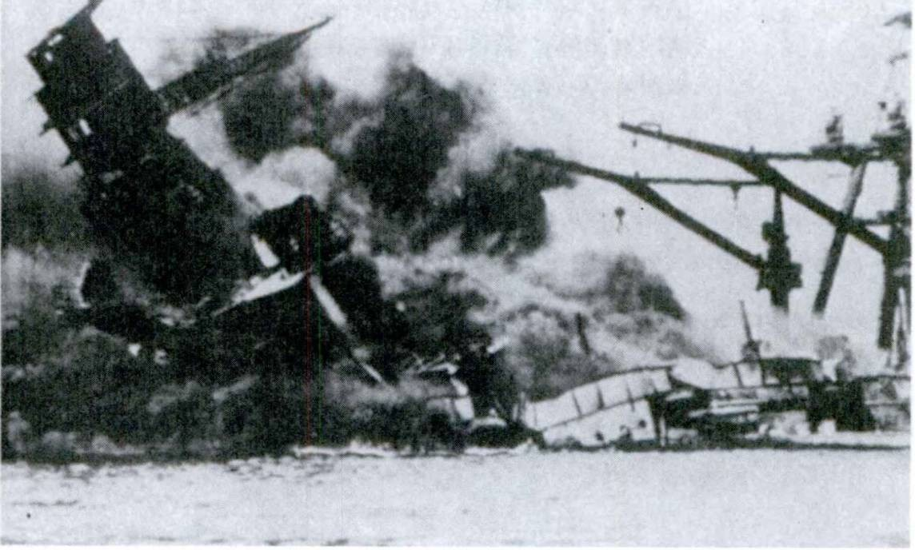FIRST YEAR LATIN 347
V

PeArL HArBor

leaders and eager for glory and empire, made an attack on our harbors and fields. But we have been defended against them by brave men. The nations which they have conquered were freed from their power; the peoples against whom they have waged war will be safe from slaughter and death; their fields shall be cleared1 of foreign armies. Let us thank the brave men who have defended us from our enemies. Let us praise them and help them. Let us always hold in memory their brave deeds,2 and, prepared for death and glory, let us always preserve the republic which they have freed from fear and the dangers of war. Besides, let us always give thanks to God our Father.

- REVIEW OF ABLATIVE CONSTRUCTIONS
STUDY: Ablative of agent, GrAmmAr, No. 764. Ablative of means, GrAmmAr, No. 765.
1 cleared of = empty (of).
2 deed: factum, i; or deeds: res gestae.

348 FIRST YEAR LATIN

Ablative of accompaniment, GrAmmAr, No. 772. Ablative of place, GrAmmAr, Nos. 915-916.
Ablative of cause, GrAmmAr, No. 781. Ablative of separation, GrAmmAr, No. 766.

REVIEW VOCABULARY
plenus, a, um; w. gen. or abl.
cum, prep. w. abl.

in, prep. w. abl. pro, prep. w. abl. ab (a), prep. w. abl.
de, prep. w. abl.

sine, prep. w. abl.
absum, abesse, afui, afuturus, intr.;
ab (a) w. abl.

P[o”n
(in front of (before)
[on behalf of (for) by
from
concerning (about) down from
from without
am away am distant

NOTE
- In the expression murum hominibus complet, hominibus, though meaning persons, is an ablative of means.
- When loco is modified by an adjective, in is often omitted.
- Proelid is generally used without a preposition: proelio,
in battle.

EXERCISE 358
  - Translate;
  - Explain the italicized constructions:
1. Legio ex Italia in Galliam a Caesare missa est. 2. Imperator cum omnibus co pits suis in provinciam contendit. 3. Hibema, natura loci atque valid munita, ab omni hostium impetu tuta erant. 4. Nonne flumen aquae plenum est? 5. Hostes, hac

FIRST YEAR LATIN 349

caede vehementer commoti, de bello in communi Galliae concilio agebant. 6. Pro communi salute nostra ad arma vos voco.
7. Maria, Mater Jesu Christi, gratia erat plena. 8. Hostes, multis proeliis victi, se suaque omnia legato dediderunt. 9. Ille legatus, nomine Labienus, impetu hostium perturbatus murum hominibus complevit. 10. Num legatus castra loco aliend posuit? 11. Sine mora milites pro porta instruct! sunt. 12. His litteris commotus, legatus in fines barbarorum contendit ne a castris abesset.
13. Barbari, hac victoria sublati, de montibus impetum in agmen nostrum impeditum fecerunt. 14. Prima luce ex eo loco castra movet. 15. A flumine in montes celeriter contendit. 16. Multi, telis occisi, de muro in hostes ceciderunt.

Ab omni maid Libera nos, Domine!

EXERCISE 359
[Essential Review of Unit Nine]
Translate:
1. The Japanese, having been driven out of the fortifications, sought the forest in flight. 2. They departed from this river that they might be safe from attack. 3. Led on by the influence of their leaders, the Japanese suddenly made an attack on our harbors. 4. These nations were our allies, but against those nations we waged war. 5. The enemy came secretly out of the forest and were suddenly seen in the rear. Besides, the cavalry of the enemy made an attack from the front. 6. Having been killed by a dart, he fell from the ship into the water. 7. We were freed by brave men from foreign power. 8. He was praised by Caesar on account of his very great courage and faithfulness. 9. The encumbered soldiers were being killed by the cavalry of the enemy. 10. The soldiers, hindered by the nature of the place, withdrew. 11. The camp was empty. For the soldiers, alarmed by the speech of the chief, had withdrawn

350 FIRST YEAR LATIN

into the province. 12. We shall ward off the enemy from these cities and fields. They shall never seize these fields and these cities. 13. The cavalry of the enemy were hindering our column. The leaders of the enemy therefore approved this manner of war. But we warded off their attacks.

EXERCISE 360
[Essential Formal Review of Unit Nine]
- How do you find the perfect participle passive?
- Explain the meaning of these phrases: milites impediti; agmen impedltum; loca impedita.
- How may hie, haec, hoc be used ?
- Explain the difference between ex, de, ab.
- When are a and e used for ab and ex?
- Explain the uses of ille and is.
- Give the rule for the ablative of separation. Give examples.

Veritas vos liberabit.
—John 8:32

UNIT TEN

LESSON 35: POSSUM; THE INFINITIVE IN NOUN CONSTRUCTIONS

  - INDICATIVE OF POSSUM
POSSUM, I am able, I can, is a compound of pote, able, and
sum, I am. The present tenses of the indicative are formed:
- By prefixing pos- to any form of sum which begins with an s (*•£., Pos + sum = possum).
- By prefixing pot to all other forms of sum (e. g.,
pot + eram = poteram).
Now, without looking in the GrAmmAr, complete the conjuga­ tion of possum:
PresenT
possum, I am able, I can potes, you are able, you can etc.
ImperfeCT
poteram, Z was able, I could etc.
FUTUre
poterd, I shall be able etc.
The perfect tenses are formed with the usual endings on the perfect stem, potu-.
ASSIGNMENT: Study GrAmmAr, Nos. 399-401.

VOCABULARY
possum, posse, potui,. i-r.reg., in.tr.. (jam able
(can
NOTE
I am unable, etc., is non possum, etc.
351

352 FIRST YEAR LATIN

EXERCISE 361
Translate:
- Potest. 2. Poteram. 3. Num possunt? 4. Non possum.
5. Potueram. 6. Poterit. 7. Poterunt. 8. Potuerunt. 9. Non
poterant. 10. Quis poterat? 11. Potesne? 12. Possumus.
13. Potuistis. 14. Non potestis. 15. Nonne potuit?

Gloria tibi, Domine!

EXERCISE 362
Translate:
  - can. 2. He was unable. 3. They could. 4. Who was able?
- He will be able. 6. They were unable. 7. Were they able?
- We can. 9. I am unable. 10. They had been able. 11. We can’t, can we? 12. We have been able. 13. They were able.
14. You are able, aren’t you? 15. Why can’t they? 16. He had been able. 17. Why was he unable? 18. You can’t, can you?

- THE INFINITIVE AS SUBJECT, PREDICATE NOUN,
AND OBJECT

The PRESENT INFINITIVE ACTIVE is the SECOND
principal part of regular active verbs (see GrAmmAr, Nos. 209, 219-221). Thus:
Laudd, laudare, laudavl, laudatus, 1, tr. praise
Present Infinitive Active: LAUD-ARE to praise
The PRESENT INFINITIVE PASSIVE is formed on the
present stem. For the endings study GrAmmAr, Nos. 284, 292-294.
Present Infinitive Passive: LAUD-ARI to be praised
The infinitive is a NEUTER VERBAL NOUN.
As a NOUN it is used as SUBJECT, PREDICATE NOUN, or OBJECT. The infinitive is always NEUTER.

FIRST YEAR LATIN 353

As subject: Orare est bonum.
To pray is good (is a good thing).
As predicate noun: Labdrare est orare.
To work is to pray.
As object: Venire parant.
They prepare to come.
As a VERB the infinitive has TENSE, takes OBJECTS, and is modified by ADVERBS and ADVERBIAL PHRASES.
Infinitive with object: Mos est fortes laudare.
It is a custom to praise the brave.

laudare
(Infin.)
fortes
(Obj.)

mos

Adverbial modifier: Fortiter pugnare possunt.
They can fight bravely.
Passive voice: Oppidum expugnari non potuit.
The town could not be taken by storm.
The PRESENT INFINITIVE, denoting another action of the same subject, COMPLETES the meaning of such verbs as possum, am able, can; contendo, strive, hasten; consuevi, have become accustomed.
Redire contendunt.
They hasten to return.
Galli se defendere non potuerunt.
The Gauls were unable to defend themselves.

354 FIRST YEAR LATIN

Notice that in most cases the Latin construction is just like the English. After can the to of the English infinitive is not used. The infinitive, when used as subject or predicate noun, may also be translated by the English verbal noun in -ing or by a noun.
Orare est bonum. To pray (Prayer, praying) is good.

VOCABULARY
possum, posse, potui, irreg.; w. infin. j \am able
[can

adversus, a, um; w. dat.

proximus, a, um; w. dat.
[facing (towards)
j
[ unfavorable
f nearest
j
[next

jam, adv. ■[]already
[now (at that time)
primum, adv. first

RELATED ENGLISH WORDS
Is it possible to fly to the moon? Penicillin is a potent drug. Meet your adversary fairly. Do men pray more in adversity? We must avoid proximate occasions of sin.

RELATED LATIN WORDS
Primus; ad (versus means having been turned).

paro, 1, tr.; w. infin.
REVIEW VOCABULARY

prepare get ready

timed, timere, timui, 2, tr.; w. in fin.

paratus, a, um; w. ad or infin.

contendo, contendere, contend!, 3, intr.; w. infin.
fear
am afraid prepared (for ready
strive contend hasten

FIRST YEAR LATIN 355

NOTE
- The w. infin. in the vocabularies indicates that these verbs and paratus MAY, when the SENSE requires it, take an infini­ tive to complete their meaning. They may also take other con­ structions. For example, note the various uses of paratus:
Ad mortem paratl sunt. They are ready for death. Pugnare paratl sunt. They are prepared to fight. ParatT sunt. They are prepared.
- Adversus, a, um is frequently used with the plural of res
to mean adversity (literally, unfavorable things).
in rebus adversis, in adversity

EXERCISE 363
  - Give the present infinitive active;
  - Give the present infinitive passive:

oro | 5. audio | 9. timed
retined | 6. defendo | 10. ago
compleo | 7. voco | 11. trado
incendo | 8. video | 12. munio

EXERCISE 364
Translate:
- Venire parant. 2. Peccatum est matrem non diligere.
- Manere possunt. 4. Arma parare utile est. 5. Exspectare timu- erunt. 6. Pervenire poterunt. 7. Roma defend! non potest.
8. Agros vastare parant. 9. Deum laudare sanctum est. 10. Cas- tra defendere paratl erant. 11. Galli pacari possunt. 12. Hiberna munire non potuerunt. 13. Impediri non potest. 14. Tutum est in castris manere. 15. Non est mos populi Romani obsides dare.

EXERCISE 365
Translate:
1. They are prepared to yield. 2. It is difficult to storm a camp. 3. They cannot be freed. 4. It is easy to incite the Gauls

356 FIRST YEAR LATIN

to war. 5. They are preparing to go away. 6. It is a sin not to love one’s1 father. 7. They are afraid to fight. 8. He strives to conquer the barbarians. 9. They are afraid to be seen. 10. It is difficult to fight in the mountains.

WARNING!
THE INFINITIVE IS NOT USED IN CLASSICAL LATIN
TO EXPRESS PURPOSE
They prepare to wage war.
(Infinitive as object) Bellum gerere parant.
BUT: They prepare arms to wage war.
(Purpose!)
Arma parant ut bellum gerant

EXERCISE 366
[Essential]
/. Translate;
- Diagram Sentences 3, 6, and 9:
1. Nonne omnes homines orare possunt? 2. Amicus certus in rebus adversis facile cerni potest. 3. Peccatum est contra amicos pugnare. 4. Propter loci naturam hostes adversi nobis consistere non potuerunt. 5. Hannibal, Caesar, Napoleon, magnas copias per montes difficiles et altos ducere potuerunt. 6. Galliam pacare difficile fuit. 7. Milites American! qui in Bataan erant, propter omnium rerum inopiam, impetus hostium diutius sustinere non jam poterant. 8. Caesar primum cum eis gentibus quae pro- vinciae proximae erant bellum gessit, turn in omnes partes Galliae legatos legionesque misit ut eas etiam partes exploraret, cognos- ceret, vinceret. 9. In rebus adversis non facile est fortiter pugnare. 10. Possumusne nos American! fines nostros ab omnibus

1 Do not translate onds.

FIRST YEAR LATIN 357

hostibus defendere et eds ex finibus nostris pellere? 11. Caesar diu in fines hostium contendit, turn constitit ut novas exspectaret copias. 12. Americani et Britanni in earn partem Galliae quae adversa Britanniae est magnum exercitum traducere potuerunt.
13. Sanctum est Deum laudare atque diligere. 14. Primum Japones Americanos propter inopiam earum rerum quae ad bellum pertinent premere atque proelid pellere potuerunt. 15. German! Gallis proximi erant, nam trans flumen Rhenum incolebant. Itaque agros Galldrum facile vastare poterant.

EXERCISE 367
[Essential]
Translate:
The Americans and British were first able to lead a large army across into Sicily. The Germans had taken up positions opposite them. There was bitter fighting there. But the Germans were not able to withstand the attacks of the Americans and their allies. The Germans had not been able to learn what plan and what manner of battle had been approved by the Allies. And so they were unable to station troops and prepare fortifications. They yielded; and the Allies conquered them. Then the Allies quickly led their forces across into Italy. They made an attack on the Germans both from the front and from the rear. They were able to seize a large part of Italy. After many battles they were able to take Rome. The Germans were now unable to withstand the forces of the Allies and they sought safety in flight. They hastened to those parts of Italy which are nearest the Alps. These places they fortified and there awaited the attack of the Allies.

SENTENTIAE SELECTAE
- Habere non potest Deum patrem qui ecclesiam1 non habet matrem. (St. Cyprian.)
- Amici probantur rebus adversis. (Proverb.)
- Sine virtute amicitia esse non potest. (Cicero.)

1 ecclesia, ae: church.

358 FIRST YEAR LATIN

- Sine virtute nihil laudari potest. (Adapted from Cicero.)
- Malum est consilium quod mutari1 non potest. (Publilius Syrus.)
- Fortis cadere potest, cedere non potest. (Proverb.)
- Sanctus Joannes, “Qui enim,” inquit, “non diligit fratrem suum quern videt, Deum, quern non videt, qudmodo1 2 potest di- ligere ? Et hoc mandatum3 habemus a Deo: ut4 qui diligit Deum, diligat et5 * 7 fratrem suum.”

READING NO. 26

DE REGIBUS SANCTIS
Possuntne etiam reges sancti esse? Reges qui imperium et regnum obtinent saepe agrorum aliendrum cupidi sunt; saepe gloria belli incitati magnos exercitus contra gentes et reges proximos ducunt. Saepe etiam fratres suds timent atque occidunt ne regnum suum armis occupent. Reges tamen sancti esse pos- sunt. Potuit enim Sanctus Stephanus® et regnum obtinere et bella gerere et tamen Deum diligere. Stephanus rex fuit Hungariae et populum suum fidem Christianam docuit.
OlimT venit homo quidam8 9 ad Stephanum ut eum occideret. Nox erat et Stephanus dormiebat.® Cum ille ad regem appropin- quaret, gladius subito ex manu cecidit. Stephanus, cum con­ silium illius cognovisset, neque commotus neque perturbatus, “Si10 11 Deus mecum est,” inquit, “quis contra me erit?”
Praeterea Wenceslaus,11 Rex Bohemiae, et sanctus et rex esse potuit. OlimT Ratislaus, dux gentis finitimae, bellum contra
1muto, /, tr.: change (ci. mutability).
2 quomodo, adv.: how.
8 mandatum, i: command (ci. mandate).
4 Translate ut by that . . . should.
5 Et here means also.
- The Feast of St. Stephen of Hungary is celebrated on September 2.
7 olim, adv.: once.
8 quidam (modifies homo): a certain.
9 dormid, 4, intr.: sleep.
10 si: if.
11 The Feast of St. Wenceslaus of Bohemia is celebrated on September 28.

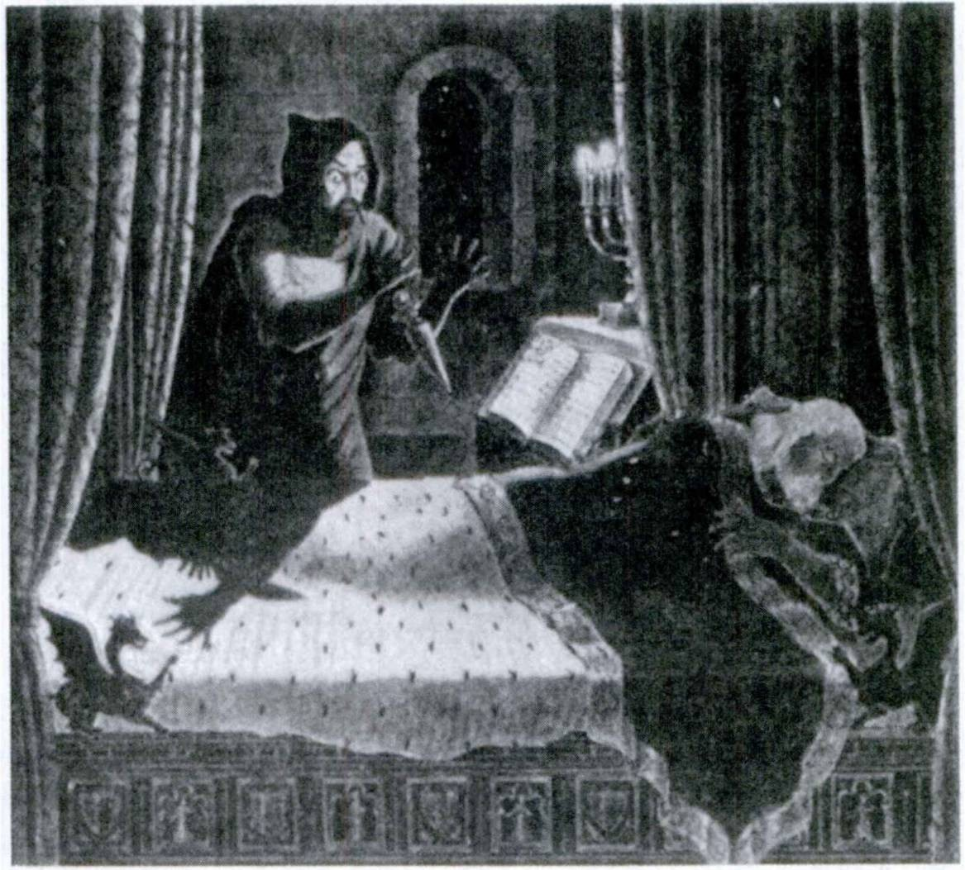FIRST YEAR LATIN 359

GLADiUs ex MAnU CeCiDiT.

Wenceslaum gerebat. Cupidus enim erat regni Bohemiae. Wen­ ceslaus legatos ad eum misit qui de pace et amicitia agerent. Tamen amicitiam confirmare non potuit. Itaque contra ilium cum omnibus copiis contendit. Cum jam hostibus appropinquaret, Wenceslaus, ne caedes esset, de nova belli ratione agebat. (Here Wenceslaus proposed that the two kings settle the war by single combat in order to save their soldiers9 lives. Ratislaus accepted.) Itaque reges inter exercitus constiterunt ut inter se pugnarent. Sed Ratislaus telum in sanctum Wenceslaum mittere non potuit. Itaque, gratia Dei victus, amicitiam cum ed confirmavit. Ita servatae sunt et militum vitae et regnum Bohemiae.

360 FIRST YEAR LATIN
- SUBJUNCTIVE OF POSSUM
ASSIGNMENT: Learn the present and imperfect subjunc­ tive of possum in GrAmmAr, Nos. 411-412. Note that the present subjunctive follows the rule given on page 351 of FirsT YeAr LATin, while the imperfect subjunctive follows the rule given in Lesson 23, page 235.
The perfect and pluperfect subjunctive of possum are formed regularly on the perfect stem, potu-.

VOCABULARY

constituo, constituere, constitul, consti- tutus, 3, tr.; w. infin.

consuevT, consuetus, 3, tr. and intr.;
w. infin.

sententia, ae regid, regionis

omni no, adv.

NOTE

place set up decide
determine
have accustomed
have become accustomed am accustomed
opinion vote
(
region
at all (with negatives like non)
altogether
in all (with numerals)

- Constituo, of course, takes an infinitive only when the SENSE requires it.
In montes contendere constituit. He determined to hasten into the mountains.
Milites in colie constituit. He placed the soldiers on the hill.
- The present tenses of consuevi are not common. Hence Only the perfect indicative active and the perfect participle passive are given. But note that the perfect can have a PRESENT meaning and the pluperfect can have a PERFECT meaning:

FIRST YEAR LATIN 361

consuevi
consueveram

intransitive

transitive intransitive
transitive

I have become accustomed=
/ am accustomed I have accustomed
I had become accustomed - I was accustomed
I had accustomed

RELATED ENGLISH WORDS
Let us defend the Constitution of the United States. The judge passes sentence; the jury merely determines the fact of the crime. Webster was a sententious writer.

Ab omni peccato, Libera nos, Domine!

EXERCISE 368
[Drill on Forms of Possum]
Change the persons in each sentence and translate:
- Arma paro ut hostes vincere possim. Arma paras ut hostes vincere possis, etc.
- Arma paravi ut hostes vincere possem, etc.
- Quaero num hostes vincere possim, etc.
- Quaero num hostes vincere potuerim, etc.
- Quaesivi num hostes vincere possem, etc.
- Quaesivi num hostes vincere potuissem, etc.

EXERCISE 369
Translate:
1. Caesar milites ad flumen constituit quo facilius pontem de- fendere possent. 2. Rogavit quantas copias ex eis regionibus cogere posset. 3. Rex sententiam suam legatis ostendere consti­ tuit. 4. Legatus copias novas exspectare constituit ne barbari se superare possent. 5. Rogo num Caesar Gallos vincere potuerit.

362 FIRST YEAR LATIN

- Galli, cum per provinciam copias suas ducere non potuissent, per loca impedita atque angusta eas ducere constituerunt.
- Caesar, cum illas regiones vastare non potuisset, legidnes trans flumen in provinciam deducere constituit. 8. Rogo quis hoc hel­ ium fortiter administrare possit. 9. Rogavit num equites eas regiones cognoscere possent. 10. Romani obsides dare non con- sueverant. 11. Milites Romani se suaque signa hostibus dedere non consueverant. 12. Milites American! omnes hostes vincere consueverunt. 13. Legatus custodes ibi constituet ne hostes eas regiones explorare possint.
EXERCISE 370
[Essential]
Translate:
1. He asked whether Columbus was able to get ready three ships in all. 2. The lieutenant placed guards there lest the bar­ barians might be able to reconnoiter those regions. 3. In all there are ten1 commandments1 2 of God. 4. Americans were asking why we were not at all able to send help to our soldiers then.
5. “We,” said the Roman leader, “are not at all accustomed to give hostages.” 6. We often ask why the Gauls were not at all able to withstand the attack of the Romans. 7. He asked whether they were able to learn the opinion of the Senate. “For,” he said, “I have decided not to wage this war against the authority of the Senate.” 8. He asked whether this man had been freed by many votes. 9. Saints were accustomed to pray often that they might be able more easily to keep the faith and to love God. 10. Caesar had determined to reconnoiter and conquer all the regions of Gaul. First therefore he waged war with those tribes which are next to the Roman province lest they might be able to make3 an attack upon him from the rear. Then he waged war with the rest of the tribes, and, after many battles and great slaughter, he was able to pacify and hold all Gaul.
1 ten: decern, indecl. adj.
2 commandment: mandatum, i.
8 to make: facere.

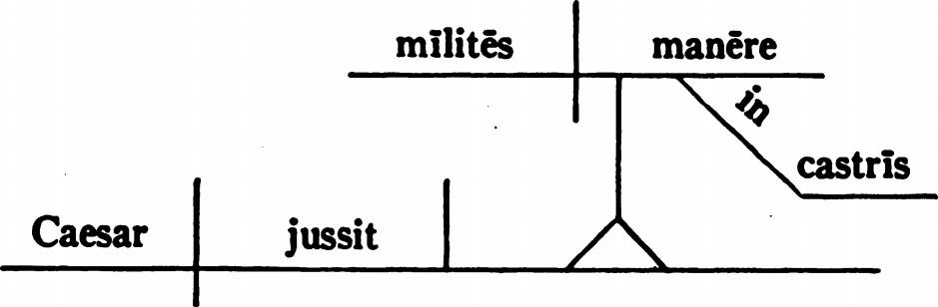FIRST YEAR LATIN 363

- THE INFINITIVE WITH SUBJECT ACCUSATIVE
Since the infinitive is a VERB it may also have a subject.

THE SUBJECT OF AN INFINITIVE IS IN THE ACCUSATIVE CASE.

When the sense requires it, the infinitive as object, subject, and predicate noun may have a subject accusative:
Malum est homines inter se pugnare.
It is a bad thing that men fight among themselves. It is bad for men to fight among themselves.
An infinitive with accusative subject is regularly used with certain verbs; for example:
- Jubeo, I order, I command is often followed by an infinitive with subject in the accusative case:
Caesar milites in castris manere jussit.
Caesar ordered the soldiers to remain in the camp.

- Oportet, it behooves may be followed by an infinitive:
Oportet te Deum diligere.
It behooves you to love God.
In better English, It is necessary that you love God.
Oportet nos bonds esse.
It is necessary that we be good. We ought to be good.

364 FIRST YEAR LATIN

VOCABULARY

jubed, jubere, jussi, jussus, 2, tr.; acc. w. infin.

oportet, oportere, oportuit, 2, intr.; acc. w. infin.1
timor, timdris

order command it behooves
fear
{

NOTE
- It is very difficult to translate oportet into good English. Various English idioms may be used:
You ought to love God.
It is proper for you to love God. You should love God.
In translating oportet always try to find a good English ex­ pression for the IDEA or MEANING of the Latin sentence.
- Jubed, in the passive, is used just as in English.
Legati convenire jussi sunt.
The lieutenants were ordered to come together.
Legatus milites ducere jussus est.
The lieutenant was ordered to lead the soldiers.
- A predicate adjective after the INFINITIVE agrees with the word, expressed or understood, to which it REFERS.
Oportet milites esse paratos.
It behooves soldiers to be prepared.
Dux militem esse para turn jussi t.
The leader ordered the soldier to be prepared.
Pueri boni esse jussi sunt.
The boys were commanded to be good.
Mater esse fortis potest.
A mother can be brave.

1 In translating use it is proper; should; it is necessary, etc.

FIRST YEAR LATIN 365

RELATED ENGLISH WORDS
We have studied the jussive subjunctive. A timorous person will not be a good soldier.
RELATED LATIN WORD

Timed
EXERCISE 371
Translate:
(First translate literally; then into good English.)
1. Oportet te matrem defendere. 2. Oportet te orare. 3. Opor- tet vos omnes Deum diligere. 4. Oportet nos legem Christi servare. 5. Oportet omnes homines Christum diligere.

In hora mortis meae voca me, Et jube me venire ad te,
Ut cum sanctis tuis laudem te In saecula saeculorum. Amen.
—From the Anima Christi

EXERCISE 372
Translate:
1. Caesar legatum manere jussit. 2. Legatus milites convenire jussit. 3. Caesar obsides occidi jussit. 4. Galli Caesarem excedere1 jusserunt. 5. Imperator milites se defendere jussit. 6. Tribuni militum in acie manere jussi sunt. 7. Hostes se dedere jussi sunt.
- Nos sancti esse a Christo jussi sumus. 9. Pueri matres diligere a Deo jussi sunt. 10. Fortis esse jussus sum.

EXERCISE 373
Translate:
1. It behooves us to help our friends. 2. Christ commanded us to pray always. 3. It behooves us to preserve our lives.
- Caesar ordered the soldiers to bum the crops. 5. It behooves
1 excedo, excedere, excesrf, excessum, 3, intr.: depart.

366 FIRST YEAR LATIN

us to call upon God. 6. He ordered them to reconnoiter the forest. 7. The slave was commanded to be good. 8. We were commanded by Christ to pray always. 9. The soldiers were ordered to burn the crops. 10. They were ordered to reconnoiter the forest. 11. It behooves us to love our mothers. 12. It be­ hooves Americans to defend their republic. 13. Lincoln ordered the Americans to free their slaves. 14. The chiefs were ordered to depart. 15. The barbarians were ordered to surrender.
EXERCISE 374
[Essential]
Translate:
  - Milites Romani, timore perturbati, non saepe salutem fuga petiverunt, attamen1 Caesar semper eos in acie manere jussit. Oportuit enim eos semper virtutem Romanam memoria tenere.
  - Christus nos et Deum diligere et omnes homines adjuvare jussit. Itaque oportet nos omnes hanc legem servare.
  - American! numquam belli cupidi erant sed, cum propter in­ juries graves pugnare atque rem publicam defendere jussi essent, sine timbre aut mora fortiter bellum cum Japonibus gesserunt. Oportet nos virtutem militum nostrorum et res ab eis gestas memoria semper tenere.
  - Dux, cum in agros alienos milites deduceret, primum equites omnia loca explorare jussit ne in loca impedita atque angusta legiones duceret. Oportuit enim ducem vitas militum suorum de­ fendere atque conservare.
EXERCISE 375
Translate:
(Use oportet in each sentence.)
1. We should all love God. 2. It is proper for soldiers to fight without fear. 3. It is necessary for you to pray often. 4. We must remember the victories of our fathers. 5. It is right for Americans to defend their state.
1 attamen: but nevertheless.

FIRST YEAR LATIN 367

READING NO. 27
DE LEGIONE THEBAIA
This is the story of a heroic band of Christian Roman soldiers who were put to death for the faith by their own commander, the Emperor Maximian.1 They had been recruited in northern Egypt around the city of Thebes (hence they were called the Theban Legion), but were martyred in Gaul near Lake Geneva, probably about A. D. 287.
Turn in exercitu Romano erat legid quae Thebaia vocabatur. In hac legione omnes milites centuridnesque Christian! erant. Erat autem eo tempore2 bellum in Gallia. Itaque Maximianus, qui cum Diocletiano imperium obtinebat, legidnes ex omnibus pro- vinciis in Galliam misit ut contra eas gentes quae cum Romanis bellum gerebant pugnarent. Maximianus autem vir bonus non erat atque multos Christianos propter nomen fidemque Christi occiderat. Itaque, cum ea legio in Galliam venisset, Maximianus earn etiam Christianos occidere jussit. Milites verb ejus legionis, Christian! fortes et nobiles, quae imperator jusserat non fecerunt. Itaque Maximianus, vehementer hac re commotus, decimum quemque3 militem occidi jussit. Post hanc caedem autem milites imperia imperatoris non fecerunt neque tamen contra eum pugna- verunt. Parati enim erant pro fide Christiana et pro Christo Rege occidi, at milites Romani erant qui contra Imperatorem Romanum armis non pugnabant. Maximianus autem rursus4 deci­ mum quemque3 militem occidi jussit. Post hanc alteram5 caedem, Sanctus Mauricius, qui in ea legione centurio erat, litteras ad Maximianum misit:
1 This account is based on the record left by St. Eucherius, Bishop of Lyons. Two reasons are given for the martyrdom of these Christian soldiers. St. Euche­ rius says that they were martyred for refusing to execute condemned Christians; another account relates that they refused to offer sacrifice before battle. The number of those martyred has been doubted.
2 eo tempore: at that time.
3 decimum quemque: every tenth (agrees with militem).
4 rursus, adv.: again.
5 alter, altera, alterum: other, second.

368 FIRST YEAR LATIN

“Milites sumus, imperator, tui, sed servi tamen Dei veri. Pro te pugnamus, te defendimus; nam imperator es noster, et tu nobis et frumentum et praemia periculorum nostrorum das. Deus autem nobis gratiam dat atque vitam aetemam. Itaque Deum, et nostrum et, imperator, tuum relinquere non posslimus. In hac re gravi imperia tua non faciemus. Fides nostra enim prohibet. Si1 contra hostes pugnare jusseris, si1 labores atque dolores, si1 im- petum barbardrum sustinere jusseris, si1 urbes hostium op- pugnare et agros vastare jusseris, pugnabimus, sustinebimus, op- pugnabimus, vastabimus. Christianos autem, etiam a te, im­ perator, jussi, occidere non possumus. Jam ex nobis multos viros bonds et fortes propter Christum occidisti, tamen contra te non pugnavimus. Ecce2 enim arma tenemus et non nos defendimus. Parati sumus omnes ad mortem, neque propter metum mortis Christum relinquemus. Deum Patrem, regem omnium, et Filium ejus, Jesum Christum, Deum adoramus. Christianos gladiis occi­ dere non possumus! ”
Maximianus vero, cum haec audivisset, vehementer commotus, illos omnes statim occidere constituit. Itaque omnes ejus legionis milites centurionesque ad mortem duci jussit. Reliqui milites, qui Christian! non erant, eos gladiis occiderunt atque ita eos sanctos Dei in Caelum ad Deum miserunt. Postea omnes Chris- tiani eorum mortem memoria tenebant et semper tenebunt. Nonne nos etiam eos laudamus? Nam et milites fortes et Christian! fortes erant.

Omnes sancti martyres,3 orate pro nobis.

1 si, co*j.: if.
’ecce: behold.
1 martyr, martyris: martyr (one who has died for the faith).

FIRST YEAR LATIN 369
MOMENTS AT MASS NO. 5
AT THe SAnCTUs
After reciting the “secret” prayers, the priest says in a loud voice: “ per omnia saecula saeculorum.”
Server. Amen.
PriesT. Dominus vobiscum. Server. Et cum spiritu tud. PriesT. Sursum corda.1
Server. Habemus ad Dominum.
PriesT. Gratias agamus Domind Deo nostro. Server. Dignum2 et justum3 est.
(The priest then reads the Preface and, bowing, says:)
PriesT. Sanctus, sanctus, sanctus (the bells ring), Dominus Deus Sabaoth.4 Pleni sunt caeli5 et terra gloria tua. Hosanna6 in excelsis.7 Benedictus8 qui venit in nomine Domini. Hosanna6 in excelsis.7

1 Sursum corda: Lift up your hearts.
2 dignus, a, um: worthy.
3 Justus, a, um: right.
4 Sabaoth: a Hebrew word meaning of Hosts.
5 In Christian Latin the plural of caelum is caeli, caelorum.
6 Hosanna: a Hebrew cry of j*oy and exultation.
7 in excelsis: m the highest.
6 benedictus, a, um: blessed.

LESSON 36: NUMERALS; IRREGULAR ADJECTIVES

- NUMERALS
ASSIGNMENT: Learn the cardinal numerals from unus, one, to decern, ten, and centum, one hundred, GrAmmAr, No. 112. Learn the declension of unus, duo, and tres, GrAmmAr, Nos. 114-
116. Notice that unus is declined like magnus except in the GENITIVE and DATIVE. Tres is declined like the plural of gravis, on the stem tr-.

VOCABULARY

quot, indecl. adj, aeternus, a, um caput, capitis
how many? eternal everlasting
head

NOTE
Indecl, means that the adjective quot never changes its form, no matter what form the noun may be with which it agrees.
Quot homines? How many men?
In quot urbibus? In how many cities?
Rogavit quot milites in castris essent.
He asked how many soldiers were in the camp.

RELATED ENGLISH WORDS
Washington is the capital of the United States. In arithmetical division which number is called the quotient? Many men were decapitated during the French Revolution.

Fili Dei, te rogamus, audi nos!

370

FIRST YEAR LATIN 371

EXERCISE 376
[Drill on Forms]
Translate:
- With three legions. 2. After two battles. 3. In five cities.
4. Without ten legions. 5. Into two cities. 6. With one general.
7. After three victories. 8. After the slaughter of a hundred hostages. 9. Across two rivers. 10. After the death of these three men. 11. On behalf of one king. 12. By one man. 13. By means of five darts. 14. On account of the courage of one man.
15. Concerning the safety of three hostages. 16. Through two provinces. 17. Out of three cities. 18. On account of one sin.
19. To one man (dative). 20. To two chiefs (dative).

Roma—Caput Mundi

EXERCISE 377
Responde Latine:
- Quot sunt quinque et quattuor?
- Quot sunt unum et quattuor?
- Quot sunt sex et unum ?
- Quot sunt quinque et unum ?
- Quot sunt quattuor et quattuor?
- Quot sunt sex et quattuor ?
- Quot sunt duo et unum?
- Quot capita habet homo ?
- Quot manus habet homo ?
- Quot corpora habet homo?
- Quot mentes habet homo ?

EXERCISE 378
Translate:
1. “Audi, Israel, Deus tuus Deus unus est.” (From the Old Tes­ tament.) 2. Uni Deo sit gloria aeterna. 3. Virtute unius viri fortis

372 FIRST YEAR LATIN

res publica saepe conservatur. 4. In uno vird salus communis saepe posita est. 5. Per unum hominem, Jesum Christum, salu- tem et vitam aeternam habemus. 6. Duo sancti, Petrus et Paulus, eds qui urbem Romam incolebant fidem Christianam docu- erunt. 7. Christus cum dudbus hominibus mails ad mortem ductus est. 8. Nomina duorum virdrum, Washingtonii qui rem publicam nostram constituit atque Lincoln qui earn constitutam conservavit, memoria semper tenebuntur. 9. Tres Personas,1 Patrem et Filium et Spiritum Sanctum, in uno Deo adoramus.
10. Christianus verus his tribus virtutibus, fide, spe, caritate,2 *
cerni potest. 11. Homo unum caput sed duas manus habet.

EXERCISE 379
[Essential]
Translate:
1. Through the death of one man, Jesus Christ, we have been freed from the danger of eternal death. 2. In what great and renowned city were there seven hills? 3. We Christians adore the five wounds of Jesus Christ, our Lord and God. 4. A cen­ turion is so called because he leads a hundred men. 5. How many are four and six? 6. There are ten commandments8 of God. 7. There are eight beatitudes.4 8. There are seven gifts5 of the Holy Spirit.

SENTENTIA SANCTI PAULI
“Unus Dominus, una fides, unum baptisma,6 unus Deus et Pater omnium, qui est super7 omnes et per omnia et in omnibus nobis.”

1 persona, ae: person.
2 caritas, caritatis: charity.
8 commandment: mandatum, I.
4 beatitude: beatitudd, beatitudinis.
5 gift: donum, i.
6 baptisma, baptismatis, n.: baptism.
r super, prep, w. acc.: above.

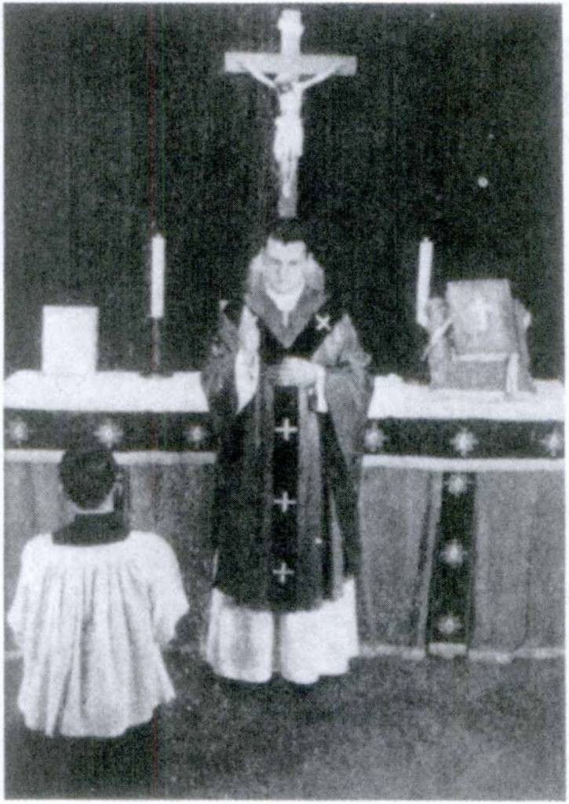FIRST YEAR LATIN 373

MOMENTS AT MASS NO. 6

The Last Blessing
Benedicat1 vos omnipotens2 Deus, Pater et Filius et SpTritus Sanctus. Amen.

1 benedico, benedicere, benedixi, benedictus, 3, tr.: bless.
2 omnipotens (an adjective modifying Deus): almighty.

374 FIRST YEAR LATIN

ADJECTIVES WITH IRREGULAR ENDINGS IN THE GENITIVE AND DATIVE SINGULAR
All the adjectives in the vocabulary are like unus in the geni­ tive and dative singular.

alius, alia, aliud
alter, altera, alterum1 uter, utra, utrum2
VOCABULARY
other
(
another (of more than two)
(the one
the other (of two)
which? (of two)

neuter, neutra, neutrum2 ullus, a, urn8
nullus, a, urn3 solus, a, urn8
totus, a, ums
neither (of two)
any
no none
(
alone
(
only (as adjective)
(whole all of

the whole of
NOTE
When totus modifies the ablative of a noun indicating place where, in is not used.
tota urbe, in the whole city
tods castris, in the whole camp
tota acie, in the whole battle line
The only forms you have to learn for these adjectives are the genitive and dative singular, and for alius, that the nominative and accusative neuter singular is aliud. All the rest you know already.

1 Like liber except in genitive and dative singular.
2 Like integer except in genitive and dative singular.
3 Like magnus except in genitive and dative singular.

FIRST YEAR LATIN 375

RELATED ENGLISH WORDS
A marriage performed for Catholics by a justice of the peace is nidi and void. What do you mean by total war? The total number of conversions each year in the United States has been steadily growing. An infinitive in Latin is always neuter. Cir­ cumstances alter cases. There have been many saints who lived as solitaries.
ASSIGNMENT: Study GrAmmAr, Nos. 84-88, 822-828.

MATER BONI CONSILli, ORA PRO NOBIS!

EXERCISE 380
[Drill]
Translate:
(Use the dative for all ^-phrases.)
1. Of another king. 2. Of the other centurion. 3. To another tribe. 4. To all Italy. 5. Of God alone. 6. To no men. 7. Not of any kingdom. 8. To this republic alone. 9. Of only this man.
10. To no mother. 11. Of no soldier. 12. Of all Gaul. 13. To the whole army. 14. Of another victory. 15. Of this boy alone.
16. Of the whole people.

EXERCISE 381
[Essential]
Translate:
1. Aliam viam habemus nullam. 2. Soli Deo, Regi Caeli et terrae, sit gloria. 3. Gallis, cum per provinciam copias ducere pararent, Caesar respondit: “More populi Romani iter per pro­ vinciam null! dare possum.” 4. Neque ullus metus neque ullum periculum milites nostros terret. 5. Cum hiberna oppugnata essent, Caesar, litteris de ea re doctus, sine ulla mora milites

376 FIRST YEAR LATIN

statim deduxit ut suds adjuvaret. 6. Barbarl eds solos laudant qul fortiter pugnare possunt. 7. Washingtonium et Lincoln omnes American! memoria tenent. Alter enim rem publicam nostram con- stituit, alter earn in. belli periculis conservavit. 8. Caesar et cum Gallis et cum Germanis bellum gessit. Alter! enim se contra eum defendebant, alter! autem agros alienos vastare consueverant.
9. In proelid alii tells, alii autem gladiis occiduntur. 10. Alii gloriae causa bellum gerunt, alii verb salutis causa. 11. Alii alios imperatores laudant. 12. Alii alias sententias probant. 13. Impe­ dimenta totius exercitus in unum locum mitti jussit. 14. Totum montem hominibus compleri jussit. 15. Caesar imperium totius Galliae obtinebat. 16. Cum hostium clamor auditus esset, milites totis castris perturbati sunt atque alius ex alio causam clamoris quaesivit.

EXERCISE 382
[Essential]
Translate:
1. The bodies of some were in the camp; the bodies of others were in the forest. 2. Some praised Caesar; others praised Han­ nibal. 3. Two men taught those who inhabited Rome the Chris­ tian faith. The one was Peter; the other was Paul. 4. Caesar and Hannibal were very great generals. The one conquered the whole of Gaul; the other was conquered by the Romans.
5. Caesar alone conquered all Gaul. 6. They determined to at­ tack the town without any delay. 7. Some are eager for war; others are eager for peace. 8. No soldiers were left in the camp.
9. We praise America; others praise other nations. 10. Caesar often thanked his whole army. 11. Lee and Grant were very great generals. The one conquered; the other was conquered.
12. Isn’t Rome the glory of all Italy? 13. Let us surrender to no enemy. 14. Christ alone is the King of all men. 15. There were two leading men in this tribe. The one was a friend of Caesar and the Roman Senate; the other was not. 16. Caesar was not accustomed to give hostages to any chief. 17. Some are afraid

FIRST YEAR LATIN 377

to fight; others are always ready to fight. 18. He seized the fields of another man. 19. The chiefs of all Gaul were con­ quered by Caesar. 20. Some approve one plan; others another.
21. There were two Ciceros, of whom one was in Caesar’s army, the other was in the Senate. 22. Some praise one nation; others another.

MOMENTS AT MASS NO. 7
As the priest places the Host on the tongue of the communicant, he prays:
Corpus Domini nos tri Jesu Christi custodiat1 animam2 tuam in vitam aeternam.

READING NO. 28

DE SANCTA TRINITATE3
Alia est enim persona4 Patris, alia Filii, alia Spiritus Sancti, sed Patris et Filii et Spiritus Sancti una est divinitas.5 . . . Aetemus Pater, aeternus Filius, aeternus Spiritus Sanctus; et tamen non tres aeterni sed unus aeternus. . . . Ita Deus Pater, Deus Filius, Deus Spiritus Sanctus, et tamen non tres Dei sed unus est Deus. Ita Dominus Pater, Dominus Filius, Dominus Spiritus Sanctus; et tamen non tres Domini sed unus est Do­ minus. . . . Unus ergo6 Pater, non tres Patres; unus Filius, non tres Filii; unus Spiritus Sanctus, non tres Spiritus Sancti. (From the Creed “Qutcumque” called the Athanasian Creed; composed in the fifth century, possibly in Spain.)

1 custodio, 4, tr.: guard, keep (cf. custos).
2 anima, ae: soul.
2Trinitas, Trinitatis: Trinity.
4persona, ae: person.
6 divinitas, divinitatis: divinity.
e ergo, adv.: therefore.

378 FIRST YEAR LATIN

SENTENTIA CHRISTI
Christus, “Unus,” inquit, “est enim Pater vester, qui in caells est”

NOTE ON TRANSLATION
Res, as is clear from its meaning, is a very general word. It is used in Latin in many contexts where we would use in English a more specific or definite word. For example:
Illud ad rem non pertinet. That does not pertain to the subject.
Avoid, as much as possible, translating res by thing. Try to find a good English word that fits the context. In this exercise choose from the list given the best English word to translate the italicized word or words in each Latin sentence:
ENGLISH WORDS: matter; reason; new deal or revolution; circumstance; affair, subject.
EXAMPLE: Illud ad rem non pertinent. That does not per­ tain to the subject.
- Qua re (abl. of cause) eum occidisti ?
- Galli rerum novdrum cupidi erant.
- Si1 res cogit, oportet hominem se etiam armis defendere.
- Legatus Caesarem de tota re docuit.
- Principes de re gravi agebant.

READING NO. 29

DE PACE AC BELLO
Pacem omnes homines laudant et petunt, at tamen nulla est pax.
Hannibal per Galliam trans flumina lata et montes altos copias
duxit ut in Italia cum Romanis bellum gereret. Milites ejus labdres atque dolores graves sustinebant; multi ex eis in mon- tibus difficilibus cadebant, multi ex eis occisi sunt. Ille tamen

1 ti: if.

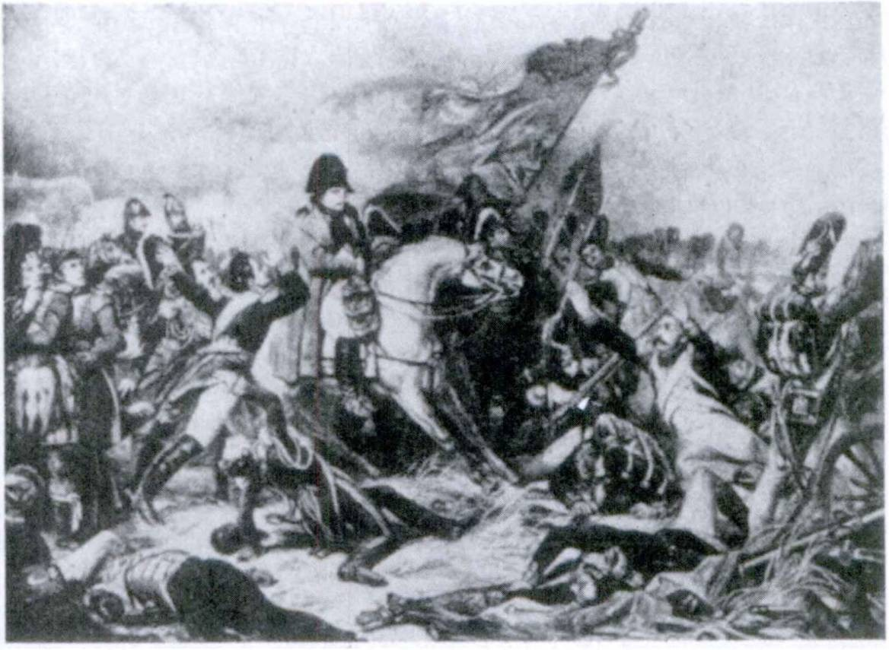FIRST YEAR LATIN 379

NApoLeon

neque constitit neque pacis causa legatos ad Romanos misit, nam constituerat et Romanos vincere et Romam occupare. Diu cum Romanis proeliis contendit, tandem verb proelio pulsus est atque victus.
Postea Romani cum Gallis et omnibus fere gentibus finitimis bella gesserunt. Illi, belli gloria adducti, hos virtute et armis superaverunt atque vicerunt. Itaque diu imperium totius Italiae atque multarum gentium aliarum obtinebant.
Turn barbari, victoriae spe adducti, in urbes et provincias
Romanas venerunt ut omnia vastarent atque occuparent. Post id multa alia bella in Europa gerebantur.
Napoleon, vir magnus et fortis, qui regnum in Gallia occu- paverat, imperii atque gloriae spe adductus, totam Europam vincere atque tenere constituit. Itaque ille in omnes gentes et civi- tates Galliae finitimas exercitus duxit ut eorum imperium obtineret. Diu omnes proeliis pepulit et bellis vicit. Magnus

380 FIRST YEAR LATIN

hominum numerus occisus est; graves dolores ab omnibus susti- nebantur. Ille verb etiam virtute et armis victus est.
Post illud imperator alius, nomine Hitler, vir gloriae et regni cupidus, totam Eurbpam vastavit atque armis vicit. Ille diu totius fere Eurdpae imperium tenuit sed nunc victus est cum omnibus sociis ejus.
Nulla est pax. Omnes tamen homines boni pacem petunt atque laudant. Bella tamen, “horrida1 bella,” semper geruntur. Cur non possumus amicitiam et pacem et fidem inter omnes populos confirmare? Nonne bonum est in pace esse? Nonne sanctum est alios adjuvare? Nonne Christianum est omnes homines inter se diligere? Christus enim, “Vos omnes,” inquit, “fratres estis.” At malum est fratres fratres occidere. Et rursus Christus, “Dilige,” inquit, “Deum ex toto animd tuo et proximum tuum sicut teipsum.”2 Illi autem qui omnes diligunt neque cum aliis pugnant neque alios occidunt. Deus, Rex Caeli et terrae, “Diligite,” in­ quit, “pacem et veritatem.” Bonum et sanctum est pacem et diligere et servare. Sanctus Paulus, “Alter,” inquit, “alterius onera3 portate.” Christianum est enim alios adjuvare. Tamtu, sicut cognovistis, nulla est pax.
Cur homines, timore mortis et belli periculis vehementer com­ mo ti, bellum tamen gerunt, agros vastant, hostes occidunt, urbes expugnant incenduntque ? Alii agrorum latorum aliendrum cupidi sunt. Alii spe gloriae ad bellum incitati sunt. Alii gentes finitimas timent. Itaque bellum gererer constituerunt ne vincerentur. Alii, injuriis commoti, milites propter gloriam nominis sui ad arma vocant.
Itaque, quod leges Dei atque Christi non erant servatae, bella semper fuerunt, undique nunc sunt et semper erunt. Nos tamen Christian! pacem cdnfirmemus, petamus, diligamus, conservemus:

Solus omnino est qui sine amico est. * 9

1 horridus, a, um: savage, wild,
steip8um: thyself.
9 onus, oneris, n.: burden.

UNIT ELEVEN

LESSON 37: 40 VERBS; RULES FOR TIME

- INDICATIVE ACTIVE OF 40 VERBS
There is a group of important verbs which have some forms like the third conjugation and some forms like the fourth con- jugation. These verbs are called -IO VERBS OF THE THIRD CONJUGATION.
They can be distinguished by the endings of the first and second principal parts, which are always -io and -ere. Thus:
“ f takecap-I cap-ERE, cepi, captus, 3, tr. i
O, 1

~' ——
They follow a simple rule:
[ capture

WHENEVER THE ENDING OF THE FOURTH CON- JUGATION BEGINS WITH TWO VOWELS, -IO VERBS USE THE ENDINGS OF THE FOURTH CONJUGATION ; OTHERWISE THEY USE THE ENDINGS OF THE THIRD CONJUGATION.
ASSIGNMENT: Study GrAmmAr, Nos. 311-314 (present system indicative). Note that the entire imperfect and future has the endings of the fourth conjugation.
The perfect tenses are formed, just like all the other verbs, on the perfect stem, e. g., cep-, with the regular endings.

VOCABULARY
capio, capere, cepi, captus, 3, tr. fugio, fugere, fugi, fugiturus, 3, tr. facid, facere, feci, factus, 3, tr.
voluntas, voluntatis
381

take capture flee
do make
good will will

382 FIRST YEAR LATIN

NOTE
- Learn these special idioms:
a. Iter facere, to march.
Iter fecerunt. They marched (literally, made a journey.)
b Consilium capere, to make a plan.
Consilium novum ceperunt. They made a new plan.
- Remember that verbs of MAKING may take a direct ob­ ject and a predicate accusative.
Te regem fecimus. We made you king.
- With tides, voluntas, and similar words, in with the accu­ sative means towards.
Tua in me voluntas, your good will towards me.

RELATED ENGLISH WORDS
The fugitive hours. Voluntary contributions. We are impressed by facts. Manufactured goods. Captives.

Fuga
RELATED LATIN WORD

Jesu, rex gloriae, miserere nobis!

EXERCISE 383
[Drill]
Translate:
1. Whom did they make king? 2. How great fortifications are they making? 3. Where did he march with all his forces? 4. Did he flee ? 5. Who fled ? 6. What plans will they make ? 7. Where will they march from that place? 8. Why does he flee? 9. Did they take the city? 10. You won’t flee before the battle, will you? 11. Has he made the bridge? 12. They didn’t take Rome, did they? 13. Who will take that hill? 14. Hannibal, you will

FIRST YEAR LATIN 383

never take Rome. 15. After the battle they fled in all directions.1
16. The leaders fled for the sake of safety. 17. Did they make him leader ? 18. They fled to the mountains, didn’t they ? 19. The hostages also were fleeing. 20. Roman soldiers do not flee.

EXERCISE 384
[Essential]
Translate:
  - De Militibus
[Drill on the Present Tense]
Oportet milites fortes et victoriae cupidds esse. Nam multos labores et dolores graves sustinent. Milites, a duce ex castris deducti, longa itinera faciunt. Castra ponunt. In fines hostium deducti, magnas munitiones celeriter faciunt. Milites, a cen- turionibus in acie instruct!, impetum in hostes faciunt. A duce jussi, colles et pontes capiunt. Milites qui fortes sunt, ab hoste pressi, non fugiunt. Hostes vero in fugam dant et copiam fru- menti et armdrum capiunt.
  - De Militibus Romanis
[Drill on the Imperfect Tense]
Milites Romani fortes erant. Non saepe, timore moti, fugie- bant. Castra munita capiebant; urbes et muris et loci natura munitas capiebant. Capiebant etiam multos milites. Impetus fortiter et in acies et in equites faciebant. Longas magnasque munitiones faciebant. Milites Romani, ab imperatore nomine appellati, propter suam in eum voluntatem acriter et diu pugna- bant. Itinera longa et per provincias et per fines hostium faciebant. Milites Romani saepe duces suds reges Romanos fecerunt.
  - De Caesare Duce
[Drill on the Perfect Tense]
Caesar, dux fortis, bella fortiter administravit. Consilia bona cepit et magnas res gessit. Urbes Galldrum cepit; magnas muni-
* directions: use partes.

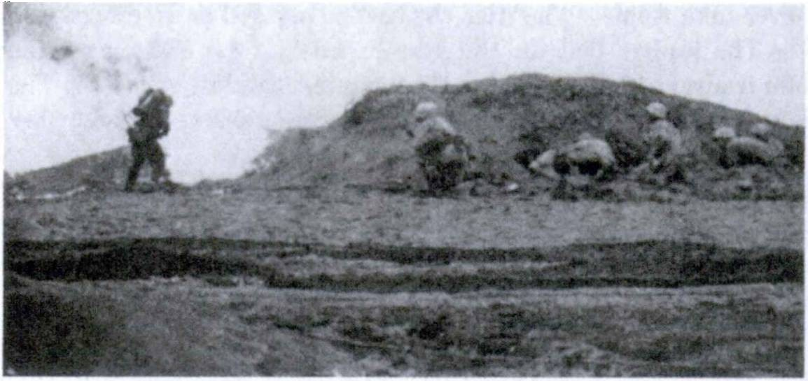384 FIRST YEAR LATIN

MiLiTes AmeriCAni

tiones fecit; longa itinera et per silvas et per montes fecit. Numquam, aut tells aut clamore territus, fugit. Bonam in milites voluntatem habebat. Itaque ex militum sudrum caede saepe magnum dolorem cepit. Milites ab eo ducti propter ejus in se voluntatem fortiter pugnaverunt. Milites propter suam in Cae- sarem voluntatem eum imperatorem appellaverunt.
  - De Militibus Americanis [Drill on the Future Tense]
Milites Americani etiam fortes sunt at belli non sunt cupidi. Pacem enim diligunt. Tamen, injuriis incitati, et acriter et forti­ ter bellum gerent. Itinera longa sine mora facient; copiam armdrum et telorum parabunt. Urbes et portus et oppida capient et capta tenebunt. Magnas munitiones facient et munitiones ab hostibus factas capient. Impetus sine mora et sine metu in hostes facient. Consilium a ducibus captum laudabunt. Pericula mortis non timebunt. Timore et telis acti, non fugient. Summam volun­ tatem in rem publicam ostendent, sicut patres nostri in civitatem nostram liberam semper voluntatem ostenderunt. Numquam milites Americani duces reges facient, nam summam in rem publicam habebunt voluntatem.
Nonne milites et Romanos et Americanos semper laudabimus et memoria tenebimus?

FIRST YEAR LATIN 385

SENTENTIAE SELECTAE
- Christus, “Non quaero,” inquit, “voluntatem meam sed voluntatem ejus qu! misit me.”
- Domine, tu es qui fecisti caelum et terram, mare1 et omnia quae in eis sunt. (From the Acts of the Apostles.)
- Christus, “Mater mea et fratres mei,” inquit, “hi sunt qui verbum1 2 3 Dei audiunt et faciunt.”

EXERCISE 385
[Essential]
Translate:
- The Japanese made a plan of war. Then suddenly they made an attack on a great harbor of the Americans.
- The soldiers marched a long time through the territory of the Gauls. Then suddenly these were seen on a hill. The Gauls had made fortifications on that hill lest the Romans might seize it. The Romans made an attack on the hill from the front. The Gauls, terrified by the darts and swords, raised (up) a shout and fled.
- The Gauls had stationed cavalry in the forest and soldiers at the river. These the Romans captured, but those they put to flight.
- The chief of the Gauls said to Caesar: “On account of your good will towards my tribe, I shall make an attack on your enemies; I shall capture their fields and towns; I shall also cap­ ture those soldiers who will not have fled.”
- The general said: “How great is the number of the enemy? How large fortifications have they made? Have they captured a supply of grain? Will they flee after the attack?”
- Napoleon made himself king and emperor of France.8
- The leader of the allies said to Caesar: “You have sta­ tioned me and my men on this hill to hold it. On account of your
1 mare, maris, sea.
2 verbum, I; word.
3 France: Gallia, ae.

386 nRST YEAR LATIN

good will towards me, I shall hold it and I shall not flee. I shall make fortifications and prepare darts. They1 will never take this hill.”
- TIME WHEN ASSIGNMENT: Study GrAmmAr, Nos. 920-921.
VOCABULARY
annus, i year
vigilia, ae watch
tempus, temporis, n. time
dies, diei, m. (f.) day
hora, ae hour
primus, a, um first
secundus, a, um 1 ,
’ ’ F secondalter, alte alterum
ra, J
tertius, a, um third

RELATED ENGLISH WORDS
An annual celebration. The school annual. St. Ignatius kept oigil at the shrine of Our Lady. The Saints do not allow temporal things to worry them. Secondary. A tertiary of St. Francis.

A.D. 1776
A. D.—Anno Domini

EXERCISE 386
Answer in English:
- Quo anno Columbus ad novas terras quas Americam voca- mus pervenit?
- Quo die Deo propter nostram liberam civitatem gratias agimus ?
1The speaker here points to the distant camp of the enemy. What pronoun would be the best to use?

FIRST YEAR LATIN 387

- Quo anno Lincoln servos a dominis eorum liberavit?
- Quo die Christus occisus est?
- Quo die homines primum Christum puerum viderunt?
- Quo die Christus in Caelum sublatus est ?

EXERCISE 387
Translate:
- at the third watch 4. in the first year
- in the second hour 5. at that time
- on the third day 6. on that day

TEMPUS FUGIT

EXERCISE 388
Translate:
1. Caesar diem constituit quo die omnes principes Galldrum ad se convenirent. Ed die omnes convenerunt. 2. Prima vigilia clamor custodum audiebatur. 3. Ed tempore bellum cum Gallis gerebatur. 4. Tertia die omnia frumenta quae in agris erant in- cenderunt. 5. Ed anno Romani Gallos multis proeliis vicerunt.
6. Ed die multi proelio ceciderunt. 7. Ed tempore custodes in muro non erant. 8. Proximo die frumentum militibus dabatur.
9. Prima vigilia legionem clam e castris deduxit. 10. Tertio die nuntius ad Caesarem a legato mittebatur qui auxilium peteret.
11. Et in bello et in pace Romani fortes erant. 12. Ed anno multa proelia adversa fecerunt. 13. Tertia vigilia ^ervus clam e castris ad Caesarem missus est.

EXERCISE 389
[Forms of -id Verbs and Time When]
Translate:
1. At the third hour they fled. 2. At that time they captured the hill. 3. On the second day they marched into the mountains.

388 FIRST YEAR LATIN

- At the third hour they pitched camp. 5. In that year they made fortifications in the province. 6. They captured the king on the third day. 7. In the next year they captured the city. 8. At the third watch the enemy made an attack.

SENTENTIA CICERdNIS
Cicero, “Historia,”1 inquit, “[est] testis1 2 * 4 temporum, lux veri- tatis, vita memoriae.”

READING NO. 30

THE “OUR FATHER”
And the Lord said: “Thus therefore shall you pray:
PATER NOSTER QUI ES IN CAELIS
SANCTIFICETUR8 * NOMEN TUUM ADVENIAT* REGNUM TUUM
FIAT5 VOLUNTAS TUA SICUT IN CAELO ETfl IN TERRA PANEM7 NOSTRUM COTIDlANUM8 DA NOBIS HODIE* ET DIMITTE NOBIS DEBITA10 11 NOSTRA
SICUT ET6 NOS DIMITTIMUS DEBITORIBUS11 NOSTRIS

1 historia, ae: history.
2 testis, testis, m.: witness.
8 sanctificetur: hallowed be.
4adveniat: (may) . . . come.
8 fiat: (may) ... be done.
8 et here means also. It may be left untranslated.
7 panis, panis, m.: bread.
8 cotidianus, a, um: daily.
*hodie, adv.: today.
10debitum, i: debt, trespass.
11 debitor, debitdris: debtor, one who trespasses.

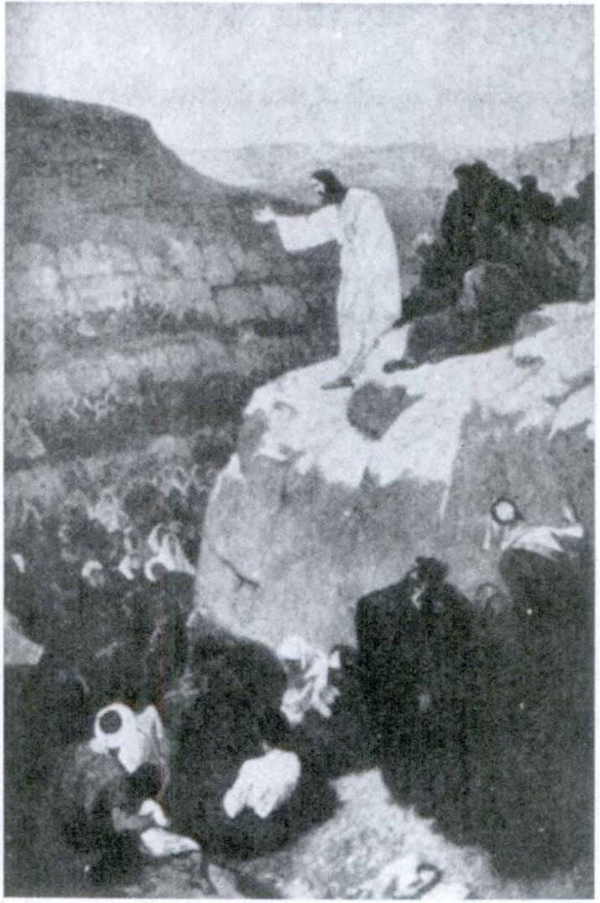FIRST YEAR LATIN 389

CHrisTUs Homines DoCeT.

ET NE1 NOS INDUCAS1 IN TENTATIONEM* * SED LIBERA NOS A MALO. AMEN ”

- SUBJUNCTIVE ACTIVE OF 40 VERBS ASSIGNMENT: Learn GrAmmAr, Nos. 315-316.
The perfect and pluperfect subjunctive of -io verbs are formed
regularly on the perfect stem.

1 ne . . . inducas: lead not,
* tentatio, tentationis: temptation.

390 FIRST YEAR LATIN

VOCABULARY
[ throw
conjicio, conjicere, con j eci, conjectus, 3, tr. j
[hurl
I[ receive
recipid, recipere, recepi, receptus, 3, tr. 1 accept
[recover

(with a reflexive Pronoun me, te, se, etc.) cupid, cupere, cupivi, cupitus, 3, tr.; w. infin. rursus, adv.
withdraw desire again

NOTE
- Notice this special use of conjicid:
In fugam hostes conjecit. He threw the enemy into flight.
- Recipid with the proper reflexive pronoun means with­ draw :
Ad castra se receperunt. They withdrew to the camp.
In silvas nos recipiemus. We shall withdraw into the forest.

RELATED ENGLISH WORD
The cupidity of misers is proverbial.

RELATED LATIN WORDS
Cupidus; capid.

Jesu, Deus pacis, miserere nobis!

EXERCISE 390
[Drill on the Present Subjunctive]
Translate :
1. Gratiam Del cupiamus. 2. Capiat urbem. 3. Fugiant
hostes. 4. Fugiamus. 5. Capiamus consilium. 6. Fugiat rex.
7. Faciamus rursus impetum in illos.

FIRST YEAR LATIN 391

EXERCISE 391
[Drill on the Present Subjunctive]
Translate:
1. Let us desire to see God. 2. Let us march into the moun­ tains. 3. May they take the town! 4. May they flee! 5. Let us make a plan. 6. May they make an attack again I 7. May they capture the king! 8. Let us flee.

EXERCISE 392
- Write a main clause for each of these sentences;
- Complete the verbs in the subordinate clauses by adding imperfect endings:
(The main clause should make sense and should demand the imperfect subjunctive in sequence. The first sentence shows how the exercise is to be done.)
1 quo facilius tela in hostes conjic
[Munitidnes fecerunt quo facilius tela in hostes conjicerent.]
2ne hostes collem cap
3ne milites se in castra recip
4quo facilius milites e timdre se recip 5ne dux hostium impetum facere cup
6ne hostes impetum fac.............................................
7ne milites sui fug
8ne hostes in loca tuta se recip..............................................
9. ut milites victoriam cup

EXERCISE 393
[Essential]
Translate:
Dux Romanus, his nuntiis commotus, legatos et tribunds militum ad se vocavit ut consilium caperet. Equitem miserat qui cognosceret quae hostes facerent. Primum in concilid hunc equitem rogat quo die hostes pervenerint, ubi castra posuerint,

392 FIRST YEAR LATIN

quantas munitiones fecerint, quantas copias habeant, num copiam frumenti et aquae habeant, quos colies ceperint. Turn a centuridnibus quaesivit num milites sui victoriam cuperent, num ad proelium parati essent, num in se bonam voluntatem haberent, num copiam telorum haberent. Post haec consilium cepit atque legatos tribunosque militum dimisit.
Proximo die dux cum omnibus copiis suis prima luce per silvas iter fecit ut collem natura loci munitum caperet. Dux verb hostium, cum agmen Rbmanum vidisset, copias ex castris duxit atque instruxit. Turn Romanis appropinquaverunt ut in eos impetum facerent. Romani, cum hostes non longe abessent, tela in eos conjecerunt. Statim multi ex hostibus, timbre moti, ces- serunt atque fugerunt. Reliqui tamen rursus impetum fecerunt. Turn Romani exspectaverunt quo facilius tela rursus conjicerent. Itaque, Romani cum rursus tela in hostes conjecissent, clamorem sustulerunt et impetum in hostes fecerunt. Rem gladiis1 gesserunt. Magna fuit caedes. Hostes alii celeriter fugerunt, alii more sub clamorem sustulerunt atque se suaque omnia Romanis dediderunt. Ita Romani et castra ceperunt et magnam omnium rerum copiam ceperunt. Itaque Romani in castra se receperunt.

EXERCISE 394
Translate :
1. The Romans stationed men on the walls to hurl darts against the enemy. 2. The Romans made fortifications lest the enemy should easily hurl darts against them. 3. The general asked whether the men desired the signal to be given. 4. Caesar shows us how great sorrow the Gauls take from the slaughter of their hostages. 5. The general asked the soldiers whether they desired glory and rewards. Then said he: “Fight bravely. The enemy will flee and we shall take their camp. It is full of all these things which you desire.” 6. When the soldiers had hurled the darts, he sent the cavalry against the enemy lest

1 This was the equivalent of the modem bayonet charge.

FIRST YEAR LATIN 393

they should recover from their fear and again make an attack. According to their, custom, the barbarians then raised (up) a shout and fled in all directions.1

- EXTENT OF TIME AND SPACE ASSIGNMENT: Study GrAmmAr, No. 761.
VOCABULARY
pes, pedis, m. foot (part of body or measure of distance)
passus, us pace (a measure of distance = 5 Roman feet [pedes])
mille, indecl. adj. thousand
milia, milium, neuter noun thousands
mille passus a mile (literally, a thousand paces =1,618 English yards)
milia passuum miles (literally, thousands of paces')
quam, interrogative adv. of how? degree
NOTE
- For mille and milia, study GrAmmAr, No. 117.
- Quam does NOT mean’ how in the sense of in what way, by what means. It CANNOT translate: “How did you do it?” It means how in the sense of to what degree, as in “how high,” “how long,” “how violently,” etc.
Quam longum est illud flumen? How long is that river?

RELATED ENGLISH WORDS
A pedestrian should be careful at crossings. A mill is one- thousandth part of a dollar. A pedometer measures the number of steps taken by a walker or runner. The pedals of a bicycle.

1 directions: use partes.

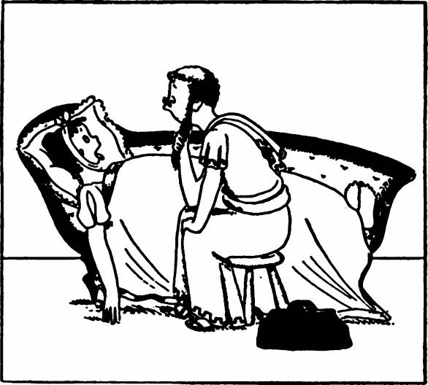394 FIRST YEAR LATIN

TO A DOCTOR TURNED UNDERTAKER
“Nuper1 erat medicus,1 2 nunc est vispillo3 Diaulus* Quod vispillo3 facit, fecerat et® medicus2” (Martial).

EXERCISE 395
[Drill]
- Translate ;
- Parse the italicised words:
1. Quinque dies iter fecerunt. 2. Quinque milia passuum iter fecerunt. 3. Castra mille passus ab montibus afuerunt. 4. Castra duo milia passuum ab montibus afuerunt. 5. Eo die tria milia hominum in proelio ceciderunt. 6. Montem tribus milibus homi­ num complevit. 7. Corpora trium milium hominum in agris visa sunt. 8. Mille dies in montibus erat. 9. Duo milia dierum in montibus erat. 10. Dux dudbus milibus hominum praemia dedit.
- Duo milia fere annorum fides Christi in terra jam est.®
- Septem annbs Caesar in Gallia cum barbaris bellum gessit.

1 nuper, adv.: formerly.
2 medicus, i: doctor.
8 vispillo, vispillonis, m.: undertaker.
*Diaulus, i: a proper name.
6 et here means also.
8 est: translate by has been.

FIRST YEAR LATIN 395

- Hostes quattuor dies celeriter fugerunt. 14. Quam lata fuit ilia fossa? 15. Quam altus est hie murus? 16. Milkes fossam decern passus latam fecerunt. 17. Vallum erat decern pedes altum.

Christum Dei Filium,
Qui suo nos redemit1 sanguine,1 2
Venite, adoremus!

EXERCISE 396
[Drill]
Translate:
1. They marched three days. 2. They marched five miles.
- The city was two miles distant from the river. 4. They fled for three days. 5. They held the hill five hours; then the Romans captured it. 6. They gave swords to three thousand men. 7. The hill was taken by two thousand men. 8. He marched into the province with a thousand men. 9. How high is this mountain?
10. The river was a mile away. 11. They fought for two hours.
12. This river is many feet wide. 13. He waited nine days.
- The Saints were often able to pray for two or three hours.
- The Americans defended Bataan for many days. 16. Shall we be able to preserve peace for many years? 17. Our state has been free many years. 18. They waged war for three years.

EXERCISE 397
Answer in English:
  - Quot milia passuum longum est illud flumen quod Missis­ sippi vocatur ?
  - Quam latum est illud flumen ?
  - Quam longe abest urbs Roma a f inibus nos tris ?

1 redemit: redeemed.
2 sanguis, sanguinis, m.; blood.

396 FIRST YEAR LATIN

  - Quot dies Christus post mortem suam in terra fuit?
  - Quot annos Christus in terra homines viam salutis docuit?
  - Quot annos American! illud bellum quod Civil vocatur inter se gesserunt?
  - Quot annos American! cum Germanis proeliis contenderunt ?

SENTENTIA CHRISTI
Christus apostolis1 suis, “Qu! recipit vos,” inquit, “me recipit; et qui me recipit, recipit eum qui misit me.”

EXERCISE 398
[Essential]
Translate:
- Christ was not seen for three days after His death, but then He showed Himself to His friends. For many days He re­ mained on the earth to teach His friends and to encourage them. Then He was raised up into heaven, and there He will remain in the glory of the Father forever.
- Let us establish and preserve peace that for many years we may be free from the fears and sorrows of war.
- Those who first came to our land often marched many miles for many days through narrow places, through forests full of dangers, through difficult and high mountains, in order to arrive at good fields and to have an abundance of water.
- It is a bad thing for men to fight among themselves. In all those wars which have been waged during thousands of years, many thousands of men have been killed and captured. It is a good thing to remain in peace; it is a good thing to love peace and to preserve it.
- The Romans pitched and fortified a camp daily.1 2 They often fortified it with a rampart ten feet high and a ditch five feet wide. Thus daily2 they marched many miles and prepared fortifications for many hours.
1 apostolus, I: apostle.
2 daily: cotidie, ado.

FIRST YEAR LATIN 397

READING NO. 31

DE SANCTO PETRO CLAVER, SERVdRUM APOSTOLd
Sanctus Petrus Claver erat Jesuita. Ad portum Carthaginem,1 quae urbs in America est, pervenit ut servos ibi adjuvaret. Nam eis temporibus homines mall ad Africam navigabant* ut illos miseros homines qui illas regiones incolebant caperent atque servos facerent. Turn eos servos in Americam traducebant atque ibi vendiderunt.8 Illi servi navibus mails et parvis ex Africa traducti sunt. In his navibus non erat copia aquae frumentique neque ullarum rerum quae ad vitam utiles sunt. Itaque Sanctus Petrus, cum naves in portum pervenissent, in naves sine mora contendebat ut servos miseros adjuvaret. Et corpora et animas* eorum adjuvabat. Difficile vero est ostendere qua virtute res gesserit. Nam multos qui propter doldrem et vulnera in navibus ceciderunt, manibus suis ex navibus portabat. Eds aqua et fru- mento adjuvabat. Ita vitas multdrum servorum conservabat. Praeterea omnes fidem Christianam docuit. Docuit eos et orare et Deum diligere. Neminem1 2 * 4 5 6 * a se prohibuit; omnes vero ad se recipiebat. Servis miseris se totum dedit. Itaque servi eum et patrem et amicum appellaverunt.
Sanctus Petrus autem multos doldres servorum salutis causa sustinuit. Nam multi domini malam in eum voluntatem habe- bant. Itaque eum impediebant. Tamen Sanctus Petrus, his injuriis neque commotus neque perturbatus, omnia sustinuit ut servos, fratres subs dilectos, Christianos faceret. Multos annos8 haec
1The Port of Cartagena, on the northeast coast of South America, was a notorious slave market. Fifty per cent of the slaves are estimated to have died in the foul holds of the slave ships during the Atlantic crossing, yet 10,000 slaves were sold annually in Cartagena. The slave trade was vigorously con­ demned by Pope Pius III.
2navigo, /, intr.: sail.
8 vendo, vend ere, vendidi, venditus, 3, tr.: sell.
4 anima, ae: soul.
5 neminem: no one (accusative).
6 He spent about thirty-five years in this work. He died September 8, 1654, and was canonized in 1888. His feast is celebrated on September 9. Pope Leo XIII made him special patron of all missions among the Negroes.

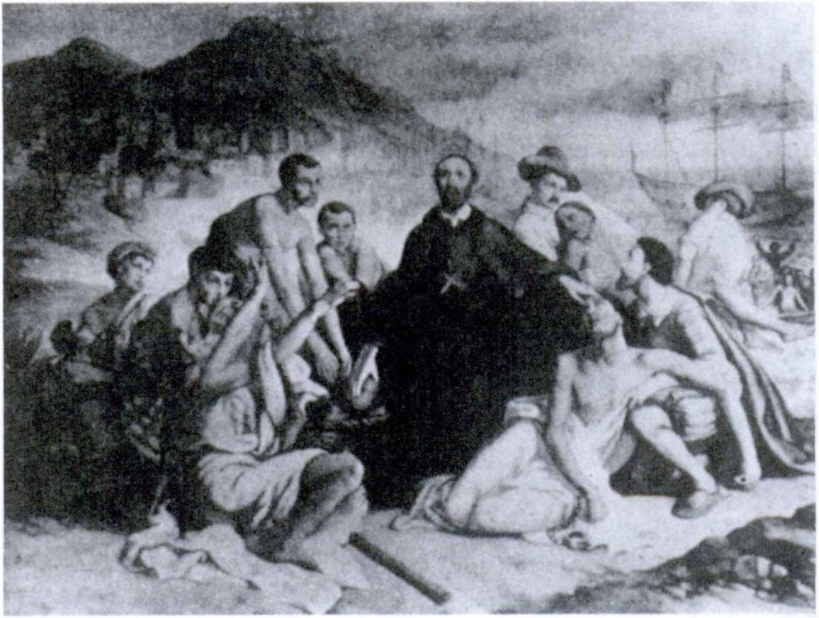398 FIRST YEAR LATIN

SAnCTUs PeTrUs CLAver

agebat, et tandem1 labdribus confectus1 2 ad caeli praemium per- venit. Post multos annds sanctus factus est et nunc ab omnibus Christianis laudatur.

INDICATIVE PASSIVE OF 40 VERBS
ASSIGNMENT: Study GrAmmAr, Nos. 311, 322-324.
The perfect tenses are formed regularly by using the perfect participle passive with the proper forms of the verb sum.
Review GrAmmAr, Nos. 312-314.

1 tandem, adv,: at last.
2 confectus, a, um: worn out.

FIRST YEAR LATIN 399

VOCABULARY
interficio, interficere, interfeci, interfectus, 3, tr.

eripid, eripere, eripui, ereptus, 3, tr.

nihil, indecl, noun
NOTE

kill
take away save (from) nothing

- The present system passive of facid is irregular, but almost all the compounds of facid, such as interficio, are regular.
- After eripid from is translated as ex (e) w. abl.
E periculo ereptus sum.
I was saved from danger,

EXERCISE 399
Translate:
1. We were being killed by the enemy. 2. They were being captured. 3. The town has been taken. 4. Rome has often been captured. 5. He was saved from the hands of the enemy.
- Many thousand soldiers were killed. 7. Darts were hurled against the enemy. 8. Two thousand of them were killed.
9. A thousand men were captured. 10. The swords were taken away. 11. Nothing was captured. 12. That town will be taken.
13.1 was saved from death by a friend.

Sancte Petre Claver, Apostole Servorum, Ora pro nobis!

EXERCISE 400
[Essential]
Translate:
- Civitas nostra e magno periculo a Washingtonio erepta est.
- Japones, saepe in loca impedita et angusta coacti, telis gla- diisque interficiebantur. 3. Dux militibus, “Quid,” inquit, “timent

400 FIRST YEAR LATIN

milites Romani?” Centurid vero ei, “Nihil,” inquit, “timemus.”
- Centurid ab equitibus e manibus hostium ereptus est. 5. A quo capta est urbs Roma? 6. Legati qui frumenti causa ad civitates Galldrum missi erant saepe a Gallis aut capti aut interfecti sunt. Haec caedes saepe fuit belli causa. Nam Caesar multa milia Galldrum interficere constitiiit ne alii legati sui ab eis occi- derentur. 7. Multi, telis interfecti, de muro ceciderunt. 8. Sancti a Deo saepe e periculis eripiuntur. 9. Nihil de hac re audivi. Audivistine tu de hac re? 10. Propter Galldrum injurias obsides a Romanis saepe interficiebantur. 11. Nihil cupitur ab eo qui copiam omnium rerum habet. 12. Multa ab hominibus cupiuntur, at maxime1 cupitur salus.

EXERCISE 401
Translate :
1. Who were being killed by Caesar? 2. Nothing was taken away from the town. 3. The grace of God is taken away from us by sin. 4. We were saved from eternal death by the Son of God. 5. That man was saved from death by a brave centurion.
- Many are now being killed by wicked men. 7. Men are often saved from death by their friends. 8. What is desired by the Saints? 9. The enemy was often thrown into flight by the Ro­ mans. 10. This city was often captured by the enemy. 11. Two thousand men were captured. 12. Was Rome captured by the Gauls? 13. All the others were either captured or killed.

READING NO. 32

THE LAZY SLAVE
Dominus servum malum castigabat.1 2 3 Servus clamavit,8 “Cur, domine, me percutis ?4 Nihil feci.” Dominus, autem, “Propter id,” inquit, “te percutio4 quod nihil fecisti.”
1 maxime, adv.: most oj all.
2 castigo, 1, tr.: punish.
3 clamo, 1, intr.: shout, cry.
4 percutio, percutere, percuss!, percussus, 3, tr.: beat.

FIRST YEAR LATIN 401
6. TIME WITHIN WHICH ASSIGNMENT: Study GrAmmAr, No. 922.

VOCABULARY

conspicio, conspicere, conspexi, conspectus, 3, tr.

accipid, accipere, accepi, acceptus, 3, tr.

conficio, conficere, confecT, confectus, 3, tr.

nemo, neminis, m.1
RELATED ENGLISH WORDS

see
catch sight of
receive accept
finish wear out
no one

A conspicuous appearance. A speech of acceptance. He ac­ cepted the nomination.
EXERCISE 402

THE FRIENDLESS MAN
Translate:
He who loves no one, praises no one, helps no one, gives thanks to no one, is alone and without friends. Within a short time he will be worn out with sorrows and toil. Help will be received from no one. He will be unable to carry on great affairs, for he will have no allies and no friends. He will be a wretched man, for life without friends and without virtue is wretched.

EXERCISE 403
Translate:
1. They will arrive within three days. 2. Within two hours the column of the enemy will be seen. 3. The letter will be re­ ceived within two days. 4. In two days the war will be finished.
- Within two days the ships were caught sight of. 6. Within three hours the soldiers will be worn out with the journey and toil. 7. No one worn out with wounds can fight long and bravely.

1 nullius, nullo, and nulla are usually used for neminis and nemine.

402 FIRST YEAR LATIN

EXERCISE 404
[Essential]
Translate:
- Sex diebus omnes munitiones confectae sunt. 2. Milites, vulneribus confacti, laborem diutius sustinere non potuerunt.
- Legio clam per silvas iter fecit neque e castris hostium con- specta est. 4. Tribus diebus ad flumen perventum est. 5. Tertia die ad castra perventum est. 6. In omnibus partibus barban con- spiciuntur. 7. Dux Romanus barbans, “Romani,” inquit, “ob- sides accipere, non dare, consueverunt.” 8. Romani illam belli gloriam quae a patribus accepta erat semper conservaverunt.
9. Litterae a Caesare acceptae sunt quibus legatus doctus est quanto in periculo legiones essent. 10. Apud Romanos servi a dominis malis saepe injurias acceperunt. 11. Multa vulnera in eo proelio accepta sunt.

READING NO. 33

THE VIATICUM1
When Holy Communion is given to the dying, the priest recites this prayer:
Accipe, frater, viaticum1 Corporis Domini nostri Jesu Christi, qui te custodiat1 2 ab hoste maligno3 et perducat4 in vitam aetemam. Amen.

SENTENTIAE SELECTAE
- Christus, “Ego,” inquit, “sum via, et veritas, et vita: nemo venit ad Patrem, nisi5 per me.”

1 viaticum, i: viaticum (the word was originally used of provision for a journey').
2 custodio, 4, tr.: guard (cf. custos).
3 malignus, a, um: evil.
4 perduco, perducere, perduxi, perductus, 3, tr.: lead to.
5 nisi: except.

FIRST YEAR LATIN 403

- Sanctus Paulus, “Fundamentum,”1 inquit, “enim aliud nemo potest ponere, praeter1 2 id quod positum est, quod est Christus Jesus.”
- Seneca, “Bonus vero vir,” inquit, “sine Deo nemo est.”

- SUBJUNCTIVE PASSIVE OF -ZO VERBS ASSIGNMENT: Study GrAmmAr, Nos. 325-326.
The perfect tenses are formed regularly by using the perfect
participle passive with the forms of the verb sum.

VOCABULARY

magnitudo, magnitudinis satis, adv.
animus, I

satis, indecl. noun w. gen.

size greatness enough
sufficiently
mind soul
enough

RELATED ENGLISH WORDS
The magmlade of the sun astounds us. The arrangement is satisfactory. An animist believes that inanimate objects have souls.
RELATED LATIN WORD
Magnus

EXERCISE 405
Translate:
1. May the fortifications be finished! 2. May the town be taken! 3. May we be saved from this danger! 4. May letters

1 fundamentum, i: foundation.
2 praeter, prep. w. acc.: besides.

404 FIRST YEAR LATIN

be received! 5. May they be captured! 6. May the bridge be finished! 7. May they flee! 8. May enough water be captured I
9. May the king be taken!

EXERCISE 406
Translate:
1. Benedictus Arnold, qui fidem in nostram rem publicam non servaverat, e castris Americanis se eripuit et in alias partes fugit ne ab eis interficeretur. 2. Christus interfectus est ut homi­ nes e morte et peccato eriperentur. 3. Castra ad flumen posita erant ut satis aquae ex flumine caperetur. 4. Vitas obsidum con- servavit ne ex eorum caede magnus dolor a Gallis caperetur.
S. Non satis tutum erat in ed loco pugnare. Itaque in castra con- tenderunt ne ab hostibus caperentur et interficerentur. 6. Ab centurionibus quaesivit num milites magnitudine itineris et vul- neribus confecti essent. 7. Arma paremus ne milites nostri ab hostibus capiantur et interficiantur. 8. Omnes duces munitiones parant ne urbes et oppida ab hostibus capiantur et muniantur.
9. Legiones clam per silvas ad collem deduxit ne a barbaris conspicerentur. 10. Dux a tribunis militum quaesivit num agmen hostium conspectum esset. 11. Legatus a centurionibus quaesivit num post urbem captam satis frumenti haberent. 12. Ibi multos dies mansit ne milites magnitudine labdris et itineris conficerentur.

EXERCISE 407

AN ASSIGNMENT FOR THE INTELLIGENCE DEPARTMENT
You are a Gaul who has been sent into the Roman camp as a spy. You have managed to get into the tent of the legatus and there you have found the tom pieces of an official message of great importance. When you fit it together, it looks something like what you see on page 405. Can you supply the missing letters and discover the plan of the Roman general staff? Draw a dia­ gram of the battle plan contained in this message.

LITTEJLAE TUAEWmE HORA I’RIMA ACCEPTAtJuNT AG\jjgh HOSTIUNTOXB EQUITIBUS MEIS HORA SE-
<TX 1)Ayx>XSRECTUM EST. HORA TERJIA CASTRA EORUM FOSITA SUNT IN COLLE QU ^JfNTUM PEDES

A I LCMINF XHESI < TRA iBI Po3|
AQUAE EX FLUAHMi^txPERETl’K SATIS FRUMENT Am^,A.1CA>CFPIS
BRUNT I T S ATIS TftPAESlVI XUMj
J^^ATIS^cJ

CEPE RUNT, ITXQVF IMPETUM T^ErE BECIPU|g^pTAQ(T
OPORTET N0$ NE EX TIMOR)
COMAS MAS
IX F(T®
^ET LAHORE SF. PER SILVAS ILLJj

COLLI PHOXIM \S ( I
» \i I EUfcTAM NE A ( I STODIHflB

CONSPTUAMIT
Al TERAM^ PARTEM COH ARIJrf A’

1XUJpSOOIIXX**SSUUM\ S CUlilXX’ABO NF. HOSTES IN RiLVAS SOfRcECIWPIEWNlTX: ALi ERAM ACT EM PARTfc.M ^FRONTE
HOSTES’MIT VM TE JUBEO LEGIOn^M'ERTIAM
st MONI^fCLAM DEDVCERE xyflX CASTRIR* WSPICLM^RjR. HAXC LEGION EM IRAN’S FLUMEN UMiNE HOSTES TRANS FI (MEN IN MONTES SE
IjjJxT. ITER ERIT SATES LONGUM ET DIFFICILE. DJU EXSPE<'TAHO ET HORA TERTl^ SIGNUM ’

ItU PRIMUM ALTERA PARS COW ARUM] SILVIS AT ALTEkJ^I \RS IMPETUM IN
|V AXEBIT
JMASTr A A

)XTE FAClET. HASTES. TIMORE MoTT. CONTRA
S MlLIH.S i : GXWJUM fl \f H Q( 1 |\
ST, POST SIGN!XUDATUM, IMPETUM X TERG<r

1 si, coxj.: if.

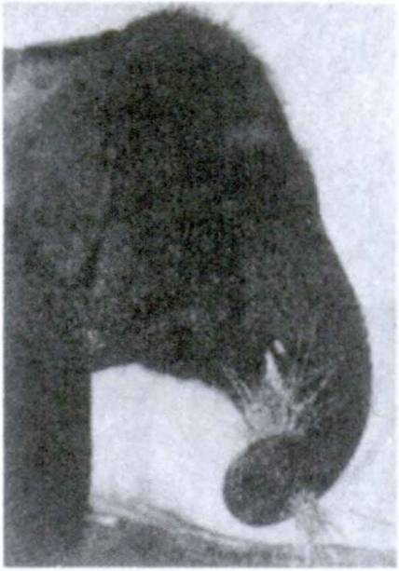406 FIRST YEAR LATIN

SENTENTIAE SELEGTAE
- DE ELEPHANTO
Why has an elephant a trunk? Here is Cicero’s explanation: Manus data elephanto est quia,1 propter magnitudinem cor­
poris, difficiles aditus2 habebat ad pastum.3
- DE SPE
Thales,4 5 rogatus quid maxime commune esset hominibus, “Spes,” inquit, “hanc enim ill! etiam habent qui nihil habent aliud.”
- SENTENTIA EPICTETP
Epictetus, rogatus quis esset dives,6 “Cui,” inquit, “satis est quod habet.”

1 quia: because (like quod).
2 aditus, us: approach (to), access (to).
3 pastus, us: forage, food.
- Thales, Thalis: Thales (one of the seven Wise Men of Greece).
5 Epictetus, i: Epictetus (an ancient philosopher).
6 dives, divitis: rich, wealthy.

LESSON 38: DATIVE VERBS; THE PASSIVE OF VERBS OF GALLING

- Many verbs in Latin take cases other than the accusative. The dative is used after some intransitive verbs, especially com­ pounds of prepositions. (GrAmmAr, Nos. 739 and 746-747.)
Legion? praeest. He is in command of the legion.
Rei publicae nocet. He does harm to the state.
Tibi non cedam. I will not yield to you.
- We have seen that verbs of calling, naming, etc., take a direct object and a predicate accusative. In the passive these verbs take a predicate NOMINATIVE.
Caesar imperator appellatur. Caesar is called commander in chief.
Imperator refers back to the subject of the sentence and is therefore in the NOMINATIVE CASE.

VOCABULARY
noceo, nocere, nocul, nociturus, 2, intr,; w. dat.
praesum, praeesse, praefui, praefuturus, intr.;
w. dat. mare, maris1 ventus, I navigo, 1, intr.
RELATED ENGLISH WORDS

do harm to injure
am in command of am in charge of sea
wind sail

A mariner; marine animals; the Merchant Marine; the Amer­ ican Marines ; a noxious weed; a navigator.

Navis; sum.
RELATED LATIN WORDS

1 Mare is declined like the neuter of gravis, grave, and NOT like flumen.
407

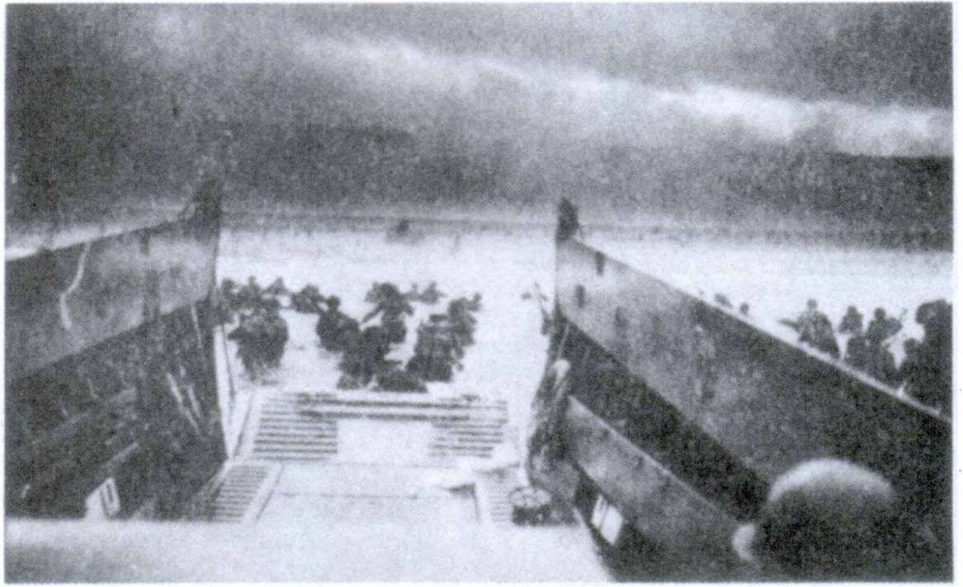408 FIRST YEAR LATIN

MAGnAe CopiAe in GALLiAm TrADUCTAe sUnT.

EXERCISE 408
D-DAY
Translate:
Cum dies constituta advenisset,1 duces American! propter mag- nitudinem vent! ad Galliam2 navigarp non potuerunt. Nam mag- nitudo ventdrum navibus nocet. Itaque in Britannia diutius manserunt ne vent! et mare navibus nocerent. Postea3 vero magnas copias trans mare in Galliam2 uno die traduxerunt ut hostibus nocerent. Hostes magnas munitiones fecerant. Tamen American! eorumque socii, et ad mortem et ad victoriam parati, illas munitiones ceperunt et hostes in fugam conjecerunt.
Dux fortis et magnus, nomine Bradley, praefuit exercitui Americano.
Nonne et ducem nostrum et milites nostros propter virtutem semper laudabimus?

1 advenisset: had arrived.
2GalJia, ae: France.
3 postea, adv.: afterwards.

FIRST YEAR LATIN 409

EXERCISE 409
[Essential]
Translate:
- A centurion was in charge of a hundred men; a lieutenant was often in charge of two or three legions; the general was in charge of the whole army.
- MacArthur, a great and brave leader, was in charge of that American army which was in Australia and the neighboring re­ gions. He did harm to the Japanese ships and soldiers.
- Sailors are brave men, for the sea is full of dangers but they
do not fear to sail. The greatness of the winds injures their ships and they are often in danger of death. Therefore I praise sailors very much.
- For many years peoples and states have contended with one another on land and sea. But in these times they have filled the sky with soldiers and arms.
- Bad men injure the state most. It behooves us to make good men leaders and chiefs. For men without faithfulness and without virtue cannot preserve a free state. Are good men in charge of our nation now ?
READING NO. 34 DE COLUMBO
Columbus, nauta fortis et bonus, constituit novis viis ad Indiam
navigare. Tamen propter inopiam omnium rerum neque naves parare neque omnia quae utilia erant comparare potuit. Itaque ad castra regis Hispaniae pervenit ut auxilium peteret. Ille autem primum eum non adjuvit; turn vero a Regina Isabella adductus omnia quae cupiebat dedit. Itaque tres naves paratae atque in* structae sunt. Prima navis in qua fuit Columbus, Santa Maria vocabatur, altera navis Pinta vocabatur; tertia navis Nina voca­ batur. His tribus navibus Columbus praeerat. Centum et viginti1 nautae etiam coacti sunt. Itaque cum omnia jam essent parata ex

1 viginti: twenty.

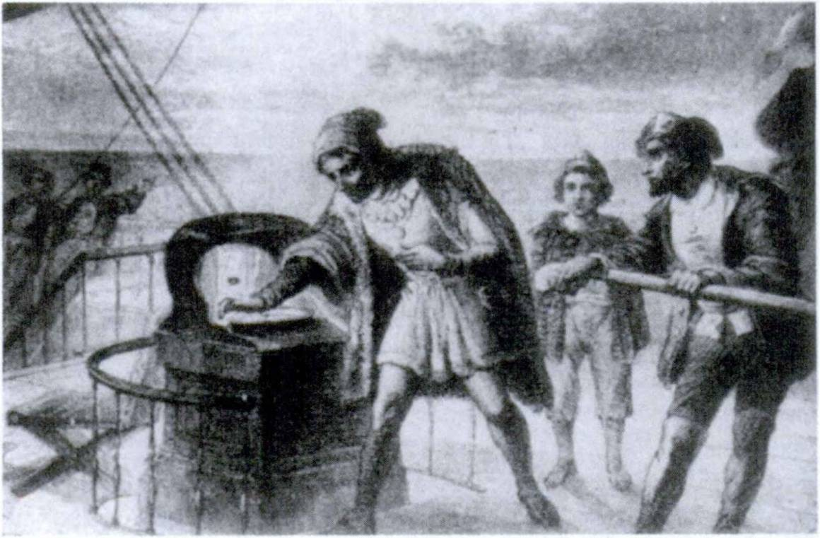410 FIRST YEAR LATIN

CoLUmBUs

portu illae tres parvae naves navigabant. Mare magnum erat. Nemo ante id tempus trans illud mare navigaverat. Quod naves parvae erant, mare periculdrum plenum fuit. Non saepe, autem, propter magnitudinem ventdrum difficile fuit navigare.
Cum multos dies navigavissent, terram viderunt. Omnes nautae vehementer commoti sunt. E navibus contenderunt atque illam terram in nomine regis Hispanic! occupaverunt. Ita Columbus ad Americam pervenit.

HOW GOOD IS YOUR IMAGINATION?
A newspaper reporter is rushed by plane from the front lines in the island fighting in the Pacific to San Francisco. He arrives in a dying condition. All you can get from him before he dies is this:
“Soldiers . . . sailors . . . ships . . . wind for days . . . wind! Got there . . . terrible ... no water . . . days on fortifications
... no water . . . rations low . . . bombarded us . . . days . . .

FIRST YEAR LATIN 411
and days ... no help . . . men killed . . . then they attack
. . . bombardment . . . thousands of Japs . . . shooting bay­
onets . . . they got ... in . . . our camp. At last . . . routed . . . fled . . . days . . . help came ... we attack . . . terrible fight­ ing .. . they ... sur ... sur ”
Now your job is to write up the story here in simple Latin for a Latin newspaper. What kind of a story can you make out of it? Use simple Latin and the words and constructions you are sure of. Here are some hints:
For rations use frumentum. For low use inopia.
For bombardment use tela conjicere. For shooting, etc., use tela conjicere. For bayonets use gladii.
For Japs use Japones.

Per adventum tuum, Libera nos, Jesu!

UNIT TWELVE

LESSON 39: THE ACCUSATIVE WITH THE INFINITIVE

- PERFECT AND FUTURE INFINITIVES ACTIVE
The PERFECT INFINITIVE ACTIVE of ALL LATIN
VERBS, REGULAR AND IRREGULAR, is formed by adding
-isse to the PERFECT stem.
laudavi (perfect indicative) STEM: laudav-
Perfect Infinitive Active: LAUDAVISSE, to have loved
The FUTURE INFINITIVE ACTIVE of ALL LATIN
VERBS is a COMPOUND tense made up of the FUTURE PARTICIPLE ACTIVE and esse.
The FUTURE PARTICIPLE ACTIVE is formed by dropping the -us of the perfect participle passive and adding -urus.
laudatus (perfect participle passive) STEM: laudat- Future Participle Active: laudaturus, a, um
Future Infinitive Active: LAUDATURUS, A, UM ESSE
ASSIGNMENT: Study GrAmmAr, Nos. 210, 222-224; 21S, 237-239; 211, 225-227.

EXERCISE 410
- Give the principal parts and the meaning;
- Give the present infinitive active;
- Give the perfect infinitive active;
- Give the perfect participle passive;
- Give the future participle active;
- Give the future infinitive active:
- lauds 3. superd 5. sustineo
- paro 4. habeo 6. audio
412

FIRST YEAR LATIN 413

7. defendo | 16. pugno | 25. | comparo
8. colloco | 17. oppugno | 26. | adducd
9. accipio | 18. instruo | 27. | obtineo
10. retineo | 19. moneo | 28. | trado
11. premo | 20. terreo | 29. | constituo
12. mitto | 21. recipio | 30. | do
13. dimitto | 22. cognosco | 31. | traduco
14. occido | 23. expugno | 32. | ostendo
15. compleo | 24. capio | 33. | vasto
Note. Remember that, when a verb is intransitive, the perfect participle passive is always given in the neuter, as pervenio, pervenire, perveni, perventum, */, intr. This is because the passive of intransitive verbs can be used only IMPERSONALLY (as we shall see), and so will always be in the NEUTER.
When, however, a verb has no perfect participle passive, the future participle active is given as the fourth principal part, as maned, manere, mans!, mansurus, 2, fw/r.
ASSIGNMENT: Review GrAmmAr, No. 332 and FirsT YeAr LATin, page 326.

EXERCISE 411
Here is a complete list of intransitive verbs which you have had. Study them and give their future infinitive active.
appropinquo, 1, intr.
navigo, 1, intr,
pervenio, pervenire, perveni, perventum, 4, intr. convenio, convenire, conveni, conventum, 4, intr. venio, venire, veni, ventum, 4, intr.
noceo, nocere, nocui, nociturus, 2, intr. discedo, discedere, discessi, discessurus, 3t intr. maneo, manere, mansi, mansurus, 2, intr.
cedo, cedere, cessi, cessurus, 3, intr. absum, abesse, afui, afuturus, intr. sum, esse, fui, futurus, intr.
valeo, valere, valui, valiturus, 2, intr.

414 FIRST YEAR LATIN

Ostende nobis, Domine, Misericordiam1 tuam!

- ACCUSATIVE WITH THE INFINITIVE AFTER VERBS OF SAYING, THINKING, SEEING, AND THE LIKE
We know that God loves all men.
We know that Caesar conquered the Gauls.
We know that God will give rewards to good men.
These are complex sentences. The MAIN clause is: WE KNOW. The THAT clauses are SUBORDINATE NOUN CLAUSES because they are used as the object of WE KNOW. What do we know? THAT GOD LOVES ALL MEN, etc.

God

We know A
loves men
1 all

Noun clauses after verbs of SAYING, THINKING, SEEING, KNOWING, AND THE LIKE are, in Latin, put in the ACCU- SATIVE WITH THE INFINITIVE.
In this construction:
  - The VERB is always an INFINITIVE.
  - The SUBJECT is always in the ACCUSATIVE CASE.
  - The TENSE of the INFINITIVE is determined by the RULE: TENSE BY RELATION.
ASSIGNMENT: Study GrAmmAr, Nos. 897-898.

1 misericordia, ae: mercy.

FIRST YEAR LATIN 415

Scimus Deum dlligere omnes homines. Literally, We know God to love all men.
Scimus Caesarem vlcisse Gallos.
Literally, We know Caesar to have conquered the Gauls.
Scimus Deum hominibus bonis praemia daturum esse. Literally, We know God to be about to give rewards to good men.
NOTE
- The that is NOT translated in Latin.
- Since the future participle active is used like an adjective in a compound tense, it will agree with the accusative subject.
Died hanc civitatem semper futuram esse liberam.
I say that this state will always be jree.
Died sanctos Deum vlsuros esse.
I say that the saints will see God.
ASSIGNMENT: Review the rules for the indirect reflexive, GrAmmAr, No. 804.

VOCABULARY
(Verbs which may take the accusative with the infinitive; tense by relation)

died, dicere, dixi, dictus, 3, tr. ] Sa„ (tell
responded, respondere, respond!, responsus, 2, tr. answer
puto, 1, tr. think
scio, 4, tr. know
audio, 4, tr. hear
RELATED ENGLISH WORDS
His diction is excellent. The response was prompt.

Jesu, Deus noster, Miserere nobis!

416 FIRST YEAR LATIN

EXERCISE 412
[Essential]
  - Point out the main clause;
  - Point out the accusative with the infinitive;
  - Explain the tense of the infinitive;
  - Translate:
    - The Present Infinitive
1. Puto omnes sanctos Deum diligere. 2. Scio Americanos fortiter pugnare. 3. Puto omnes homines amicitiam quaerere.
- Legatus dixit Caesarem Gallos vincere. 5. Centurio dixit milites acriter pugnare. 6. Nuntius dixit Gallos oppugnare urbem.
    - The Perfect Infinitive
  - Scimus Caesarem vicisse Gallos. 2. Scimus Columbum ad American! pervenisse. 3. Scimus Romanos occidisse Christum.
- Caesar audivit Gallos occidisse legatum. 5. Caesar putavit equites ad castra pervenisse. 6. Legatus putavit Caesarem hostes vicisse.
    - The Future Infinitive
Warning. Remember that the future participle is declined like magnus, a, um and must agree with the SUBJECT ACCUSA­ TIVE.
  - Puto Americanos fortiter pugnaturos esse. 2. Scio homines bonos Deum visuros esse. 3. Puto Americanos semper hostes victuros esse. 4. Scio Mariam semper Deum visuram esse.
- Puto Deum omnibus hominibus gratiam daturum esse.
- Caesar putavit Gallos cessuros esse.
    - Reflexives after Infinitives
Explain the italicized words:
  - Died me esse Christianum, fuisse Christianum, semper futurum Christianum. 2. Putasne te esse sanctum? 3. Caesar dixit se victurum esse Gallos. 4. Dicimus nos esse liberos.
- Dicitisne DOS obsides daturos nobis esse? 6. Romani dixerunt

FIRST YEAR LATIN 417

se imperium totius Galliae obtinere. 7. Died me agros meds defensurum esse. 8. Hie Americanus ostendit nullum regem in civitate sua regnum tenere. 9. Christus dixit nos esse fratres suds. 10. Caesar putavit suds fortiter esse pugnaturos. 11. Maria scivit se Filium suum adorare posse.
    - Agreement after Infinitives
Warning. Remember that ACCORDING TO THE GENERAL RULE a linking verb takes the same case after it as before it. Therefore a predicate adjective or noun in the accusative with the infinitive will agree with the subject accusative.
Explain the agreement of the italicized words:
1. Dicit Christum esse Filium Dei. 2. Died omnes fere homines gloriae cupidos esse. 3. Scio nostram civitatem liber am esse. 4. Vir sanctus Romanis respondit Christum esse Filium Dei. 5. Romani sciverunt Caesarem esse summum imperatorem.
- Romani sciverunt Romam esse magnam.

EXERCISE 413
Translate:

1. The American says that Americans fight bravely. 2. The American says that Washington was a very great general. 3. The American says that his soldiers will fight bravely.

  - The lieutenant said that Caesar was conquering the Gauls.
  - The lieutenant said that Caesar had conquered the Gauls.
  - The lieutenant said that his men would conquer the enemy.

1. We shall know that God loves us. 2. We shall know that God took away our sins. 3. We shall know that our men will conquer.

418 FIRST YEAR LATIN

1. I was saying that our state was free. 2. I was saying that the Roman state had been free. 3. I was saying that our state would always be free.

1. He said that he would see God. 2. I said that I would see Rome. 3. She said that she would see Gaul. 4. They said that they would fight bravely. 5. You said that you would send hostages to us. 6. He said that Caesar would give him a reward.

1. He had heard that they were in arms. 2. He had heard that the Gauls had fled. 3. They had heard that the Gauls would send hostages.
EXERCISE 414
[Essential]
Translate:
- Present Infinitive
1. I say that Americans fight bravely. 2. He says that God defends good men. 3. They say that our soldiers are conquering the enemy. 4. He said that Caesar was conquering the Gauls.
  - They said that the Senate was praising Caesar. 6. They said that the Gauls were sending hostages.
- Perfect Infinitive
1. I say that the Romans fought bravely. 2. He says that the Americans were conquering the enemy. 3. We say that Caesar had conquered Gaul. 4. They said that the Gauls had attacked the winter quarters. 5. They said that Caesar had hastened into Gaul. 6. He said that the Senate had given thanks to Caesar.
- Future Infinitive
1. I say that the Americans will fight bravely. 2. He says that we shall conquer the enemy. 3. They will know that we will send help. 4. He said that he would conquer the barbarians.

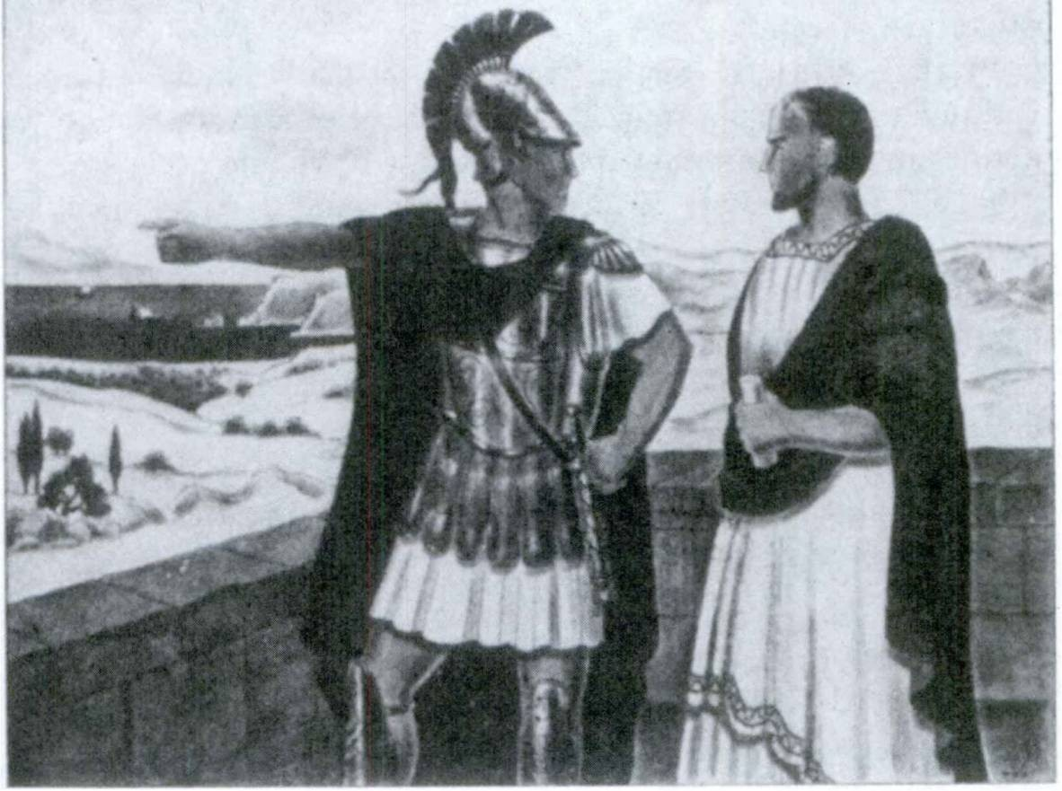FIRST YEAR LATIN 419

PYrrHUs eT CineAs

READING NO. 35

DE PYRRHO, EPjRl REGE
Pyrrhus erat rex Epiri. Potesne hoc regnum in tabula1 videre? Pyrrhus non erat Romanus. Neque in Italia neque in Gallia incolebat. Erat Graecus. Erat autem rex fortis et gloriae cupidus. Multas alias gentes vincere constituit. Erat cum exercitu ejus amicus, nomine Cineas. Hie vero vir bonus fuit neque ednsilia Pyrrhi probavit. Quod Pyrrhi amicus fuit, eum fortiter monere

1 tabula, ae: map. (See the map on page 30.)

420 FIRST YEAR LATIN

non timebat. Olim1 Pyrrhus, gloria sublatus, ei dixit se exercitum in Italiam ducturum esse et Romanos victurum esse. Putavit enim se eos facile superare posse.
Cineas autem, “Post illam victoriam, Rex magne,” inquit, “quid constituisti facere?”
Pyrrhus, “Insula2 Sicilia, bona et magna,” inquit, “Italiae finitima est. In illam traducam milites meds ut earn vincam atque obtineam. Facile erit earn insulam2 armis et virtute occupare.”
Turn Cineas, “Post illam victoriam,” inquit, “quid dicis te facturum esse?”
Ei Pyrrhus respondit se milites suds trans mare in Africam ducturum esse atque eas etiam regiones victurum esse.
Cineas, “Post haec proelia atque has victorias, quid constituisti facere?”
Respondit Pyrrhus, “Post has victorias pacem confirmabo.”
Statim autem Cineas, “Cur, O Rex bone,” inquit, “non nunc pacem confirmas? Quid te impedit?”

- ACCUSATIVE WITH THE INFINITIVE AFTER VERBS OF SAYING, THINKING, SEEING, AND
THE LIKE (CONTINUED)
We have seen that when a verb is used impersonally in Latin:
  - It has no definite subject (English it, as in “It rains”).
  - It is in the third person singular.
  - In a compound tense the participle is always neuter singular.
An impersonal verb is used in the accusative with the infinitive construction:
- In the infinitive;
- Without a subject expressed (English, it).
- In a compound infinitive the participle is always NEUTER.

1 olim, adv.: once.
2 insula, ae: island.

FIRST YEAR LATIN 421

It behooves us to love God.
Oportet nos Deum diligere.
I say that it behooves us to love God.
Died oportere nos Deum diligere.
It was bitterly fought (i. e., there was bitter fighting).
Acriter pugnatum est.
I say that it was bitterly fought (i. e., that there was bitter fighting).
Dico acriter pugnatum esse.

We have seen that verbs like jubed and oportet take the accu- sative with the infinitive. Note this difference: IN THE ACCU- SATIVE WITH THE INFINITIVE AFTER VERBS OF SAY- ING, ETC., THE TENSE OF THE INFINITIVE IS DETER-
MINED BY RELATION. When the accusative with the in- finitive is used AFTER OTHER VERBS AND EXPRESSIONS the tense is generally PRESENT.
VOCABULARY
(More verbs that may take the accusative with the infinitive; tense by relation)
scribo, scribere, scrips!, scriptus, 3, tr. write
reperio, reperire, repperi, repertus, 4, tr. find (out)
nego, 1, tr. 1 deny
I jay . . . not
nuntio, 1, tr. |announce
[report
demonstro, 1, tr. f show
[point out
NOTE
Verbs which may take an accusative with the infinitive do not always do so. When the sense requires, they also govern indirect questions, accusative objects, etc.
Haec nuntiavit. He reported these things.
Nuntiavit quot essent hostes. He reported how many the enemy were.

422 FIRST YEAR LATIN

RELATED ENGLISH WORDS
Some people’s script is illegible. He described the inscriptions found on ancient monuments. They gave a negative answer. He was demonstrating the use of a tank.
RELATED LATIN WORD
Caesar nuntium a legato suo accepit.

REVIEW VOCABULARY
cemo, cernere, 3, tr. f distinguish
{see
cognosco, cognoscere, cognovi, cognitus, 3, tr. f learn
[find out
confirmo, 1, tr. affirm
— I Set!conspicio, conspicere, conspexi, conspectus, 3, tr. | i ^ j
ca c ^gbi o
ostendo, ostendere, ostendl, ostentus, 3, tr. show
probo, 1, tr. [approve
[prove
moned, 2, tr. [warn
[advise
video, videre, vidi, visus, 2, tr. see

EXERCISE 415
[Essential]
Translate:
1. Probat se Chris tianum esse. 2. Dicimus viros bonds verita- tem virtutemque semper quaerere. 3. Vos moned vltam esse brevem. 4. Puer respondit se res a Washingtonio gestas memoria tenere. 5. Te moned Deum hominibus malls praemia non esse daturum. 6. Scio Americanos se posse defendere. 7. Confirmamus milites nostros fortiter pugnare. 8. Nos Christian! confirmamus Deum, Patrem nostrum, omnes gentes diligere. 9. Nautae dicunt ventos magnos navibus nocere. 10. Scimus omnes homines, periculo mortis perturbatos, orare atque gratiam a Deo petere.

FIRST YEAR LATIN 423

11. Scimus memoriam esse custodem rerum cognitarum. 12. Vos, pueri, moned bonam memoriam ad vitam esse utilem. 13. Co­ lumbus repperit barbards incolere Americam. 14. Cicero, vir bonus atque nobilis, scripsit se semper virtutem laudaturum esse.
15. Sanctus Paulus scripsit Christum se de rebus quae ad fidem pertinent docuisse. 16. Scriptum est Sanctum Paulum Christum in via subito vidisse. 17. Washingtonius, cum audivisset Bene- dictum Arnold ad hostes fugisse, repperit ea omnia esse vera.
18. Christus dixit omnes sanctos secum in Caelo Deum visuros esse. 19. Nonne, amice mi, audivisti omnes nos esse fratres?
20. Christus jussit nos omnes homines diligere. 21. Christus, cum a Pilato rogatus esset, respondit se esse regem. 22. Christus negavit se armis et legionibus regnum tenere. 23. Thomas More, cum ad mortem duceretur, negavit se a fide Christiana dis- cessurum esse. 24. Apostoli omnibus hominibus nuntiaverunt Christum esse Filium Dei atque pro nobis interfectum esse.
25. Pilatus putavit Christum esse virum bonum at timuit eum dimittere. Judaei enim dixerunt Christum se regem vocare. Itaque dixerunt, “Qui se regem facit, contradicit1 Caesari.” 26. Colum­ bus putavit se non ad novas terras sed ad Indiam pervenisse.
27. Imperatores Romani reppererunt Christianos in Italia et in omnibus provinciis esse. Itaque multos ex eis ad mortem duci jusserunt. Tamen non potuerunt fidem Christi vincere.

EXERCISE 416
[Imitation]
Imitate the construction of the model in translating these sentences:

MODEL: Negavit se venturum esse.
He said that he would not come.
- They said that they would not give hostages to him.
- He said that he would not surrender the arms.
- They said that they would not flee.
1 contradico, contradicere, contradixi, contradictum, 3, intr.; w. dat.: speak against.

424 FIRST YEAR LATIN

EXERCISE 417
Translate:
Warning. In some of these sentences the main verb of SAY­ ING, etc., governs the accusative with the infinitive, in some it governs an indirect question or an accusative object.
1. I found that those things were true. 2. We found out where the enemy had stationed guards. 3. We saw that the enemy had prepared fortifications. 4. We saw where the enemy had pitched camp. 5. They said that the greatness of the winds had injured the ship. 6.1 said that Caesar was in charge of the legion. 7. He said that he would not hand over the slaves. 8. He showed that he was a brave man. 9. They reported the slaughter of the hostages. 10. They knew how large the Roman camp was.
11. They were saying that the Gauls were afraid to fight. 12. He
saw that the barbarians had come out of the forest. 13. He had seen that the barbarians had prepared fortifications. 14. He knew the names of the centurions. 15. He said that the plans were not useful.
EXERCISE 418
[Essential]
Translate:
Warning. Remember that after verbs of SAYING, etc., the tense of the infinitive is TENSE BY RELATION; after jubed and other expressions it is generally PRESENT.
1. I am able to fight. 2. I said that I was able to fight. 3. I say that I was able to fight. 4. I shall prove that I was able to fight. 5. He said he would fight. 6. He was ordered to fight.
- They ordered him to fight. 8. It is good to fight bravely.
9. They determined to fight at once. 10. It behooved us to fight bravely. 11. We are prepared to sail. 12. They said they were prepared to sail. 13. They said that they had been prepared to sail for five days. 14. He said he would be prepared to sail within two days. 15. On the third day he was able to sail. 16. It be-

FIRST YEAR LATIN 425

hooves us to sail at once. 17. They are accustomed to sail from this harbor. 18. They said they were accustomed to sail from that harbor. 19. They said there was not sufficient water.
20. It is not difficult to pray. 21. He said that the enemy had fled five miles. 22. On account of the greatness of the winds he said he would not sail. 23. He ordered them to defend the hill until night. 24. They said that they would defend the hill for three days. 25. He did not know whether they had attacked the column. 26. Christ said that He would help and defend all men.
READING NO. 36
DE REGE FORTI
Leonidas qui Lacedaemoniorum1 rex erat, et cui Xerxes, Per* sarum2 * rex, scripserat, “Mitte arma,” ei respondit, “Veni et ea cape.”

Christum Regem adoremus.

READING NO. 37

PILATE’S REPLY
Posuerunt in cruce8 Jesu signum in quo scriptum erat: “Hie est Jesus Rex Judaedrum.”4 Itaque principes Judaedrum4 cum hoc signum vidissent, vehementer moti, ad Pilatum venerunt. “Noli5 6
scribere: Rex Judaedrum”* inquiunt,® “sed: ‘ZTfc dixit se esse regem Judaedrum!”*

1 Lacedaemonii, orum: the Spartans, who were famous for their courage and their brevity of speech.
2 Persae, arum: the Persians.
8 crux, crucis: cross.
4 Judaei, Judaedrum: the Jews.
8 noli scribere: do not write (literally, be unwilling to write).
6 inquiunt: they said.

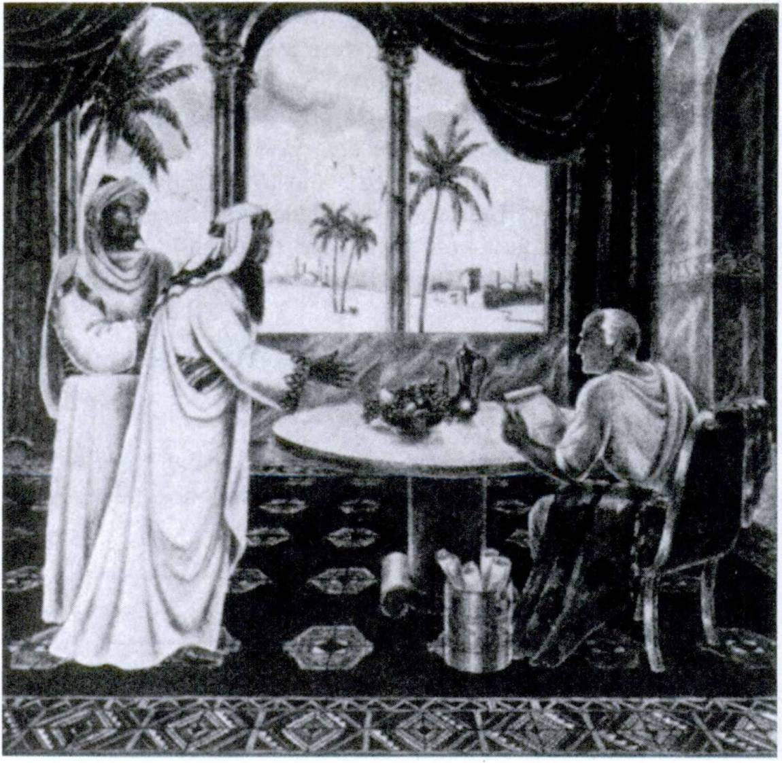426 FIRST YEAR LATIN

“QUoD' SCripsi, SCripsi

Respondit Pilatus: “Quod scripsi, scripsi!” (Adapted from the account of St, John.)

A LATIN RIDDLE
Can you solve it?
Quis est qui non est et tamen nomen habet et quaerenti1 respondet ?

1 quaerenti: to one asking.

FIRST YEAR LATIN 427

O bone Jesu, miserere nobis!

READING NO. 38
DE BELLO CUM PYRRHO GESTO
Jam demonstravimus Romanos multas Italiae gentes vicisse atque imperium magnae partis Italiae obtinere. Cum gentes sibi proximas vicissent, bellum cum aliis gentibus gerebant. Itaque Tarentini, qui Romanos t’mebant, contra eos pugnabant ne ab eis vincerentur. Tarentini, quod Romanos pellere soli non potu­ erunt, legatos ad Pyrrhum, regem Epiri, miserunt qui auxilium ab eo peterent. Pyrrhus, gloriae cupidus, dixit se exercitum in Italiam auxilii causa ducturum esse.
Interim Romani omnia quae ad bellum pertinebant parabant. Itaque Pyrrhus, cum exercitum in Italiam traduxisset, repperit Romanos ad bellum paratos esse. Itaque cum omnibus copiis contra eos contendit. Romani aciem instruxerunt et impetum Pyrrhi exspectabant. Pyrrhus autem secum multos elephantos habebat. Hos primum in equites Romanos misit; turn, cum equites in fugam dati essent, in aciem militum misit. Romani autem numquam ante id elephantos in proeliis viderant. Itaque, ordines eorum ab elephantis perturbati sunt atque multi milites occisi
-sunt. Tamen Romani fortiter pugnabant. Sed magnitudine corporis elephantdrum territi hostes vincere non potuerunt. Post magnam caedem Romani in castra se receperunt ne omnes omnind occi- derentur.
Septem milia militum Romanorum in hoc proelio ceciderunt.
Agri corporum pleni erant, sed Pyrrhus, cum corpora Roma­ norum interfectorum vulnera in fronte1 habere vidisset, dixit se cum his militibus Romanis omnes omnind terras vincere posse. Ex militibus Pyrrhi quattuor milia occisa sunt. Romani facile alios milites cogere potuerunt sed difficile fuit novas copias ex Epiro comparare. Itaque Pyrrhus propter magnum occisorum
1 in fronte: m front.

428 FIRST YEAR LATIN

numerum vidit hanc victoriam non satis utilem esse. “If I con­ quer again in this same manner,” inquit, “I shall have no soldiers left.”
Ever since then a victory won at the cost of disastrous losses has been called a “Pyrrhic victory.”

- PASSIVE INFINITIVES
ASSIGNMENT: Review the present infinitive passive, GrAm­
mAr, Nos. 284, 292-294.
The perfect infinitive passive is a COMPOUND tense formed by using the perfect participle passive with esse.
Since the participle in a compound tense is declined like an adjective, the participle will agree with the SUBJECT ACCU­ SATIVE.
I say that the Gauls were conquered.
Died Gallos victos esse.
The future infinitive passive is very rare; hence you need not
learn it now.
ASSIGNMENT: Study GrAmmAr, Nos. 285, 295-297.

VOCABULARY
(Words that may take the accusative with the infinitive; tense by relation.)
existimo, 1, tr. think
feel
sentio, sentire, sens?, sensus, 4, tr. perceive
think

RELATED ENGLISH WORDS
We cannot perceive God with our senses. He sensed that some­ thing was wrong. The sensation caused by extreme heat.
ASSIGNMENT: Write out the present and perfect infinitives passive of the verbs in Exercise 410.

FIRST YEAR LATIN 429

EXERCISE 419
[Essential]
Translate:
1. Died omnes homines a Deo diligi. 2. Dico Gallos a Caesare victos esse. 3. Dixit Caesarem a senatu laudari. 4. Dixit Gallos a Caesare pulsos esse. 5. Caesar dixit se a Gallis non laudari.
6. Died me a Deo defend!. 7. Dixisti te a senatu laudari.
8. Dicit se a barbaris adjuvari. 9. Dicimus nos ab hostibus videri.
10. Dicitis vos a Deo adjuvari. 11. Dicunt se a duce appellari.
12. Dixi me a barbaris captum esse. 13. Negavit te a barbaris captum esse. 14. Dixit se a Caesare laudatum esse. 15. Dicimus nos, a viris fortibus liberatos esse. 16. Dixerunt se in castra a Caesare vocatos esse. 17. Legatus negaverat Caesarem a Gallis victum esse. 18. Legatus negaverat Caesarem a Gallis vinci.
19. Nego me ibi collocatum esse.

Dominus nos benedicat1 et ab omni malo defendat et in vitam perducat2 aeternam.

EXERCISE 420
[Essential]
Translate:
1. I think that Lincoln was killed by a bad man. 2.1 perceive that the hill has been seized. 3. He thought that Rome was being attacked. 4. He denied that Rome had been seized. 5. I think that Lincoln is praised by all good men. 6. We said that we had been freed by a brave man. 7. You know that our slaves were freed by Lincoln. 8. You heard that America was found by Columbus. 9. We know that grace is being given to all men.
10. We knew that fortifications were being prepared by the enemy.

1 benedico, benedicere, benedixi, benedictus, 3, tr,: bless,
2 perduco, perducere, perduxi, perductus, 3, tr,: lead to.

430 FIRST YEAR LATIN

11. We knew that the enemy were being aroused to war by their leaders. 12. We knew that arms were not being prepared by our own leaders. 13. You know that all men are loved by God.
14. Do you think that God has always been adored? 15. We think that God is being adored and praised by good Christians.

EXERCISE 421
- Translate;
- Parse the italicized words:
1. Scimus Washingtonium virurn fortem ab omnibus vocatum esse. 2. Diximus obsides a Caesare propter injurias Galldrum saepe occlsos esse. 3. Jam demonstravimus Christum a Romanis interfectum esse. 4. Dicimus in bello matres saepe interfici.
- American!, cum audivissent suds in Bataan captos esse, vehe- menter perturbati sunt. 6. Galli audiverunt obsides suds a Caesare occisos esse. Praeterea sciverunt omnia frumenta ab ed incensa esse; urbes et oppida aut expugnata esse aut expugnari; arma et servos captos esse; exercitus victos esse; totam Galliam vastatam esse neque se ab ed defend! posse. Itaque miser! ad eum legatos mittere coacti sunt qui pacem ab ed peterent. 7. German!, cum nuntiatum esset magnas copias ab Americanis eorumque sociis in Galliam esse traductds, vehementer moti atque pertur­ bati sunt.
READING NO. 39

DE PYRRHO ET FABRICIO
Post illud proelium de quo jam demonstravimus Romani de pace non egerunt. Copias novas coegerunt; arma ac tela com- parabant. Pyrrhum enim atque ejus elephantos vincere et ex Italia pellere jam constituerant.
Fabricius imperator factus est et contra Pyrrhum missus est. Cum ad castra Pyrrhi appropinquavisset atque castra posuisset, medicus1 ex castris Pyrrhi ad Fabricium venit. Hie dixit se

1 medicus, i: doctor {ci. medical).

FIRST YEAR LATIN 431

Pyrrhum regem occisurum esse, et ita Romanos ab eo liberaturum esse. Praemia autem rogavit. Fabricius vero eum cepit et jussit eum ligatum1 ad Pyrrhum duel. Praeterea ad Pyrrhum scripsit Romanos gladiis non perfidia2 pugnare. Pyrrhus, ita ab hoste de periculo sud monitus, vehementer motus est. “It is easier,” inquit, “to move the sun from its course, than Fabricius from the path of honesty.”
Romani autem Fabricium, virum fortem, ad Pyrrhum mise- runt qui de captivis commutandis3 ageret. Pyrrhus, cum de hac re cum Fabricio egisset, vidit eum esse virum fortem atque nobilem. Itaque ei praemia dabat ut secum pugnaret. Fabricius autem haec praemia non accepit. Ita ostendit se esse verum Romanum. Turn Pyrrhus, “Cur non mecum in Epirum venies?” inquit; “tibi magnam regni mei partem dabd.” Rursus Fabricius negavit se regnum accepturum esse dixitque se semper in re publica libera mansurum.
Post hoc Pyrrhus legatos ad senatum Romanum misit qui de pace agerent. Itaque in senatum ducti sunt atque demonstrave- runt quae essent pacis condiciones 4 In senatu alii pacem con- firmare cupiverunt, alii vero negaverunt se condiciones4 accep- turos. Praeterea hi ostenderunt exercitum Romanum victum esse; agros sociorum vastatos esse; gloriam nominis Romani non conservatam esse. Diu de hac re agebant. At unus ex eis, vir summus, nomine Appius Claudius, vehementer commotus, “The Roman people,” inquit, “will not discuss terms of peace while an armed and victorious foe yet stands on the soil of Italy.” Itaque senatus condiciones4 non probavit et bellum rursus gerere constituit.

Vir fortis neque armis neque praemiis vinci potest.

1 ligo, Z, /r.r bind.
2 perfidia, ae: treachery.
3 de captivis commutandis: concerning an exchange of prisoners.
4 condicio, condicionis: condition, term(s).

432 FIRST YEAR LATIN

READING NO. 40

THE POLITE FLY
In dorso1 tauri2 musca3 parva erat. Musca,3 “Si4 te premo,” inquit, “statim discedam.” Taurus2 autem ei respondit, “Ubi es? Nihil enim sentio.”

EXERCISE 422
[Formal Review of Unit Twelve]
- Explain the formation of: (a) the present infinitive active;
(b) the perfect infinitive active; (c) the future participle active;
(d) the future infinitive active; (e) the present infinitive passive;
(f) the perfect infinitive passive.
- Give the rules for the accusative with the infinitive after verbs of saying, etc.
- Explain the rule, “Tense by Relation?’
- With what does a predicate noun or adjective in the accusa­ tive with the infinitive agree ?
- How is a verb used IMPERSONALLY in the accusative with the infinitive?

1 dorsum, i: back.
2 taurus, i: bull. 8 musca, ae: fly. 4 si, conj.: if.

FIRST YEAR LATIN 433

- Is there any important difference between the use of the accusative with the infinitive after verbs of saying, etc., and after other verbs?
- Must verbs of saying, etc., ALWAYS take an accusative with the infinitive? Name some other constructions they MAY take and give examples.

EXERCISE 423
[Functional Review of Unit Twelve]
  - Translate;
  - Explain the italicized constructions:
1. Dico Deum esse bonum. 2. Respondit se fidem Christianam non negaturum esse. 3. Caesar putavit omnem Galliam esse pacatam. 4. Sancti scripserunt Deum omnes homines diligere.
5. Columbus repperit multas gentes Americam incolere. 6. Nega- vit se venturum esse. 7. Nuntiatum est acriter pugnatum esse.
- Demonstravit oportere eos se dedere. 9. Existimo nos Ameri­ canos liberos semper juturds esse. 10. Sensit se in magno periculo esse. 11. Dixit se eo anno in Gallia fuisse.

UNIT THIRTEEN

LESSON 40: THE COMPARISON OF ADJECTIVES

  - REGULAR COMPARISON OF ADJECTIVES
POSITIVE DEGREE. An adjective may simply describe a noun, as:
The Gaul is brave. Gallus est fortis.
This is called the POSITIVE DEGREE of the adjective.
COMPARATIVE DEGREE. An adjective may COM­ PARE a noun with some other noun either expressed or under­ stood. In this case the COMPARATIVE DEGREE of the adjec­ tive is used. In English the comparative degree is formed either by adding -er to the positive or by using the adverb more with the positive.
The Roman is braver than the Gaul.
Braver is the COMPARATIVE DEGREE of brave. The “other noun” (Gaul) is EXPRESSED.
This thing is more useful.
More useful is the COMPARATIVE DEGREE of useful. An­ other noun is here UNDERSTOOD. “This thing is more useful than some other thing!1
SUPERLATIVE DEGREE. An adjective may show that a noun has a quality in the HIGHEST DEGREE. In this case the SUPERLATIVE DEGREE of the adjective is used. In English the superlative degree is formed either by adding -est to the positive or by using the adverb most with the positive.
The Belgians are the bravest of all the Gauls.
Bravest is the SUPERLATIVE DEGREE of brave.
434

FIRST YEAR LATIN 435

This thing is most useful.
Most useful is the SUPERLATIVE DEGREE of useful.
ASSIGNMENT: Study GrAmmAr, Nos. 91-98. Memorize the rules for comparison. To COMPARE an adjective means to give the positive, comparative, and superlative degrees, e. g.:
CompArison of ForTis AnD UTiLis

Positive Comparative
fortis, e fortior, fortius
brave braver
utilis, e utilior, utilius
useful more useful
Superlative
fortissimus, a, um
bravest
utilissimus, a, um
most useful

EXERCISE 424
Compare these adjectives:

1. alienus | 6. communis | 11. sanctus
2. altus | 7. longus | 12. verus
3. angustus | 8. gravis | 13. tutus
4. brevis | 9. plenus | 14. latus
5. cupidus | 10. nobilis | 15. certus

EXERCISE 425
Compare these adjectives:

1. facilis | 3. liber | 5. miser
2. difficilis | 4. integer | 6. similij

  - DECLENSION OF COMPARATIVE AND SUPERLATIVE ADJECTIVES

VOCABULARY
aestimd, 1, tr.; acc. w. infin. judico, /, tr.; acc. w. infin. quam, adv.
certiorem (-es) facere; acc. w. infin.; de w. abl., or an indirect question

think judge than
to inform

436 FIRST YEAR LATIN

NOTE
- Quam, than, takes the same case after as before it.
They are braver than the Gauls.
Ei fortiores sunt quam Galli (nominative).
He said that they were braver than the Gauls.
Dixit eos fortiores esse quam Gallos.
- Certiorem (-es) is the comparative of certus. Literally the phrase certiorem facere means to make (someone) more certain. Certiorem (-es) will therefore always agree with the DIRECT OBJECT of facid.
They informed Caesar.
Gaesarem certiorem fecerunt. (Literally: They made Caesar more certain.)
He informed the Gauls.
Gallos certidres fecit.
Certiorem (-es) facere may take either: (1) de with the ablative, (2) the accusative with the infinitive (tense by rela­ tion), or (3) an indirect question, since the phrase is like a verb of saying.
  - He informed Caesar about this matter.
Gaesarem de hac re certiorem fecit.
  - He informed Caesar that Gaul had been pacified.
Caesarem certiorem fecit Galliam pacatam esse.
  - informed Caesar how large the fortifications were.
Gaesarem certiorem fecit quantae munitidnes essent.
ASSIGNMENT: Study GrAmmAr, Nos. 101-102,

- servus miserior
- via difficilior
- flumen latius
EXERCISE 426
Decline:
- mons altissimus
- clvitas Uberrima
- agmen longissimum

FIRST YEAR LATIN 437

EXERCISE 427
Translate:
1. On account of a more wretched life. 2. On a higher wall.
- On account of a truer friendship. 4. Across a wider ditch.
5. With braver military tribunes. 6. With a most holy man.
7. Without a most difficult plan. 8. With a braver lieutenant.
9. On account of most serious effort. 10. In a longer rank.
11. On behalf of the most wretched hostages. 12. Into a safer place. 13. On the higher mountains. 14. On a longer journey.
15. Through most difficult places. 16. Across the widest river.
17. With the truest friends. 18. On account of most serious af­ fairs. 19. For a nobler leader. 20. In a freer state.

EXERCISE 428
[Essential]
Translate:
1. Mens est pars hominis nobilissima. 2. Maria est omnium sanctorum sanctissima. 3. Haec via brevior est quam ilia.
- Quid verius esse potest quam fides nostra? 5. Caesar gloriae cupidissimus erat. 6. Judicasne Lincoln fortidrem et nobilidrem fuisse quam Washingtonium ? 7. Aestimasne Americanos liberi- ores esse quam alios ? 8. Nonne arma et tela ad bellum utilissima sunt? 9. Is qui nos in rebus adversis sine mora adjuvat est amicus certissimus et verissimus. 10. Nonne judicas sanctos similiores Christo esse quam alios Christianos? 11. Maria est gratia plenissima. 12. Tutius est in castris manere quam in acie pugnare. Tamen oportet omnes milites fortissimos, a duce jussos, in acie pugnare. 13. Difficillimum est per montes iter facere.

EXERCISE 429
Answer in English:
  - Fuitne Lincoln fortior quam Washingtonius ?
  - Estne flumen Mississippi omnium fluminum longissimum?
  - Estne flumen Mississippi longius quam flumen Missouri?

438 FIRST YEAR LATIN

  - Quod flumen longissimum omnium fluminus est ?
  - Qui montes in nostris finibus altissimi sunt ?
  - Estne mons Pike’s Peak altior quam mons Wilson ?

EXERCISE 430
Translate:
- Quae sunt utilissima ad bellum? Nonne arma et tela sunt utilissima ad bellum ? Nonne copia frumenti et exercitus magnus utilissima etiam sunt? Sumusne nos ad bellum parati? Sumusne paratiores ad bellum quam alii populi et gentes ? Judicasne opor- tere nos omnium populorum paratissimos ad bellum semper esse ? Num times hostes? Num putas bellum rursus futurum esse?
- Qui vir amicus verissimus et certissimus esse potest ? Veris- simus amicus summam in nos fidem atque summam in nos voluntatem habet. Vir fortis et sanctus verissimus amicus esse potest, nam etiam Cicero, qui Christianus non fuit, dicit nullam posse esse amicitiam sine virtute et fide. Nonne judicamus opor- tere verissimum et certissimum amicum nos semper adjuvare atque diligere? Nonne in rebus adversis ab eo auxilium petimus atque exspectamus ? Verus amicus etiam post longissimum tempus in fide amicitiaque manet. Itaque quis amicus verior esse potest quam Christus? Nam pro nobis dolores graves sustinuit atque ad mortem ductus est. Quis certior amicus esse potest quam Chris­ tus? Nam semper nos diligit et adjuvat. Nemo nobis amicior1 est quam Christus. Nonne eum diligemus ? In fide et amicitia cum eo semper maneamus.
- In nostris finibus sunt multi montes et alti et magni. Scisne qui mons altissimus sit omnium montium qui in nostris finibus sunt ? Estne mons Pike’s Peak altior quam mons Wilson ? Estne altissimus omnium nostrdrum montium ?
- In nostris finibus etiam sunt multa flumina longa et lata. Cognovistine quae sint flumina longissima? Estne flumen Missis­ sippi longius quam flumen Missouri? Estne flumen Mississippi longissimum omnium fluminum quae in nostris finibus sunt?
amicus, a, urn: friendly.

FIRST YEAR LATIN 439

Quod flumen latissimum est? Estne flumen Missouri aut flumen Ohio latius quam flumen Mississippi? Estne flumen Mississippi latissimum omnium nostrdrum fluminum?

Veni, Sancte Splritus!

EXERCISE 431
[Essential]
Translate:
1. Was Caesar the bravest of all the Romans? 2. Do you think that Caesar was braver than all other generals? 3. This way is easier than that. 4. Do you judge that this way is easier than that? 5. Who informed you that this way is safest?
6. This mountain is higher. 7. It is safer to withdraw from the first battle line, but it is braver to withstand the attack of the enemy. 8. Hope is the most common of all things. 9. Generals often lead their troops across the widest rivers and through the highest mountains. 10. The Roman slaves were often most wretched. 11. Which state is freest of all? 12. The chiefs in­ formed Caesar that this tribe was the bravest of all the Gauls.
13. Was Caesar more eager for victory than Napoleon ? 14. Don’t you think that Christ is the truest of all friends?

- THE ABLATIVE OF COMPARISON
ASSIGNMENT: Study GrAmmAr, Nos. 777-780.

EXERCISE 432
Translate:
1. Nihil fide nostra verius est. 2. Caesar aliis ducibus fortior erat. 3. Quid est in homine mente nobilius? 4. Quis Caesare fortior erat? 5. Quern judicas nostro Washingtonio nobilidrem fuisse? 6. Nemo Christo sanctior -esse potest. 7. Num ille mons est hoc monte altior ? 8. Saepe tutius est pugnare quam fugere.

440 FIRST YEAR LATIN

EXERCISE 433
Translate :
(Use the ablative of comparison whenever possible.)
1. What river is longer than this river? 2. What is more com­ mon than hope? 3. What mountain is higher than that moun­ tain ? 4. One way is more narrow; the other, however, is safer.
- This ditch is wider than that. 6. No one is more holy than Christ. 7. The way through the mountains is shorter than the other way. 8. What is more certain than the friendship of Christ? 9. Who was braver than Caesar? 10. Who was more wretched than a Roman slave?

- IRREGULAR COMPARATIVES AND SUPERLATIVES
ASSIGNMENT: Learn the irregular comparatives and su­ perlatives in GrAmmAr, Nos. 99, 1-6, 11; 100, 2 and 7-8. Study
GrAmmAr, page 22, footnote 2.

SenTenTiA CiCeronis
Nihil est veritatis luce dulcius.1

NOTE ON IDIOM
The Latin superlative may often be translated by very with the English positive (GrAmmAr, No. 93).
Haec via optima est. This way is very good.

EXERCISE 434
Translate:
1. With greater forces. 2. Towards the greatest city. 3. With the best men. 4. In a smaller camp. 5. In the greatest danger.
- On account of more rewards. 7. For the sake of greater glory.
8. With the worst men. 9. After the greatest slaughter. 10. After

1dulcis, e: sweet, delightful.

FIRST YEAR LATIN 441

the smallest things. 11. On account of very great danger. 12. For the sake of very great rewards.

EXERCISE 435
[Essential]
Translate:
1. Quid virtute melius est? 2. Judicasne amicitiam melidrem esse quam virtutem? 3. Aestimd nihil virtute melius esse.
4. Nonne plurimi homines aestimant gloriam aut imperium melius esse quam virtutem? 5. Ei tamen pessimi sunt homines qui, gloriae causa, omnia loca maxima caede et summo doldre complent. 6. Itaque dicimus virtutem esse rem optimam et summam. 7. Quid peccato pejus est? 8. Judicatisne mortem pejorem esse quam peccatum? 9. Nonne peccatum pessimum est Christum relinquere et fidem negare? 10. Itaque aestimamus nihil peccato pejus esse, nam Deus nos docet peccatum esse rem omnium rerum pessimam. 11. Sed difficile est ad summam vir­ tutem pervenire, nam per maximos labores et summum dolorem ad summam virtutem pervenimus. 12. Deo Optimo Maximo gratias agamus. 13. Salus populi sit suprema lex. 14. Cicero, “Summus dolor,” inquit, “plures dies manere non potest.”
15. Nihil pejus est quam ex acie fugere. 16. Peccata et maxima
et minima relinquamus. 17. Melius est a regibus et dominis liberum esse. 18. Sunt plurimae et maximae urbes in nostris finibus. 19. Melior et facilior est via brevissima quam via longis- sima. 20. Legatus pessimus plus frumenti petivit, sed Galli plus frumenti dare non potuerunt. 21. Scimus Romam minorem esse quam multas alias civitates. 22. Sunt plures homines in nostris finibus quam in Gallia. 23. Quern judicas esse omnium hominum pessimum? 24. Romani castra locis superioribus semper pone- bant. 25. Rdma propior est Galliae quam nostrae urbes. 26. Is qui majoribus copiis impetum in hostes facit, saepe vincit.
- In Bataan nostrae copiae minores erant quam Japonum.
- Caesar legidnes ex aliis hibernis ad se vocavit quo majores copias secum haberet.

442 FIRST YEAR LATIN

SENTENTIAE SELECTAE
  - Iracundiam1 qui vincit, hostem superat maximum. (Publi- lius Syrus.)
  - Virtus praemium est optimum. (Plautus.)
  - Nihil est virtute melius. (Adapted jrom Cicero.)
  - Ad majorem Dei gloriam. (Motto of the Jesuits.)

E pluribus unum
(Inscription on coins of the United States)

EXERCISE 436
[Essential]
Translate :
1. Caesar took up a stand on a higher place and waited for larger forces. 2. Very many men praise virtue, but of these many are very bad men. 3. It behooves the best men to be in charge of the state. 4. Was not Judas2 worse than Benedict3 Arnold? The latter helped the enemies of his own state, but the former gave Jesus Christ into the hands of the worst men. 5. Do you judge that Lincoln was a better man than Washington? 6. Brave men with a smaller supply of arms often conquer a larger band of the enemy. 7. Don’t you think that sailors and soldiers are often in the greatest danger ? Let us pray for them. 8. MacArthur with a very small band of men long withstood the strongest at­ tacks of the enemy. 9. We were not able to send MacArthur more arms and provisions4 because he was many miles away and the ships of the enemy were on all sides. 10. More men have been killed in this war than in any other war. 11. The highest law is the law of Christ.

1 iracundia, ae: anger.
2 Judas: Judas, ae.
3 Benedict: Benedictus, i.
* provisions: irumentum, 1.

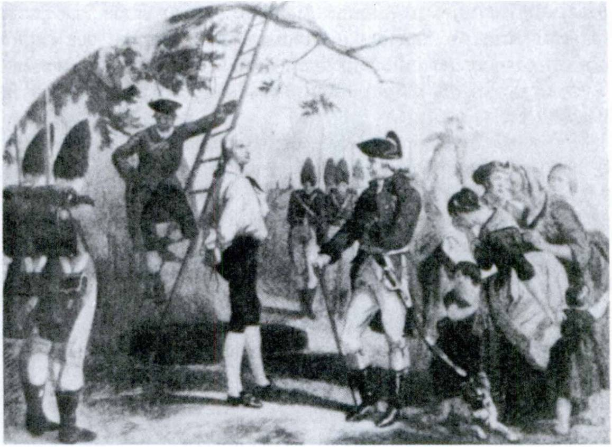FIRST YEAR LATIN 443

NATHAn HALe

READING NO. 41
NATHAN HALE
Romani virtutem virdrum optimdrum memoria semper tenu- erunt. Nos American! etiam multos optimos virds qui pro hac nostra re publica maximas res gesserunt laudamus atque mefnoria tenemus.
Olim1 nostri cum Britannis maximum bellum gerebant ut rem publicam nostram ab edrum impend liberarent. Imperator Ameri- canus fuit Washingtonius, vir optimus et fortissimus, qui diu pro civitate sua et res magnas gessit et gravissimos sustinuit dolores.
Cum dux Britannorum copias suas in Manhattan traduxisset, Washingtonius cum omnibus suis copiis adversus ei constitit. Con­ silium autem capere non potuit, nam non cognoverat ubi impera­ tor hostium milites suds collocavisset. Erat autem in exercitu
1 olim, adv,: once.

FIRST YEAR LATIN

Americano centurio fortissimus, nomine Nathan Hale. Hie para- tus erat in castra hostium contendere atque omnia loca explo- rare ut cognosceret quibus in locis hostes custodes collocavissent quantaeque essent edrum munitiones. Hunc Washingtonius in hostium castra misit.
Sine mora Hale in hostium castra contendit. Clam pervenit.
Omnia loca exploravit. Custodes, armdrum copiam, munitiones vidit—at hostes tandem1 intellexerunt2 quid ageret. Itaque eum captum ad ducem duxerunt. Dux, de re certior factus, eum ad mortem duel jussit. Cum autem fortissimus ille Nathan Hale ad mortem duceretur, “I regret,” inquit, “that I have but one life to give for my country.”
Nonne virtute maxima hujus viri incitati confirmatique rem publicam nostram diligere atque defendere paratiores sumus?

READING NO. 42
THE ANSWER OF THE SPARTAN KING
Lacedaemonii3 magnam gloriam belli et virtutis habebant. Olim4 bellum gerebant. Venit nuntius ad regem Lacedaemoniorum.3 “Magnus,” inquit, “est numerus hostium.” Rex, vir fortissimus, ei respondit, “Tanto5 major erit gloria nostra.”

1 tandem, adv.: at last.
2 intellego, intellegere, intel lexi, intellectus, 3, tr.: understand.
3 Lacedaemonii, Lacedaemoniorum: the Lacedaemonians, the Spartans.
4 olim, adv.: once.
5 tanto: lit., by so much; translate so much the .. .

LESSON 41: DEPONENT VERBS

- INDICATIVE OF DEPONENT VERBS
In Latin some verbs have PASSIVE FORMS but ACTIVE MEANINGS. Such verbs are called DEPONENTS. They are conjugated like the passive of the regular conjugations but each PASSIVE FORM has the corresponding ACTIVE MEANING.
Conor. I try.
Ducem sequetur. He will follow the leader.
Hannibal Romanos vincere conatus est.
Hannibal tried to conquer the Romans.
ASSIGNMENT: Study GrAmmAr, Nos. 334-335.

VOCABULARY
conor, conari, conatus sum, 1, tr.; w. infin.
vereor, vereri, veritus sum, 2, tr.; w. infin.
sequor, sequi, secutus sum, 3, tr.
patior, pati, passus sum, 3, tr.; acc. w. infin.

orior, oriri, ortus sum, 4, intr.

[try
I attempt fear follow
I suffer
|.a#0w [rise
1 arise

RELATED ENGLISH WORDS
The Orient. We have learned the rules for the sequence of tenses. We have been saved by the Passion and death of Christ. The Saints were very patient.

EXERCISE 437
Write out the third person, singular and plural, of the present, imperfect, future, perfect, and pluperfect indicative of the words in the vocabulary and give the English meanings.

445

446 | FIRST YEAR LATIN
 | EXERCISE 438
 | Translate:
1. conabatur | 10. orietur | 18. sequuntur
2. verebantur | 11. conata est | 19. patior
3. sequebar | 12. ortum est | 20. oriuntur
4. patiebamur | 13. passus est | 21. ortum erat
5. oriebatur | 14. veriti sumus | 22. passi erant
6. conabuntur | 15. secuti estis | 23. secuta erat
7. verebitur | 16. conaris | 24. veriti estis
8. sequar | 17. veretur | 25. conata es
9. patiemur
EXERCISE 439
Translate:
1. We were trying. 2. They were following the centurion.
3. He fears the military tribune. 4. They were following the ships. 5. He is trying to flee. 6. He had feared the allies.
7. They fear severe wounds. 8. He will follow no leader. 9. They will not allow it. 10. A shout arose. 11. They fear God alone.
12. He had tried to capture the king. 13. A band of men followed them. 14. Will he allow us to lead our troops across the river?
15. They will try to capture the fortifications and to bum the town.
EXERCISE 440
Translate:
- Hostes non vereor. 2. Christian! Christum sequuntur.
- Christus multa passus est. 4. Bellum novum ortum est. 5. Eds interficere non veritus est. 6. Christian! plurima patiebantur.
7. Orare non conatus es. 8. Qui sequitur Christum, ducem op­ timum sequitur. 9. Romani Deum verum non verebantur.
10. Eos per provinciam contendere non passus est. 11. Te, Christe, sequar. 12. Fugere conabantur. 13. Cur eum seque- bantur? 14. Maria doldres gravissimos passa est. 15. Equites hostes secuti sunt. 16. Maximus clamor undique ortus est.

FIRST YEAR LATIN 447
M
SenTenTiA OviDii
. Video meliora proboque; Deteriora2 sequor.”

- Timor inter milites subito ortus est. 18/Judaei Deum vehe- menter verebantur. 19. Illam urbem capere conabatur. 20. Eds ’’nterficere conati sumus.

EXERCISE 441
[Essential]
Translate:
  - Non patiar maximas copias per provinciam duel. 2. Cum Caesar totam Galliam pacatam esse putavisset, subito novum et difficillimum bellum ortum est. 3. Pilatus Christum verebatur et adjuvare conatus est. Veritus est tamen etiam Judaeos et Romanos. Itaque eos passus est Christum ad mortem ducere.
- Plurimae gentes Romanos vincere conatae sunt, at nulla gens eos vicit. 5. Omnes sancti, gratia Dei incitati, Christum secuti sunt. 6. Christus pro salute nostra gravissimos dolores passus est. 7. Plurimi milites Napoleon, propter ejus magnitudinem animi, secuti sunt. 8. Plurimae gentes deos non veros verebantur,
9. Te, dux, non sequar, nam gloriae cupidus, omnia loca caede atque dolore complebis. 10. Cum legiones ad oppidi muros ap- propinquavissent, maximus clamor ortus est, nam Galli more suo clamaverunt1 se omnia Romanis dedituros esse.

EXERCISE 442
[Essential]
Translate:
1. I am following Caesar. 2. You fear God. 3. He is suffering pain. 4. We do not allow him to come. 5. You (pl.) are trying
1 cl a mo, lt intr.: shout.
2 deterior, ius: worse.

448 FIRST YEAR LATIN

to fight. 6. Wars arise on account of injustices done. 7. They were trying to flee. 8. You (pl.) were fearing Caesar. 9. We were allowing them to flee. 10. A war was arising. 11. You were following the commander in chief. 12. I was fearing death.
13. Wars will always arise. 14. He will not allow us to fight.
15. He tried to capture Rome. 16. The Romans swiftly followed the enemy. 17. They had allowed the hostages to depart.
- A new war had arisen. 19. You have followed Christ for a long time. 20. We have not feared to fight.

- SUBJUNCTIVE OF DEPONENT VERBS
ASSIGNMENT: Study GrAmmAr, Nos. 334-335. Review GrAmmAr, Nos. 267-282, 518, 561, 660-662, and FirsT YeAr LATin,
page 300.

EXERCISE 443
[Subjunctive in Wishes]
Translate:
  - Ne patiatur eds fugere. 2. Ne oriatur novum bellum.
- Sequatur ducem. 4. Vereantur Deum. 5. Patiantur nos in castra venire.

Regem qui fecit nos, Venite adoremus!

EXERCISE 444
[Hortatory Subjunctive]
Translate:
  - Sequamur Christum etiam ad mortem. 2. Pro Christo patiamur. 3. Sancti esse conemur. 4. Patiamur omnes in pace esse. 5. Ne vereamur mortem. 6. Deum vereamur. 7. Conemur pacem servare. 8. Ne sequamur duces malos.

FIRST YEAR LATIN 449

EXERCISE 445
[Indirect Questions]
Translate:
1. Rogavit num novum bellum ortum esset. 2. Milites rogavit num mortem vehementer vererentur. 3. Quaesivit num sancti Christum secuti essent. 4. Eds certiores fecit quis se secutus esset. 5. Rogo quae gentes Romanos vincere conatae sint.
- Senatus Caesarem rogavit num Gallos maximas copias per provinciam ducere passus esset. 7. Dux tribunum militum rogavit quantae copiae se secutae essent. 8. Rogo cur omnes homines Deum verum et unum non vereantur.

EXERCISE 446
[Gum-Clauses]
Translate:
  - Hostes, cum maximas copias trans flumen latissimum ducere conarentur, a Caesare in fugam conjecti sunt. 2. Caesar, cum hostes difficillima via secutus esset, eos in fugam dedit.
- Christus, cum gravissimos dolores pateretur, nobis matrem suam dedit. 4. Lincoln, cum bellum in nostra civitate ortum esset, omnes servos a dominis liberavit. 5. Caesar, cum Gallos per provinciam iter facere omnino non passus esset, fines pro- vinciae armis defendit.

EXERCISE 447
[Essential]
T ranslate :
  - Jesus Christ, the Son of God, allowed Himself to be led to death for our salvation. Let us therefore also follow Him without delay and without fear. Let us not fear the greatest danger. Let us not fear the worst death. Let us place our hope in God that He may not allow us to be overcome in adversity by the enemy.
  - Our soldiers, when they were following the bravest leaders

450 FIRST YEAR LATIN

and the best generals, did not fear the attacks of the enemies or the dangers of sea and forest. When the enemy tried to drive them out of their fortifications, when the enemy tried to withstand their attacks, they did not leave the battle line nor did they flee. Our leader, Christians, is the bravest and best of all. Let us try always to do the things He orders that we may follow Him to certain victory and to the greatest glory.
  - You ask how great things Christ suffered. He suffered the greatest and worst. You ask why He suffered the greatest pains. He suffered the greatest pains that we, moved by His sorrow, might follow Him, that we might try always to remain in His friendship.
  - They always asked why wars arose. Now in these times they are again asking why wars arise. Wars arise because kings and those who are in charge of nations do not follow Christ.

- PERFECT PARTICIPLE OF DEPONENT VERBS
The perfect participle of deponent verbs has an ACTIVE meaning:
secutus, having followed (NOT: having been followed)
passus, having allowed conatus, having tried veritus, having feared ortus, having arisen

VOCABULARY
polliceor, polliceri, pollicitus sum, 2, tr.; acc. w. future infinitive
loquor, loqui, locutus sum, 3, tr.
proficiscor, proficisci, profectus sum, 3, intr.;
ad w. acc.
nactus, a, um

Promise

speak talk
set out

having obtained
.having found

FIRST YEAR LATIN 451

NOTE
Nactus, a, um is the perfect participle of a deponent verb The other forms of this verb are not common.

EXERCISE 448
[Essential]
Translate:
- Caesar, ad Galliam profectus, tribus diebus ad castra Ro- mana pervenit. 2. Christus, multa cum amicis suis locutus, in Caelum sublatus est. 3. Romani, locum ad castra idoneum1 nacti, constiterunt. 4. Equites, hostes celeriter sectiti, plurimos ex eis occiderunt. 5. Christus, gravissimos dolores et mortem pessimam pro nobis passus, ad gloriam suam pervenit. 6. Bar- bari, Caesarem veriti, fuga montes petiverunt. 7. Caesar Gallos castra expugnare conatbs in silvas pepulit. 8. Caesar, ad urbem profectus, tertia die pervenit. 9. Barbari, homines fortissim!, in Romanos e castris profectos impetum fecerunt. 10. Propter novum bellum ortum, Caesar in Galliam profectus erat.

De CHrisTo
Numquam locutus est homo sicut hie homo.

EXERCISE 449
[Essential]
Translate:
- Christ, having spoken with His friends for many days and having promised to send them the Holy Spirit, was raised up into heaven.
- Saint Poly carp,2 having been asked whether he was a Chris­ tian, answered that, having followed Christ very many years and having always feared God, he would not deny Him.
1 idoneus, a, um: suitable.
2 Polycarp: Polycarpus,?.

452 FIRST YEAR LATIN

- Columbus, having promised to give his sailors the greatest and best rewards, collected a small band of brave men and pre­ pared three ships. Having obtained a good wind, he set out.
- The leaders of the Jews,1 having often tried to injure Christ, at last2 * captured and killed Him. Then His friends, having followed Him for two or three years, fled and, having feared the Jews,1 withdrew into a safe place. When, however, the Holy Spirit had been sent to them, they set out from the city and an­ nounced to all men that Christ was the Son of God.

READING NO. 43

DE PRAEMIO TARPEIAE
Sabini,8 qui Romanis proximi erant, bellum cum eis gerebant. Ex suis finibus cum maximis copiis profecti, in agros Romandrum venerunt. Romani, copias edrum veriti, se in urbem Romam receperunt. Itaque Sabini, celeriter secuti, omnes agros vasta- verunt atque occupaverunt. Etiam in urbem Romam brevi tem­ pore copias duxerunt, nam Romani impetus eorum sustinere non potuerunt. Capitolium4 autem, munitionibus et loci natura muni turn, Sabini capere non potuerunt.
Sabini, cum non longe a Capitolio4 abessent, Tarpeiam,5 6 filiam® ducis Romani, quae aquam in Capitolium4 portabat, viderunt. Itaque earn captam ad ducem duxerunt. Dux vero putavit earn exercitum suum in Capitolium4 ducere posse. Itaque pollicitus est se ei maxima praemia daturum esse. Tarpeiam5 autem rogavit quod praemium cuperet. Ea dixit se cupere eas res quas Sabini in sinistris7 manibus gererent. Itaque dux pollicitus est se eas res

1 Jews: Judaei, Judaeorum.
2 at last: tandem, adv,
8 Sabini, drum: the Sabines (an ancient Italian tribe).
4 Capitolium, i: the Capitoline (one of the seven hills of Rome).
8 Tarpeia, ae: Tarpeia (a feminine proper name).
6filia, ae: daughter.
1 sinister, sinistra, sinistrum: left. (The Sabines wore gold rings and brace* lets on their left hands.)

FIRST YEAR LATIN 453

TArpeiA eT SABinUs

Tarpeiae1 traditurum esse. Sabini, earn secuti, brevi tempore Capitolium occupa- verunt.
Tarpeia,1 neque Deum ne- que patrem suum verita, po- pulum suum et urbem suam in manus hostium praemii causa tradiderat. Ecce2 prae- mium ejus. Sabini, cum in Capitolio constitissent, subito scuta3 in Tarpeiam omnes conjecerunt. Fidem tamen ita

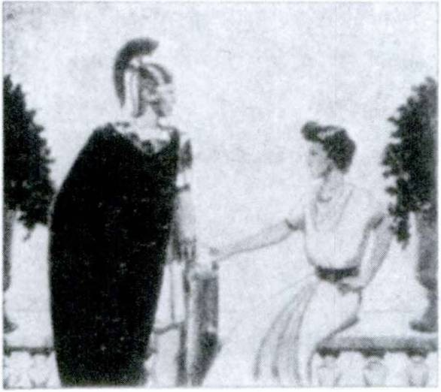conservaverunt et quae polliciti sunt dederunt, nam Sabini etiam
scuta3 in sinistris4 manibus gerebant. Ita ilia miserrima inter- fecta est.

Auxilium Christianorum, Ora pro nobis!

- INFINITIVES OF DEPONENT VERBS
The present and perfect infinitives of deponent verbs are formed just like the regular passive infinitives of the four con­ jugations.
BUT THE FUTURE INFINITIVE is ACTIVE both in form and meaning.
Dixit se profecturum esse. He said that he wotdd set out.
ASSIGNMENT: Study GrAmmAr, Nos. 336-338. Review all infinitive constructions, pages 352, 363, 414, 420.

1 Tarpeia, ae: Tarpeia.
2 ecce: behold.
8 scutum, i: shield.
4 sinister, sinistra, sinistrum: left.

454 FIRST YEAR LATIN

VOCABULARY
egredior, egredi, dgressus sum, 3, intr.
progredior, progredi, progressus sum, 3, intr.
arbitror, arbitrari, arbitrates sum, 1, tr.; acc. w. infin.

hortor, hortari, hortatus sum, I, tr.

NOTE
Arbitror takes the accusative with the infinitive (tense by relation) because it is a verb of thinking.

go out advance
think consider
urge encourage

EXERCISE 450
Form the three infinitives of all the words in the vocabulary.

Divinum1 auxilium maneat semper nobiscum. Amen.

EXERCISE 451
[Present Infinitive of Deponents]
Translate:
- Post difficillimum proelium Caesar suds progredi jussit.
  - Ex difficillimis locis egredi non potuerunt. 3. Caesar saepe tri­ bunds militum suds hortari atque confirmare jussit. 4. Nonne oportet nos prima luce proficisci? 5. Oportet homines pessimos Deum vehementer vereri. 6. Oportet Christianos sanctos esse semper conari. 7. Caesar jussit legatum cum ducibus hostium loqui. 8. Optimum est Christum sequi sed difficillimum etiam est. 9. Oportet nos multa et gravissima pati. 10. Egredi non possumus; tamen, a te jussi, conabimur. 11. Oportet nos omnes Christum sequi, plurimos dolores pati et ita ad gloriam nostram pervenire.
1 divinus, a, urn: divine.

FIRST YEAR LATIN 455

EXERCISE 452
[Present and Perfect Infinitives of Deponents]
Translate:
1. Nuntius dixit hostes prima luce egressos esse. 2. Dixerunt se ex difficillimd loco egressos non esse. 3. Arbitratus est tribunos militum suds hortatos esse. 4. Dixit oportere nos prima luce pro- ficisci. 5. Nos certiores fecit hostes profectos esse. 6. Con- firmavit legionem esse egressam. 7. Audivimus Gallos copias maximas trans flumen ducere cdnatos esse. 8. Christian! putant optimum esse Christum sequi.

EXERCISE 453
[Future Infinitive of Deponents]
Translate:
1. Caesar dixit se tribus diebus profecturum esse. 2. Pollicitus est se haec omnia duobus diebus facturum esse. 3. Legatus Ro- manus dixit se numquam cum hoste locuturum esse. 4. Putavimus eos quinque diebus egressurds esse. 5. Dixit se non passurum eos hac via maximas copias ducere. 6. Scimus ducem, virum fortis- simum et optimum, suds hortaturum esse. 7. Apostoli polliciti sunt se Christum semper secuturos esse. 8. Rex dixit se in locum tutissimum progressurum esse.

SenTenTiA Livn
Et facere et pati fortiter Romanum est.

EXERCISE 454
Translate:
1. I think that the enemy has advanced two miles. 2. He an­ nounced that the cavalry had suddenly gone out of the camp.
  - We saw that the military tribunes and centurions were en­ couraging the soldiers. 4. The hostages promised that they would not go out of the camp. 5. They thought that they would not set

456 FIRST YEAR LATIN

out at dawn. 6. They feared to speak the truth. 7. Having set out, they followed the enemy three miles. 8. He said that, having set out, they had followed the enemy four miles. 9. He said that, having obtained a good wind, the ships had set out on the third day. 10. He said he would set out within three days.
11. The soldiers said they would not follow that leader. 12. He said he would not allow them to march through the province.
13. They affirmed that they would suffer the worst pains. 14. He tried to set out but was captured by the cavalry. 15. The horse­ man announced that the enemy, having advanced three miles into the province, was trying to come across the river. 16. They in­ formed Caesar that the enemy were trying to seize the hill.

UNIT FOURTEEN

LESSON 42: THE IRREGULAR VERB EO

1. INDICATIVE OF EO
ASSIGNMENT: Learn the present, imperfect, and future oi eo, GrAmmAr, Nos. 363-365. The perfect tenses are formed regu­ larly on the stem iv- or i-.
Review GrAmmAr, Nos. 761, 915-924, and the lesson on de, ex, and ab, FirsT YeAr LATin, page 336.

VOCABULARY
eo, ire, ivi (ii), itum, irreg., intr.
exed, exire, exit, exitum, irreg., intr.
ineo, inire, inii, initus, irreg., tr.

NOTE

go
go out go into
enter upon

Compounds of eo like exed and ineo are conjugated like eo, but note that the v is regularly dropped in the perfect stem of compounds.
EXERCISE 455
Give the third person, singular and plural, of the present, im­ perfect, future, perfect, and pluperfect indicative of the words in the vocabulary.
EXERCISE 456
- Translate;
- Explain the italicized words:
1. Totam noctem iverunt. 2. Secunda vigilia exiit. 3. Duo milia passuum iit. 4. Tribus diebus exibit. 5. Centum pedes ierat. 6. Qua hord, amice mi,1 exibis? 7. Novum consilium ini- erunt. 8. Quot dies ierunt ? 9. Altera legio e castris exiit; altera

1 See GrAmmAr, No. 28.

457

458 FIRST YEAR LATIN

in castris mansit. 10. Salutis causa in oppida inierunt.
11. Omnes fere exeunt. 12. De jinibus suis exibant. 13. Ad flumen it. 14. Tertia die exibat. 15. Centurio cum centum hominibus exibit. 16. Legid sine ulla mora exiit. 17. Quam diu ierat ? 18. Quo, fill mi, ibis ? 19. Per loca impedita et difficillima ierat. 20. Christus, “Ad Patrem,” inquit, “ibo.”

EXERCISE 457
Translate:
- They went five miles. 2. He went out to the camp on the second day. 3. Others were going out of the camp. 4. Within three days he will enter the city. 5. Will we all go to heaven?
6. He is going through a very large forest. 7. Where did you go?
8. Caesar went into the province. 9. They came into the winter quarters. 10. They entered upon a new method of war. 11. They will go within five days. 12. They went out of the camp.
- They entered the province on the third day. 14. Having set out on that day, they went four miles. 15. They entered a very deep river. 16. Having obtained a good wind, they went out of the harbor. 17. They went into Gaul by the shortest way.
- For two days they went through the highest mountains.
- In the first watch he went secretly out of the town. 20. When they had set out, they went three miles and pitched camp.

  - Translate;

EXERCISE 458

  - Answer the questions in complete Latin sentences:
    - Milites American! ex nostris finibus trans mare latissimum in Galliam ierunt ut contra hostes pugnarent.
QUesTion. QUo ierunt?
Answer. E nostris finibus trans mare latissimum in Galliam ierunt.
- Ex quo loco ierunt?
- Ieruntne trans mare latissimum?
- Cur in Galliam ierunt ?

FIRST YEAR LATIN 459

    - Christus, multos dies cum amicis suis locutus, in Caelum ad Patrem suum ivit.
      - Cum quibus locutus est Christus?
      - Quam diu cum eis locutus est ?
      - Quo ivit?
      - Ad quern ivit?
    - Omnes sancti, Christum fortiter secuti, in Caelum ibunt.
      - Qui Christum sunt secuti?
      - Quo ibunt?
    - Marquette, vir optimus et fortissimus, multos dies per silvas periculorum plenas et per loca impedita et difficillima ierat. Turn audivit non longe abesse flumen latissimum et longissimum. Hoc flumen ab eis qui eas regiones incolebant Pater Aquarum vocabatur. Itaque nave parva rursus profectus, plurimos dies iit et tandem* flumen quod nunc a nobis Mississippi vocatur primus iniit.
      - Quot dies ierat Marquette?
      - Per quae loca ierat?
      - Num per silvas ierat?
      - Quid turn audivit?
      - Quid illud flumen vocabatur?
      - Qui id Patrem Aquarum vocabant?
      - Estne Marquette rursus profectus?
      - Ad quod flumen pervenit ?
      - Cognovistine quo loco Marquette hoc flumen primum con- spexerit?
      - Scisne quis socius Patris Marquette fuerit?
      - Fuitne Marquette Jesuita?
    - Jam demonstravimus milites nostros non potuisse diutius in Bataan impetum hostium sustinere. Nam, sicut cognovistis, Japdnes mAjoribus copiis et pluribus armis in nostros impetus faciebant. MacArthur, qui praesidio nostro praeerat, jussus est
1 tandem, adv.: at last.

460 FIRST YEAR LATIN

milites relinquere et ex ed loco qui Corregidor vocatur exire. Itaque sine mora nave parva cum paucis sociis exiit. Plurimas noctes per maria periculdrum plena ierunt. Saepe portus natura loci munitos inierunt atque ibi per diem manserunt ne ab hostibus conspicerentur. Nocte rursus profecti celeriter ierunt. Ita e manibus hostium se eripuerunt et tandem2 1 portum a nostris oc- cupatum inierunt.
- Cur nostri impetus Japonum sustinere non potuerunt?
- Cui praesidio praeerat MacArthur?
- Quid facere jussus est?
- Exiitne statim ?
- Quibuscum exiit?
- Ubi saepe manserunt?
- Cur ibi manserunt?
- Conspexeruntne eos hostes?
- Quo tandem1 pervenerunt ?

A mala morte, Libera eum, Domine!
—From the Prayers for the Dying

- SUBJUNCTIVE OF EO
ASSIGNMENT: Study GrAmmAr, Nos. 375-376. Review GrAmmAr, Nos. 518, 546-549, 561, 660-662.

VOCABULARY
transeo, transire, transii, transitus, irreg,, tr.
reded, redire, redii, reditum, irreg,, intr.

go across cross return
go to

adeo, adire, adii, aditus, irreg,, tr. approach visit

1 tandem, adv,: at last.

FIRST YEAR LATIN 461

- Translate;
EXERCISE 459

- Explain the mood and tense of the italicized verbs:
  - Columbus, cum mare latissimum transiret, in periculd maximo saepe erat. 2. Columbus, cum ex portu egressus mare transits set, ad Americam pervenit. 3. Caesar, cum omnes Galliae gentes adiisset, in Italiam rediit. 4. Legiones, cum totam noc- tem iissent, constiterunt et castra posuerunt. 5. Dux, cum opti- mam belli rationem innsse/, hostes facilius vicit. 6. Equites, cum a duce jussi ex castris exiissent, hostes celeriter secuti sunt.

    - Translate;
EXERCISE 460

    - Explain the italicized constructions:
1. Eamus. 2. Ne ex prima acie exeamus. 3. In hiberna rede- amus. 4. Omnes Italiae civitates ad eamus. 5. Ne eat. 6. Celeri­ ter redeant.

EXERCISE 461
- Translate;
2. Explain the italicized constructions:
1. Rogat quantae copiae flumen transeant. 2. Dux rogavit
qua hora hostes ex castris extissent. 3. Rogo num in castra ieris.
- Caesarem certidrem fecit quot hostes flumen transiissent.
- Rogo qua via per montes ierint.

  - Translate;
EXERCISE 462

  - Explain the italicized constructions:
- Caesar pontem in flumine latissimo fecit quo facilius equites
redirent. 2. Custodes undique collocat ne barbari e silvis exeanf.
- Milites American! multos portus occupaverunt ne naves hostium in eos redirent. 4. Equites celeriter misit qui flumen trdnsirent. 5. ImperStor centuriones ad se vocavit ut novum

462 FIRST YEAR LATIN

consilium iniret. 6. Munitiones in portu fecerunt ne naves eum
intent.

A cunctis1 nos, quaesumus,2 Domine, mentis et corporis defende periculis.

EXERCISE 463
Translate:
Cum novum bellum in Europa ortum esset et omnes illius regionis gentes terra marique inter se armis contenderent, nos primum Gallos et Britannds copia armdrum et frumenti adjuva- bamus, turn bellum cum eis contra hostes gerebamus. Itaque plurimas naves paravimus ut nostri milites mare transient; maximam telorum et armdrum copiam paravimus ut, cum nostri in Europam transiissent, fortiter contra hostes et diu pugnare possent. In hoc bello milites American! multa loca adierunt. Nam alii in Africam transierunt; alii primum in Britanniam, turn in Galliam transierunt; alii etiam in alias regiones transierunt. Scimus nostros in omnibus his locis fortiter pugnare et fortiter pugnaturos esse. Multos dolores et plurima vulnera pass! post victoriam ad nos redibunt. Eds eorumque res gestas semper memoria teneamus.
Answer in complete Latin sentences:
- Ubi erat novum bellum ortum?
- Quae gentes inter se armis contendebant?
- Quibus rebus socios nostros primum adjuvimus ?
- Bellumne cum eis gessimus ?
- Quo ierunt milites nostri ?
- Nonne alii in Britanniam, alii autem in Africam transi­ erunt?
- Arbitrarisne nostros milites fortiter pugnare?
- Quo tempore ad nos redibunt?

1 cunctus, a, um: all.
2 quaesumus: we beseech.

FIRST YEAR LATIN 463

EXERCISE 464
Translate:
1. The Japanese, when they had gone out of the fortifications, sought the forest in flight. 2. They returned from this river that they might be safe from attack. 3, The ships of the Japanese crossed the sea secretly that they might make an attack on our harbors. 4. These soldiers are returning from the camp, but those are going to the camp. 5. The enemy went secretly out of the forest and were suddenly seen in the rear. 6. When he had returned to the ship, he was killed by a dart and fell into the water. 7. These brave soldiers went to France to free the French from a foreign power. 8. The cavalry drove back the enemy that the encumbered soldiers might go across the river. 9. The soldiers, hindered by the nature of the place, returned to the camp. 10. The camp was empty, for, when the soldiers had gone into the province, none returned. 11. We shall ward off the enemy from these fields and these cities, that those who dwelt in them may return. 12. The leaders of the enemy entered upon a new manner of war. Their cavalry went out of the towns to hinder our columns. 13. We warded off the attack of the cavalry in order that the legion might return into the winter quarters.
- The lieutenant said, “I ask where your allies have gone.”
- The leader asked the envoys what races of men they had visited. 16. The Romans constructed roads that they might more easily visit the provinces. 17. The cavalry made an at­ tack from the rear lest the enemy return to their camp. 18. He went to the chiefs to ask who was most influential among them.
19. When the leaders of the Jews had gone to Pilate, they said that Christ had called Himself by the name of king. 20. Christ asked the Apostles by what name He was called. 21. The chief men assembled to enter on new plans. 22. There was bitter fighting there and very many did not return. 23. He sent envoys to visit the leading men of those tribes. 24. The leader asked with how great forces the enemy had gone into the province.
25. When they had gone down from the hill, they there took up

464 FIRST YEAR LATIN

a position. 26. When Caesar had gone out of the camp, the enemy approached the rampart. 27. When the Romans had gone into the territory of the enemy, they pitched camp and fortified it with a ditch and a rampart. 28. He asked whether the hostages had gone secretly out of the camp. 29. When Caesar returned from Italy, he asked whether everything useful for war had been prepared. 30. They asked where he had returned from. 31. Ter­ rified by the arrival of Caesar, the barbarians went into their own territory. 32. When Caesar returned to the winter quarters, he found that a new war had arisen in Gaul.

  - INFINITIVES OF EO
ASSIGNMENT: Study GrAmmAr, No. 378. Form the perfect and future infinitive active of ed according to the general rules. Review all infinitive constructions, pages 352, 363, 414, 420.

- Translate;
EXERCISE 465

- Explain the italicized constructions:
1. Christus dixit se paucis diebus in Caelum iturum esse.
- Oportet nos redire. 3. Pessimum est ad socios maids jam relictos reclire. 4. Respondit equites non jam rediisse. 5. Chris­ tus pollicitus est se rediturum esse. 6. Equites reppererunt bar­ bards jam flumen transiisse. 7. Caesar obsides e castris ad suds exire non passus est. 8. Dux scripsit se duobus diebus rediturum esse. 9. Nuntius ostendit quot homines castra iniissent. 10. Pila- tus dixit Judaeos non probavisse Christum esse hominem pessi­ mum. 11. Puto plurimos homines in Caelum ituros esse. 12. Dux arbitratus est optimum esse flumen statim transire. 13. Caesarem certiorem fecit barbaros tria milia passuum iisse. 14. Equites sine mora flumen transire jussit. 15. Legatus constituit oportere se statim cum omnibus copiis ad Caesarem ire ut eum contra barbaros adjuvaret. 16. Equites reppererunt hostes jam in castra rediisse. 17. Tribunus militum scripsit se in agros hostium

FIRST YEAR LATIN 465

transiturum esse. 18. Judaei constituerunt Pilatum adire ut Christus occideretur. 19. Christus, doldribus atque vulneribus conjectus, per vias ductus est. 20. Christus se a manibus edrum eripere potuit, nam Deus erat. 21. Judaei, cum Pilatum Christum adjuvdre condri sensissent, ei dixerunt Christum se regem fecisse.

EXERCISE 466
Translate:
1. They were unable to go. 2. Caesar will not allow the Hel­ vetians to go. 3. He said he would go within three days. 4. The centurion announced that the enemy had returned. 5. It be­ hooved Caesar to visit Gaul. 6. They were ordered to go out of the camp. 7. They said they would return with greater forces.
8. He did not allow them to cross the river. 9. It is good to enter upon this plan. 10. They informed Caesar that the Gauls had gone three miles. 11. On account of the Roman soldiers they were unable to cross the river. 12. He determined to return on the third day.
EXERCISE 467
Translate:
Caesar, cum in Galliam pervenisset, audivit Helvetios per pro- vinciam ire constituisse ut in novos agros pervenirent. Helvetii erant gens Galldrum quae provinciae proxima erat. Hi omnia quae ad iter pertinebant paraverant quo facilius ex suis finibus exirent. Caesar vero arbitratus est oportere se eos prohibere. Itaque negavit se passurum eos per provinciam ire. Custodes col- locavit ne flumen quod inter provinciam et agros eorum erat transirent. Ei autem cum omnibus suis copiis transire multos dies conabantur. Caesar armis eos prohibebat. Itaque, cum flumen transire et provinciam inire non potuissent, altera via, difficiliore et angustiore, ire constituerunt. Caesar, cum nuntiatum est eos de finibus suis exiisse ut hac via in novos agros irent, statim cum omnibus suis copiis e castris exiit et eos secutus est. Multos dies eos secutus est; tandem proeliis eos vicit. Galli, a Caesare

466 FIRST YEAR LATIN

omnino superati, se suaque omnia e! dediderunt. Eds in suds fines redire jussit. Itaque redierunt. Numquam enim Caesar passus est gentes Galliae ex suis finibus in alios transire.
Answer in English:
- Quid audivit Caesar post adventum suum?
- Ubi incolebant Helvetii?
- Cur per provinciam ire constituerunt ?
- Nonne omnia quae ad iter utilia sunt comparaverunt?
- Estne Caesar passus eos e finibus suis exire ?
- Quod flumen transire conati sunt ?
- Potueruntne id flumen transire?
- Cur non potuerunt flumen transire?
- Quid turn fecerunt?
- Audivitne Caesar eos e finibus suis exiisse?
- Estne Caesar eos secutus?
- Putasne Caesarem flumen de quo jam demonstravimus transiisse ?
- Quibuscum profectus est Caesar?
- Quot dies eos secutus est?
- Vicitne eos Caesar?
- Redieruntne Helvetii in suds agros, cum redire a Caesare jussi essent?
- Num Caesar passus est alias gentes ex suis finibus exire?

READING NO. 44

THE CONDEMNATION OF CHRIST
Duds aut tres annos Christus Judaeos1 viam salutis docuerat. De regno caelorum et de voluntate Patris sui eis locutus erat. Se esse Filium Dei atque omnium hominum regem ostenderat. Bonam in omnes homines voluntatem semper ostenderat. Omnes ad se vocaverat nam “Venite,” inquit, “ad me.” Omnes receperat; omnes adjuverat. Tamen plurimi principes Judaeorum,1 homines

1 Judaei, 6rum: the Jews.

FIRST YEAR LATIN 467

pessimi, eum timebant. Arbitrati enim sunt eum regnum Judae- drum1 occupaturum esse atque suum imperium sublaturum esse. Itaque hi consilia capiebant ut Christum caperent et occiderent. Ad eds, cum consilium caperent, venit unus de discipulis* Christi, nomine Judas.8 9 Hie pollicitus est se Christum in manus edrum traditurum esse. “Quid,” inquit, “dabitis mihi et ego vdbis eum tradam?” At illi constituerunt ei triginta* argenteos.® Ex hoc tempore Judas® paratus erat Christum tradere.
Christus vero post illam coenam® in qua sacramentum7 sanctis- simum nobis reliquit, ex urbe exivit. Egressus, trans flumen quod Cedron vocabatur transiit et in locum quod Gethsemani vocabatur ivit. Consueverat enim in hunc locum cum amicis suis se redpere ut oraret. Itaque hac nocte, paucos® pedes ab amicis progressus, in terram cecidit et vehementer oravit. Scivit enim se maximos dolores pro nobis passurum esse. Diu oravit. “Non mea voluntas,” inquit, “sed tua fiat.”® Post haec ad discipulos1 2 * 4 * * venit et illis, “Ecce,”10 11 * * inquit, “appropinquavit hora et Filius hominis tradetur in manus peccatorum.11 Eamus; ecce appropinquavit qui me tradet.” Cum jam loqueretur, Judas,® unus de duodecim,1® venit. Cum eo autem erat manus militum a principibus Judaeorum missa. Judas ad Christum venit et eum osculatus1® est. Hoc autem signum eis dederat ut scirent quis Christus esset. Illi autem Jesus, “Amice,” inquit, “ad quid venisti? Juda, osculo14 Filium hominis tradis?” Turn Jesus progressus ad eds qui missi sunt.

1 Judaei, drum: the Jews,
2 discipulus, i: disciple,
8 Judas, ae: Judas, (Juda is the vocative.)
4 triginta: thirty,
*argenteus, i: piece of silver,
ecoena, ae: supper.
7 sacramentum, i: sacrament,
8pauci, ae, a: jew.
9 fiat: be done.
10ecce: behold.
11 peccator, peccatoris: sinner.
18duodecim: “the Twelve” (i.e., tAe twelve Apostles}.
18 osculor, 1, tr.: hiss.
14osculum, i: a kiss.

468 FIRST YEAR LATIN

“Quem,” inquit, “quaeritis?” Responderunt el, “Jesum Nazare- num.”1 Els Jesus, “Ego,” inquit, “sum.” Cum dixisset eis, “Ego sum,” ill! in terram ceciderunt. Rursus eds rogavit, “Quem quaeritis?” Illi autem responderunt, “Jesum Nazarenum.”1 Re- spondit Jesus, “Dixi vobis quia2 ego sum. Si3 ergo* me quaeritis, sinite5 hos abire.”6
Illi Christum ceperunt et ad concilium duxerunt. Pontifex7 eum interrogavit8 de discipulis9 ejus et de doctrina10 ejus. Respondit ei Jesus: “Ego palam11 locutus sum mundd. Ego semper docui in synagoga12 et in templo,13 quo omnes Judaei conveniunt; et in occulto14 locutus sum nihil. Cur me interrogas?8 Interroga8 eds qui audiverunt quid locutus sim. Ecce15 hi sciunt quae dixerim ego.”
Pontifex7 interrogabat8 eum: “Tu es Christus Filius Dei bene­ dict! ?”16 Jesus autem illi, “Ego,” inquit, “sum.” Et omnes cla- maverunt17 eum esse reum18 mortis.
Itaque mane19 Christum ad Pilatum duxerunt. Exiit Pilatus ad eds et rogavit cur Christum ad se duxissent. Responderunt Christum pessimum hominem esse. Pilatus autem eis, “Accipite,” inquit, “vos, et secundum20 legem vestram judicate eum.” Dixerunt
1 Nazarenus, a, um: of Nazareth.
2 quia: that (introducing a noun clause as in English).
8 si, conj.: if.
4 ergo, adv.: therefore.
5 sino, sinere, sivi, situs, 3, tr.; acc. w. infin.: allow, permit.
8 abed, abire, abii, abitum, irreg., intr.: go away.
7 pontifex, pontificis: priest, high priest.
8interrogd, 1, tr.: question.
9 discipulus, i: disciple.
10 doctrina, ae: teaching.
11 palam, adv.: openly.
12 synagoga, ae: synagogue.
18 templum, i: temple.
14 in occulto: in secret.
15ecce: behold.
16 benedictus, a, um: blessed.
17 clamo, 1, intr.: shout.
18 reus, a, um: guilty of.
19 mane, adv.: in the morning.
20 secundum, prep. w. acc.: according to.

FIRST YEAR LATIN 469

autem Judaei se non posse eum ad mortem ducere. Itaque iniit Pilatus et vocavit Jesum et dixit ei, “Tu es Rex Judaeorum?” Respondit Jesus, “A temetipso1 hoc dicis an2 alii dixerunt tibi de me?” Respondit Pilatus: “Numquid3 ego Judaeus sum ? Gens tua et pontifices4 tradiderunt te mihi. Quid fecisti?” Respondit Jesus: “Regnum meum non est de hoc mundo; si5 ex hoc mundo esset regnum meum, ministri6 mei utique7 decertarent8 ut non traderer Judaeis: nunc autem regnum meum non est hinc.”9 Itaque ei Pilatus, “Ergo,”1* inquit, “rex es tu?” Respondit Jesus: “Tu dicis quia11 rex sum ego. Ego in hoc natus12 sum et ad hoc veni in mundum, ut testimonium13 perhibeam14 veritati; omnis qui est ex veritate audit vocem meam.” Ei Pilatus, “Quid,” inquit, “est veritas?” Et cum hoc dixisset, rursus exiit ad Judaeos et dixit eis se nullam causam in eo reperire. Erat autem mos dimittere unum vinctum15 tempore Paschae.16 Itaque Pilatus Judaeis, “Dimittamne vobis regem Judaeorum?” Clamaverunt17 omnes: “Non hunc, sed Barabbam.18 Tolle hunc! Et dimitte nobis Barabbam.”18 Erat autem Barabbas18 latro.19
Illis Pilatus, “Quid,” inquit, “faciam de Jesu qui vocatur

1 temetipso: yourself (an emphatic form).
2 an: or.
3 numquid: an emphatic form of num.
4 pontifex, pontificis: priest, high priest.
5 si, conj.: if.
6 minister, ministry: servant.
1 utique, adv.: certainly.
8decerto, 1, tr.: strive.
9 hinc, adv.: hence, from here.
10 ergo, adv.: therefore.
11 quia, conj.: that (introducing a noun clause as in English).
12 natus sum: (I) was bom.
13 testimonium, i: testimony.
14perhibeo, 2, tr.: give.
15 vinctus, a, um: bound (i. e., a prisoner).
16 Pascha, ae: the festival of the Pasch.
17 clamo, 1, intr.: shout.
18 Barabbas, ae: Barabbas.
19 latro, latronis: a robber.

Christus Rex

FIRST YEAR LATIN 471

Christus?” Clamabant1 omnes, “Crucifigatur.”1 2 * * Ulis Pilatus, “Quid enim mall,” inquit, “fecit?” At ill! rursus clamabant,1 “Crucifigatur.”2
Turn Pilatus Christum flagellar!8 jussit. Milites verb, plectentes* coronam5 * spineam,® imposuerunt7 capiti ejus et veste8 purpurea* circumdederunt10 11 eum. Et veniebant ad eum et dicebant, “Ave, Rex Judaeorum.” Et dabant ei alapas.11
Rursus exiit Pilatus et dixit Judaeis: “Ecce adduco vobis eum ut cognoscatis me nullam causam in eo reperire.” Exiit Jesus. Portabat autem coronam5 spineam® et purpuream9 vestem.8 Pilatus autem eis, “Ecce,”12 inquit, “homo! ”
Principes Judaeorum autem, cum eum vidissent, clamabant,1 “Crucifige,2 crucifige eum.” Eis Pilatus: “Accipite,” inquit, “vos et crucifigite.2 Ego enim non reperio in eo causam.” Responderunt ei Judaei: “Nos legem habemus, et secundum13 legem oportet eum interfici, quod Filium Dei se fecit.” Haec Pilatus cum audivisset, vehementer timuit. Rursus iniit et Jesu, “Unde es,” inquit, “tu?” Jesus autem nihil respondit. Dicit ei Pilatus: “Mihi non loqueris ? Nescis14 quia15 * potestatem1® habeo crucifigere2 te et potestatem1® habeo dimittere te ?” Respondit Jesus: “Non haberes17 potestatem1®

1 clamo, 1, intr,: shout.
2 crucifigo, crucifigere, crucifix!, crucifixus, 3, tr.: crucify.
8 flagello, 1, tr,: scourge.
* plectentes: platting.
8 corona, ae: crown.
8 spineus, a, um: of thorns.
r impono, imponere, imposui, impositus, 3, tr.; w. dot.: put upon.
®vestis, vestis: garment.
°purpureus, a, um: purple.
10 circumdo, circumdare, circumdedi, circumdatus, 1, tr,: clothe.
11 alapa, ae: blow, slap.
12 ecce: behold.
18 secundum, prep, w. ace,: according to.
14 nescid, nesciri, nescivi, 4, tr,: not know.
18 quia: that (introducing a noun clause as in English).
18potestas, potestatis: power,
17 non haberes: you would not have.

472 FIRST YEAR LATIN

adversum1 me ullam, nisi tibi datum esset desuper.1 2 * Propterea8 qui me tradidit tibi, ma jus peccatum habet.”
Ex hoc tempore conabatur Pilatus eum dimittere. Judaei autem clamabant:4 “Si5 6 hunc dimittis, non es amicus Caesaris; omnis enim qui se regem facit, contradicit® Caesari.” Pilatus autem cum haec audivisset, dixit Judaeis, “Ecce rex vester.” Illi autem clamabant,4 “Tolle! Tolle! Crucifige7 eum!” Pilatus eis, “Re­ gem,” inquit, “vestrum crucifigam ?”7 Responderunt principes Judaedrum, “Non habemus regem, nisi Caesarem.” Itaque Pi­ latus, Caesarem atque Judaeos veritus, Jesum eis tradidit. Eum autem in locum qui Golgotha vocabatur duxerunt atque ibi Jesum Christum, Filium Dei, crucifixerunt.7

1 adversum, prep. w. acc.: against.
2 desuper, adv.: jrom above.
8propterea: therefore. 4 clamo, 1, intr.: shout. 8 si, conj.: if.
6 contradico, contradicere, contradixi, contradictum, 3, intr.; w. dat.: speak
against.
7 crucifigo, crucifigere, crucifix!, crucifixus, 3, tr.: crucify.

MASTERY REVIEW VOCABULARY NO. 3
[Units Six-Fourteen]

VERBS OF THE FIRST CONJUGATION

addro, 1, tr.
aestimo, 1, tr.; acc. w. infin.

appello, 1, tr.; two accs. appropinquo, 1, intr.; w. ad or dat. confirmo, 1, tr.; acc. w. tnfin.
demonstro, 1, tr.; acc. w. infin.
existimo, 1, tr.; acc. w. in fin.
expugno, 1, tr.

exspecto, 1, tr.
judico, 1, tr.; acc. w. infin. libero, /, tr.; abl. of separation navigo, 1, intr.
nego, 1, tr.; acc. w. infin.

nuntid, 1, tr.; acc. w. in fin.
paco, 1, tr.
probo, 1, tr.

puto, 1, /r.; acc. w. infin.
rogo, 1, tr.
473
adore think call
call upon
address draw near to approach
encourage strengthen affirm
show Point out think
storm
take by storm wait for
wait
judge
free (from) sail
deny
say . . . not
announce report
pacify approve prove
think ask

474 FIRST YEAR LATIN

vaato, 1, tr.
voco, 1, tr.; two accs.
lay waste ravage call

VERBS OF THE SECOND CONJUGATION

commoveo, commovere, commovi, commotus,
2, tr.
doceo, docere, docui, doctus, 2, tr.1

jubeo, jubere, j’ussi, jussus, 2, tr.; acc. w. in fin.
moved, movere, movl, motus, 2, tr.
noceo, nocere, nocui, nociturus, 2, intr.; w. dat. pertineo, pertinere, pertinul, 2, intr.; ad w. acc. prohibeo, 2, tr.; abl. of separation
responded, respondere, respond!, responsus, 2, tr.;
acc. w. infin.

valeo, valere, valui, valiturus, 2, intr.
alarm arouse
teach inform order
command
move
do harm to injure Pertain to
stretch to
ward off (from) prevent
answer

am strong am well
am influential

VERBS OF THE THIRD CONJUGATION

adduco, adducere, adduxl, adductus, 3, tr. cado, cadere, cecidT, casurus, J, intr. cerno, ceraere, 3, tr.
lead to lead on
fall distinguish see

1 Doceo takes two accusatives when it means “teach someone something!

FIRST YEAR LATIN 475

cognSscS, cognSscere, cognSvi, cognitus,
3, tr.
cogo, cogere, coegi, coactus, 3, tr.

consists, cSnsistere, constiti, 3, intr.

constituo, constituere, constitu!, constitutus, 3, tr.; w. infin.

consuevi, cSnsuetus, 3, tr. and intr.; w. infin.1

contendo, contendere, contend!, 3, intr.;
w. infin.

dedS, dedere, dedidi, deditus, 3, tr?

deducS, deducere, deduxi, deductus, 3, tr.
defendo, defendere, defend!, defensus,
3> tr.; abl. of separation
dico, dlcere, dixl, dictus, 3, tr.; acc. w. infin.
dlligS, diligere, dilexi, dilectus, 3, tr.
discedo, discedere, discessi, discessurus,
3, intr.
incolo, incolere, mcolui, 3, tr.
ostendo, ostendere, ostendi, ostentus,
3, tr.

learn
find out collect force
halt
take a position place
set up
decide determine
have accustomed
have become accustomed
.am accustomed strive
contend
hasten give up surrender
\lead
[lead away defend

[tell love depart
withdraw
inhabit dwell in
show

1The present tenses of consuevi are not common. Hence only the perfect indicative active and the perfect participle passive are given. BUT note that the perfect can have a PRESENT meaning and the pluperfect can have a PERFECT meaning.
1 Dedo always takes an object in Latin.

476 FIRST YEAR LATIN

quaerd, quaerere, quaeslvi, quaesitus, 3, tr.

rego, regere, rex!, rectus, 3, tr.

relinquo, relinquere, reliquT, relictus, 3, tr.

scribo, scribere, scrips!, scriptus, 3, tr.; acc. w. infin.
tollo, tollere, sustuli, sublatus, 3, tr.
traduco, traducere, traduxi, traductus, 3, tr.; two accs. or acc. and trans w. acc.1

seek ask
direct rule leave
leave behind
write

raise (up) take away lead across
(

VERBS OF THE FOURTH CONJUGATION

audio, 4, tr.; acc. w. infin.
impedio, 4, tr.
pervenio, pervenlre, perveni, perventum, 4, intr.; in or ad w. acc.
reperio, reperire, repperi, repertus, 4, tr.; acc.
w. infin.
scio, 4, tr.; acc. w. infin.

sentio, sentire, sens!, sens’us, 4, tr.; acc. w. infin.
hear hinder impede
arrive find (out)
know feel perceive
think

-IO VERBS OF THE THIRD CONJUGATION

accipio, accipere, accept, acceptus, 3, tr.

capio, capere, cep!, captus, 3, tr.
receive accept
take capture

1With traduco the thing OVER WHICH the direct object is led, is put either (1) in the accusative, or (2) with trans in the accusative.

FIRST YEAR LATIN 477

conficio, conficere, confeci, confectus, 3, tr. -jfinish
[wear out
conjicio, con j ice re, con j eci, con j ectus, 3, tr. j[ throw
[hurl
conspicid, conspicere, conspexi, conspectus, 3, tr. j see
[catch sight of

cupio, cupere, cupivi, cupitus, J, tr.; w. infin.
eripio, eripere, eripui, ereptus, 3, tr.; ex (e) w. abl.
desire
1 take away
[save (from)

facio, facere, feci, factus, 3, tr. <\do [make
fugio, fugere, fugi, fugiturus, 3, tr. flee
interficio, interficere, interfeci, interfectus, 3, tr.1 kill

recipio, recipere, recepi, receptus, 3, tr.

(with a reflexive pronoun me, te, se, etc.)
receive accept recover
withdraw

DEPONENT VERBS OF THE FIRST CONJUGATION

arbitror, arbitrary, arbitrates sum, 1, tr.; acc.
w. infin.2
f think
[ consider

conor, conari, conatus sum, 1, tr.; w. infin. \try [attempt
hortor, hortarl, hortatus sum, 1, tr. [urge [encourage

DEPONENT VERBS OF THE SECOND CONJUGATION

polliceor, polliceri, pollicitus sum, 2, tr.; acc.
w. future infinitive
vereor, vereri, veritus sum, 2, tr.; w. infin.
promise fear

1 The present system passive of facio is irregular but almost all the com­
pounds of facio, such as interficio, are regular.
2 Arbitror takes the accusative with the infinitive (tense by relation) because it is a verb of thinking.

478 FIRST YEAR LATIN

DEPONENT VERBS OF THE THIRD CONJUGATION

loquor, loqui, locutus sum, 3, tr. 1 .
{speak
proficiscor, proficisci, profectus sum, 3, intr.; set out
ad w. acc.
sequor, sequi, secutus sum, 3, tr. follow

DEPONENT VERBS OF THE FOURTH CONJUGATION
orior, oriri, ortus sum, 4, intr. rise arise

DEPONENT -IO VERBS OF THE THIRD CONJUGATION

egredior, egredt, egressus sum, 3, intr. patior, pad, passus sum, 3, tr.; acc. w. infin. progredior, progredi, progressus sum, 3, intr.
go out suffer allow advance

VERBS LIKE E6

adeo, adire, adii, aditus, irreg., tr.

eo, ire, ivi (il), itum, irreg., intr.1
exeo, exire, exii, exitum, irreg., intr.
ineo, inire, inn, initus, irreg., tr.
redeo, redire, redii, reditum, irreg., intr.
transeo, transire, transii, transitus, irreg., tr.

go to approach visit
go
go out go into
enter upon
return
go across cross

1 Compounds of eo like exeo and ineo are conjugated like eo, but note that the v is regularly dropped in the perfect stem of compounds.

FIRST YEAR LATIN 479

IRREGULAR VERBS AND IDIOMS

absum, abesse, afui, afuturus, intr.; ab (a) w. abl.
certiorem (-es) facere; acc. w. in fin.; de w. abl., or an indirect question1
inquit*

memoria teneo, tenere, tenui, tentus, 2, tr.

miserere nobis nactus, a, um*
oportet, oportere, oportuit, 2, intr.; acc. w. infin.
possum, posse, potui, irreg.; w. infin.

praesum, praeesse, praefui, praefuturus, intr.;
w. dat.
arn distant am away
to inform
t

( he says
[As said
(keep in memory remember
have mercy on us (having obtained
having found
it behooves4

am able can
am in command of am in charge of

1 Certiorem (-es) is the comparative of certus. Literally the phrase certiorem facere means to make (someone) more certain. Certiorem (-es) will therefore always agree with the direct object of facio.
1 Inquit is always used with DIRECT quotations; that is, with quotations enclosed in QUOTATION MARKS.
8 Nactus, a, um is the perfect participle of a deponent verb. Since, however, the other forms of this verb are not common, it is sufficient to learn only the participle, which is frequently used.
* In translating use it is proper; should; it is necessary, etc.

480 FIRST YEAR LATIN

NOUNS OF THE FIRST DECLENSION
amicitia, ae friendship
aqua, ae water
causa, ae cause
fossa, ae ditch
fuga, ae flight
bora, ae hour

injuria, ae
[ injustice
j
[wrong

memoria, ae memory
mora, ae delay
natura, ae nature
sententia, ae -j [ opinion
[vote
vigilia, ae watch
vita, ae life

MASCULINE NOUNS OF THE SECOND DECLENSION

animus, i annus, I legatus, i
nuntius, T
socius, 1 tribunus, i ventus, l
mind sold year
envoy lieutenant
messenger message ally
tribune wind

FIRST YEAR LATIN 481

NEUTER NOUNS OF THE SECOND DECLENSION

auxilia, auxilidrum auxilium, I concilium, i consilium, I
peccatum, i praesidium, I vallum, i
reinforcements help
aid
council plan counsel
mistake
sin (in Christian Latin)
garrison protection
wall rampart

MASCULINE AND FEMININE NOUNS OF THE THIRD DECLENSION LIKE LEX

auctoritas, auctoritatis custos, custodis
dolor, doldris
labor, laboris magnitudo, magnitudinis mos, moris, m.1
munitio, munitidnis nemo, neminis, m. obses, obsidis, c.1 2
J authority
{influence
guard
f pain
1 sorrow
f effort
I toil
(size
1 greatness
f custom [ habit
fortification no one hostage

1 The ablative of mos, more, may be translated according to custom.
2 Obses is marked c = common gender; that is, it may be either masculine or feminine, as hostages were men and women. However, use it as masculine unless it clearly refers to women.

482 FIRST YEAR LATIN

ordo, ordinis, m. pes, pedis, m.

ratio, rationis1
regid, regionis timor, timoris
voluntas, voluntatis
rank (of soldiers)
foot (part of body or measure of distance)
[reason
■)
[ manner
region
fear (good will
J
[will

NOUNS OF THE THIRD DECLENSION LIKE PARS

mens, mentis navis, navis2 nox, noctis
mind ship night

NEUTER NOUNS OF THE THIRD DECLENSION
caput, capitis head
genus, generis, n. f kind (race
tempus, temporis, n. time

OTHER NOUNS
dies, diei, m. (f.) day

manus, us, f.
mare, mans’
milia, milium, neuter noun
[ a band of men
j
[hand
sea thousands

1 Ratio is used in a great number of meanings; the vocabulary gives only the most general idea of them. Be sure to translate ratio into good English as the sense and context demand.
2 The ablative may be either navi or nave.
- Mare is declined like the neuter of gravis, grave, and NOT like flumen.

FIRST YEAR LATIN 483

milia passuum mllle passus
nihil, indecl. noun
passus, us

res publica, rei publicae satis, indecl. noun w. gen.

miles (literally, thou­ sands of paces)
a mile (literally, a thou­ sand paces)
nothing
pace (a measure of dis­ tance)
state republic enough

hie, haec, hoc ille, ilia, illud

is, ea, id

qui, quae, quod

qul, quae, quod quis, quid

suus, a, um

PRONOUNS
this (pl., these)
that (as a demonstrative)
he, she, it (as a personal pronoun)
that (as a demonstrative)
he, she, it (as a personal
. pronoun)
{who (whose, whom) which
that (which? [what?
(who?
[what? his (own)
her (own)
its (own) their (own)

484 FIRST YEAR LATIN

ADJECTIVES OF THE FIRST AND SECOND DECLENSION

adversus, a, um; w. dot.

aeternus, a, um barbarus, a, um1 certus, a, um
latus, a, um
facing (towards) unfavorable eternal everlasting barbarian certain
sure
wide

liber, libera, liberum; abl. of separation free (from)

novus, a, um
paratus, a, um; w. ad or infin.

parvus, a, um primus, a, um
proximus, a, um; w. dat.

quantus, a, um, interrogative adj.
summus, a, um tertius, a, um
tutus, a, um; abl. of separation vacuus, a, um; abl. of separation verus, a, um
new
prepared (for) ready
small little first
nearest next
how large? how great? highest
greatest
very great third
safe (from) empty (of) true

1 Barbarus can, of course, be used as a noun to mean barbarian.

FIRST YEAR LATIN 485

alius, alia, aliud

OTHER ADJECTIVES
other
another (of more than two)

alter, altera, alterum

alter, altera, alterum 1 secundus, a, um J
mille, indecl. adj,
neuter, neutra, neutrum nullus, a, um
quot, indecl. adj.1

solus, a, um

totus, a, um

ullus, a, um
uter, utra, utrum utilis, e; w. ad

acriter, adv.

celeriter, adv.
clam, adv.
cur, adv.

diu, adv.
the one
the other (of two)

second

thousand neither (of two) no
none
how many? alone
only (as adjective)
whole all of
the whole of
any
which? (of two)
useful (for)

ADVERBS
| bitterly [eagerly swiftly
secretly why?
(a long time [long

diutius, comparative adv. longer
facile, adv. easily

1 Indecl. means that the adjective quot never changes its form, no matter what form the noun may be with which it agrees.

486 FIRST YEAR LATIN

facilius, comparative adv,

jam, adv.

numquam, adv.

omnlno, adv.

plurimum, adv.

praeterea, adv.

primum, adv.
quam, adv.1
quam, interrogative adv. of degree

quo, interrogative adv.2

rursus, adv.

satis, adv.

statim, adv.

subito, adv.
ubi, interrogative adv.2

unde, interrogative adv.2

usque, adv.

vero, postpositive2
more easily [ already
[now (at that time)
never
at all (with negatives like non)
.altogether
in all (with numerals)
[ very much [very
f besides [furthermore
first than how? whither?
where . . . (to)?
to what place? again
enough sufficiently
at once immediately
suddenly where? whence?
from what place?
.where . . . from? all the way
in truth but

1 Quam, than, takes the same case after as before it.
2 Ubi, quo, and unde can all translate the English where. Ubi can be used only when the where refers to place IN WHICH and implies REST; quo can be used only when the where refers to place TO WHICH and implies MOTION or direction; unde can be used only when the where refers to place FROM WHICH and implies MOTION or direction.
8 Vero is postpositive, i. e., it never stands first in a clause.

FIRST YEAR LATIN 487

PREPOSITIONS
from

ab (a), prep. w. abl.1 *

ad, prep. w. acc.

ante, prep. w. acc.

apud, prep. w. acc.

contra, prep. w. acc.

causa, preceded by gen.‘

de, prep. w. abl.

ex (e), prep. w. abl.3

in, prep. w. abl.

in, prep. w. acc.

inter, prep. w. acc.

sine, prep. w. abl.
away from by (agency)
to until at
for (with adjectives)
before among
(
in the presence of
(against
[ opposite
for the sake of concerning about
down from
from (out of
{from

Ion into in
against
upon onto on
between among
{
without

1 The form a is never used before words beginning with a vowel or h.
’The ablative of causa is used as a preposition. It governs the GENITIVE and always stands AFTER the word it governs.
1 The form e is never used before words beginning with a vowel or h.

488 FIRST YEAR LATIN

CONJUNCTIONS

at, conj.
cum, conj.
-que, conj.
but when and

OTHER WORDS AND IDIOMS

a fronte a tergo
ave! interjection
in the front from the front
in the rear from the rear
hail!

LATIN-ENGLISH VOCABULARY

a. See ab.
a fronte, in the front, from the front, a tergo, in the rear, from the rear, ab (a), prep. w. abl., by, from, away
from.
absum, abesse, afui, afuturus, mfr.;
ab (a) w. abl., am away, am dis­ tant.
ac. See atque.
accipio, accipere, accept, acceptus, 3, tr., receive, accept.
acies, aciei, battle line, acriter, adv., bitterly, eagerly.
ad, prep. w. acc., to, until, at, for. adduco, adducere, adduxi, adductus,
3, tr., lead to, lead on.
adeo, adire, adii, aditus, irreg., tr.,
go to, approach, visit.
adjuvo, adjuvare, adjuvi, adjutus, 1, tr., help, aid.
administro, 1, tr., manage, attend to. adoro, 1, tr., adore.
adventus, us, arrival, coming, adversus, a, um; w. dat., facing (to­
wards), unfavorable; res adversae, rerum adversarum, adversity,
aestimo, 1, tr.; acc. w. in fin., think, aeternus, a, um, eternal, everlasting. Africa, ae, Africa.
ager, agri, field.
agmen, agminis, column (of soldiers), army (on the march).
Agnes, Agnetis, Agnes.
ago, agere, egi, actus, 3, tr., drive,
do, act, treat; gratias agere, to give thanks, to thank.
alienus, a, um, unfavorable, another’s, foreign.
alius, alia, aliud, other, another (of more than two).
Alpes, Alpium, m., the Alps, alter, altera, alterum, the one, the
other (of two), second.
altus, a, um, high, deep. Ambiorix, Ambiorigis, Ambiorix. America, ae, America.
Americanus, a, um, American. Americanus, i, an American, amicitia, ae, friendship, amicus, i, friend.
angustus, a, um, narrow, animus, i, mind, soul, annus, i, year.
ante, prep. w. acc., before.
appelio, 1, tr.; two accs., call (upon), address.
Appius (1) Claudius (i), Appius Claudius (a Roman senator).
appropinquo, 1, intr.; w. ad or dat.,
draw near to, approach.
apud, prep. w. acc., among, in the presence of.
aqua, ae, water.
arbitror, arbitrary arbitrates sum, I, tr.; acc. w. in fin., think, consider.
arma, armorum, arms. at, conj., but.
atque (ac), conj., and.
auctoritas, auctoritatis, authority, in­ fluence.
audio, 4, tr.; acc. w. in fin., hear. Augustus, i, Augustus.
aut, conj., or.
aut . . . aut, conjs., either ... or. autem, conj., postp., however, auxilia, auxiliorum, reinforcements, auxilium, i, help, aid.
ave! interjection, hail!

barbarus, a, um, barbarian, barbarus, i, a barbarian, bellum, i, war.
Benedictus, i, Benedict. Bethlehem, indecl. n., Bethlehem, bonus, a, um, good.
brevis, e, short.

489

490 FIRST YEAR LATIN

Britannia, ae, Great Britain. Britannus, I, a Briton.

cado, cadere, cecidi, casurus, 3, intr.,
faU.
caedes, caedis, slaughter, caelum, i, sky, heaven. Caesar, Caesaris, Caesar.
eapiS, capere, cepl, captus, 3, tr., take, capture; consilium capere, to make a plan.
caput, capitis, head. Carthiginienses, Carthaginiensium,
the Carthaginians, castra, castrSrum, camp.
causa, ae, cause; causa, w. gen., for the sake of.
cedS, cedere, cessi, cessurus, 3, intr.,
give way, yield.
Cedron, indecl. n., Cedron. celeriter, adv., swiftly, centum, one hundred.
centuriS, centariSnis, a centurion, cerno, cernere, 3, tr., distinguish, see. certiSrem (-5s) facere; acc. w. infin.;
de w. abl., to inform.
certus, a, um, certain, sure; certiorem (-6s) facere; acc. w. infin.; de w. abl., to inform.
Christianus, a, um, Christian. Christianus, i, a Christian.
Christas, i, Christ. Cicero, CicerSnis, Cicero.
Cineas, Cineae, m., Cineas.
civitas, civitatis, state. clam, adv., secretly,
clamor, clamoris, shouting, shout, cognosco, cognSscere, cognovi, cogni-
tas, 3, tr., learn, find out.
cogo, cogere, coegi, coactas, 3, tr.,
collect, force. colIis, collis, m., hill,
col loco, 1, tr., place, station. Columbus, i, Columbus.
com moved, commovere, commovi, commotas, 2, tr., alarm, arouse,
communis, e, common.
comparo, 1, tr., get, prepare. compleS, complere, complevi, com-
pletus, 2, tr.; w. abl., fill (with), concilium, i, council.
cSnficiS, cSnficere, cSnfeci, cSnfectas,
3, tr., finish, wear out.
confirmo, 1, tr.; acc. w. infin., affirm, encourage, strengthen.
conjiciS, conjicere, conjeci, con j ectas, 3, tr., throw, hurl; in fugam con- jicere, to throw into flight.
conor, cSnari, cSnatus sum, 1, tr.; w. infin., try, attempt.
cSnservS, 1, tr., preserve, spare, consilium, i, plan, counsel; consilium
capere, to make a plan.
consisto, consistere, cSnstiti, 3, intr.,
halt, take a position.
conspiciS, cSnspicere, conspexi, con­ spectus, 3, tr., see, catch sight of. cSnstituS, cSnstituere, cSnstitai, cSn- stitutus, 3, tr.; w. in fin., place, set
up, decide, determine.
cSnsuevi, consuetus, 3, tr. and intr.;
w. infin., have accustomed, have be­ come accustomed, am accustomed. (The present tenses of consuevi are not common. Hence only the per­ fect indicative active and the perfect participle passive are given. BUT note that the perfect CAN have a PRESENT meaning and the plu­ perfect can have a PERFECT meaning.)
contends, contendere, contend?, 3, intr.; w. infin., strive, contend, hasten.
contineo, continere, continui, conten- tas, 2, tr., restrain, hold in.
contra, prep. w. acc., against, opposite. conveniS, convenire, convent, conven- tam, 4, intr., come together, assem­
ble.
copia, ae, supply, abundance, copiae, copiarum, troops, forces, corpus, corporis, «., body.
Corregidor, indecl. n., Corregidor.

FIRST YEAR LATIN 491

cum, con}., when.
cum, prep. w. abl., with,
cupidus, a, um; w. gen., eager, de­ sirous.
cupio, cupere, cupivi, cupitus, 3, tr.;
w. infin., desire. cur, adv., why?
custos, custodis, guard.

de, prep. w. abl., concerning, about, down from, from.
decern, ten.
dedo, dedere, dedidi, deditus, 3, tr.,
give up, surrender.
deduco, deducere, deduxi, deductus, 3, tr., lead, lead away.
defendo, defendere, defend!, defen* sus, 3, tr., defend.
demonstro, 1, tr.; acc. w. infin., show, point out.
Deus, Dei, God.
died, dicere, dixi, dictus, 3, tr.; acc.
w. infin., say, tell. dies, diei, m. (f.), day. difficilis, e, difficult.
diligo, diligere, dilexi, dilectus, 3, tr.,
love.
dimitto, dimittere, dimisi, dimissus,
3, tr., send away, dismiss. Diocletianus, i, Diocletian, discedo, discedere, discessi, disces-
surus, 3, intr., depart, withdraw, diu, adv., for a long time, long, diutius, comparative adv., longer.
do, dare, dedi, datus, 1, tr., give; in fugam dare, to put to flight; inter se dare, to exchange.
doceo, docere, docui, doctus, 2, tr.; two accs.; acc. w. infin., teach, in­ form.
dolor, doloris, pain, sorrow. dominus, i, master, Lord (in Chris­
tian Latin used of God or Christ), duco, ducere, duxi, ductus, 3, tr., lead,
guide.
duo, ae, o, two. dux, ducis, leader.

e. See ex. ego, mei, I.
egredior, egredi, egressus sum, 3, intr., go out.
elephantus, i, elephant. enim, conj., postp., for.
eo, ire, ivi (ii), itum, irreg., intr., go. Epirus, i, Epirus.
eques, equitis, horseman {pl., cav­ alry).
equitatus, us, cavalry.
eripio, eripere, eripui, ereptus, 3, tr.; ex w. abl., take away, save (from),
et, con;., and.
et . . . et, both . . . and. etiam, adv., also.
Europa, ae, Europe.
ex (e), prep. w. abl., out of, from. exeo, exire, exii, exitum, irreg., intr.,
go out.
exercitus, us, army.
existimd, 1, tr.; acc. w. infin., think, exploro, 1, tr., reconnoiter, find out. expugno, 1, tr., storm, take by storm, exspecto, 1, tr., wait for, wait, exterior, ius, outer,
extremus, a, um, outermost.

Fabricius, i, Fabricius. facile, adv., easily, facilis, e, easy.
facilius, comparative adv., more easily, facio, facere, feci, factus, 3, tr., do,
make; iter facere, to march; certi- orem (*es) facere; acc. w. infin.; de w. abl., to inform.
fere, adv., almost.
tides, fidei, faith, reliability, faithful­ ness.
filius, i, son.
fines, finium, m., territory.
finitimus, a, um; w. dat., neighboring, next.
flumen, fluminis, river, fortis, e, brave, strong,
fortiter, adv., bravely, strongly, fortune, ae, fortune.

492 FIRST YEAR LATIN

fossa, ae, ditch.
frater, fratris (fratrum), brother, frumentum, 7, grain {pl., crops).
fuga, ae, flight; in fugam conjicere, to throw into flight; in fugam dare, to put to flight.
fugio, fugere, fugi, fugiturus, 3, tr.,
flee.

Gabriel, Gabrielis, Gabriel. Galilaea, ae, Galilee.
Gallia, ae, Gaul. Gallus, 7, a Gaul. gens, gentis, tribe.
genus, generis, n., kind, race. Germania, ae, Germany.
Germanus, 7, a German.
gero, gerere, gessi, gestus, 3, tr.,
carry, carry on, wage (w. bellum). Gethsemani, indecl. n., Gethsemani. gladius, 7, sword.
gloria, ae, fame, glory. Graecus, 7, a Greek.
gratia, ae, favor, influence, grace, gratiae, gratiarum, thanks; gratias
agere, to give thanks, to thank, gravis, e, heavy, severe, serious.

habeo, 2, tr., have.
Hannibal, Hannibalis, m., Hannibal (a great Carthaginian general who fought against the Romans).
Helvetii, Helvetiorum, the Helvetians. hTberna, hibernorum, winter quarters, hie, haec, hoc, this.
Hispania, ae, Spain. Hispanicus, a, um, Spanish. homo, hominis, man.
hora, ae, hour.
hortor, hortari, hortatus sum, 1, tr.,
urge, encourage.
hostis, hostis, enemy (in war).

ibi, adv., there.
ille, ilia, illud, that, he, she, it. impedimenta, impedimentdrum, bag­
gage, baggage train.
impedio, 4, tr., hinder, impede, impeditus, a, um, encumbered, diffi­
cult.
imperator, imperatoris, commander in chief, general, emperor.
imperium, 7, command, power, empire, impetus, us, attack.
in, prep. w. abl., in, on; prep. w. acc., in, into, against, upon, onto, on, towards.
in fugam conjicere, to throw into flight.
in fugam dare, to put to flight, in principio, in the beginning,
in saecula saeculorum, world without end, forever.
incendo, incendere, incendi, incensus,
3, tr., set fire to, burn. incito, 1, tr., incite, arouse.
incolo, incolere, incolui, 3, tr., in­ habit, dwell in.
India, ae, India.
ineo, inire, inii, initus, irreg., tr., go into, enter upon.
injuria, ae, injustice, wrong, inopia, ae, scarcity, want, inquit, he says, he said.
instruo, instruere, 7nstrux7, instruc-
tus, 3, tr., draw up, equip.
integer, integra, integrum, fresh, un­ injured, whole.
inter, prep. w. acc., between, among, inter se dare, to exchange.
interficio, interficere, interfeci, inter- fectus, 3, tr., kill.
interim, adv., meanwhile. is, ea, id, that, he, she, it. Isabella, ae, Isabella.
Israel, Israelis, Israel. ita, adv., so, thus.
Italia, ae, Italy.
itaque, conj., therefore, and so.
iter, itineris, n., journey, march, route; iter facere, to march.

jam, adv., already, now (at that time). Japo, Japonis, a Japanese.

FIRST YEAR LATIN 493

Japonia, ae, Japan. Jesuita, ae, m., a Jesuit.
Jesus, u (declined: Jesus, Jesu, Jesu, Jesum, Jesu), Jesus.
Joannes, is, John. Josephus, i, Joseph.
jubeo, jubere, jussi, jussus, 2, tr.; acc. w. infin., order, command.
Judaeus, i, a Jew.
judico, 1, tr.; acc. w. infin., judge.

Labienus, i, Labienus. labor, laboris, effort, toil. La tine, adv., in Latin, latus, a, um, wide,
laudo, 1, tr., praise.
legatus, i, envoy, lieutenant, legio, legionis, /., legion.
Leonidas, Leonidae, m., Leonidas, lex, legis, law.
liber, libera, liberum; abl. of separ.,
free, free (from).
libero, 1, tr.; abl. of separ., free (from).
litterae, litterarum, letter (an epis- tie), dispatch.
locus, i (pl., loca, locorum), place, longe, adv., far, by far.
longus, a, um, long.
loquor, loqui, locutus sum, 3, tr., talk, speak.
lux, lucis, light; prima luce, at dawn.

magnitudo, magnitudinis, size, great­ ness.
magnus, a, um, great, large,
major, ma jus, greater, malus, a, um, bad.
maneo, manere, mansi, mansurus, 2, intr., remain.
manus, us, /., a band of men. hand. Marcus, i, Marcus (a Roman name), mare, maris, sea. (Mare is declined
like the neuter of gravis, grave, and NOT like flumen.)
Maria, ae, Mary.
mater, matris (matrum), mother.

Mauricius, i, Maurice. Maximianus, i, Maximian. maximus, a, um, greatest, melior, ius, better.
memoria, ae, memory; memoria tene- re, to keep in memory, to remember,
mens, mentis, mind. metus, us, fear.
meus, a, um, my, mine,
miles, militis, soldier; tribunus (-i) militum, military tribune.
milia, milium, neuter noun, thou­ sands; milia passuum, miles (liter­ ally, thousands of paces).
mille, indecl. adj. (pl., milia, milium, n.), thousand; mille passus, a mile (literally, a thousand paces),
minimus, a, um, smallest, minor, minus, smaller,
miser, misera, miserum, wretched, miserere nobis, have mercy on us. mitto, mittere, misi, missus, 3, tr.,
send.
moneo, 2, tr., warn, advise. mons, montis, m., mountain. mora, ae, delay.
more, according to custom. mors, mortis, death.
mos, moris, m., custom, habit; more, according to custom.
moved, movere, movi, motus, 2, tr.,
move.
multus, a, um, much (pl., many), mundus, i, world.
munio, 4, tr., fortify, construct (w. viam or vids).
munitio, munitionis, fortification, murus, i, wall.

nactus, a, um, having obtained, having found.
nam, conj., for (when for means be­ cause and introduces a REASON),
natura, ae, nature. nauta, ae, sailor, navigo, 1, intr., sail, navis, navis, ship.

494 FIRST YEAR LATIN

ne, conj. (in negative purpose clauses),
lest, in order that not, that not.
-ne, particle used in questions.
uego, 1, tr.; acc. w. in fin., deny, say . . . not.
nemo, neminis, m., no one. neque, conj., nor, and . . . not.
neque . . . neque, conjs., neither . . . nor.
neuter, neutra, neutrum, neither (of two).
nihil, indecl. noun, nothing,
nobilis, e, noble, renowned, uoceo, nocere, nocui, nociturus, 2,
intr.; w. dat., do harm to, injure, nomen, nominis, name; nomine,
named (by name). non, adv., not.
non possum, posse, potui, irreg.,intr.;
w. infin., am unable.
nonne, particle used m questions ex­ pecting an affirmative answer.
nos, nostri, we.
noster, nostra, nostrum, our, ours, novem, nine.
novus, a, um, new. nox, noctis, night, nullus, a, um, no, none.
num, particle used in questions ex­ pecting a negative answer.
numerus, T, number, numquam, adv., never. nunc, adv., now.
nuntio, 1, tr.; acc. w. infin., announce, report.
nuntius, i, messenger, message.

obses, obsidis, c., hostage.
obtineo, obtinere, obtinui, obtentus,
2, tr., hold, occupy.
occido, occidere, occidi, occisus, 3, tr.,
kill.
occupo, 1, tr., seize. octo, eight.
umnino, adv., at all (w. negatives Hie non); altogether, in all (w. numerals).
omnis, e, all, every.
oportet, oportere, oportuit, 2, intr.; acc. w. in fin., it behooves fm trans­ lating use: it is proper, should, it is necessary, etc.).
oppidum, i, town.
oppugno, 1, tr., attack, assault, storm, optimus, a, um, best,
dratio, orationis, speech, prayer, ordo, ordinis, m., rank (of soldiers), orior, oriri, ortus sum, 4, intr., arise,
rise.
oro, 1, tr., beg, pray.
ostendo, ostcndere, ostendi, ostentus,
3, tr., show.

paco, 1, tr., pacify.
paratus, a, um; w. ad or infin., pre­ pared (for), ready.
paro, 1, tr.; w. infin., prepare, get ready.
pars, partis, part, parvus, a, um, small, little.
passus, us, pace (a measure of dis­ tance) ; mille passus, a mile (liter­ ally, a thousand paces); milia pas- suum, miles (thousand of paces),
pater, patris (patrum), father.
patior, pati, passus sum, 3, tr.; acc.
w. infin., suffer, allow. Paulus, T, Paul.
pax, pacis, peace.
peccatum, T, mistake, sin (in Christian Latin).
pejor, pejus, worse.
pel Io, pellere, pepuli, pulsus, 3, tr.,
drive, repulse, rout.
per, prep. w. acc., through, periculum, i, danger.
pertineo, pertinere, pertinui, 2, intr.; ad w. acc., pertain to, stretch to.
perturbo, 1, tr., confuse, disturb, pervenio, pervenire, perveni, perven-
tum, 4, intr.; in or ad w. acc.,
arrive.
pis, pedis, m., foot (part of body or measure of distance).

FIRST YEAR LATIN 495

pessimus, a, um, worst.
peto, petere, petivi, petitus, 3, tr., seek, beg, request.
Petrus, i, Peter.
Philippinus, a, um, Philippine. Pilatus, i, Pilate.
Piso (Pisonis) Aquitanus (i), Piso Aquitanus.
plenus, a, um; w. gen. or abl., full,
plures, a, more.
plurimi, ae, a, very many, plurimum, adv., very much, very, plurimus, a, um, most.
plus, pluris, n.; w. gen., more, polliceor, polliceri, pollicitus sum, 2,
tr.; acc. w. future infinitive, promise, pono, ponere, posui, positus, 3, tr.,
put, place, set, pitch (w. castra).
pons, pontis, m., bridge, populus, i, people, nation, porta, ae, gate.
potto, 1, tr., carry, portus, us, harbor,
possum, posse, potui, irreg., intr.; w. infin., am able, can.
post, prep. w. acc., after, behind, postea, adv., afterwards, praemium, i, reward,
praesidium, i, garrison, protection, praesum, praeesse, praefui, praefu- turus, intr.; w. dat., am in com­
mand of, am in charge of.
praeterea, adv., besides, furthermore, premo, premere, press!, pressus, 3,
tr., press, press hard. prima luce, at dawn, primum, adv., first, primus, a, um, first.
princeps, principis, chief, leading man. pro, prep. w. abl., in front of (before),
on behalf of (for),
probo, 1, tr., approve, prove, proelium, i, battle.
proficiscor, proficisci, profectus sum,
3, intr.; ad w. acc., set out.
progredior, progredi, progressus sum,
3, intr., advance.

prohibeo, 2, tr.; abl. of separ., ward off (from), prevent.
propinquus, a, um, near, propior, ius, nearer.
propter, prep. w. acc., on account of. provincia, ae, province.
proximus, a, um; w. dat., nearest, next, puer, pueri, boy.
pugno, 1, intr., fight.
puto, 1, tr.; acc. w. infin., think. Pyrrhus, i, Pyrrhus.

quaero, quaerere, quaesivi, quaesitus,
3, tr., seek, ask.
quam, adv., than (same case after as before); interrogative adv. of de­ gree, how?
quantus, a, um, interrogative adj.,
bow large? how great? quattuor, four,
-que, conj., and.
qui, quae, quod, relative pronoun, who (whose, whom), which, that; interrogative adj., which ? what ?
quinque, five.
quis, quid, interrogative pronoun,
who? what?
quo, interrogative adv., whither? to what place? where ... (to) ?; conj., in order that, that (before compara­ tives in purpose clauses).
quod, conj., because.
quot, indecl. adj., how many?

ratio, rationis, reason, manner. Be sure to translate ratio into good English as the sense and context demand. The vocabulary gives only the most general idea of the great number of meanings.
Ratislaus, Ratislai, Ratislaus. recipio, recipere, recepi, receptus, 3,
tr., receive, accept, recover; w. a reflexive pronoun (mi, ti, si, etc.), withdraw.
redeo, redire, redii, reditum, irreg., intr., return.

496 FIRST YEAR LATIN

regina, ae, queen, regio, regidnis, region,
regnum, i, kingdom, royal power.
rego, regere, rexi, rectus, 3, tr., di­ rect, rule.
relinquo, relinquere, reliqui, relictus,
3, tr., leave, leave behind.
reliquus, a, um, remaining, the rest of. reperio, reperire, repperi, repertus,
4, tr.; acc. w. infin., find (out). res, rei, thing, affair.
res adversae, rerum adversarum, ad­ versity.
res publica, rei publicae, state, re­
public.
responded, respondere, respond?, re- sponsus, 2, tr.; acc. w. infin., an­ swer.
retined, retinere, retinui, retentus, 2, tr., hold back, keep.
rex, regis, king.
Rhenus, i, the Rhine (a river). rogo, 1, tr., ask.
Roma, ae, Rome. Romanus, a, um, Roman. Romanus, i, a Roman, rursus, adv., again.

saepe, adv., often.
salus, salutis, safety, welfare, salva­ tion.
sanctus, a, um, holy, sanctus, i; sancta, ae, a saint,
satis, adv., enough, sufficiently; in- decl. noun w. gen., enough.
scio, 4, tr.; acc. w. infin., know.
Scipio, Scipionis, Scipio (the name of several great Roman generals).
scribo, scribere, scrips?, scriptus, 3, tr.; acc. w. in fin., write.
secundus, a, um, second. sed, conj., but.
semper, adv., always, senatus, us, senate, sententia, ae, opinion, vote,
sentid, sentire, sens?, sensus, 4, tr.; acc. w. infin., feel, perceive, think.
septem, seven.
sequor, sequi, secutus sum, 3, tr.,
follow.
servo, 1, tr., guard, keep, servus, i, slave, servant. sex, six.
Sicilia, ae, Sicily, sicut, conj., as.
signum, i, standard, signal, sign, silva, ae, forest.
similis, e; w. gen. or dat., like, similar, sine, prep. w. abl., without,
socius, i, ally,
solus, a, um, alone, only (as adj.), spes, spei, hope.
spiritus, us, breath, spirit,
statim, adv., at once, immediately, subito, adv., suddenly.
sui {third personal reflexive pronoun, Gr., No. 127), himself, herself, itself, themselves.
sum, esse, fui, futurus, intr., am. summus, a, um, highest, greatest, very
great.
superior, ius, higher.
supero, 1, tr., overcome, conquer, sur­ pass.
supremus, a, um, highest,
sustined, sustinere, sustinui, susten- tus, 2, tr., sustain, withstand.
suus, a, um, his (own), her (own), its (own), their (own),

tamen, adv., nevertheless. Tarentinus, i, an inhabitant of Ta­
rentum, a Tarentine. telum, i, dart,
tempus, temporis, n., time, teneo, tenere, tenui, tentus, 2, tr.,
hold; memoria tenere, to keep in memory, to remember.
terra, ae, earth, land, terreo, 2, tr., terrify, tertius, a, um, third. Thebaius, a, um, Theban.
Thomas, Thomae, m., Thomas. Tiberis, is, m., the Tiber (a river).

FIRST YEAR LATIN 497

timeo, timere, timui, 2, tr.; w. infin.,
fear, am afraid. timor, timoris, fear.
Titus, i, Titus (a Roman name), tollo, tollere, sustuli, sublatus, 3, tr.,
raise (up), take away.
totus, a, um, whole, all of, the whole of.
trado, tradere, tradidi, traditus, 3, tr., hand over.
traduco, traducere, traduxi, traduc- tus, 3, tr.; two accs. or acc. and trans w. acc., lead across,
trans, prep. w. acc., across. transeo, transire, transit, transitus,
irreg., tr., go across, cross. tres, tria, three.
tribunus, i, tribune; tribunus (-1) militum, military tribune.
tu, tui, you (sing.).
turn, adv., then, at that time, tutus, a, um, safe (from).
tuus, a, um, your, yours (when re­ ferring to one person).

ubi, adv., where ? ullus, a, um, any. ulterior, ius, farther,
ultimus, a, um, farthest.
unde, adv., whence? from what place? where . . . from?
undique, adv., from all sides, on all sides.
unus, a, um, one.
urbs, urbis, city.
usque, adv., all the way.
ut, conj., in order that, that (in pur­ pose clauses).
uter, utra, utrum, which? (of two), utilis, e; w. ad, useful (for).

utinam, may, would that (used with the subjunctive in wishes).

vacuus, a, um; abl. oj separ., empty (of).
valed, valere, valui, valiturus, 2, intr.,
am strong, am well, am influential, vallum, i, wall, rampart,
vastd, 1, tr., lay waste, ravage, vehementer, adv., greatly, violently, venio, venire, veni, ventum, 4, intr.,
come. ventus, i, wind.
vereor, vereri, veritus sum, 2, tr.; w. in fin., fear.
veritas, veritatis, truth.
vero, adv., postp., in truth, but. verus, a, um, true.
vester, vestra, vestrum, your, yours (when referring to more than one),
via, ae, road, way. victoria, ae, victory,
video, videre, vidi, visus, 2, tr., see. vigilia, ae, watch.
vinco, vincere, vici, victus, 3, tr., con­ quer.
vir, viri, man.
virtus, virtutis, courage, virtue, vita, ae, life.
voco, 1, tr.; two accs., call, voluntas, voluntatis, good will, will, vos, vestri, you (pl.).
vox, vocis, voice, cry. vulnus, vulneris, n., wound.

Washington, Washington (the city).
Washingtonius, i, Washington (George).

Xerxes, Xerxis, Xerxes.

ENGLISH-LATIN VOCABULARY

able, am, possum, posse, potui, irreg., intr.; w. infin.
about, de, prep. w. abl.
abundance, copia, ae.
accept, accipid, accipere, accepi, ac- ceptus, 3, tr.; recipio, recipere, re- cepi, receptus, 3, tr.
according to custom, more,
account of, on, propter, prep. w. acc.
accustomed, am, or have accustomed, consuevi, consuetus, 3, tr. and intr.;
w. infin.
across, trans, prep. w. acc.
across, go, transeo, transire, transit, transitus, irreg., tr.
across, lead, traduco, traducere, tra- duxi, traductus, 3, tr.; two accs. or acc. and trans w. acc.
act, ago, agere, egl, actus, 3, tr. address, appello, I, tr.; two accs. adore, adoro, 1, tr.
advance, progredior, progredi, pro- gressus sum, 3, intr.
adversity, res adversae, rerum adver- sarum.
advise, moneo, 2, tr.
affair, res, rel.
affirm, confirmd, 1, tr.; acc. w. infin.
afraid, am, timed, timere, timui, 2, tr.;
w. infin.
after, post, prep. w. acc. afterwards, postea, adv. again, rursus, adv.
against, contra, prep. w. acc.; in, prep,
w. acc.
aid, auxilium, I.
aid, adjuvo, adjuvare, adjuvl, adjutus, I, tr.
alarm, commoveo, commovere, com- movl, commotus, 2, tr.
all, omnis, e.
all of, totus, a, um (Gr., No. 84). all the way, usque, adv.
allow, patior, pati, passus sum, 3, tr.; acc. w. infin.
ally, socius, I. almost, fere, adv.
alone, solus, a, um (Gr., No. 84). Alps, Alpes, Alpium, m.
already, jam, adv.
also, etiam, adv. altogether, omnlno, adv. always, semper, adv.
am, sum, esse, fui, futurus, intr.
am able, possum, posse, potui, irreg., intr.; w. in fin.
am accustomed, consuevi, consuetus,
3, intr.; w. in fin.
am afraid, timed, timere, timui, 2, tr.;
w. infin.
am away, absum, abesse, aful, afutu- rus, intr.; ab (a) w. abl.
am distant, absum, abesse, aful, afu- turus, intr.; ab (a) w. abl.
am in charge of, praesum, praeesse, praeful, praefuturus, intr.; w. dat.
am in command of, praesum, praeesse, praeful, praefuturus, intr.; w. dat.
am influential, valeo, valere, valui, valiturus, 2, intr.
am strong, valeo, valere, valui, vali­ turus, 2, intr.
am well, valeo, valere, valui, valiturus, 2, intr.
America, America, ae. American, Americanus, a, um.
Americans, American!, Americanorum.
among, apud, prep. w. acc.; inter,
prep. w. acc.
and, atque (ac) ; et; -que, conjs.
and . . . not, neque, conj.
and so, itaque, conj.
announce, nuntio, 1, tr.; acc. w. infin.
another (of more than two), alius, alia, aliud (Gr., Nos. 85-86).
another’s, alienus, a, um.
499

500 FIRST YEAR LATIN

answer, responded, respondere, respon­ ds responsus, 2, tr.; acc. w. in fin.
any, ullus, a, um (Gr., No. 84). apostle, apostolus, I.
approach, aded, adire, adii, aditus, irreg., tr.; appropinquo, 1, intr.; w. ad or dat.
approve, probo, 1, tr.
arise, orior, oriri, ortus sum, 4, intr.
arms, arma, armdrum.
army, exercitus, us; (on the march), agmen, agminis.
arouse, commoveo, commovere, com- movi, commotus, 2, tr.; incito, I, tr.
arrival, adventus, us.
arrive, pervenio, pervenire, perveni, perventum, 4, intr.; in or ad w. acc.
as, sicut, conj.
ask, quaero, quaerere, quaesivi, quae- situs, 3, tr.; rogo, 1, tr.
assault, oppugno, /, tr.
assemble, convenio, convenire, con­ vent, conventum, 4, intr.
at, ad, prep. w. acc.
at all (w. negatives), omnino, adv.
at dawn, prima luce. at once, statim, adv.
at that time, turn, adv. attack, impetus, us. attack, oppugno, 1, tr.
attempt, Conor, conari, conatus sum,
1, tr.; w. in fin.
attend to, administro, 1, tr. Augustine, Augustinus, i. Australia, Australia, ae. authority, auctoritas, auctoritatis.
away, am, absum, abesse, aful, afu- turus, intr.; ab (a) w. abl.
away, lead, deduco, deducere, deduxi, deductus, 3, tr.
away, send, dimitto, dimittere, dimisi, dimissus, 3, tr.
away, take, eripio, eripere, eripui, ereptus, 3, tr.; tollo, tollere, sustuli, sublatus, 3, tr.
away from, ab (a), prep. w. abl.
back, hold, retineo, retinere, retinui, retentus, 2, tr.
bad, malus, a, um.
baggage, impedimenta, impedimentd­ rum.
baggage train, impedimenta, impedi­ mentdrum.
band of men, manus, us, /. barbarian (adj.), barbarus, a, um;
(noun), barbarus, i.
Bataan. Use the English form un­ changed in Latin.
battle, proelium, i. battle line, acies, aciei. be. See am.
because, quod, conj.
become accustomed, have, cdnsuevi, consuetus, 3, tr. and intr.; w. in fin.
before (time), ante, prep. w. acc.; (place), pro, prep. w. abl.
beg, oro, 1, tr.; peto, petere, petivi, petitus, 3, tr.
beginning, in the, in principio. behalf of, on, pro, prep. w. abl. behind, post, prep. w. acc.; leave be­
hind, relinquo, relinquere, reliqui, relictus, 3, tr.
behooves, it, oportet, oportere, opor- tuit, 2, intr.; acc. w. in fin.
besides, praeterea, adv. best, optimus, a, um. better, melior, ius. between, inter, prep. w. acc. bitterly, acriter, adv.
body, corpus, corporis, n. both . . . and, et . . . et. boy, puer, pueri.
brave, fortis, e. bravely, fortiter, adv. breath, spiritus, us. bridge, pons, pontis, m.
British, Britanni, Britannorum. brother, frater, fratris (fratrum). burn, incendo, incendere, incendi, in­
census, 3, tr.
but, at, conj.; sed, conj.; vero, adv., postp.

FIRST YEAR LATIN 501

by, ab (a), prep. w. abl.
by far, longe, adv.
by name, nomine.

Caesar, Caesar, Caesaris. call, voco, 1, tr.; two accs.
call (upon), appello, 1, tr.; two accs.
camp, castra, castrorum; to pitch camp, castra ponere.
can, possum, posse, potui, irreg., intr.;
w. in fin.
capture, capid, capere, cepi, captus, 3, tr.
carry, gero, gerere, gessi, gestus, 3, tr.; porto, 1, tr.
carry on, gero, gerere, gessi, gestus, 3, tr.
Carthaginians, Carthaginienses, Car** thaginiensium.
catch sight of, conspicio, conspicere, conspexi, conspectus, 3, tr.
cause, causa, ae.
cavalry, equitatus, us; equites, equi- tum.
centurion, centurib, centurionis. certain, certus, a, um.
charge of, am in, praesum, praeesse, praefui, praefuturus, intr.; w. dat.
chief, princeps, principis. Christ, Christus, I.
Christian (adj.), Christianus, a, um;
(noun), Christianus, I. Cicero, Cicero, Ciceronis. city, urbs, urbis.
collect, cogb, cogere, coegi, coactus, 3,
tr.
Columbus, Columbus, I.
column (of soldiers), agmen, agminis. come, venio, venire, veni, ventum, 4,
intr.
come together, convenio, convenire, conveni, conventum, 4, intr.
coming, adventus, us. command, imperium, i.
command, jubeo, jubere, jussi, jussus,
2, tr.; acc. w. infin.
command of, am in, praesum, prae­

esse, praefui, praefuturus, intr.; w.
dat.
commander in chief, imperator, im- peratoris.
common, communis, e. concerning, de, prep. w. abl. confuse, perturbo, 1, tr.
conquer, superb, 1, tr.; vinco, vincere, vici, victus, 3, tr.
consider, arbitror, arbitrari, arbitratus sum, 1, tr.; acc. w. infin.
construct, munio, 4, tr. (w. viam or vids).
contend, contendo, contendere, con­ tend!, 3, intr.; w. in fin.
council, concilium, i. counsel, consilium, I. courage, virtus, virtutis.
crops, frumenta, frumentbrum, cross, transeo, transire, transii, tran-
situs, irreg., tr.
cry, vox, vocis.
custom, mos, moris, m.; according to custom, more.

danger, periculum, I. dart, telum, i.
dawn, at, prima luce. day, dies, diei, m. (j.). death, mors, mortis.
decide, constitub, constituere, consti- tui, constitutus, 3, tr.; w. in fin.
deep, altus, a, um.
defend, defendo, defendere, defend!, defensus, 3, tr.; abl. of separ.
delay, mora, ae.
deny, negb, 1, tr.; acc. w. infin.
depart, discedo, discedere, discessi, discessurus, 3, intr.
desire, cupio, cupere, cupivi, cupitus,
3, tr.; w. infin.
desirous, cupidus, a, um; w. gen.
determine, constitub, constituere, con- stitui, constitutus, 3, tr.; w. infin.
difficult, difficilis, e; impeditus, a, um.
direct, rego, regere, rexi, rectus, 3, tr.

502 FIRST YEAR LATIN

dismiss, dlmittd, dlmittere, dlmlsl, dimissus, 3, tr.
dispatch, litterae, litterarum.
distant, am, absum, abesse, ftful. ifu- turus, intr.; ab (a) w. abl.
distinguish, cemd, cernere, 3, tr.
disturb, perturbd, 1, tr.
ditch, fossa, ae.
do, agd, agere, dgl, actus, 3. tr.; fadd, facere, feci, factus, 3, tr.
do harm to, noced, nocere, nocul, no- dturus, 2, intr.; w. dat.
down from, de, prep. w. abl.
draw near to, appropinquo, I, intr.;
w. ad or dat.
draw up, Instruo, Instruere, instruxi, instructus, 3, tr.
drive, ago, agere, dgl, actus, 3, tr.;
pelld, pellere, pepuli, pulsus, 3, tr.
dwell in, incold, incolere, incolul, 3,
tr.

eager, cupidus, a, um; w. gen.
eagerly, acriter, adv.
earth, terra, ae.
easily, facile, adv.; more easily, fa- cilius, comparative adv.
easy, fadlis, e.
effort, labor, labdris. eight, octd.
either . . . or, aut . . . aut, conjs.
elephant, elephantus, I.
emperor, imperator, imperatoris. empire, imperium, I.
empty (of), vacuus, a, um; abl. of separ.
encourage, cdnfirmd, I, tr.; acc. w. infin.; hortor, hortari, hortatus sum, 1, tr.
encumbered, impeditus, a, um. enemy (in war), hostis, hostis, m. enough, satis, adv. and tndecl. noun
w. gen.
enter upon, ined, inlre, inil, initus,
irreg., tr.
envoy, legatus, T.
equip, instruo, instruere, instruxi, in­ structus, 3, tr.
eternal, aeternus, a, um. everlasting, aeternus, a, um. every, omnis, e.
exchange, inter se dd, dare, dedi, datus, 1, tr.

facing (towards), adversus, a, um; w. dat.
faith, fides, fidel. faithfulness, fides, fidel.
fall, cado, cadere, cecidi, casurus, 3, intr.
fame, gloria, ae.
far, longe, adv.; by far, longe, adv.
farther, ulterior, ius. farthest, ultimus, a, um.
father, pater, patris (patrum), favor, gratia, ae.
fear, metus, us; timor, timoris.
fear, timed, timere, timui, 2, tr.; w. infin.; vereor, verdri, veritus sum, 2, tr.; w. infin.
feel, sentid, sentire, sensi, sensus, 4, tr.; acc. w. infin.
field, ager, agri. fight, pugno, I, intr.
fill (with), compled, complere, com- plevi, completus, 2, tr.; w. abl.
find, reperio, reperire, repperl, re- pertus, 4, tr.; acc. w. infin.; having found, nactus, a, um.
find out, cognoscd, cogndscere, cog- no vi, cognitus, 3, tr.; explord, 1, tr.; reperid, reperire, repperl, re- pertus, 4t tr.; acc. w. infin.
finish, conficio, conficere, confScI, cdn-
fectus, 3, tr.
fire to, set, incendd, incendere, in- cendi, incensus, 3, tr.
first, primus, a, um; primum, adv.
five, quinque.
flee, fugid, fugere, fugl, fugittirus, 3,
tr.
flight, fuga, ae; to put to flight, in fugam dare; to throw into flight, in fugam conjicere.
follow, sequor, sequl, secfltus sum, 3,
tr.

FIRST YEAR LATIN 503

foot (part of body or measure of dis* tance), pes, pedis, m.
for (conf,), enim, postp.; nam (when meaning is because and introduces a reason).
for (prep.), pro, prep. w. abl.; ad,
prep. w. acc. (w. adj.),
tor the sake of, causa w. gen.
force, cogd, cogere, coegi, coactus, 3,
tr.
forces (a military term), copiae, co- piarum, /.
foreign, alienus, a, um. forest, silva, ae.
forever, in saecula saeculorum. fortification, munitio, munitidnis. fortify, munio, 4, tr.
fortune, fortuna, ae.
found, having, nactus, a, um. four, quattuor.
France. Use Gallia, ae.
free, liber, libera, liberum; free (from), liber, libera, liberum; abl. of separ.
free (from), libero, 1, tr.; abl. of separ.
French. Use Galli, Gallorum. fresh, integer, integra, integrum, friend, amicus, I.
friendship, amicitia, ae.
from, ab (a), prep. w. abl.; de, prep,
w. abl.; ex (S), prep. w. abl. from all sides, undique, adv. from the front, a fronte. from the rear, a tergd.
from what place, unde, front, from the, a fronte. front, in the, a fronte.
front of, in, pro, prep. w. abl.
full, plenus, a, um; w. gen. or abl.
furthermore, praeterei, adv.

garrison, praesidium, I. gate, porta, ae.
Gaul (the country), Gallia, ae.
Gaul (an inhabitant of Gaul), Gallus, I.
general, imperdtor, imperitdris.

get, compard, 1, tr.
get ready, paro, 1, tr.; w. in fin. give, do, dare, dedi, datus, I, tr. give thanks, gratias ago, agere, egL
actus, 3, tr.
give up, dedo, dedere, dedidi, deditus,
3, tr.
give way, cSdo, cedere, cessi, cessurus,
3, intr.
glory, gloria, ae.
go, eo, ire, ivi (ii), itum, irreg., intr.
go across, transeo, transire, transit, transitus, irreg., tr.
go into, ineo, inire, inii, initus. irreg., tr.
go out, egredior, egredi, egressus sum, 3, intr.; exeo, exire, exii, exitum, irreg., intr.
go to, aded, adire, adii, aditus, irreg., tr.
God, Deus, Dei. good, bonus, a, um.
good will, voluntas, voluntatis, grace (in Christian Latin), gratia, ae. grain {pl., crops), frumentum, I.
Grant. Use the English form un­ changed in Latin.
great, magnus, a, um; how great, quantus, a, um. interrogative adj.
greater, major, majus.
greatest, maximus, a, um; summus, a, um.
greatly, vehementer, adv.
greatness, magnitudd, magnitudinis. guard, custos, custodis.
guard, servo, 1, tr.
guide, duco, dQcere, duxi, ductus, 3, tr.

habit, mcs, moris, m.
hail, ave! interjection.
halt, consisto, consistere, constitl, 3, intr.
hand, manus, us, f.
hand over, trado, tradere, tradidi, traditus, 3, tr.
Hannibal, Hannibal, Hannibalis, m.
harbor, portus, us.
harm to, do, noced, nocdre, nocui, nociturus, 2, intr.; w. dat.

504 FIRST YEAR LATIN

hasten, contends, contendere, con­ tend!, 3, intr.; w. in fin.
have, habeo, 2, tr.
have accustomed, consuevi, consuetus,
3, tr.; lb; infin.
have become accustomed, consuevi, consuetus, 3, intr.; w. in fin.
have mercy on us, miserere nobis.
he, masc. of is, ea, id or of ille, ilia, illud.
head, caput, capitis.
hear, audio, 4, tr.; acc. w. infin.
heaven, caelum, I. heavy, gravis, e. help, auxilium, I.
help, adjuvo, adjuvare, adjuvi, adju- tus, 1, tr.
Helvetians, Helvetii, Helvetiorum. her (own), suus, a, um.
herself, sul.
high, altus, a, um. higher, superior, ius.
highest, summus, a, um; supremus, a, um.
hill, collis, collis, m.
himself, sul.
hinder, impedio, 4, tr.
his (own), suus, a, um.
hold, obtineo, obtinere, obtinui, ob- tentus, 2, tr.; teneo, tenere, tenui, tentus, 2, tr.
hold back, retineo, retinere, retinui, retentus, 2, tr.
hold in, contined, continere, continul,
contentus, 2, tr. holy, sanctus, a, um. hope, spes, spei.
horseman (pl., cavalry), eques, equitis. hostage, obses, obsidis, c.
hour, hora, ae.
how, quam, interrogative adv.
how great, quantus, a, um, interroga­ tive adj.
how large, quantus, a, um, interroga­ tive adj.
how many, quot, indecl. adj.
however, autem, conj., postp.
hundred, one, centum.
hurl, conjicio, conjicere, conjecl, con- jectus, J, tr.

I, ego, mei.
immediately, statim, adv.
impede, impedio, 4, tr.
in, in, prep. w. abl.; in, prep. w. acc.
in all (w. numerals), omnino, adv.
in charge of, am, praesum, praeesse, praefui, praefuturus, intr.; w. dat.
in command of, am, praesum, prae­ esse, praefui, praefuturus, sntr.; w. dat.
in front of, pro, prep. w. abl.
in order that, ut, conj. (in purpose clauses); quo, conj. (before com­ paratives). (Gr., No. 546.)
in order that not, ne, conj. (in nega­
tive purpose clauses). (Gr., No. 546.)
in the beginning, in prlncipio. in the front, a fronte.
in the presence of, apud, Prep. w. acc.
in the rear, a tergd.
in truth, verb. adv., postp.
incite, incito, 1, tr.
influence, auctoritas, auctoritatis; gra­ tia, ae.
influential, am, valed, valere, valul, valiturus, 2, intr.
inform, certiorem <-es) facio, facere, feci, factus, 3, tr.; acc. w. infin.; de
w. abl.; doceo, docere, docul, doctus,
2, tr.; two accs.; acc. w. in fin. inhabit, incolo, incolere, incolul, 3, tr. injure, noceo, nocere, nocul, nocitbrus,
2, intr.; w. dat. injustice, injuria, ae. into, in, prep. w. acc.
it, is, ea, id; ille, ilia, illud. Italy, Italia, ae.
its (own), suus, a, um. itself, sul.

Japan, Japonia, ae. Japanese, Japo, Japonis.

FIRST YEAR LATIN 505

Jesus, Jesus, u (declined: Jesus, Jesu, Jesu, Jesum, Jesu).
Jew, Judaeus, I. journey, iter, itineris, n.
judge, judico, 1, tr.; acc. w. infin.

keep, retined, retinere, retinui, reten- tus, 2, tr.; servo, I, tr.
keep in memory, memoria tened, tenere, tenui, tentus, 2, tr.
kill, interficio, interficere, interfeci, in- terfectus, 3, tr.; occido, occidere, occidi, occisus, 3, tr.
kind, genus, generis, n. king, rex, regis. kingdom, regnum, i.
know, scio, 4, tr.; acc. w. in fin.

Labienus, Labienus, i. land, terra, ae.
large, magnus, a, um; how large, quantus, a, um, interrogative adj.
law, lex, legis.
lay waste, vasto, 1, tr.
lead, duco, ducere, duxl, ductus, 3, tr.; deduco, deducere, deduxi, deductus, 3, tr.
lead across, traduco, traducere, tra- duxi, traductus, 3, tr.; two accs. or acc. and trans w. acc.
lead away, deduco, deducere, deduxi, deductus, 3, tr.
lead on, adduco, adducere, adduxi,
adductus, 3, tr.
lead to, adduco, adducere, adduxi, ad­ ductus, 3, tr.
leader, dux, duds.
leading man, princeps, principis. learn, cognosco, cognoscere, cognovi,
cognit us, 3, tr.
leave, relinquo, relinquere, rellqui, re- lictus, 3, tr.
leave behind, relinquo, relinquere, re­ llqui, relictus, 3, tr.
legion, legio, legionis, /.
lest, ne, conj. (in negative purpose clauses).

letter (an epistle), litterae, litterarum, lieutenant, legatus, i.
life, vita, ae. light, lux, lucis.
like, similis, e; w. gen. or dat.
Lincoln. Use the English form un- changed in Latin.
little, parvus, a, um.
long, longus, a, um; diu, adv. long time, for a, diu, adv. longer, diutius, comparative adv.
Lord, Dominus, i (in Christian Latin used of God or Christ).
love, diligo, diligere, dilexi, dilectus, 3, tr.

MacArthur. Use the English form un­ changed in Latin.
make, fadd, facere, feci, factus, 3, tr.
make a plan, consilium capid, capere, cepi, captus, 3, tr.
man, homo, hominis; vir, viri; band of men, manus, us, /.
manage, administro, 1, tr.
manner, ratio, rationis.
many, plural of multus, a, um; how many, quot, indecl. adj.
march, iter, itineris, n.; to march, iter facere.
Mary, Maria, ae. master, dominus, I. meanwhile, interim, adv.
memory, memoria, ae; to keep in memory, memoria tenere.
mercy on us, have, miserere nobis, message, nuntius, i.
messenger, nuntius, I.
mile (literally, a thousand paces), mille passus; miles, milia passuum.
military tribune, tribunus (-1) mili- tum.
mind, animus, I; mens, mentis. mine, meus, a, um.
mistake, peccatum, i.
more (adj.), pl tires, a; (noun), plus, pluris, n.; w. gen.
most, plurimus, a, um.

506 FIRST YEAR LATIN

mother, miter, mitris (m&trum). mountain, mons, montis, m.
move, moved, movire, mdvl, mdtus,
2, tr.
much, multus, a, um. my, meus, a, um.

name, ndmen, ndminis; named (by name), nomine.
Napoleon. Use the English word un­ changed m Latin.
narrow, angustus, a, um. nation, populus, I. nature, nitura, ae.
near, propinquus, a, um.
near to, draw, appropinqud, 1, intr.;
w. ad or dat.
nearer, propior, ius.
nearest, proximus, a, um; w. dat.
necessary, it is, oportet, oportdre, oportuit, 2, intr.; acc. w. in fin.
neighboring, finitimus, a, um; w. dat.
neither (of two), neuter, neutra, neu- trum (Gr., No. 88).
neither . • • nor, neque . . . neque,
confs.
never, numquam, adv. nevertheless, tamen, adv. new, novus, a, um.
next, finitimus, a, um; w. dat.; proxi­ mus, a, um; w. dat.
night, nox, noctis. nine, novem.
no, nflllus, a, um (Gr., No. 84). no one, ndmd, ndminis, m. noble, ndbOis, e.
none, nflllus, a, um (Gr., No. 84). nor, neque, con).
not, ndn, adv.
nothing, nihil, indecl. noun.
now, nunc, adv.; (at that time), jam,
adv.
number, numerus, I.

obtained, having, nactus, a, um. occupy, obtined, obtindre, obtinul, ob-
tentus, 2, tr.
often, saepe, adv.
on, in, prep. w. abl.; in, prep. w. acc. on account of, propter, £re£. w. acc. on all sides, undique, adv.
on behalf of, prd, prep. w. abl.
once, at, statim, adv.
one, Onus, a, um; (of two), alter, altera, alteram (Gr., No. 87).
one hundred, centum.
only, solus, a, um (Gr., No. 84). onto, in, prep. w. acc.
opinion, sententia, ae. opposite, contra, prep. w. acc. or, aut, conf.
order, jubed, jubdre, jussl, jussus, 2, tr.; acc. w. in fin.
other, alius, alia, aliud (Gr., No. 85); (of two), alter, altera, alteram (Gr., No. 87).
ought. See oportet.
our (ours), noster, nostra, nostrum, out of, ex (e), prep. w. abl.
outer, exterior, ius. outermost, extremus, a, um. overcome, supero, 1, tr.

pace, passus, us. pacify, piled, 1, tr. pain, dolor, doldris. part, pars, partis. Paul, Paulus, I. peace, pix, pdds. people, populus, I.
perceive, sentio, sentire, sdnsl, sdnsus,
4, tr.; acc. w. infin.
pertain to, pertined, pertindre, perti- nul, 2, intr.; ad w. acc.
Peter, Petrus, I. Pilate, Pilatus, I.
pitch, pdnd, pdnere, posul, positus, 3, tr. (w. castra).
place, locus, I (pl., loca, loedram); from what place, unde.
place, collocd, 1, tr.; ednstitud, con- stituere, cdnstitul, ednstitfltus, 3, tr.;
w. infin.; pdnd, pdnere, posul, posi­ tus, 3, tr.

FIRST YEAR LATIN 507

plan, cSnsilium, I; to make a plan, consilium capere.
point out, demSnstrS, 1, tr.; acc. w.
infin.
position, take a, consists, cSnsistere, constiti, J, intr.
power, imperium, I. praise, laudS, 1, tr. pray, SrS, 1, tr.
prayer, SratiS, SratiSnis.
prepare, comparS, 1, tr.; parS, 1, tr.;
w. infin.
prepared (for), paratus, a, um; w. ad or infin.
presence of, in the, apud, prep. w. acc.
preserve, conservo, 1, tr.
press, premo, premere, pressl, pressus,
3, tr.
press hard, premo, premere, pressl, pressus, J, tr.
prevent, prohibeS, 2, tr.; abl. of separ.
promise, polliceor, poDicSrl, pollicitus sum, 2, tr.; acc. w. future infinitive.
proper, it is, oportet, oportSre, opor- tuit, 2, intr.; acc. w. in fin.
protection, praesidium, I. prove, probd, 1, tr. province, prSvinda, ae.
put, pdnS, pSnere, posul, positus, 3, tr.
put to flight, in fugam do, dare, dedi, datus, 1, tr.

race, genus, generis, n.
raise (up), tolls, tollere, sustull, subli- tus, 3, tr.
rampart, vallum, I.
rank (of soldiers), ordo, ordinis, m.
ravage, vastS, 1, tr.
ready, paratus, a, um; w. ad or infin.;
get ready, parS, I, tr.; w. infin.
rear, from the, & tergS. rear, in the, a tergS. reason, ratiS, ratiSnis.
receive, acdpiS, accipere, acripT, ac- ceptus, 3, tr.; redpiS, redpere, re- cSpT, receptus, 3, tr.

reconnoiter, explSrS, 1, tr.
recover, redpiS, redpere, recipl, re­ ceptus, 3, tr.
region, regiS, regiSnis. reinforcements, auxilia, auxiliSrum. reliability, fidSs, fidel.
remain, maneS, manSre, minsl, m&n- sQrus, 2, intr.
remaining, reliquus, a, um.
remember, memorik teneS, tenere, tenui, tentus, 2, tr.
renowned, nobflis, e.
report, nuntiS, 1, tr.; acc. w. infin. republic, ris pQblica, rei publicae. repulse, pellS, pellere, pepull, pulsus,
3, tr.
request, petS, petere, petlvl, petltus,
3, tr.
rest of, the, reliquus, a, um.
restrain, contineo, continere, continul, contentus, 2, tr.
return, redeS, redire, redil, reditum,
irreg., intr.
reward, praemium, T.
rise, orior, orfrl, ortus sum, 4, intr.
river, flumen, fluminis. road, via, ae.
Roman fodJJ, RSmanus, a, um;
(noun), RSm&nus, I. Rome, Roma, ae.
rout, pellS, peflere, pepuIT, pulsus, 3, tr.
route, iter, itineris, n.
royal power, rignum, I.
rule, regS, regere, rixT, rictus, 3, tr.

safe, tutus, a, um; abl. of separ.
safety, salus, salutis. said, he (she, it), inquit. sail, navigS, 1, intr. sailor, nauta, ae.
saint, sanctus, I; sancta, ae. sake of, for the, causa w. gen. salvation, salus, salutis.
save (from), eripiS, eripere, SripuT, ereptus, 3, tr.
say, dico, dlcere, dlxl, dictus, 3, tr.;

508 FIRST YEAR LATIN

acc. w. in fin.; inquit (w. direct quo­ tations).
say . • . not, nego, 1, tr.; acc. w. infin.
says, he (she, it), inquit. scarcity, inopia, ae.
Scipio, Scipio, Scipionis.
sea, mare, maris (declined like gravis, grave).
second, alter, altera, alterum; secun-
dus, a, um (Gr., Nos. 87, 826). secretly, clam, adv.
see, cerno, cernere, 3, tr.; conspicio, conspicere, conspexi, conspectus, 3, tr.; video, videre, vidi, visus, 2, tr.
seek, peto, petere, petivi, petitus, 3,
tr.; quaerd, quaerere, quaesivi, quae- situs, 3, tr.
seize, occupo, 1, tr.
senate, senatus, us.
send, mitto, mittere, misi, missus, 3, tr.
send away, dimitto, dimittere, dimisi, dimissus, 3, tr.
serious, gravis, e. servant, servus, i.
set, pond, ponere, posui, positus, 3, tr.
set fire to, incendo, incendere, in- cendi, incensus, 3, tr.
set out, proficiscor, proficisci, profec- tus sum, 3, intr.; ad w. acc.
set up, constitud, constituere, constitui,
constitutus, 3, tr.; w. in fin.
seven, septem. severe, gravis, e.
she, fem. of is, ea, id or of ille, ilia, illud.
ship, navis, navis. short, brevis, e. should. See oportet.
shout, clamor, clamdris. shouting, clamor, clamdris.
show, demonstro, 1, tr.; acc. w. infin.; ostendo, ostendere, ostendi, ostentus, 3, tr.
Sicily, Sicilia, ae.
sides, from all, undique, adv.
sides, on all, undique, adv.
sight of, catch, conspicio, conspicere, conspexi, conspectus, 3, tr.
sign, signum, I. signal, signum, i.
similar, similis, e; w. gen. or dat.
sin, peccatum, i. six, sex.
size, magnitudo, magnitudinis. sky, caelum, i.
slaughter, caedes, caedis. slave, servus, I.
small, parvus, a, um. smaller, minor, minus, smallest, minimus, a, um.
so, ita, adv.; and so, itaque, conj.
soldier, miles, militis. son, filius, i.
sorrow, dolor, doloris. soul, animus, i.
spare, cdnservo, lt tr.
speak, loquor, loqui, locutus sum, 3,
tr.
speech, oratio, orationis. spirit, spiritus, us. standard, signum, i.
state, civitas, civitatis; res publics, rei publicae.
station, colloco, 1, tr.
storm, expugno, lt tr.; oppugno, /,
tr.
storm, take by, expugno, I, tr.
strengthen, confirmd, 1, tr.
stretch to, pertineo, pertinere, pertinui, 2, intr.; ad w. acc.
strive, contendo, contendere, contend!,
3, intr.; w. infin.
strong, fortis, e.
strong, am, valeo, valere, valui, vali- turus, 2, intr.
strongly, fortiter, adv.
suddenly, subito, adv.
suffer, patior, pati, passus sum, 3, tr.; acc. w. infin.
sufficiently, satis, adv. supply, copia, ae. sure, certus, a, um. surpass, supero, 1, tr.

FIRST YEAR LATIN 509

surrender, dedo, dedere, dedidi, de- ditus, 3, tr.
sustain, sustineo, sustinere, sustinui, sustentus, 2, tr.
swiftly, celeriter, adv.
sword, gladius, I.

take, capid, capere, cepi, captus, 3, tr.
take a position, cdnsisto, consistere, constiti, 3, intr.
take away, eripio, eripere, eripui, ereptus, 3, tr.; tollo, tollere, sustuli, sublatus, 3, tr.
take by storm, expugno, I, tr.
talk, loquor, loqui, locutus sum, 3, tr.
teach, doceo, docere, docui, doctus, 2, tr.; two accs.; acc. w. infin.
tell, died, dicere, dixi, dictus, 3, tr.; acc. w. infin.
ten, decern.
terrify, terreo, 2, tr. territory, fines, finium, m. than, quam, adv., or Gr. 777.
thank, gratias ago, agere, egi, actus, 3, tr. (person thanked in dat.).
thanks, gratiae, gratiarum; to give thanks, gratias agere.
that (con;.), ut; quo (before compara­ tives in purpose clauses, Gr., No. 546).
that (demon, pronoun), is, ea, id; ille,
ilia, illud; (relative pronoun), qui, quae, quod.
that not, ne, con;. (in negative pur­ pose clauses, Gr., No. 546).
their (own), suus, a, um. themselves, suf.
then, turn, adv.
there, ibi, adv. therefore, itaque, con;. thing, res, rei.
think, aestimo, 1, tr.; acc. w. infin.; arbitror, arbitrari, arbitratus sum, 1, tr.; acc. w. infin.; existimo, 1, tr.;
acc. w. infin.; puto, 1, tr.; acc. w. infin.; sentio, sentire, sensi, sensus,
4, tr.; acc. w. in fin.

third, tertius, a, um. this, hie, haec, hoc.
thousand, mille, indecl. adj. thousands, milia, milium, neuter noun. three, tres, tria.
through, per, prep. w. acc.
throw, conjicio, conjicere, conjeci, conjectus, 3, tr.
throw into flight, in fugam conjicio, conjicere, conjeci, conjectus, 3, tr.
thus, ita, adv.
Tiber, Tiberis, is, m.
time, tempus, temporis, n.; for a long time, diu, adv.
to, ad, prep. w. acc.
to what place, quo, interrogative adv.
together, come, convenio, convenire, conveni, conventum, 4, intr.
toil, labor, laboris.
towards, adversus, a, um; w. dat.;
in, prep. w. acc.
town, oppidum, i.
treat, ago, agere, egi, actus, 3, tr.
tribe, gens, gentis.
tribune, tribunus, I; military tribune, tribunus (-i) militum.
troops, copiae, copiarum, /. true, verus, a, um.
truth, veritas, veritatis; in truth, vero, adv., postp.
try, Conor, conari, conatus sum, 1, tr.;
w. infin.
two, duo, ae, o.

unable, am, non possum, posse, potui,
irreg., intr.; w. in fin.
unfavorable, adversus, a, um; w. dat.>
alienus, a, um.
uninjured, integer, integra, integrum, until, ad, prep. w. acc.
upon, in, prep. w. acc.
urge, hortor, hortari, hortatus sum,
1, tr.
useful (for), utilis, e; w. ad.

Vandals, Vandalii, Vandaliorum. very, plurimum, adv.

510 FIRST YEAR LATIN

very great, summus, a, um; maximus, a, um.
very many, plurimi, ae, a. very much, plurimum, adv. victory, victoria, ae. violently, vehementer, adv. virtue, virtus, virtutis.
visit, adeo, adire, adii, aditus, irreg., tr.
voice, vox, vocis. vote, sententia, ae.

wage, gero, gerere, gessi, gestus, 3, tr. (w. bellum).
wait, exspecto, I, tr.
wait for, exspecto, 1, tr. wall, murus, I; vallum, i. want, inopia, ae.
war, bellum, i.
ward off (from), prohibed, 2, tr.; abl. of separ.
warn, moneo, 2, tr. Washington, Washingtonius, I. waste, lay, vasto, 1, tr.
watch, vigilia, ae. water, aqua, ae.
way, via, ae; all the way, usque, adv.; give way, cedo, cedere, cessi, ces- surus, 3, intr.
we, nos, nostri.
wear out, conficio, conficere, confeci, confectus, 3, tr.
welfare, salus, salutis.
well, am, valed, valere, valui, vali- turus, 2, intr.
what (interrogative adj.), qui, quae, quod; (interrogative pronoun), quis, quid.
when, cum, conj.
whence, unde, interrogative adv.
where, ubi, adv.
where . . . from, unde, interrogative adv.
where ... to, quo, interrogative adv.
which (interrogative adj.), qui, quae, quod; (relative pronoun), qui, quae, quod.
which (of two), uter, utra, utrum (Gr., No. 88).
whither, quo, interrogative adv.
who (interrogative pronoun), quis, quid; (relative pronoun), qui, quae, quod.
whole, integer, integra, integrum; totus, a, um (Gr., No. 84).
whole of, totus, a, um (Gr., No. 84). why, cur, interrogative adv.
wide, latus, a, um.
will, voluntas, voluntatis. wind, ventus, i.
winter quarters, hiberna, hibemorum. with, cum, prep. w. abl.
withdraw, discedo, discedere, discessi, discessurus, 3, intr.; me (te, se) re- cipio, recipere, recepi, receptus, 3, tr.
without, sine, prep. w. abl.
withstand, sustineo, sustinere, sustinui, sustentus, 2, tr.
world, mundus, i; world without end, in saecula saeculorum.
worse, pejor, pejus. worst, pessimus, a, um.
would that, utinam (used with the subjunctive in wishes),
wound, vulnus, vulneris, n.
wretched, miser, misera, miserum. write, scribo, scribere, scrips!, scriptus,
3, tr.; acc. w. in fin.
wrong, injuria, ae.

year, annus, I.
yield, cedo, cedere, cessi, cessurus, 3, intr.
you (sing.), tu, tui; (pl.), vos, vestri. your (yours), tuus, a, um (when re­
ferring to one person); vester, ves- tra, vestrum (when referring to more than one person).

Ablative
case, 24, 58, 77, 85, 115, 156, 168,
185, 194, 314, 345
of accompaniment, 203
of agent, 185, 199
of cause, 319
of comparison, 439
of means, 194, 199
of separation, 345
of time, 386, 401
with adjectives, 85
with verbs, 156 Accompaniment, ablative of, 203 Accusative
INDEX1
Agreement
of adjectives, 73, 173, 305
of nouns, 27, 39, 407, 417
of perfect participle passive, 208 of pronouns, 247
of verbs, 10, 105
Antecedent, 247
Appositives, 38-39

Causal clause, 31
Cause, expressions of, 319 Clauses
adjective, 246
adverbial, 227

case, 13, 24, 57, 242, 253, 275, 363,
393, 414
double, 275
of extent of time and space, 393 subject of infinitive, 363
with infinitive, 414, 420
Active voice, 179 Adjectives
agreement of, 73 cases governed by, 85
comparison of, 434, 440
demonstrative, 331, 341
interrogative, 274
irregular, 374
of first and second declensions, 72, 168
of third declension, 82 position of, 74
possessive, 173, 305
predicate, 75-76, 364, 417
reflexive, 305, 306 used as nouns, 241
Adverbs comparative, 263
interrogative, 115, 267
position of, 15
Agent, ablative of, 185, 199
causal, 31
main, 31, 226, 246, 414
noun, 281, 414
purpose, 226, 230, 237, 258, 263, 356
relative, 246
subordinate, 31, 226, 246, 309, 414
temporal, 318
Commands, 296
Comparative degree, 263, 434, 440 Comparison, ablative of, 439 Conjugation, 101. See also Verbs

Dative case, 22, 85, 407 Declension. See Adjectives, Nouns Demonstrative adjectives and pro­
nouns, 331, 341
Deponent verbs, 445, 450, 453
Diagrams, 11, 14, 23, 27, 40, 227, 246,
275, 281, 353, 363, 364, 414
Direct object, 13
Direct questions, 114-15, 117, 267-74
Direct quotations, 287
Direct reflexives, 135, 305, 306
Double accusative, 275

ed, conjugation of, 457 Exhortations, 300

1 Short selections, stories, and prayers are listed only under Readings and
Prayers in this index.
511

512 INDEX

Gender
of adjectives, 72, 73
of nouns, 9, 17, 20, 35
of pronouns, 247
Genitive case, 16, 85

Hortatory subjunctive, 300

Idiom study, 242, 255, 275, 309, 382
Imperative mood, 296
Impersonal verbs, 255, 420
Indicative mood, 101, 225
Indirect discourse. See Accusative with infinitive
Indirect object, 22, 198
Indirect questions, 281-82, 309
Indirect reflexives, 309
Infinitive, 352-54, 355, 412, 428, 453
accusative with, 414, 420
future, 412, 453
perfect, 412, 428
present, 352
subject of, 363
used as nouns, 353, 363
with verbs, 355, 360, 414 Interrogative
adjective, 274
adverbs, 115, 267
particles, 117, 269
pronoun, 115, 271

Mass, moments at, 174, 297, 339, 346,
369, 373, 377
Mastery review vocabularies, 91, 217,
473
Means, ablative of, 194, 199 Mood
imperative, 296
indicative, 101, 225
subjunctive, 225, 237, 282, 286, 300,
317, 389

Nominative case, 10, 27, 407 Nouns
adjectives used as, 241 fifth declension, 62
first declension, 6-9
fourth declension, 56
infinitives used as, 353, 363
second declension, 17-20
third declension, 35-36 Number
of nouns, 4
of verbs, 100
Numerals, 370

Object
direct, 13
indirect, 22, 198
Order of words, 14, 15, 28, 59, 74,
117, 287, 294, 296

Participle future, 326
perfect, 450
perfect passive, 208, 317, 325
Particles, interrogative, 117, 269
Passive voice, 179, 364, 428 Person
adjectives of first, second, third, 173, 305, 306
of verbs, 100
pronouns of first, second, third, 125, 128, 132, 135, 305
Personal pronouns, 125, 128, 132, 135
Possessive adjectives, 173
Possessive case, 16
possum, conjugation of, 351 Prayers
Anima Christi, 365
Doxology, 118
Hail Mary, 311
Our Father, 388 Sign of the Cross, 90
Predicate accusative, 275
Predicate adjectives, 75-76, 364, 417
Predicate nominative, 407
Predicate noun, 27, 417
Prepositions, 24, 57, 77, 185, 242, 253,
336
omission of, 115, 156, 168, 348, 37*
Primary sequence, 282
Primary tenses, 228
Principal parts, 101 Pronouns
demonstrative, 331 332, 341

INDEX 513

interrogative, 115, 271
personal, 125, 128, 132, 135
reflexive, 135, 305, 306, 309
relative, 246-47
Punic War, 176, 188, 195, 200, 204
Purpose clauses, 226, 230, 237, 258,
263

Questions
direct, 114-15, 117, 267-74
indirect, 281-82, 309 Quotations
direct, 287
indirect, 414, 420

Readings
A Christian Sermon, 299 A Dream of Judgment, 157 A Gallic Captive, 277
A Lieutenant Addresses His Men, 308
A Roman “Spotter,” 142
Assignment for the Intelligence De­ partment, 404
Bataan, 290
Christian and Roman Virtues, 138 Columbus, 409
D-Day, 408
Eternal Rome, 171 Examination of Christians, 129
Hannibal Annihilates a Roman Ar­ my, 195
Hannibal in Italy, 188 Holy Kings, 358
Hostages, 244
Italy and Gaul, 167 Jesus Christ, 69
King David, 322
Letter from Marcus to His Mother, 126
Nathan Hale, 443 Peace and War, 378
Pictures from the Past, 213 Pilate’s Reply, 425
Pyrrhus and Fabricius, 430 Pyrrhus, King of Epirus, 419 Report from the Front, 265 Roman Army on the March, 89

Roman Empire, 31
Scipio Invades Africa, 200 Second Punic War, 176 Slaughter of the Christians, 60 St. Peter Claver, 397 Tarpeia’s Reward, 452
The Battle of Zama, 204
The Condemnation of Christ, 466 The Death of Brave Brothers, 239 The First Christians, 302
The Holy Trinity, 377
The Patriotism of Mucius Scaevola, 261
The Roman Camp, 66 The Senate, 150
The Theban Legion, 367 The War with Pyrrhus, 427
Through Our Lord Jesus Christ, 252 War Information, 285
“Woe to the Conquered!” 66 Woe to the Weak, 233
Reflexive pronouns, 135, 305, 306, 309
Relation, tense by, 414, 421
Relative clauses, 246, 258
Relative pronouns, 246-47
Review vocabularies, 91, 217, 473

Secondary sequence, 286
Secondary tenses, 237 Separation, ablative of, 345 Subject, 10, 363
Subjunctive mood, 225-27, 237, 282,
286, 300, 317, 389
sum, conjugation of, 28, 151
Superlative degree, 434, 440

Temporal clauses, 318
Tense (Tenses), 100, 102, 155, 208
future, 112, 145
future perfect, 160, 208
imperfect, 108, 235
perfect, 155, 208
pluperfect, 160, 208
present, 102, 181, 225
primary, 228, 282
secondary, 237, 286
Time, expressions of, 386, 393, 401
Translation, notes on, 48, 232, 266, 378

514 INDEX

Verbs
agreement of, 10, 105
dative, 407
defective, 326
deponent, 445, 450, 453
eo, 457
first conjugation, 101-03, 108, 112,
181
followed by -ne, 117
fourth conjugation, 147, 202
impersonal, 255, 420
infinitives with, 355, 360, 414, 420
intransitive, 147, 326, 413
position of, 14, 28, 117
possum, 351
second conjugation, 120-21, 192
sum, 28, 151, 208
third conjugation, 140, 143, 145, 197,
381
transitive, 104 Vocabulary
English-Latin, 499
Latin-English, 489
review, 91, 217, 473
Vocative case, 293
Voice, 179

Wishes, 300

The HENLE LAHN SERIES from Loyola Press

Humanistic insight and linguistic training are the goals of this integrated four-year Latin course. Time-tested and teacher endorsed, this comprehensive program is designed to lead the student systematically through the fundamentals of the language itself and on to an appreciation of selected classic texts.

LATIN GRAMMAR

Designed for student use through all four years of Latin study.

Paperback ISBN: 0-8294-0112-1

FIRST YEAR LATIN

Paperback ISBN: 0-8294-1026-0

SECOND YEAR LATIN

Paperback ISBN: 0-8294-1027-9

THIRD YEAR LATIN

Paperback ISBN: 0-8294-1028- 7

FOURTH YEAR LATIN

Paperback ISBN: 0-8294-1029-5

PRESS
3441 N. AsHLAnD AvenUe CHiCAGo, ILLinois 60657
(800) 621-1008

ISBN-13: 978-0-8294-1026-6
ISBN-10: 0-8294-1026-0
9780829410266

